## Required Questions

1. Which states have populations less than eight million?

|  |
| --- |
| g = { $group : { _id : "$state", totalPop : { $sum : "$pop"} } }  m = { $match : {totalPop : { $lte : 8000000 } } }  db.zips.aggregate(g, m) |

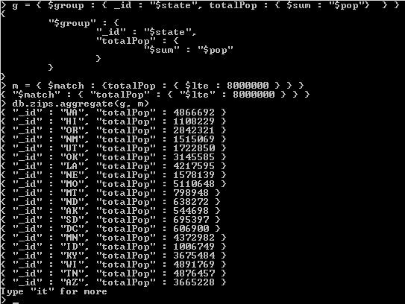

1. What is the fifth largest city in New York?

|  |
| --- |
| g = { $group :  { _id : { state : "$state", city : "$city"}, cityPop : { $sum : "$pop"} }  }  l = { $limit : 5 }  s = { $sort : { cityPop : -1 } }  m = { $match : { state :"NY" } }  db.zips.aggregate([m, g, s, l]) |

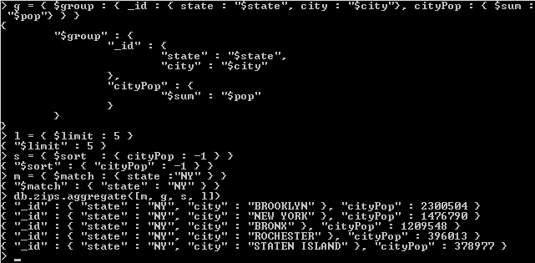

1. What is the total number of cities in each state according to this data set?

|  |
| --- |
| g = { $group : { _id : { state : "$state", city : "$city"}, zipCount : { $sum : 1} } }  s = { $sort : { cityCount : -1 } }  g2 = { $group : { _id : { state : "$_id.state"}, cityCount : { $sum : 1} } }  db.zips.aggregate([g, g2, s]) |

