CV Used Auto

Software Requirements Specification

Version 3.0

Software Engineers:
Aaron Champagne
Rafael Veras

Prepared for
CSI 518 Software Engineering
Instructor: Zumrut Akcam
Spring 2016

Revision History

Date | Description | Author | Comments
03/30/2016 | Version 1.0 | Rafael Veras | First writing for Section 1 & 2
04/16/2016 | Version 2.0 |  | Continuation of Section 1&2, first writing of Section 3 and Sequence Diagrams
05/13/2016 | Version 3.0 | Aaron Champagne | Finish SRS

Document Approval

The following Software Requirements Specification has been accepted and approved by the following:
Signature | Printed Name | Title | Date
 |  | Lead Software Eng.
 | Zumrut Akcam | Instructor
 |  | Lead Software Eng.

Table of Contents

Document Approval ii
1. Introduction 1
1.1 Purpose 1
1.2 Scope 1
1.3 Definitions, Acronyms, and Abbreviations 1
1.4 References 1
1.5 Overview 1
2. General Description 2
2.1 Product Perspective 2
2.2 Product Functions 2
2.2.1 Provide Comprehensive Product Details 2
2.2.2 Detailed Product Categorizations 2
2.2.3 Provide Search Facility 2
2.2.4 Maintain Customer Profile 2
2.2.5 Email Confirmation 2
2.2.6 Provide Shopping Cart Facility 2
2.2.7 Allow Multiple Payment Methods 2
2.2.8 Allow Online Change or Cancellation of Order 3
2.2.9 Allow Online Product Reviews and Ratings 3
2.3 User Characteristics 3
2.4 General Constraints 3
2.5 Assumptions and Dependencies 3
3. Specific Requirements 3
3.1 External Interface Requirements 3
The external interface requirements specify user interfaces, hardware interfaces, software interfaces, and communications interfaces. Simplicity, consistency, and commonly understood terminology are required to eliminate the need of training the users for using the website functions. Hardware interfaces, software interfaces, and communications interfaces should be straightforward for understanding. 3
3.1.1 User Interfaces 4
3.1.2 Hardware Interfaces 4
3.1.3 Software Interfaces 4
3.1.4 Communications Interfaces 4
3.2 Functional Requirements 4
3.2.1 Search Textbook 5
3.2.2 Register 5
3.2.3 Update Account 6
3.2.4 Login 6
3.2.5 Logout 7
3.2.6 List Textbooks 7
3.2.7 Shopping Cart 8
3.2.8 Purchase Textbook 8
3.2.9 Update Order 9
3.2.10 Rate Textbooks or Users 9
3.2.11 Contact Users by Sending Email 10
3.2.12 Maintain by Administrator 10
3.3.1 Use Case for Buyer 10
3.3.2 Use Case for Seller 11
3.4 Classes / Objects 14
3.5 Non-Functional Requirements 14
3.5.1 Performance 14
3.5.2 Reliability 15
3.5.3 Availability 15
3.5.4 Security 15
3.5.5 Maintainability 15
3.5.6 Portability 15
3.6 Inverse Requirements 15
3.7 Design Constraints 15
3.8 Logical Database Requirements 15
3.9 Other Requirements 16
4. Analysis Models 16
4.1 Sequence Diagrams 16
4.3 Data Flow Diagrams (DFD) 17
4.2 State-Transition Diagrams (STD) 17
5. Change Management Process 17
A. Appendices 17
A.1 Appendix 1 17
A.2 Appendix 2 17

1. Introduction

1.1 Purpose
The purpose of the Software Requirement Specification (SRS) is to adequately and completely document the requirements and specifications of an online vehicle system called CV Used Auto. The audience will be other Software Engineers, who wish to know how this project was formalized, programmers that are developing this project, as well as, most importantly, the users who will navigate through the finished product.

1.2 Scope
1.2.1 The product is called the: CV Used Auto.
1.2.2 The goal of this project is to create and implement a full functioning website.
1.2.3 The site will be used by the User, which consists of the Buyer and Seller, as well as the Administrator. The User will be able to login, search a particular model, make and year, sell and view the vehicles that are for sale. The administrator will be the individual controlling the site, regarding the functionality of login, passwords, facilitation of selling and purchasing of cars, and trading.

1.3 Definitions, Acronyms, and Abbreviations
HTML – Hyper Text Markup Language: Used to create static web pages.
JSP – Java Server Pages: Used to create dynamic web contents.
HTTP – Hyper Text Transfer Protocol: A transaction oriented client/server protocol between a web browser and a web server.
Java Database: A database management system that provides a flexible and efficient database platform.

(Will add more after finishing the entire document)

1.4 References
Sections of this document are based upon the IEEE Guide to Software Requirements Specification (ANSI/IEEE Std. 830-1984). The SRS templates have also be used as guides in developing this template for the CSI 518 Software Engineering 2016.

1.5 Overview
The CV Used Auto site will furnish different types of vehicles for selling, and buying. The development of the website will involve Visual Studio and SQL server, which will take a data model and make it easy for use and store data of any structure and dynamically modify the schema. The site will allow the option to login as a user, or administrator. The user will be able to view vehicles, post vehicles for sale as approved by owner. The administrator will have full control of the site such as: adding and deleting accounts. The seller will have the ability to post the information of the vehicle that will be sold. Specifically, Section Two will provide a general description of the project. Section Three will provide the specific requirements for the project. The last one, Section Four will provide the analysis models used in developing the project.

2. General Description

2.1 Product Perspective
CV Used Auto is a website which can be used by buyers, sellers, and site administrators. This system will provide functionality to facilitate the search of vehicles and reserve vehicles online. Site administrators or staff can keep the inventory updated all the time so that users get updated information all the time.

2.2 Product Functions

2.2.1 Provide Comprehensive Product Details
CV Used Auto will display detailed information of the vehicles.

2.2.2 Detailed Product Categorizations
CV Used Auto will display detailed vehicle categories like make, model, year, miles, color, price, transmission type, drive type, and VIN number.

2.2.3 Provide Search Facility
CV Used Auto will enable the user to search for vehicles by make, model, and price

2.2.4 Maintain Customer Profile
CV Used Auto will allow the user to create an account with their username, password, address, city, state, and zip code.

2.2.5 Provide Shopping Cart Facility
CV Used Auto will provide a reservation button that will allow users to reserve a vehicle.

2.3 User Characteristics
CV Used Auto refers to two types of users:
2.3.1 General Users who can use the software to cover their needs:
– Buyers who want to view/search the inventory and reserve vehicles.
– Sellers who want to put vehicles up for sale on the website.
– Both the buyer and the seller are able to contact each other, as well as the store administrator.

2.3.2 Site Administrators who can use more sophisticated tools to maintain the software:
– A Site Administrator is expected to maintain the website and keep it in working order. The administrator will update the inventory and answer any questions from the contact us email.

2.4 General Constraints
The store shall be compatible with the four major Internet browsers: IE, Safari, Chrome, and Firefox, regardless of operation systems.

2.5 Assumptions and Dependencies
The factors that may affect the specific requirements in the SRS include:
- The users are assumed to have access to the Internet while using CV Used Auto.
- The users use one of the four major Internet browsers, i.e., IE, Safari, Chrome, and Firefox, regardless of operation systems.
- CV Used Auto is mainly developed using Visual Studio.
- The development tools and database are restricted to Visual Studio and SQL server.

3. Specific Requirements

3.1 External Interface Requirements

The external interface requirements specify user interfaces, hardware interfaces, software interfaces, and communications interfaces. Simplicity, consistency, and commonly understood terminology are required to eliminate the need of training the users for using the website functions. Hardware interfaces, software interfaces, and communications interfaces should be straightforward for understanding.

3.1.1 User Interfaces
CV Used Auto website will allow the users to access the vehicle inventory, search inventory, reserve a vehicle, sell a vehicle, and contact the site administrator. There are two different user interfaces associated with this website: buyers/sellers and administrators. A non-administrator user can be a buyer/seller simultaneously.
- Buyers/Sellers can browse and search the vehicle inventory without having to login. However a buyer/seller must login first if they would like to reserve a vehicle or sell a vehicle.
- Store Administrator must login at any time in order to perform any functions associated with administrators, such as managing user accounts, answering emails, and updating inventory.

3.1.2 Hardware Interfaces
CV Used Auto is a world wide web website that is supported by most Internet browsers. The website requires an Internet connection at the server site and user end, network servers, and network management tools.

3.1.3 Software Interfaces
CV Used Auto was mostly developed using Visual Studio. Data manipulation and transmission are handled by Visual Studio and SQL server.. Outgoing data includes vehicle inventory, search results, and vehicle information. Incoming data includes user login, search, create user, and contact us.

3.1.4 Communications Interfaces
Emails will be sent to the database by SQL server. Communication between users and administrators will occur in the following situations:
- Whenever a user reserves a vehicle
- Whenever users/administrators contact each other;

3.2 Functional Requirements
Functional requirements specify in details the services that the system should provide, how the system should react to particular inputs and how the system should behave in particular situations. Functional user requirements may be high-level statements of what the system should do.

3.2.1 Search Inventory
3.2.1.1 Introduction
This functional feature deals with any user that wants to search the inventory for a specific vehicle. Login is not required to use this function.
3.2.1.2 Inputs
The inputs include at least one of the following:
- Make
- Model
- Price range
3.2.1.3 Processing
The search information will be sent to the server. The server produces queries on the basis of the information and sends the queries to the database server. The database server returns vehicles that meet the search criteria.
3.2.1.4 Outputs
All of the vehicles that are returned from the database.

3.2.2 Create Account
3.2.2.1 Introduction
This functional feature allows the user to create an account and set up a password to retrieve the account information in the future. Administrator accounts cannot be created in this function.
3.2.2.2 Inputs
The inputs must consist of:
- Username
- Password;
- Address
- City
- State
- Zip code
3.2.2.3 Processing
The request with account information will be sent to the server. The server produces queries on the basis of request and sends the queries to the database server. The database server creates a record with the supplied information.
3.2.2.4 Error Handling
If the server is not able to create and account for some reason then an error message is printed to the screen.

3.2.4 Login
3.2.4.1 Introduction
This functional feature allows the user to access their account by inputting their username and password.
3.2.4.2 Inputs:
- Username
- Password
3.2.4.3 Processing
The request with username and password is sent to the server. The server produces queries on the basis of the request and sends the queries to the database server. The database server confirms the information with data records and logs the user in.
3.2.4.4 Outputs
A confirmation message indicating whether or not the login is successful
3.2.4.5 Error Handling
If the login fails then the web site will print a suitable error message.

3.2.5 Logout
3.2.5.1 Introduction
This functional feature allows the user to logout of their account.
3.2.5.2 Inputs
Click logout button.
3.2.5.3 Processing
The logout request will be sent to the server. The server terminates the user account login session.

3.2.6 List Inventory
3.2.6.1 Introduction
This functional feature allows the user to view all of the vehicles in the inventory.
3.2.6.3 Processing
The server will send a query to the database server. The database server will send a response to the query to the server.
3.2.6.4 Outputs
A list of all the inventory is printed to the screen.

3.2.7 Sell Vehicle
3.2.7.1 Introduction
This functional feature allows the user to put a vehicle up for sail.
3.2.7.2 Inputs
The inputs must consist of the order ID and any of the following:
- Make
- Model
- Color
- Transmission
- Drive
- Miles
- Price
- Year
- VIN
3.2.7.3 Processing
The information will be sent from the website server to the database server. The database server will create a new record with the new vehicle information.
3.2.7.5 Error Handling
If a new record cannot be create then a suitable error message is printed.

3.2.8 Contact Us
3.2.8.1 Introduction
This functional feature allows a user to contact an administrator by sending a message.
3.2.8.2 Inputs
The inputs must consist of the following:
- First name
- Last name
- Email address
- Message
3.2.8.3 Processing
The website server sends a query to the database server. The database server saves the message as a record.
3.2.8.5 Error Handling
If the record cannot be created then a suitable error message is printed.

3.3 Use Cases
This section outlines the use cases for the buyer/seller and the administrator, respectively.

3.3.1 Use Case for Buyer/Seller
This use case describes how the buyer/seller searches inventory, creates an account, logs in, logs out, sells a vehicle, and sends a message.

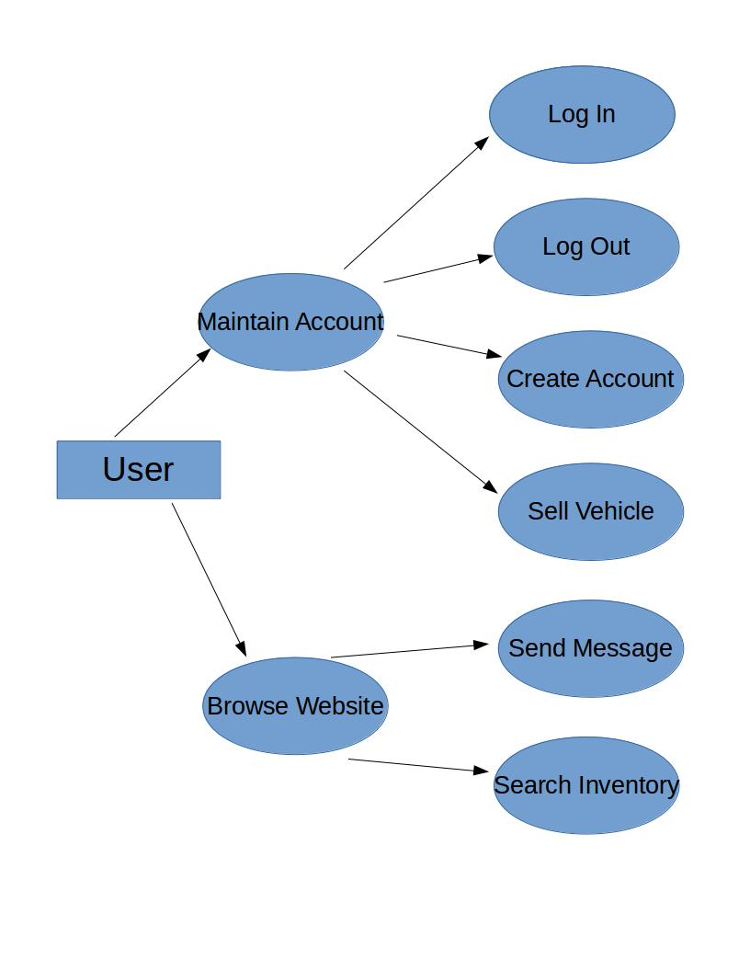

3.3.3 Use Case for Administrator
This use case describes how the seller maintains the system, manages user accounts, manages orders, etc.
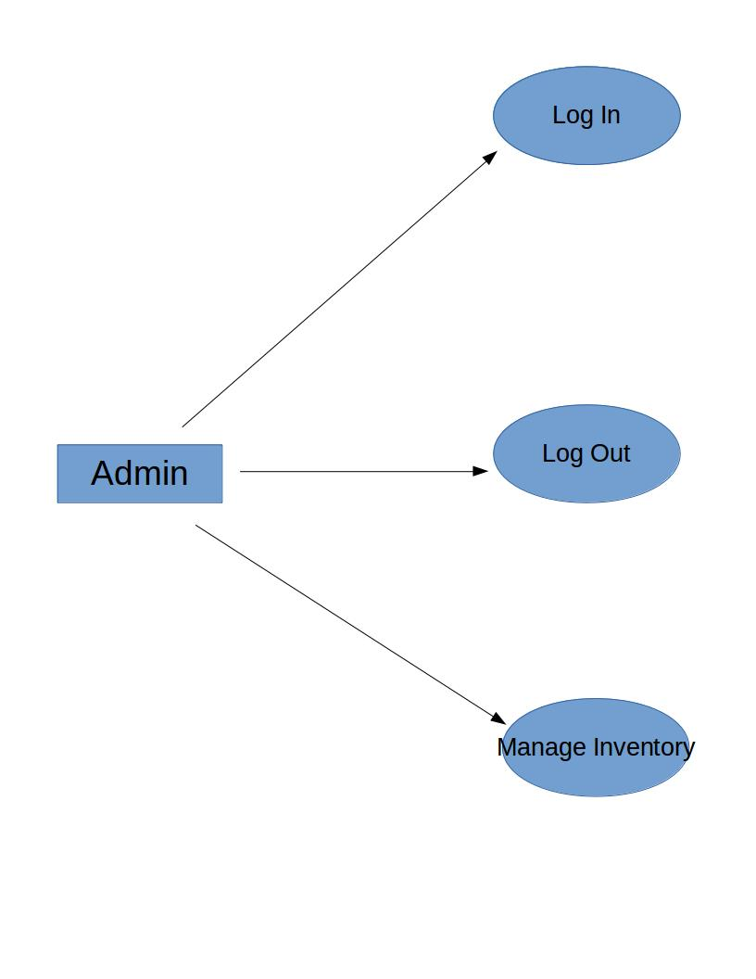

3.4 Non-Functional Requirements
Non-functional requirements may exist for the following attributes. Often these requirements must be achieved at a system-wide level rather than at a unit level. State the requirements in the following sections in measurable terms (e.g., 95% of transaction shall be processed in less than a second, system downtime may not exceed 1 minute per day, > 30 day MTBF value, etc.).

3.5.1 Performance
The system is using the most modern and reliable framework and SQL server which will provide a fast and reliable service.

3.5.2 Reliability
The systems architecture provides the reliability required by the system, with the efficient and robust design of the system, the system can achieve reliability as high as 99.99% under heavy load, while the system is 100% reliable under normal load.

3.5.3 Availability
The website platform was developed with the most modern technologies like Visual Studio and SQL server. The website is capable of 100% uptime.
The interface of the website is customized both for web and mobile devices so that the user can have seamless experience and availability over variety of devices.

3.5.4 Security
Security was considered during the development of the system. Visual Studio and SQL server provide reliable security features to the system and the communication over the network.
SQL server is a highly secure and robust system.

3.5.5 Maintainability
The system is designed to serve as a zero maintenance platform however, it is suggested to perform regular monthly checks over the system to make sure the performance is always high. Maintenance should take about an hour.

3.5.6 Portability
The system multi-tier architecture makes it highly portable. The entire system can be ported within minutes.

3.6 Inverse Requirements
The system is not supposed to perform payment transaction in the real world.

3.7 Design Constraints
Systems payments are supposed to be fully functional. These subsystems can be designed such that they can be made fully functional in further revisions of the product.

3.8 Logical Database Requirements
SQL server will be used as the database for the system. The object oriented database system gives a high performance boost to the system.

3.9 Other Requirements
Catchall section for any additional requirements in the future.

4. Analysis Models
This section lists all analysis models used in developing specific requirements previously given in this SRS, including Sequence Diagrams, Data Flow Diagrams, and State-Transition Diagrams.

4.1 Sequence Diagrams
The sequence diagram below shows how processes operate with one another and the order of the events. Both the two types of users (buyer and seller) may interact with inventory to search textbooks. The seller is allowed to list textbooks into the inventory for sale. The administrator can manage the inventory by more options. Both the buyer and seller must register for an account and login before purchasing or listing textbooks. The buyer and seller can update their own account information, while the administrator can manage all accounts in the database. The buyer may add textbook into the shopping cart and manage the shopping cart. After the buyer checkouts with the shopping cart (place order), both the buyer and seller are able to access to the information of the order that has been placed, and update their own order information as needed. The administrator can manage the information for all orders.

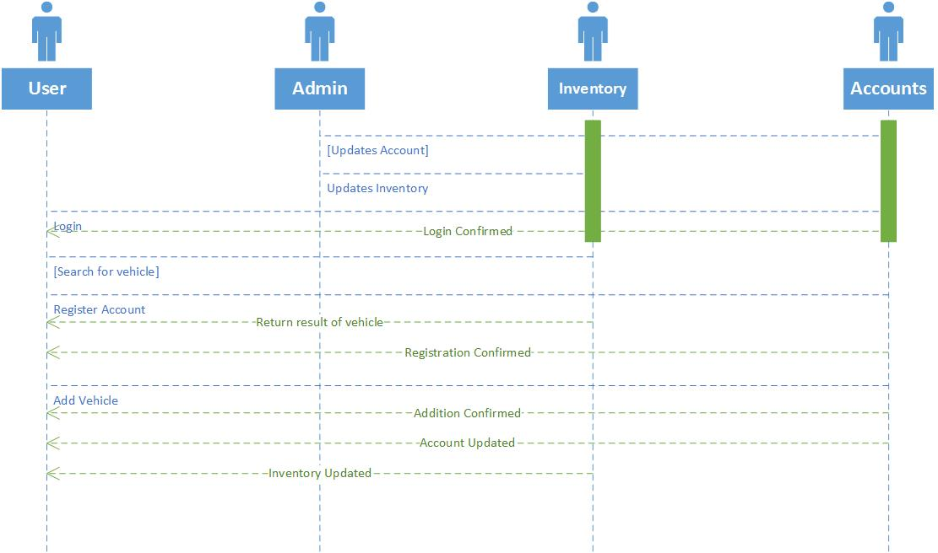

4.2 Data Flow Diagrams (DFD)

5. Change Management Process
Identify and describe the process that will be used to update the SRS, as needed, when project scope or requirements change. Who can submit changes and by what means, and how will these changes be approved.

A. Appendices
Appendices may be used to provide additional (and hopefully helpful) information. If present, the SRS should explicitly state whether the information contained within an appendix is to be considered as a part of the SRS’s overall set of requirements.

Example Appendices could include (initial) conceptual documents for the software project, marketing materials, minutes of meetings with the customer(s), etc.

A.1 Appendix 1

A.2 Appendix 2

