**Group 13 – Phase 4 Remote Multitasking CLI Shell with Scheduling Capabilities**

**Jun & Sonya**

**Overview**

In Phase4, the program was upgraded from Phase3 with scheduling capabilities, Round Robin with different quantum based on the rounds and Shortest Job Remaining First. The server serves multiple concurrent clients using threads. A dummy program is created with a parameter representing the job remaining time as a simulation of process entering CPU. When a dummy program is called, it is recorded as a node and enter the waiting queue built with a linked list. When a new process/request arrive, the scheduler function will select the next process to execute based on SJRF controlled by round numbers. A counting semaphore is used to ensure mutually exclusive execution of different process.

**Usage**

1. Open the directory in TWO separate UNIX-based terminals
2. Compile the files required for running by using the Makefile. Run ‘make all’ to compile the client, server, and dummyProgram.c file.
3. In one of the terminals, run the server by running the command “./Phase3-server.o”
4. In the other terminals, run the client by running the command “./Phase3-client.o”
5. The order is important! The server should be run first before the client, otherwise the clients will report “Connection error” as there is no server to connect to.
6. Once the connection is created, the client terminal will report the successful connection. You can start entering commands listed on the CLI including command “./dummyProgram.o X” (X represents an integer) to send to the server, and the server will run the commands or put the program in the waiting queue before sending back the output of the commands to the client.
7. You can also connect with more than 1 client by repeating steps 4-6 to create more clients.
8. If the input commands are not among the listed ones, then the client will get an error message specifying “commands are not available”.
9. To exit the program, input “exit” on the client end.

**Implementation Details**

**Dummy Program –**

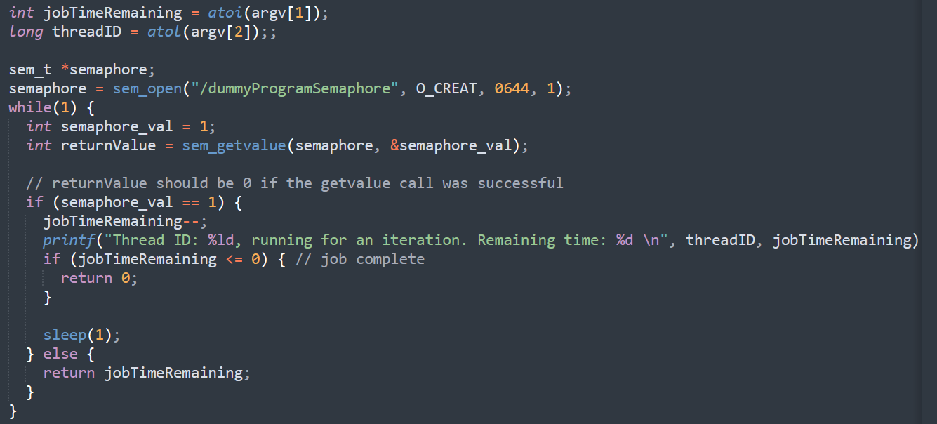

The dummy program takes a parameter as job remaining time and contains a loop with sleep function. The dummy program is compiled in MakeFile. After calling, it return an integer of its remaining job time. A named semaphore is used to allow it is only executed when being selected by the scheduler function. A named semaphore is used so that the semaphore is accessible in multiple files, the dummyProgram.c and the server.c files. The dummy program does not ‘wait’ for the semaphore, it only reads the value from it. This is so that the state of the semaphore is only controlled by the scheduler, and also prevents the possibility of a deadlock happening.  
  
**Node for holding process / Process Queue**

A linked list structure is used to act as the process queue. Each node represents one process running on one thread and we record its threadID, remaining job time, round number, and a pointer to the thread semaphore.   
  
  
**When a client requests to run the dummyProgram, the client creates a ‘process’ object, and inserts it into the Process Queue. It then waits for the Scheduler to release the semaphore before actually executing the command.   
  
**As seen in the screenshot above with the code of the dummyProgram, the execution is not actually paused. Instead, it returns early and returns the remaining execution time left after it’s current execution.   
  
On the client thread, the parent process will get the return value from the dummyProgram execution after it is done executing ( either return early because scheduler locked the named semaphore, or return when it has completed execution, jobTimeRemaining = 0 ). It then updates the details of the job in the Process Queue, and the Scheduler can select this job again in the future.  
  
   
**In themain function of the server, a thread is created to run the SchedulerFunction. The SchedulerFunction initializes the named semaphore used to control the execution of dummyPrograms. The function runs in a loop, with a sleep(1) every iteration to simulate a CPU cycle. Whenever the quantum for the currently running program has finished, or a new process has entered the queue, the scheduler will schedule a new process to run.   
  
It first stops the execution of any currently running thread by holding the semaphore for the threads, if any.   
  
Then, it selects a new thread to be run, and releases the semaphores required by the program to run for a time quantum based on that thread’s roundNumber. Once the time quantum finishes, this process repeats.



**Multiclient capability -**   
After the server begins listening to connections, there is a while loop where the server will allocate new memory for the arguments needed for a new client, such as the socket fd and thread arguments. Once a new client connects, the server calls pthread_create on HandleClient() for each client, so there will be 1 thread running HandleClient() for each client that is connected to the server. Text  
  
In HandleClient(), the thread is detached from the main process, so that the main process does not need to wait for the termination of this thread. After receiving the socket variable as an argument from the thread creator, the thread frees the argument and starts listening to user inputs from the client using the socket as previously implemented in Phase3. A semaphore is initialized for every client.  
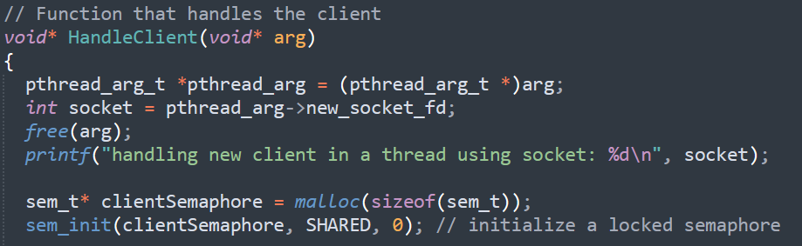  
  
  
**



**Group 13 – Phase 3 Remote Multitasking CLI Shell**

**Jun & Sonya**

**Overview**

In Phase3, the program was upgraded from Phase2 with multiclient capability. The Phase3 server is able to serve multiple concurrent clients using threads. Some issues from Phase2 has also been fixed in this version, such as CTRL-C signals on the client now properly being sent to the server for proper termination. Commands that have no output are also working now. Executions of invalid commands no longer offset future user inputs.  
  
**Usage**

1. Open the directory in TWO separate UNIX-based terminals
2. Compile the files required for running by using the Makefile. Run ‘make all’ to compile the client, server, and test .c file.
3. In one of the terminals, run the server by running the command “./Phase3-server.o”
4. In the other terminal, run the client by running the command “./Phase3-client.o”
5. The order is important! The server should be run first before the client, otherwise the client will report “Connection error” as there is no server to connect to.
6. Once the connection is created, the client terminal will report the successful connection. You can start entering commands listed on the CLI to send to the server, and the server will run the commands before sending back the output of the commands to the client.
7. You can also connect with more than 1 client by repeating steps 4-6 to create more clients.
8. If the input commands are not among the listed ones, then the client will get an error message specifying “commands are not available”.
9. To exit the program, input “exit” on the client end.

**Implementation Details**

**Multiclient capability -**   
After the server begins listening to connections, there is a while loop where the server will allocate new memory for the arguments needed for a new client, such as the socket fd and thread arguments. Once a new client connects, the server calls pthread_create on HandleClient() for each client, so there will be 1 thread running HandleClient() for each client that is connected to the server. Text  
  
In HandleClient(), the code is mostly the same as in the single-client case as previously implemented in Phase2. The thread is detached from the main process, so that the main process does not need to wait for the termination of this thread. After receiving the socket variable as an argument from the thread creator, the thread frees the argument and starts listening to user inputs from the client using the socket as previously implemented in Phase2.

**Fixing CTRL-C not working**   
  
In the client, we listen to the SIGINT command (CTRL+C) from the user. If the user tries to exit the client using CTRL-C, we catch that and gracefully exit by sending one last message to the server, “exit_client” which signals the server to terminate this client session.   
  
On the server:  
  
**Fixing commands with no output**

In the previous versions of the shell, the ‘execvp’ functions were piped directly to the socket. This caused some issues when the execvp functions was one that did not return anything, as the client expects a response message for every command it sends, as it is listening with recvp(). How do we send an empty message if the command has no output?  
  
We fixed the problem by creating a new pipe and piped the return values from execvp to it. Thus, the output of execvp is captured in our pipe, fd. For every command to be run in the server, we fork the HandleClient thread, and run the execvp command in the child process. In our child process, we call execvp to get an output in the FD pipe. Then in the parent process, we read from FD to determine if there is an output or not.  
  
As the pipes are properly closed in the child process, the read() function will return “0” if the pipe is empty. It will return an integer > 0 if the read was successful, and the pipe contained data. Thus, if the pipe contains a message, we send that message back to the client. If it does not, that meant that the command has no output, e.g “grep ‘zzzzzzzzzzzz’ when there are no files named ‘zzzzzzzzzzz’. In that case, we simply send an empty buffer so that the client’s recv() waiting call will receive a response and to signal that the client can proceed to send the next command.  
  
  
**Terminating the thread after user exit**  
After the client exits for any reason, be it the client sending the “exit” command or SIGINT (CTRL+C) signal, the server will process it and terminate the thread running the session for that particular client.  
  
  
As there is 2 processes in the thread for every command, (The child, running the execvp and the parent processing the results from the execvp), we have to terminate the thread in the parent process instead of the child process. We write a message to our pipe in the child process, so that the parent process will receive an “exit” message.  
  
In the parent process, we simply pthread_exit() if we receive an “exit” message in the FD pipe. Thus, the thread is terminated, but other threads and other clients being served from the server will keep running as the thread is detached.  
  
  
**Group 13 – Phase 2: Remote CLI Shell**

**Jun & Sonya**

**Usage of the program**

We upgraded Phase1 with socket communication. The client takes inputs from the user and sends requests to the server. The client will then receive the output/result from the server and print it on the screen.

**To run the client/server**

1. Open the directory in TWO separate UNIX-based terminals
2. In one of the terminals, run the server by running the command “gcc Phase2-server.c -o Phase2-server.o && ./Phase2-server.o”
3. In the other terminal, run the client by running the command “gcc Phase2-client.c -o Phase2-client.o && ./Phase2-client.o”
4. The order is important! The server should be run first before the client, otherwise the client will report “Connection error” as there is no server to connect to.
5. Once the connection is created, the client terminal will report the successful connection. You can start entering commands listed on the CLI to send to the server, and the server will run the commands before sending back the output of the commands to the client.
6. If the input commands are not among the listed ones, then the client will get an error message specifying “commands are not available”.
7. To exit the program, input “exit” on the client end. Do not enter ctrl+c on the client because it will not close the server properly. **Example test cases and results** valid test cases

*--- 3 pipes ---*

"cat words.txt | grep yasin | tee output1.txt | wc -l"

6

"cat words.txt | uniq | sort | head -10"

Android

Banana

Cat

Coffee

Edamame

Hello

Hersheys

Mcdonalds

Starbucks

Sun

"sort alphabets.txt | head -10 | tail -n 5 | tee output3.txt" f

g h

i

k

*--- 2 pipes ---*

"sort words.txt | head -10 | grep 'a'"

Banana

Cat

Edamame

Mcdonalds

Starbucks

"cat words.txt | grep yasin | wc -l"

6

*--- 1 pipe ---*

"cat alphabets.txt | tail -10"

l

w

q

r

z

f

u g n h

"cat words.txt | uniq"

Hello

Mcdonalds Coffee yasin hey

Starbucks Banana yasin

Water Test fish yasin yo bread potato Cat Edamame

yasin more Sun burger

Hersheys

Swimming

Android

"df | tee disk_usage.txt"

Filesystem 1K-blocks Used Available Use% Mounted on rootfs 249467900 217039252 32428648 88% / none 249467900 217039252 32428648 88% /dev none 249467900 217039252 32428648 88% /run none 249467900 217039252 32428648 88% /run/lock none 249467900 217039252 32428648 88% /run/shm none 249467900 217039252 32428648 88% /run/user tmpfs 249467900 217039252 32428648 88% /sys/fs/cgroup

C:\ 249467900 217039252 32428648 88% /mnt/c

D:\ 249470972 46119964 203351008 19% /mnt/d

*--- 0 pipes ---*

"cat alphabets.txt"

b d k e

m

a c p

i t

y

l

w

q

r

z

f

u g n h

"ls -l"

-rwxrwxrwx 1 yaya1721 yaya1721 2550 Apr 5 18:32 Phase2-client.c

-rwxrwxrwx 1 yaya1721 yaya1721 17328 Apr 4 23:17 Phase2-client.o

-rwxrwxrwx 1 yaya1721 yaya1721 15541 Apr 5 18:52 Phase2-server.c

-rwxrwxrwx 1 yaya1721 yaya1721 22048 Apr 4 23:17 Phase2-server.o

-rwxrwxrwx 1 yaya1721 yaya1721 12665 Apr 4 23:17 Phase2Report.docx

-rwxrwxrwx 1 yaya1721 yaya1721 13024 Apr 5 18:51 a.out

-rwxrwxrwx 1 yaya1721 yaya1721 63 Apr 3 11:25 alphabets.txt

-rwxrwxrwx 1 yaya1721 yaya1721 581 Apr 6 02:40 disk_usage.txt

-rwxrwxrwx 1 yaya1721 yaya1721 54 Apr 6 02:37 output1.txt

-rwxrwxrwx 1 yaya1721 yaya1721 15 Apr 6 02:38 output3.txt

-rwxrwxrwx 1 yaya1721 yaya1721 189 Apr 3 11:25 words.txt

"man"

What manual page do you want?

"pwd"

/mnt/c/Users/Sonya/Documents/GitHub/OS-Project/Phase2

"echo hello" hello

"ps"

PID TTY TIME CMD

9 tty1 00:00:01 bash

27334 tty1 00:00:00 a.out

27433 tty1 00:00:00 ps

"whoami" yaya1721

"exit"

Closing socket from clientside

Exited invalid test cases

"cd"

Command is currently unavailable, change one...

Group 13 – Phase 1

Jun & Sonya

# Usage of the program

We developed our own shell in C that replicates feature from the Linux commands or a program to execute including its name. We implemented single and composed commands using 0 to 3 pipes.

# Example test cases and results

*--- 3 pipes ---*

cat words.txt | grep yasin | tee output1.txt | wc -l

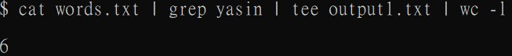

cat words.txt | uniq | sort | head -10

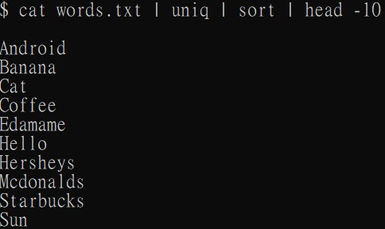

sort alphabets.txt | head -10 | tail -n 5 | tee output3.txt

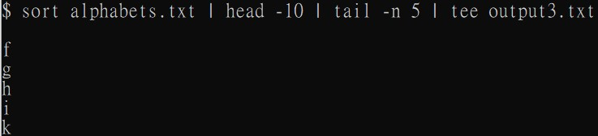

*--- 2 pipes ---*

sort words.txt | head -10 | grep 'a'

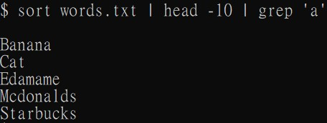

cat words.txt | grep yasin | wc -l

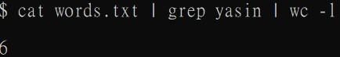

*--- 1 pipe ---* cat alphabets.txt | tail -10

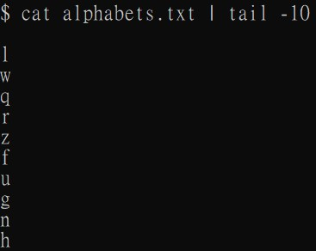

cat words.txt | uniq

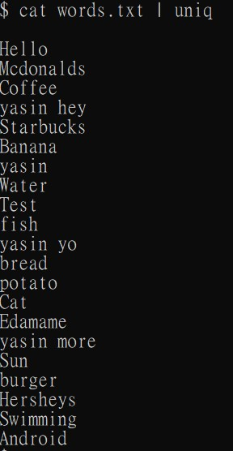

df | tee disk_usage.txt

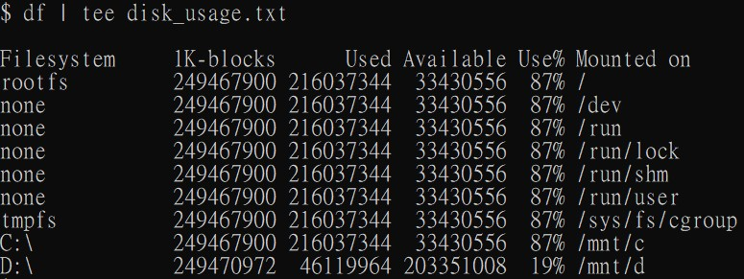

*--- 0 pipes ---* cat alphabets.txt

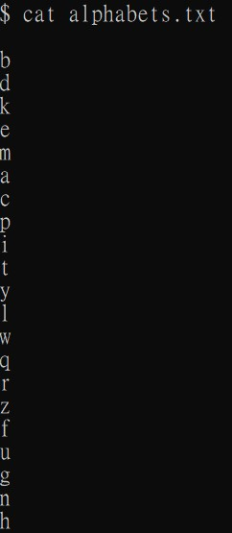

ls -l

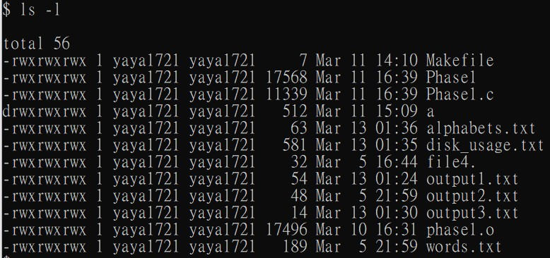 man

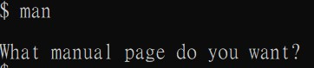

pwd

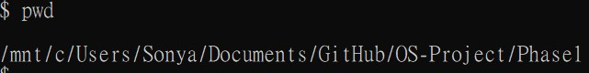 touch dummy.txt

Create a file in the same directory called dummy.txt rm dummy.txt

Remove the file, dummy.txt ping google.com

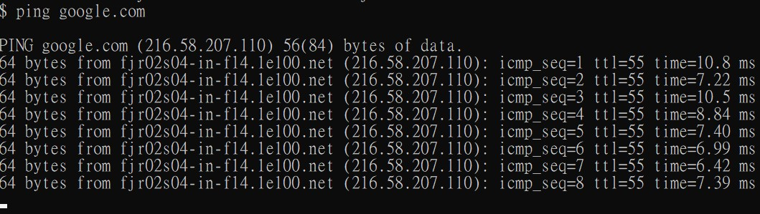

# Description of implementation

We developed our own shell in C programming language. After parsing the input from the command line, we determined how many pipes should be used in each command and called the corresponding function. Within each function, we forked child process and created pipes. Parent process should execute the last command after its child process executed the previous commands if the number of commands is larger than one. User is able to exit the program by inputting “exit” on the command line interface.