1. Conceptual database design:

Here is a small image of the ER Diagram. A larger version is available in ER.pdf.

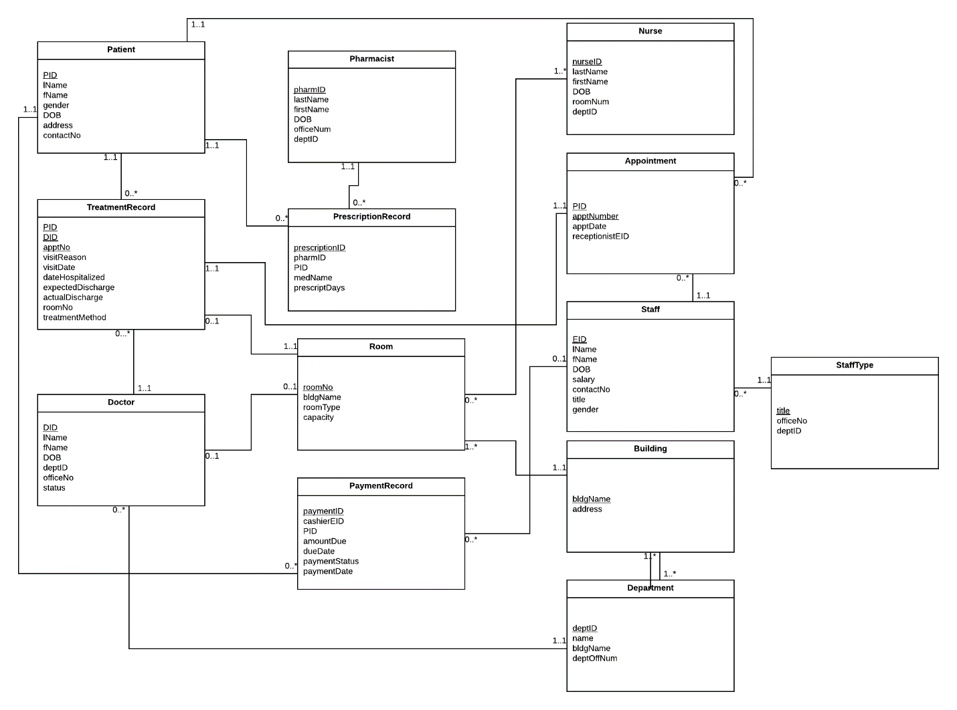

Constraints include Room- a doctor may only have one office, and an office may only be used by one doctor. This is different for different employees- all receptionists share the same office, for example.

StaffType was pulled out of staff to ensure our tables were in third normal form. All staff of the same type are in the same department, office, and have the same title, so storing these in Staff is redundant.

1. Logical database design
2. Normalization analysis

FDs:

Patient:

{PID -> lName, fName, gender, DOB, address, contactNo}

Room:

{roomNo -> bldgName, roomType, capacity}

Doctor:

{DID -> lName, fName, DOB, deptID, officeNo, status}

Pharmacist:

{pharmID -> lName, fName, DOB, deptID, officeNo}

PrescriptionRecord:

{prescriptionID -> pharmID, PID, medName, prescriptDays}

Nurse:

{nurseID -> lName, fName, DOB, deptID, roomNo}

Staff:

{EID -> lName, fName, DOB, deptID, salary, contactNo, title, gender}

Appointment:

{PID, apptNumber -> apptDate, receptionistEID}

Treatment Record:

{PID, DID, apptNo -> visitReason, visitDate, dateHospitalized, expectedDischarge, actualDischarge, roomNo, treatmentMethod}

PaymentRecord:

{paymentID -> cashierEID, PID, amountDue, dueDate, paymentStatus, paymentDate}

The above tables are in 3NF since the only FD is a superkey determining everything else.

Building:

{bldgName -> address}, {address -> bldgName}

Department:

{number -> name, bldgName, deptOffNum}, {name -> deptID, bldgName, deptOffNum}

StaffType:

{title -> officeNo, deptID}, {officeNo -> title, deptID}, {deptID -> title, officeNo}

The above tables are in 3NF since attributes are all determined by superkeys. Both have multiple candidate keys- in fact, every member of stafftype is a candidate key.

1. Query Description

Our query chose to figure out which receptionists scheduled appointments for patients receiving Viagra prescribed by a given pharmacist. This allows a pharmacist to discover who is aware of the medication a patient is taking. Without this feature, it may be difficult to discover who is involved in the stages of a patient’s hospital lifetime in the case of an emergency. Starting with a Pharmacist ID, it checks the PrescriptionRecord table for a matching ID and Viagra as the prescription. Then it checks the Patient ID associated with that prescription, and finds appointments for that patient, checking the receptionist that made the appointment and printing them out.