Endangered Species Database

COSC 386

Dr Yaping Jing

Michael Mandulak, Billy Wolf, Ian Thomas, Hannah Wichrowski, Daniel Weitman

Project Description

The Endangered Species Database project consisted of the implementation of an optimal MySQL database to be accessed through a visually pleasing, user-friendly and functional webpage in order to improve upon existing endangered animal databases by offering a concise portal for necessary information regarding certain species for those that are less involved in the topic.

Requirements

* The database tracks endangered **ORGANISM** species, storing each species’ unique *BinomialNomenclature* and the level of endangerment on the *WatchList* (critical to endangered), the current living *Population* total, a common *Name*, and a link for the *Picture*. Also ORGANISMS live in a particular REGION as well as are affected by DANGERS.
* Each **ANIMAL** is an instance of ORGANISM with a common *Classification* (mammal, reptile, etc.) and a measured average *Lifespan*.
* Each **PLANT** is an instance of ORGANISM with a *LifeDuration* (annual, perennial, biennial).
* Information on **REGIONS** that endangered species reside in is kept, tracking a unique *Name* and the *Biome* that the REGION supports.
* Various **DANGER** sources are tracked in order to categorize the threats to these endangered species by the unique *Name* and whether or not the danger to the ORGANISM is *HumanCaused.*
* Nonprofit Organizations (**NPO**s) are marked with a unique *Name,* a *WebLink* to the support and information page and a main source of *Funds.* The NPOs are identified as a mitigation to the DANGERs of an endangered species while also being associated with a particular REGION of aid and also help ORGANISMS.

Project Description

Based on current databases of endangered animal species that lack necessary information, have poor interface design and fail to convey information to a wide range of audiences, this project seeks to create a database as an improvement to the aforementioned databases in order to effectively convey the important information regarding endangered species and how they can be supported. This database will focus on covering the essential identifiers for endangered species (scientific name, common name, habitat, etc.) while also providing information regarding the non-profit organizations (NPOs) that currently support endangered species preservation. Similarly, the audience targeted will be the general public in hopes of spreading awareness of the topic as well as providing a means of public involvement in preservation through the provided NPO information. Based on this goal of information extension, an online database would be the most effective method as an easy-access platform for users to quickly search for information based on current necessity or interest.

E/R Diagram

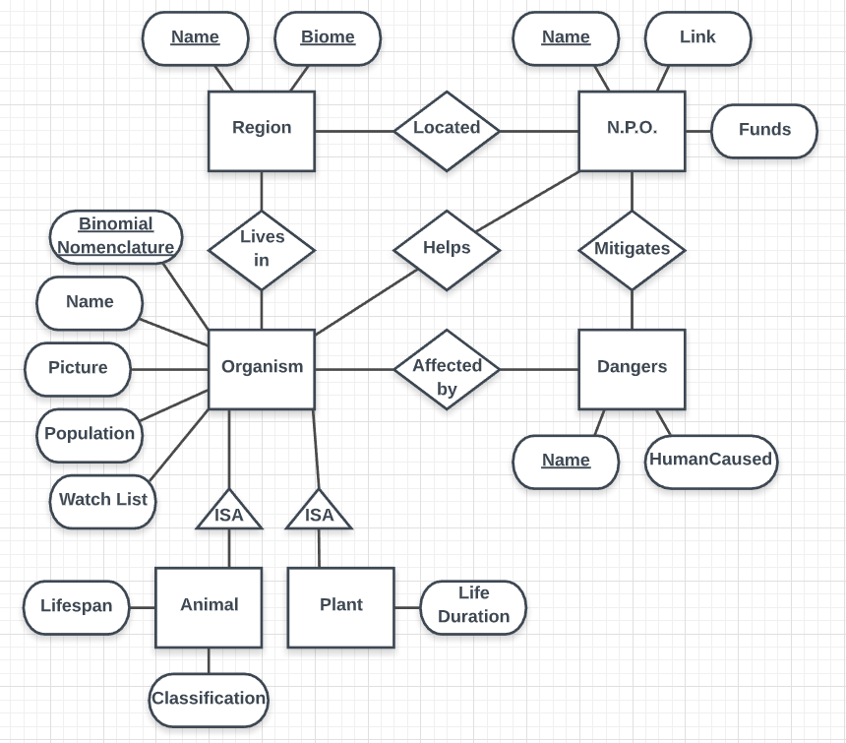

Database Schema - No Decompositions Necessary

Dangers(Name, HumanCaused);

Region(Name, Biome);

NPOs(Name, Link, Funds);

Organism(Binomial Nomenclature, Population, Watch List, Name, Picture);

Animal(Binomial Nomenclature, Classification, Lifespan)

foreign key (Binomial Nomenclature) references Organism(Binomial Nomenclature);

Plant(Binomial Nomenclature, Life Duration)

foreign key (Binomial Nomenclature) references Organism(Binomial Nomenclature);

Mitigates(dName, npoName) foreign key (dName) references Dangers(Name),

foreign key (npoName) references NPOs(Name);

Helps(npoName, Binomial Nomenclature) foreign key(npoName) references NPOs(Name), foreign key(Binomial Nomenclature) references Organism(Binomial Nomenclature);

Located(rName, npoName) foreign key (rName) references Region(Name), foreign key (npoName) references NPOs(Name);

Lives_In(rName, Binomial Nomenclature) foreign key (rName) references Region(Name), foreign key (Binomial Nomenclature) references Organism(Binomial Nomenclature);

Affected_By(Binomial Nomenclature, dName) foreign key(Binomial Nomenclature) references Organism(Binomial Nomenclature), foreign key(dName) references Dangers(Name);

Implementation

The implementation of the website for the endangered species database is composed of HTML webpages for basic website functionality alongside AJAX for PHP implementation and general functionality and Javascript to display search results and updates to the page from AJAX in the HTML. The website consists of a homepage, an endangered species search page, a nonprofits search page, a danger information page, a login page, a contact page and an admin page. Behind user view, there are many more PHP files for functionality, visual assets and styling content. The PHP implementation builds queries based on the given user input through AJAX and executes these queries on the MySQL database, returning a success or fail value and cueing Javascript prompts. The HTML coupled with CSS creates a visually pleasing interface while maintaining the functionality through the connection of HTML with AJAX.

Website: [acadweb1.salisbury.edu/~mmandulak1/ESD/index.php](http://acadweb1.salisbury.edu/~mmandulak1/ESD/index.php)

Functionalities

* Login security with hashed passwords and admin functionality for editing the database
* Fully functional endangered species database search, listing various information regarding the species searched
* Descriptive dangers page to provide details to users regarding the main dangers that impact endangered species
* Functional nonprofits search for users to look up nonprofits that help endangered species
* User friendly and visually pleasing interface
* Functional contact form for users submissions regarding the website, which are stored in the database and available for administrative view on the admin page.

Methodology

The database queries and implementation utilizes MySQL while the website development was conducted using Javascript (AJAX, JSON, JQuery), PHP, HTML and CSS. Putty was used for SFTP and Github was used for version control. Visual Studio Code was the text editor utilized for HTML, Javascript and PHP development.

Testing Details

All of the tables and data were tested for correctness thoroughly with comparisons between the data collected and the data in the database. The data was held in files and loaded into the database while being checked for correctness. The data was tested after the implementation of the interface was completed so to ensure that all of the data would be accurately displayed. Similarly, the application was tested administratively and from a user standpoint by both the developers and willing users. Any issues noted during these test runs were resolved for the sake of website functionality and ease of usage. Performance-wise, the database was loaded with a fair amount of data and despite this, the application continues to perform while maintaining user experience through a lack of delays and visual bugs.

Summary

Overall, this project was a large time commitment and a large crash course in web development and database implementation. As a group, the project was split up so that Dan and Billy handled the database design, implementation and data entry, Hannah covered the HTML, CSS and other visual assets for interface design, Ian helped with AJAX, HTML and Javascript code and Michael did the PHP, website security/login features and some AJAX and Javascript. As a group, we worked well together and everyone covered their individual task very well. From all perspectives of the project work, this project covers a wide range of database implementation topics, web development topics and general software development practices, making the project very beneficial for general development skills.