华东师范大学期末试卷（A）
2004—2005学年第二学期
总分
任课教师签名

学生姓名 学号
学生系别 专业 年级 班级
课程名称 数据结构
课程性质（专业必修）
一、 单项选择题(18分，每题3分)
1. One difference between a Queue and a Stack is:
a) Queue implementations require linked lists, but stack implementations do not.
b) Stack implementations require linked lists, but queue implementations do not.
c) Queues use two ends of a linear structure, stacks use only one.
d) Stacks use two ends of a linear structure, queues use only one.

2. Which one of the following sort is stable?
a) Insertion sort
b) Shell sort
c) Selection sort
d) Quick sort

3. which one of the following list can use binary search?
a) 1 3 5 2 4
b) 1 2 3 4 5
c) 2 4 1 3 5
d) 5 3 1 2 4

4. Shell sort finally perform an ordinary ( )?
a) Insertion sort
b) Heap sort
c) Selection sort
d) Quick sort

5. A heap is a list in which each entry contains a key, and, for all positions i in the list, the key at position i is at lease as large as the keys in positions 2i+2 and ( ), provided these positions exist in the list.
a) 2i
b) 2i-1
c) 2i-2
d) 2i+1

6. The following function sums the integers from low through limit, inclusive:
int Sum( /* in */ int low,
/* in */ int limit )
{
if ( ) // Condition is missing
return limit;
else
return low + Sum(low + 1, limit);
}
What is the missing If condition?
a) low == 1
b) limit == 1
c) low == limit
d) low > limit
e) low < limit

二、 填空题（18分，每题6分）
1. Read the following program and fill the blank to complete the method.
Error_code Hash_table :: insert(const Record &new_entry)
/* Post: If the Hash table is full, a code of overflow is returned. If the table already
contains an item with the key of new_entry, a code of duplicate_error is returned.
Otherwise: The Record new_entry is inserted into the Hash table
and success is returned.
Uses: Methods for classes Key , and Record . The function hash . */
{
Error_code result = success;
int probe_count, // Counter to be sure that table is not full.
increment, // Increment used for quadratic probing.
probe; // Position currently probed in the hash table.
probe = hash(new_entry);
probe_count = 0;
increment = 1;
while (table[probe] != 0 // Is the location empty?
&& // empty because delete
&& table[probe] != new_entry // Duplicate key?
&& ) { // Has overflow occurred?
probe_count++;
probe = (probe + increment)%hash_size;
increment += 2; // Prepare increment for next iteration.
}
if (table[probe] == 0) table[probe] = new_entry;
if (table[probe] == -1) table[probe] = new_entry;
// Insert new entry.
else if (table[probe] == new_entry) ;
else result = overflow; // The table is full.
return result;
}
2. The following program is the connect_trees function of Buildable_tree; please fill the blank to complete the function.
template <class Record>
void Buildable_tree<Record> :: connect_trees(
const List < Binary_node<Record>* > &last_node)
/* Pre: The nearly-completed binary search tree has been initialized. List last_node
has been initialized and contains links to the last node on each level of the tree.
Post: The final links have been added to complete the binary search tree.
Uses: Methods of class List */
{
Binary_node<Record>
*high_node, // from last node with NULL right child
*low_node; // candidate for right child of high node
int high_level = last_node.size( ) - 1, low_level;
while ( ) {
last_node.retrieve(high_level, high_node);
if (high_node->right != NULL)
high_level--; // Search down for highest dangling node.
else { // Case: undefined right tree
low_level = high_level;
do { // Find the highest entry not in the left subtree.
last_node.retrieve(--low_level, low_node);
} while (low_node != NULL && );
high_node->right = low_node;
high_level = low_level;
}
}
}

3. The following program is the divide_from function of Merge Sort; please fill the blank to complete the function.
Node<Record> * divide_from(Node<Record> *sub_list)
/* Post: The list of nodes referenced by sub_list has been reduced to its first half, and a pointer to the first node in the second half of the sublist is returned. If the sublist has an odd number of entries, then its first half will be one entry larger than its second.*/
{
Node<Record> *position, // traverses the entire list
*midpoint, // moves at half speed of position to midpoint
*second_half;
if ((midpoint = sub_list) == NULL) return NULL; // List is empty.
position = midpoint->next;
while ( ) {
// Move position twice for midpoint's one move.
position = position->next;
if (position != NULL) {

position = position->next;
}
}
second_half = midpoint->next;
midpoint->next = NULL;
return second_half;
}

三、 简答题（64分，每题9分，最后一题10分）
1. Please explain what is preorder traversal, inorder traversal and postorder traversal of a Binary tree. And draw the Binary tree with the following preorder and inorder sequences.

Preorder:
0 1 3 7 8 4 9 2 5 6
inorder:
7 3 8 1 9 4 0 5 2 6

2. Apply quicksort to the list ( 16, 33, 10, 35, 29, 19, 12 ), where the pivot in each sublist is chosen to be the last number in the sublist. Please draw the tree of recursive calls.

3. Please give the definition of heap. Apply heap sort to the list (x, y, p, d, f, b, k, a, c); Please give the process with diagram.

4. Please give the definition of AVL tree. In each of the following order:
( A，Z，B，Y，C，X，D，W，E，V，F )
(A，V，L，T，R，E，I，S，O，K)
Insert the keys into an empty AVL tree; please give the process with diagram. Then give the preorder and postorder of the two AVL trees.

5. With the following recursive function search_for_node, please write the Nonrecursive version and give some comment in your program.
template <class Record>
Binary_node<Record> *Search_tree<Record> :: search_for_node(
Binary_node<Record>* sub_root, const Record &target) const
/*
Pre: sub_root is NULL or points to a subtree of a Search tree
Post: If the key of target is not in the subtree, a result of NULL is returned. Otherwise, a pointer to the subtree node containing the target is returned.
*/
{
if (sub_root == NULL || sub_root->data == target)
return sub_root;
else if (sub_root->data < target)
return search_for_node(sub_root->right, target);
else return search_for_node(sub_root->left, target);
}

6. Implement the following function for the BinaryTree class:
int leaves(Binary_node *root);
//returns the number of leaves in this tree
//the class Binary_node is like below, it is also for question 7.
struct Binary_node {
// data members:
int data;
Binary_node *left;
Binary_node *right;
// constructors:
Binary_node( );
Binary_node(const int &x);
};

7. Implement the following function for the BinaryTree class:
void reflect(Binary_node *root);
//swaps the two children of each node in this tree
//for example, like the diagram below:

before reflect after reflect

0
1
2
5
6
0
2
1
6
5

数据结构参考答案
一、单项选择题
1． C
2． A
3． B
4． A
5． D
6． C

二、填空题
1. table[probe] != -1 probe_count < (hash_size + 1)/2
result = duplicate_error
2. high_level > 2
low_node->data < high_node->data
3. position != NULL midpoint = midpoint->next;

三、简答题
1.
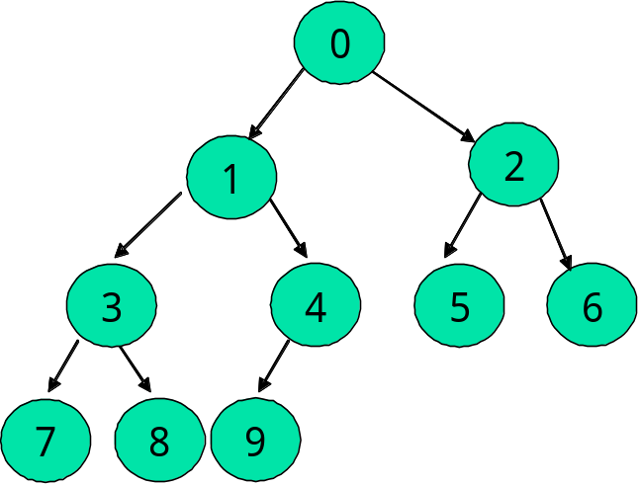

2.
12
10 16
33
29 35
19

3.
y-z r-y
(z, y, p, d, f, b, k, a, c)
(y, f, p, d, c, b, k, a, z)
(p, f, k, d, c, b, a, y, z)
(k, f, b, d, c, a, p, y, z)
(f, d, b, a, c, k, p, y, z)
(d, c, b, a, f, k, p, y, z)
(c, a, b, d, f, k, p, y, z)
(b, a, c, d, f, k, p, y, z)
(a, b, c, d, f, k, p, y, z)
（注：此题答案中似乎有误，Z应该为原题中X，但为保持原版本的内容，故不做改动，仅附加此注说明）

4.
Preorder:
E C B A D W V F Y X Z
inorder:
A B C D E F V W X Y Z
Postorder:
A B D C F V X Z Y W E

Preorder:
L E A I K T R O S V
inorder:
A E I K L O R S T V
Postorder:
A K I E O S R V T L

5.
//Nonrecursive version:
template <class Record>
Binary_node<Record> *Search_tree<Record> :: search_for_node(
Binary_node<Record>* sub_root, const Record &target) const
{
while (sub_root != NULL && sub_root->data != target)
if (sub_root->data < target) sub_root = sub_root->right;
else sub_root = sub_root->left;
return sub_root;
}

6.
Implement the following function for the BinaryTree class:
int leaves(Binary_node *root)
//returns the number of leaves in this tree
//the class Binary_node is like below, it is also for question 7.
struct Binary_node {
// data members:
int data;
Binary_node *left;
Binary_node *right;
// constructors:
Binary_node( );
Binary_node(const int &x);
};

{
if(!root)return 0;
if(root->left==0 && root->right==0) return 1;
return leaves(root->left)+leaves(root->right);
}

7.
Implement the following function for the BinaryTree class:
void reflect(Binary_node *root)
//swaps the two children of each node in this tree, like the diagram below:
{
if(!root) return;
reflect(root->left);
reflect(root->right);
int tmp= root->left->data;
root->left->data= root->right->data;
root->right->data=tmp;
}

