华东师范大学期末试卷（B）
2004—2005学年第二学期
总分
任课教师签名

学生姓名 学号
学生系别 专业 年级 班级
课程名称 数据结构
课程性质（专业必修）
一、 单项选择题(18分，每题3分)
1. What is the missing statement?
void Sortable_list :: build_heap( )
/* Post: The entries of the Sortable list have been rearranged so that it becomes
a heap. */
{
int low;
for ( ; low >= 0; low--) {
Record current = entry[low];
insert_heap(current, low, count - 1);
}
}
a) count = 0
b) low = count/2 + 1
c) low = count/2
d) low = count/2 - 1

2. Which of the following statements could describe the base case of a recursive algorithm?
a) F(x) = x - F(x - 1)
b) If the array size is 100, do nothing.
c) All parameters are integers.
d) F(0) = 27
e) b and d above

3. Which one of the following sort is stable?
a) Insertion sort
b) Shell sort
c) Selection sort
d) Quick sort

4. which one of the following list can use binary search?
a) 1 3 5 2 4
b) 1 2 3 4 5
c) 2 4 1 3 5
d) 5 3 1 2 4

5. Shell sort finally perform an ordinary ( )?
a) Insertion sort
b) Heap sort
c) Selection sort
d) Quick sort

6. A heap is a list in which each entry contains a key, and, for all positions i in the list, the key at position i is at lease as large as the keys in positions 2i+2 and ( ), provided these positions exist in the list.
a) 2i
b) 2i-1
c) 2i-2
d) 2i+1
二、 填空题（18分，每题6分）
1. The following program is the divide_from function of Merge Sort; please fill the blank to complete the function.
Node<Record> * divide_from(Node<Record> *sub_list)
/* Post: The list of nodes referenced by sub_list has been reduced to its first half, and a pointer to the first node in the second half of the sublist is returned. If the sublist has an odd number of entries, then its first half will be one entry larger than its second.*/
{
Node<Record> *position, // traverses the entire list
*midpoint, // moves at half speed of position to midpoint
*second_half;
if ((midpoint = sub_list) == NULL) return NULL; // List is empty.
position = midpoint->next;
while ( ) {
// Move position twice for midpoint's one move.
position = position->next;
if (position != NULL) {

position = position->next;
}
}
second_half = midpoint->next;
midpoint->next = NULL;
return second_half;
}

2. Read the following program and fill the blank to complete the function build_insert.
template <class Record>
void Buildable_tree<Record> :: build_insert(int count, const Record &new_data,
List < Binary_node<Record>* > &last_node)
/* Post: A new node, containing the Record new_data , has been inserted as the
right most node of a partially completed binary search tree. The level of this new
node is one more than the highest power of 2 that divides count .
Uses: Methods of class List */
{
int level; // level of new node above the leaves, counting inclusively
for (level = 1; ; level++)
count /= 2; // Use count to calculate level of next node .
Binary_node<Record>
*next_node = new Binary_node<Record>(new_data),
*parent; // one level higher in last node
last_node.retrieve(level - 1, next_node->left);
if ( )
last_node.insert(level, next_node);
else
last_node.replace(level, next_node);
if (last_node.retrieve(level + 1, parent) == success && )
parent->right = next_node;
}

3. The following program is the move function of Hanoi Towers; please fill the blank to complete the function.
void move(int count, int start, int finish, int temp)
{
if (count > 0) {

cout << "Move disk " << count << " from " << start
<< " to " << finish << "." << endl;

}
}

三、 简答题（64分，每题10分， 最后一题14分）
1. Complete the following function remove_root.
template <class Record>
Error_code Search_tree<Record> :: remove_root(Binary_node<Record> * &sub_root)
/* Pre: sub_root is either NULL or points to a subtree of the Search tree .
Post: If sub_root is NULL , a code of not_present is returned. Otherwise, the root of
the subtree is removed in such a way that the properties of a binary search tree
are preserved. The parameter sub_root is reset as the root of the modified
subtree, and success is returned. */
{
……
}

2. Please explain what is preorder traversal, inorder traversal and postorder traversal of a Binary tree. And give the preorder traversal, inorder traversal and postorder traversal of the following Binary tree.
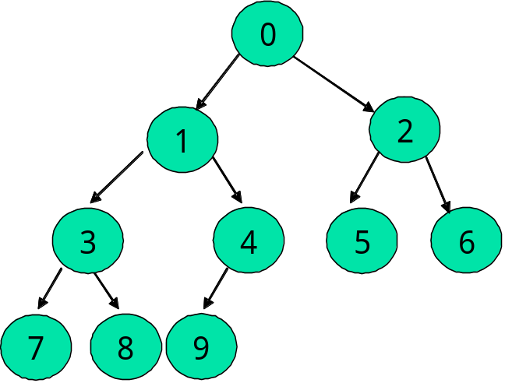

3. Apply mergesort to the list ( Tim, Roy, Guy, Ron, Jan, Dot, Kay ); Please draw the tree of recursive calls.

4. Please give the definition of AVL tree. In each of the following order:
( a, b, f, c, g, d )
(A，V，L，T，R，E，I，S，O，K)
Insert the keys into an empty AVL tree; please give the process with diagram. Then give the preorder and postorder of the two AVL trees.

5. With the following recursive function search_for_node, please write the Nonrecursive version and give some comment in your program.
template <class Record>
Binary_node<Record> *Search_tree<Record> :: search_for_node(
Binary_node<Record>* sub_root, const Record &target) const
/*
Pre: sub_root is NULL or points to a subtree of a Search tree
Post: If the key of target is not in the subtree, a result of NULL is returned. Otherwise, a pointer to the subtree node containing the target is returned.
*/
{
if (sub_root == NULL || sub_root->data == target)
return sub_root;
else if (sub_root->data < target)
return search_for_node(sub_root->right, target);
else return search_for_node(sub_root->left, target);
}

6. Implement the following function for the BinaryTree class:
void reflect(Binary_node *root);
//swaps the two children of each node in this tree
//for example, like the diagram below:

数据结构参考答案
一、单项选择题
1． D
2． E
3． A
4． B
5． A
6． D

二、填空题

1. position != NULL midpoint = midpoint->next;
2. count%2 == 0
last_node.size( ) <= level
parent->right == NULL
3. move(count - 1, start, temp, finish);
move(count - 1, temp, finish, start);

三、简答题
1.
template <class Record>
Error_code Search_tree<Record> :: remove_root(Binary_node<Record> * &sub_root)
/* Pre: sub root is either NULL or points to a subtree of the Search tree .
Post: If sub root is NULL , a code of not_present is returned. Otherwise, the root of
the subtree is removed in such a way that the properties of a binary search tree
are preserved. The parameter sub root is reset as the root of the modified
subtree, and success is returned. */
{
if (sub_root == NULL) return not_present;
Binary_node<Record> *to_delete = sub_root;
// Remember node to delete at end.
if (sub_root->right == NULL) sub_root = sub_root->left;
else if (sub_root->left == NULL) sub_root = sub_root->right;
else { // Neither subtree is empty.
to_delete = sub_root->left; // Move left to find predecessor.
Binary_node<Record> *parent = sub_root; // parent of to_delete
while (to_delete->right != NULL) { // to_delete is not the predecessor.
parent = to_delete;
to_delete = to_delete->right;
}
sub_root->data = to_delete->data; // Move from to_delete to root.
if (parent == sub_r oot) sub_root->left = to_delete->left;
else parent->right = to_delete->left;
}
delete to_delete; // Remove to_delete from tree.
return success;
}

2.
Preorder:
0 1 3 7 8 4 9 2 5 6
inorder:
7 3 8 1 9 4 0 5 2 6
Postorder:
7 8 3 9 4 1 5 6 2 0

3.
Tim, Roy, Guy, Ron, Jan, Dot, Kay (Dot, Guy, Jan, Kay, Ron, Roy, Tim)

Tim, Roy, Guy, Ron,(Guy,Ron,Roy,Tim) Jan, Dot, Kay(Dot,Jan,Kay)

Tim, Roy(Roy, Tim) Guy, Ron(Guy,Ron) Jan, Dot(Dot,Jan) Kay

Tim Roy Guy Ron Jan Dot
4.
c
b f
a d g

Preorder:
L E A I K T R O S V
inorder:
A E I K L O R S T V
Postorder:
A K I E O S R V T L

5.
//Nonrecursive version:
template <class Record>
Binary_node<Record> *Search_tree<Record> :: search_for_node(
Binary_node<Record>* sub_root, const Record &target) const
{
while (sub_root != NULL && sub_root->data != target)
if (sub_root->data < target) sub_root = sub_root->right;
else sub_root = sub_root->left;
return sub_root;
}

6.
Implement the following function for the BinaryTree class:
void reflect(Binary_node *root)
//swaps the two children of each node in this tree, like the diagram below:
{
if(!root) return;
reflect(root->left);
reflect(root->right);
int tmp= root->left->data;
root->left->data= root->right->data;
root->right->data=tmp;
}

