Table of Contents

1 Introduction 3
2 Architecture Overview 3
2.1 The Architectural Pattern 3
2.2 Tiers of DWPM System. 3
2.2.1 Process Design 3
2.2.2 Process Instantiation 3
3. Architectural Goals and Constraints 4
3.1 Architectural Goals 4
4. Use-Case View 5
4.1 Significant Use-Cases 5
4.2 Use-Case Realizations 5
4.2.1 DWPM Main Process 5
5. Logical View 8
5.1 DWPM Design Components. 8
6. Process View 9
6.1 Service inclusion/removal Processes 9
6.2 Workflow creation and modification process 10
8. Implementation View 11
8.1 Overview 11

Table of Figures

Figure 1: Abstract illustration of the DWPM system main components 4
Figure 3: Use case of main Actors of the DWPM. 5
Figure 4: Use case scenario of the Design View 6
Figure 5: Use case scenario of the Instance view. 7
Figure 8: UML Class diagram representing the DWPM System. 8
Figure 11: Service inclusion/removal Processes Activity diagram 9
Figure 12: Workflow creation and modification Processes Activity diagram 10
Figure 20: DWPM overview Component diagram 11

1 Introduction

This document provides a high level overview of the evolving technical architecture for the DWPM System, using a number of different architectural views to depict different aspects of the system.

The document also provides a high-level description of the goals of the architecture, the use cases supported by the system and architectural styles and components that have been selected to best achieve the use cases. It is these detailed design specifications that will guide the development of DWPM System.

2 Architecture Overview

This section gives a general view of the software architecture of the DWPM System, and how it is represented conceptually.

2.1 The Architectural Pattern
DWPM System will adapt the 2-tier client/server architecture. The client will be responsible for input and output processing and processing some business rules logic. The server performs all storage and process enactment tasks.

2.2 Tiers of DWPM System.

2.2.1 Process Design
The design component constitutes the foundation of the systems capabilities. The output of this component forms the base from which the successive system process namely instantiation obtains is input.

2.2.2 Process Instantiation
The instantiation process reads from a repository populated with workflow by the preceding component, the process design to bring to life predefined workflow using them to deliver a consumable service.

Figure 1 demonstrates the abstract illustration of the DWPM system main components represented in a producer consumer pattern

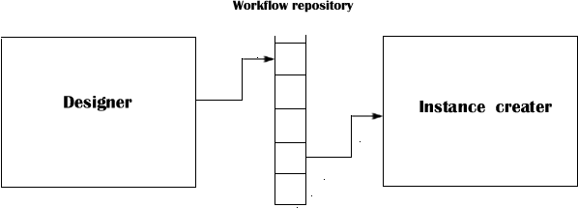

Figure 1: Abstract illustration of the DWPM system main components

3. Architectural Goals and Constraints

This section describes the software requirements, strategy or constraints that have some significant impact on the architecture.

3.1 Architectural Goals

The DWPM System is basically a service broker type of system structured around workflow provisioning or definition and usage enabling stakeholders to introduce new capabilities or services to already existing workflow on the fly without shutting the system down.

The goals of the architecture presented are:
- To allow process designers to bring new features into their workflow design space from outside the systems boundary.
- To incorporate these new features into workflows; new and already running.
- To make the resulting workflow available for use by enterprise wide systems as well as on the move mobile agent users.

4. Use-Case View

This section lists use cases or scenarios from the use-case model that represent some significant, central functionality of the system illustrating specific aspects the architecture.

4.1 Significant Use-Cases

Figure 3 present the main actors from a system’s point of view and their interactions with the DWPM System.

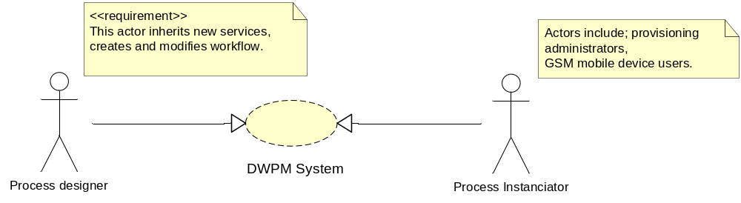

Figure 3: Use case of main Actors of the DWPM.

4.2 Use-Case Realizations

This section illustrates how the system actually works by giving a few selected use-case (or scenario) realizations, and explains how the various design model elements contribute to their functionality.

4.2.1 DWPM Main Process

The identified actors interfacing with DWPM System include the Process designer and the process initiator.

Figure 4 presents the interaction of the process designer actors with the main DWPM System component i.e. process design. Specifically, the process designer refreshes the service list to make new services display in the service menu list. He is then able to create a workflow or open an existing one and effect changes on it. When creating the workflow he specifies the type of notification to be sent to stake holders in a particular workflow given the occurrence off any of the following events; task completion, rejection, and delayed task execution.

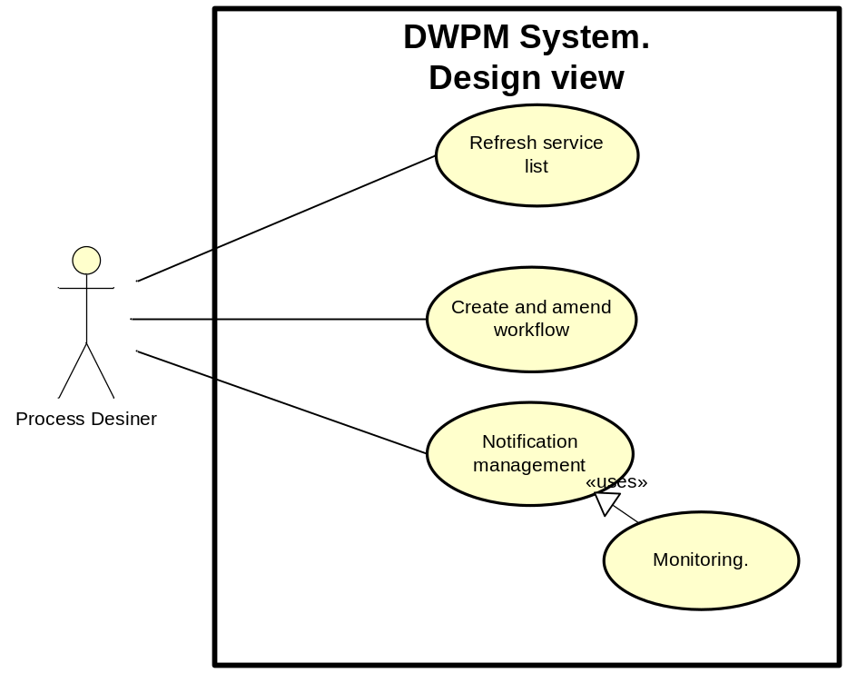
Figure 4: Use case scenario of the Design View

Figure 5 presents the interaction of the Process Instanciator. The process instanciator selects and starts a process that suits their need. They get notification on the progress of the process as it progresses.

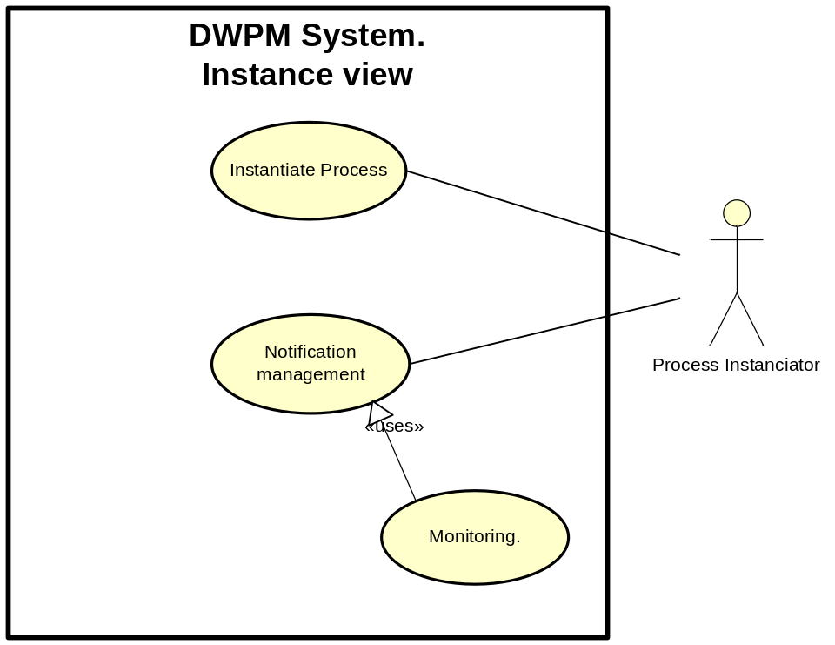
Figure 5: Use case scenario of the Instance view.

5. Logical View

This section describes the architecturally significant parts of the design model, such as its decomposition into subsystems and packages, and for each significant package, its decomposition into classes and class utilities.

5.1 DWPM Design Components.

Figure 8 presents the interaction between DWPM System Design components.

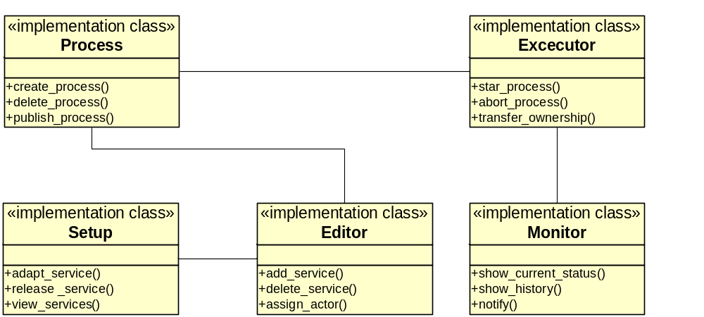

Figure 8: UML Class diagram representing the DWPM System.

6. Process View

This section describes the system's decomposition into lightweight processes (single threads of control) and heavyweight processes (groupings of lightweight processes). It is organized by groups of processes that communicate or interact. The main modes of communication between processes, such as message passing, and interrupts are described.

6.1 Service inclusion/removal Processes

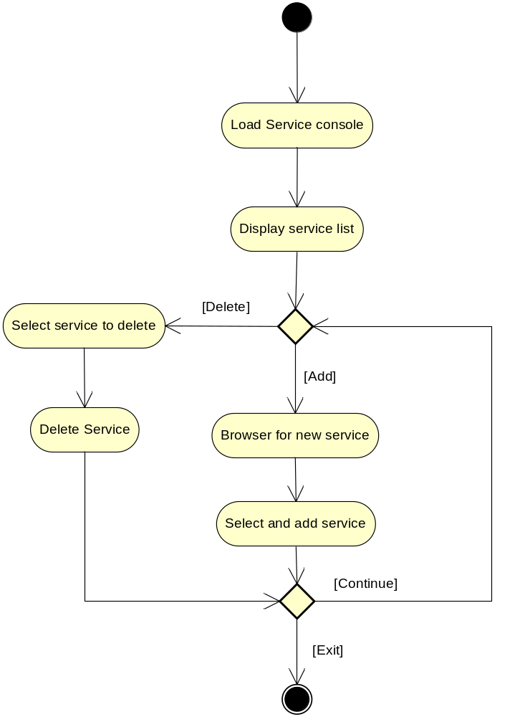
Figure 11: Service inclusion/removal Processes Activity diagram

6.2 Workflow creation and modification process
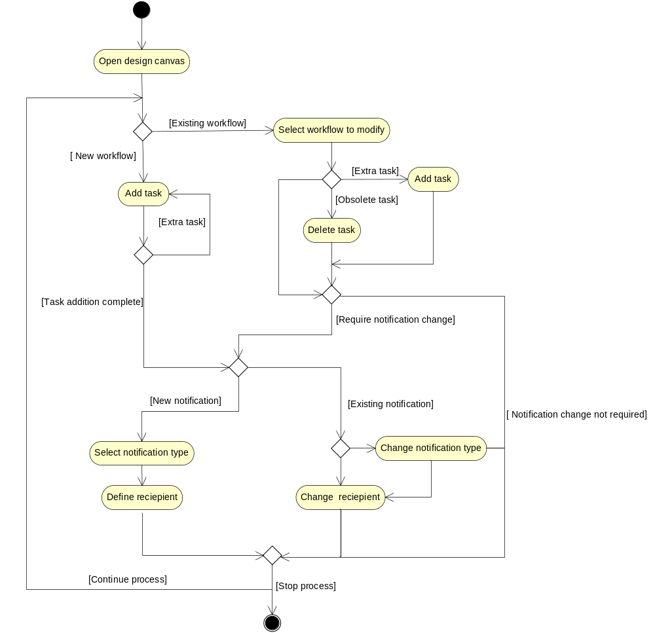

Figure 12: Workflow creation and modification Processes Activity diagram

8. Implementation View

DWPM System allows for adaptation of new services making them available for inclusion into both new and existing workflows.

8.1 Overview

This subsection defines the various layers and their contents, the rules that govern the inclusion to a given layer, and the boundaries between layers. Include a component diagram that shows the relations between layers.

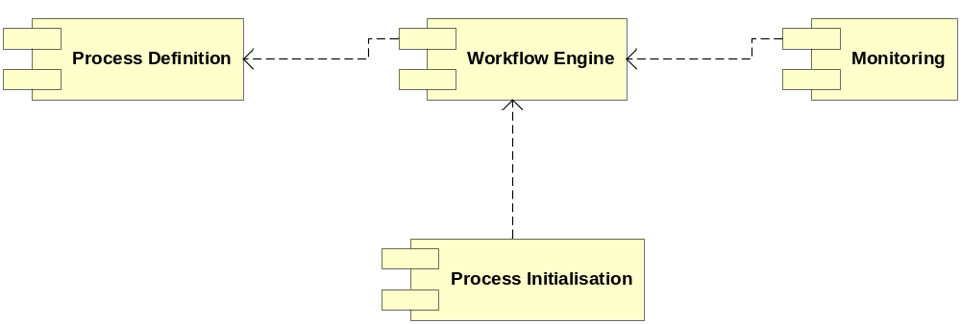
Figure 20: DWPM overview Component diagram

