Data Science: Deep Learning Prerequisites – Linear Reg in Python Notes

**Appendix: Coding tips (part 1)**

there are 2 steps in supervised machine learning

1. create a training function that fit’s to X and Y

2. then use model to predict(X)=Y

pseudocode example

you can tell several things about a function and the characteristics of the elements within by just seeing the function

Note

when they say a sample from a normal distribution

they mean between 2 values and a normal distribution within that

not all variables will be provided to you

you may need to fill some of them in yourself

sample values of learning rate

try 0.1

then lower it by factors of 10

so 0.01

then 0.001

etc

best practices for coding

**plot the cost as a function of iteration**

see where things go

you can also use to help plot a learning rate

too high-explodes

too low-slow convergence

source: <https://www.udemy.com/data-science-linear-regression-in-python/learn/v4/t/lecture/7096186?start=0>

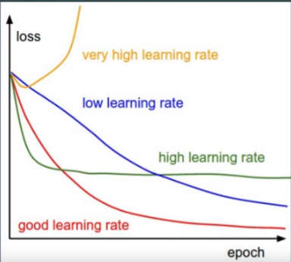

you can use classes to represent your models

**Appendix: Coding tips (part 2)**

TDD

test driven development