Data Science: Deep Learning Prerequisites – Linear Reg in Python Notes

**Section 3: Multiple Linear Regression and Polynomical Regression Notes**

multiple linear regression

if there are mulitiple inputs int eh data set

most realistic – usually multiple inputs affect the outpout

housing price and other things

for simple linear regression

it is (x1,y1) etc….

for multiple linear regression

still have this format but x1 is now a fector, not a scalar

dimensionality is equal to the size of X represented by letter D

This is just like the notes from Stats class

dimmentionality is the (number of input variables -1)

model is:

y^=wtx+b

wtx means “w transpose x”

transpose is

<https://www.khanacademy.org/math/linear-algebra/matrix-transformations/matrix-transpose/v/linear-algebra-transpose-of-a-vector>

transpose becomes X times the w vector

so See notes to explain how this is like a dot product

can absorb b into w by appending 1 to vector x in cell 0 and setting w0 to b

y^=W0X0+W1X1+W2X­2…… where W0=b and X0=1

things to note about Data matrix X

it is an NxD matrix

N=number of samples

D=numper of inputs and features

1 row of X represents one full sample

this is called the feature vector

need to transpose W so that we can multiply since you need to have a valid matrix vector

you can actually just multiply the matricies

because 4x3 matrix can be multiplied by a 3x1 matrix

so don’t separate out ingto separate matrices

just multiply all

after finding predictions we need to minimize error

so we use our error function but plug in our new prediction matrix

**see page 4 of notes**

**See the example in the notes on page 3**

**Section 3: original lecture notes**

original lecture

**See notes on pages 7-9 (shows the missing elements of the updated lecture notes)**

**Section 3: How to solve linear regression using only matricies**

cost function example

see notes on pages 11 and 12

helpful source from haya in udemy

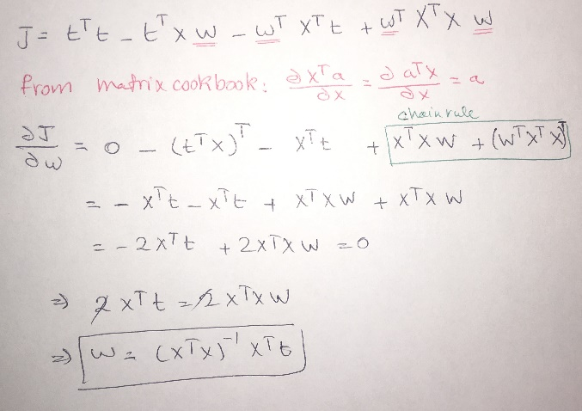

**Coding: see the code directory for information about how to code by using multivariable formula**

**coding with polynomical regression**

notice that the weights are still linear

the inputs are not

you can still apply a linear regression to a quadradic equation

**Quiz regarding Rsquared**

**if you add noise to X in a new column will it improve?**

yes if it is random

bareless