Increasing Flow Capacity Of Existing Injection Water Pipeline Through Injection Of Chemicals Schmoo Remover To Clean Solid Deposits In Injection Water Pipeline At PT. Pertamina Hulu Energy Ogan Komering
Feby Zulkarnain And Dr. Ir. Dyah Rini Ratnaningsih, M.T.

Study Program Magister Of Petroleum Engineering
Pembangunan Nasional University Of Veteran Yogyakarta
Jl. SWK 104 (Lingkar Utara), Condongcatur, Yogyakarta 55283
feby.zulkarnain@gmail.com
rini_diah@yahoo.com
Abstract. PT. Pertamina Hulu Energi Ogan Komering (PHE OK) is one of the KKKS (Cooperation Contract Contractors) with the Gross Split mechanism operating in the Ogan Komering Block working area in Ogan Komering Ulu, Ogan Ilir and Muara Enim, South Sumatra Province. Water injection began in 1998, by injecting excess water in abandoned wells in Central ASD and continued in October 2000 and January 2002, and since May 2006 the injection rate was increased above 30,000 BWPD.
From the analysis carried out, one of the obstacles in the injection water process at PHE OK is the main pipe capacity of the injection water which is getting smaller and the pressure drop along the pipe is very large. The pressure drop occurs due to the solid / deposition pile on the inside of the pipe, causing obstacles in the process of transfering injection water from the Block Station to the injection wells. From the laboratorium analysis, the solid deposite inside the pipe wall is consist of more than 50% organic and hydrocarbon matters (paraffin, oils, and light asphaltene) often called as “Schmoo” depsosit. some pigging activities cannot be done due to pipe size, pipe geometry that does not support, pipe construction that is not designed for pigging activities. To overcome the solid deposit problem, PHE OK carried out field trial of Schmoo Remover Chemical to clean the pipe without using pipe pig.
From the field trial result, the removal resulted in a significant increase in water injection rates and an associated decrease in pipe pressure drop.
Key words: Schmoo, cleaner, solid deposit, surfactant, water injection, production maximization.

INTRODUCTION
PT. Pertamina Hulu Energi Ogan Komering (PHE OK) is one of the KKKS (Cooperation Contract Contractors) with the Gross Split mechanism operating in the Ogan Komering Block working area in Ogan Komering Ulu, Ogan Ilir and Muara Enim, South Sumatra Province with an area of the current work is 1,155 km2 of the original total area of ​​4,630 Km2. The Ogan Komering block has experienced 3 relinquishment, namely in 1991, 1994 and 1997. The first contract was signed between Pertamina and Canada Northwest Energy (South Sumatra) Ltd. on February 29, 1988 for a period of 30 years, and ended February 28, 2018. In 1994, Talisman Energy took all Participating Interest from Canada Northwest Energy. Then in 2016 Repsol took all Participating Interest from Talisman Energy. In 2017 Jadestone Energy Canada finally took all Participating Interest from Repsol until the contract expires on May 20, 2018. After changes in Participating Interest have taken place alternately, the current operatorship holder is PT. Pertamina Hulu Energi Ogan Komering (PHE OK).

Water injection began in 1998, by injecting excess water in abandoned wells in Central ASD and continued in October 2000 and January 2002, on the North-East ASD field and Thunder. From the evaluation of the pressure response, PHE OK implemented a full scale waterflood by increasing injection from 8000 BWPD to 16000 BWPD. And since May 2006 the injection rate was increased above 30,000 BWPD for North East ASD & Guruh Area which was covered in NE-ASD-GRH waterflood POD. At present the injection water rate is at 33000 BWPD. The initial water injection rate can achieved 50,000 BWPD through the 6 inch carbon steel mainline but decrease by the time until present maximum injection rate at 33,000 BWPD.

From the analysis carried out, one of the obstacles in the injection water process at PHE OK is the main pipe capacity of the injection water which is getting smaller and the pressure drop along the pipe is very large. The pressure drop occurs due to the solid / deposition pile on the inside of the pipe, causing obstacles in the process of transfering injection water from the Block Station to the injection wells. From the laboratorium analysis, the solid deposite inside the pipe wall is consist of more than 50% organic and hydrocarbon matters (paraffin, oils, and light asphaltene).

Tabel 1. Solid deposit analysis result
No | Test Parameter | % Weight
1 | Dissolved Salt | 10%
2 | Organic (Paraffin, Oil, And Light Asphaltene | 53%
3 | Iron Carbonate | 14%
4 | Iron Oxide | 10%
5 | Elemental Carbon | 13%

The effort that can be done to overcome the problem of schmoo accumulation in water injection pipes is to do routine pigging activities. But in fact, some pigging conditions cannot be done due to pipe size, pipe geometry that does not support, pipe construction that is not designed for pigging activities, or the absence of pig launcher or pig receiver facilities. For this reason, there must be other alternative efforts that can be done to eliminate schmoo deposits on water injection pipes.

Among the ways that can now be done is by injecting a chemical formula specifically designed to remove solid / schmoo deposits in injection water pipes, these chemicals are generally called Schmoo Remover. It is a formula made from a kind of surfactant containing a corrosion inhibitor. This paper will only explain about the effectivity of the surfactant compound to clean the schmoo deposit inside the pipeline. The corrosion inhibitor activity will need another experiment/field trial to rate the inhibitions effectivity.

LITERATURE REVIEW
Over the past 150 years of oil production, there have been few times that maintaining production has been as critical as it is today. With the oil price riding at all time highs and the world’s demand unrelenting, it is critical for companies to maximize their production. Pipeline become one of the critical production facilities, especially for water injection purpose. The water quality shall be maintainned to it’s specfication to prevent the reservoir plugging and in the otherhands solid components and oily particles in the water can deposit inside the pipeline and restrict the flow. In many cases, these deposits are not easily removed from a pipeline due to the absence of pig launchers and receivers. Even in cases where maintenance pigs can be run, the result still not maximal to remove all the oily solid and debris inside the pipeline.

Problem related to fouling in production and water injection are widely observed and costly phenomenon in oil and gas industry. There are three Category types of deposit exist, Inorganic (e.g. mineral scale or corrosion product), organic (e.g. asphaltene, wax or biofouling), and a combination of these two types often called as “Schmoo” (Vera et al.,2012).

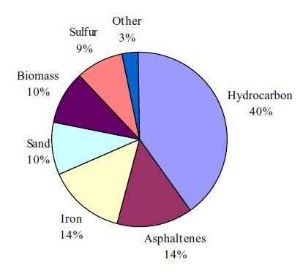
Figure1. Analysis of field Schmoo (Horsup et al.,2007)
There are three main mechanisms for the removal of oil from a surface by surfactant solutions. These are solubilization, emulsification and roll up (Horsup et al .,2007).

Solubilization is where oil is incorporated into the hydrophobic cores of micelles to form a thermodynamically stable microemulsion.

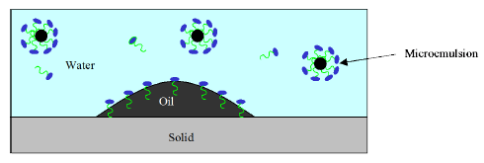
Figure 2. Solubilization Mechanism

Emulsification occurs when adsorption of the surfactant to the oil-water interface reduces the interfacial tension to such an extent that new interface can be easily formed. Mechanical shear or even the natural buoyancy of the oil then allows small drops of the oil to release from the main body of oil.
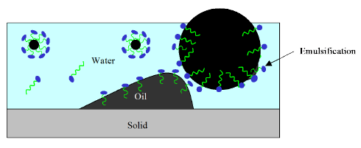
Figure 3. Emulsification Mechanism

A roll up mechanism occurs when adsorption of surfactant to the oil-water and water-solid interfaces causes a change in γow and γsw. The three forces acting at the contact line rapidly rebalance themselves to give a new contact angle and work of adhesion.

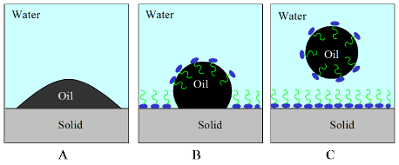
Figure 4. Roll-up Mechanism

CASE STUDY
Water Injection System in PHE OK can be classified as old facility due to it’s age almost more than 30 years old. The facilities consist of Three phase separator, Water wash tank, Water Surge Tank, and HPS pump for injecting water to injection wells. There’s no no facilities or equipment for solid removal in injection water. As the consequence of the abensence of solid removal equipment, the solid concentration in water injection or TSS (Total Suspended Solid) achieve more than 300 mg/L. The high solid concentration and get worst by oil content in water injection caused the oily solid deposition inside the pipe and reduce the flow capacity also have consequence in pipe intergrity due to corrosion problems.

The water injection pipeline is unpiggable due to a lot of 90º elbow and diameter decrease due to corrosion product deposition in the pipe wall. The risk of stuck pig is very high and can be serious problems for the water injection system operation. To overcome the problems, Company try to inject the Schmoo Remover Chemical in the partial section of the pipeline network to remove the Schmoo deposits.

The Schmoo Remover chemical used in this field trial is from Nalco-Champion company (“Clean and Corr” brand). It’s one of the Schmoo Remover chemical product available in the market and has proven succes story in many areas for these types of aplication. This product consist of two major function as a cleaner and a corrosion inhibitor. In this field trial activities, we will only focus at cleaner function, as the corrosion inhibitor function need another type of research to evalaute the performance.

The pipeline chosen for the field trial is located on the NEASD area. This area has very important role for the water injection program because it’s support for the many oil wells producer. The average water injection flowrate through the pipeline is about 7,061 BWPD and the average pressure drop is 700 Psig for 4,200 meters pipeline length made from 6 inch Carbon Steel Sch. 40. The big operation issue at this area is the pressure at the end of the pipeline is very big due to solid deposits inside the pipe as show in the below picture.

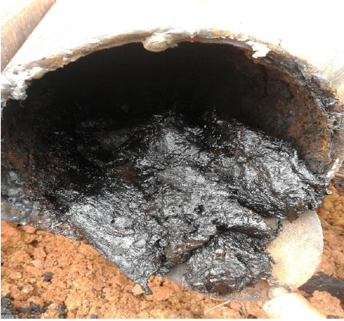
Figure 5. Schmoo deposit in the pipeline
The big pressure drop result in lack of water injection rate to injection wells and commonly cause injection well plugging. The field trial will be done in this area by direct injection of the Schmoo Removal chemical into the pipeline with the initial dosage at 100 ppmV and maintenance dosage at 20 ppmV as the recommendation from the manufacturer.

FIELD TRIAL EVALUATION METHOD
The method used for evaluating the Schmoo Remover chemical performance is by monitoring the pressure drop and flowrate changes with same operating condition of the injection pumps. The pressure drop and flowrate changes data will be correlated using Hazen-Williams pressure formula.

The Hazen–Williams equation is an empirical relationship which relates the flow of water in a pipe with the physical properties of the pipe and the pressure drop caused by friction. It is used in the design of water pipe systems such as fire sprinkler systems, water supply networks, and irrigation systems. It is named after Allen Hazen and Gardner Stewart Williams.

The Hazen–Williams equation has the advantage that the coefficient C is not a function of the Reynolds number, but it has the disadvantage that it is only valid for water (Wikipedia, 2019).

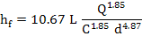

Where :

hf = Pressure drop in meter water column
L = Pipe length in meter
Q = Volumetric flow rate in m3/s
C = Roughness coefficient
d = Pipe ID in meter

The Hazen–Williams equation has the advantage that the coefficient C is not a function of the Reynolds number and valid for water system since the flowing fluid in the water injection pipeline is produced water.

In this field trial, Hazen-Williamns Roughness Coefficient (C) is used to correlate / evaluate the effectiveness of cleaning activity by the Schmoo Remover chemical. The initial data (flowrate, pressure drop, and C coefficient will be recorded as baseline and will be compared with samekind data after injection. The increase of flowrate, decrease of pressure drop, and increase of C coefficient is the indication of success field trial.

FIELD TRIAL RESULT
Below is the result of the field trial

Tabel 2. Field trial result

Day | Flowrate | C | dP | Dosage | Remark
 | BWPD |  | Psig | ppmV
1 | 6967 | 20,32 | 696 | 0 | Before Injection
2 | 6935 | 20,50 | 679 | 0
3 | 7065 | 20,77 | 686 | 0
4 | 7185 | 20,91 | 699 | 0
5 | 7121 | 20,56 | 709 | 0
6 | 7093 | 20,40 | 714 | 0
7 | 7061 | 20,33 | 713 | 0
8 | 6993 | 20,18 | 710 | 72 | After Injection
9 | 7058 | 20,52 | 700 | 71
10 | 6890 | 21,52 | 613 | 136
11 | 7110 | 22,07 | 620 | 97
12 | 6629 | 21,22 | 586 | 104
13 | 6886 | 22,10 | 583 | 101
14 | 7177 | 21,66 | 653 | 88
15 | 7122 | 21,64 | 645 | 88
16 | 7170 | 21,77 | 646 | 88
17 | 7225 | 21,87 | 650 | 30
18 | 7207 | 26,29 | 460 | 35
19 | 7600 | 25,95 | 520 | 33
20 | 7948 | 27,87 | 495 | 32

Data collection for baseline is completed in 7 days while the field trial itself completed in 13 days. From the data above, we can analyze that based on the field trial success criteria (The increase of flowrate, decrease of pressure drop, and increase of C coefficient) the field trial is showing good trend at cleaning the Schmoo solid inside the pipeline.

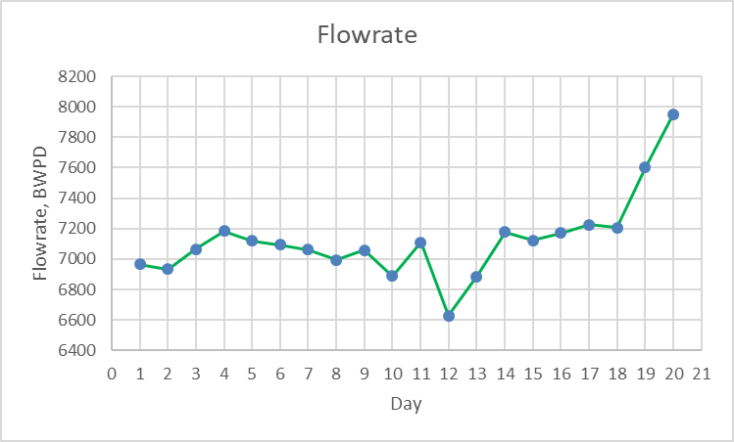
The average of flowrate from 7061 BWPD increase to 7948 BWPD at the end of field trial.

Figure 6. Flowrate Graph

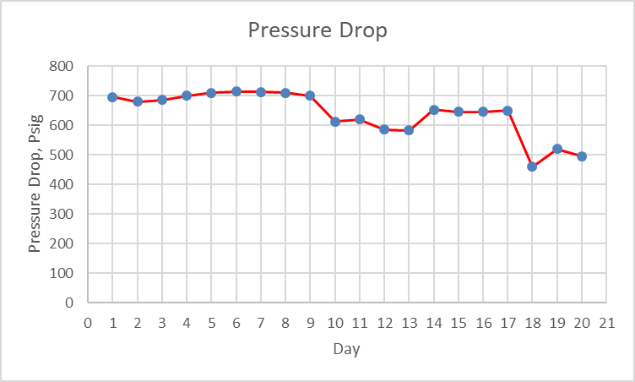 Figure 7. Pipeline Pressure Drop Graph
The average of pressure drop from 699 Psig decrease to 606 Psig at the end of field trial.

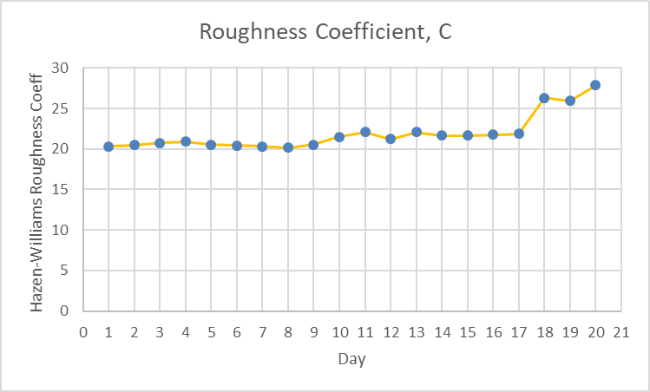
The average of Hazen-Willimas roughness coefficient from 20,58 increase to 27,87 at the end of field trial.

Figure 8. Hazen-Williams Roughness Coeff. Graph

CONCLUSION
From the result described above, the field trial success criteria have been achieved with average flowrate from 7061 BWPD increase to 7948 BWPD (12.6 % increase), average pressure drop from 699 Psig decrease to 606 Psig (13.3 % decrease), and the average of Hazen-Willimas roughness coefficient from 20,58 increase to 27,87 at the end of field trial (35.4 % increase). The actual chemical dosage is range from 36 – 136 ppmV for cleaning and maintenance process.

RECOMMENDATION
In this field trial, the subject discussed was how the injection of Schmoo Remover Chemical can clean the Schmoo deposit inside the pipe, to better understand the influence of corrosion inhibitor to protect the pipe integrity from corrosion, more specific and comprehensive research must be carried out.

However, from the results described in this paper, it can be used as a reference by the oil and gas operator as an alternative way to clean the water injection pipeline from Schmoo deposit inside the pipe due to unpiggalbe pipe condisition such as in the absence of pipe launcher/receiver, not suitable pipe geometry and others factor.

Acknowledgments
We thank our colleagues from field production department, technical services department, maintenance department, Chemical Services Company, and all the plant operators who provide assistance and services in this field trial.

References
- David I. Horsup, Timothy S. Dunstan, John H. Clint, “A Break-Through Corrosion Inhibitor Technology For Heavily Fouled Systems”, NACE Paper No. 07690, Presented at NACE International Corrosion & Conference Expo, Houston, Texas, 2007.
- David I. Horsup, Richard Meyer, Laxmikant Tiwari, “Integrity Control In Heavily Fouled Systems – Phase II Environmentally Sustainable Solutions”, NACE Paper No. 08623, Presented at NACE International Corrosion & Conference Expo, Houston, Texas, 2008.
- David I. Horsup, “A Breakthrough Technology For Maximizing Water Injectivity And Asset Integrity”, SPE Paper No. 108675, Prepared for presentation at the 2007 SPE Annual Technical Conference And Exhibition , Anaheim, California, U.S.A.,11-14 November 2007.
- Albert F. Chan, Plano, William Mark Bohon, David J. Blumer, Kieu T. Ly, U.S. Patent No. 5,996,692 (7 December 1999).
- Brian Michael Bennett, Sebastian Dennis Mancuso, U.S. Patent Application Publication No. US 2015/0011453 A1 (8 January 2015).
- Nalco Champion, “Clean And Corr Technology For Water Injection”, Technical Proposal For JOB Pertamina-Talisman Ogan Komering (OK), Jakarta, Indonesia, 26 April 2017.
- Wikipedia website, https://en.wikipedia.org/wiki/Hazen-Williams_equation, accessed at 10 June 2019.

