Identification of Ground Motion Prone areas Triggering Earthquakes Based on Microtremor Data in Jati Agung District, South Lampung Regency, Lampung, Indonesia
Rizqi Prastowo^{1, b)}, Vico Luthfi Ipmawan^{2, a)}, Akhmad Zamroni^{1,c)}, Rofiqul Umam^{3,d)}, Ikah Ning Prasetiowati Permanasari^{2,e)}, Rahmat Nawi Siregar^{2,f)}
¹Department of Technical, Institut Teknologi Nasional Yogyakarta, Jl. Babarsari, Caturtunggal, Depok, Sleman, Yogyakarta, Indonesia
²Department of Physics, Institut Teknologi Sumatera, Indonesia.
³School of Science and Technology, Kwansei Gakuin University, Gakuen, Sanda 669-1337, Japan
^{a)}email korespondensi: Vico.luthfi@fi.itera.ac.id
^{b)}rizqi@itny.ac.id
^{c)}akhmadzamroni@itny.ac.id
^{d)}egk71822@kwansei.ac.jp
^{e)}ikahning@fi.itera.ac.id
^{f)}rahmat.siregar@fi.itera.ac.id
Abstract. Jati Agung District is an area planned by the Lampung government to become a new city of the central government in Lampung. Aspects of city planning include aesthetics and safety. The geophysical study is conducted as disaster mitigation efforts to make the city have a good level of safety. The purpose of this study is to measure earthquake activities in the research areas that could be developed as data in disaster mitigation. The geophysical study was conducted by measuring the microtremor at 15 points. The microtremor signal is processed by the HVSR method to obtain information on natural frequency and amplitude. Natural frequencies and amplifications were analyzed to obtain the Peak Ground Acceleration (PGA) and Ground Shear Strain (γ) values. The results of PGA values and Ground Shear Strains indicate indications of soil fracture-prone areas. The results showed that the PGA value was 12.34638 gal to 22.18974 gal, while the Ground Shear Strain (γ) value was 53.34322x10-6 to 729.6847x10-6. The area of this study is a very safe area against the impact of earthquakes. Because the deformation in the event of an earthquake is very small, this is due to the type of rock found. In the study area, the type is rock that has large compacting properties. Also based on the geography on this research area is a region that is quite safe from tsunami waves, because in the west there are high mountains, and there are also small island islands that can reduce tsunami waves from the southwest of the research location (Jati Agung Area).
Keywords: Earthquake, geophysics, PGA, Ground Shear Strain, microtremor

INTRODUCTION
Jati Agung is a district planned by the Lampung provincial government as a new city as the center of government. Jati Agung Regency as a city center of government caused Jati Agung to have high human activities. Kota Baru, which is a city center for governing government policies to drive regional development, needs to consider aspects of urban planning. One aspect of urban planning is the aspect of disaster. One of the unpredictable natural disasters is the earthquake.
Jati Agung as a New City is located on the island of Sumatra which has a fault (Figure 1). The fault extends from the Sunda Strait to the north of the island of Sumatra. In addition there is a Subduction zone in western Sumatra because the Indo-Australian oceanic plate moves below the Eurasian continental plate [1,2]. This situation caused Lampung to be in an earthquake-prone area. One of the impacts of the earthquake is the occurrence of ground cracks.

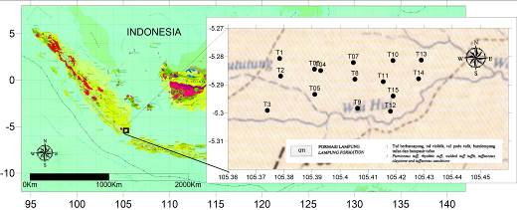
FIGURE 1: Recording Locations Denotes by Solid Black circle. The Entire Research Area is Part of the Same Geological Formation, the Quartenary Tuff Lampung

Efforts to prevent the occurrence of casualties and buildings due to earthquakes in Jati Agung, namely by mitigating the disaster caused by earthquakes. In addition to earthquake disaster mitigation parameters such as dominant frequency, amplification factor, and seismic vulnerability, the Peak Ground Acceleration also requires ground shear strain parameters. All these parameters can be known by conducting microtremor signal analysis, namely the Horizontal Vertical Spectral Ratio (HVSR) method. HVSR method is a method used by Nakamura that is widely used for site effect studies by means of analyzing microtremor recordings [3].
The location of the research is in Jati Agung District, South Lampung Regency, Indonesia. The site is at distance, approximately, 23 km from Bandar Lampung Town. Based on Tanjung Karang geological map, All of Kota Baru area is a part of Barisan zone volcanic sedimentary. The rocks unit are dominated by pumiceous tuff, rhyolitic tuff, welded tuff tuffit, tuffaceous claystone, and tuffaceous standstones [3].

Horizontal to Vertical Spectral Ratio
This method can be used to determine the local site effect of an earthquake by identifying the fundamental frequency and amplification factors. In this method, the ratio of the Fourier spectra of the horizontal and vertical components of seismic noise recorded on a threecomponent seismometer (H/V ratio) is calculated. The spectrum must be smoothed before the H/V ratio can be computed. In this study, the Konno and Ohmachi smoothing function was used [4]. Each time window produces one H/V ratio; the average H/V ratio was then calculated. The average H/V peak curve can be associated with fundamental frequencies to indicate the amplification.The HVSR method is based on the following assumptions: 1) the environment consists of a rigid substratum covered by a layer of soft soil, and 2) microtremors are formed by Rayleigh waves [5]. From these assumptions, the transfer function (HVSR) of a site can be derived from the spectral ratio of the horizontal and vertical components of microtremors recorded at a given point [6,7,8,9]. The following equation is used

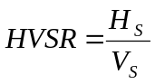 (1)

Where 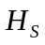 is the spectral amplitude of the horizontal components of the microtremors measured at the surface of the soil layer and 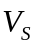 is the spectral amplitude of the vertical components of microtremors measured at the surface of the soil layer.
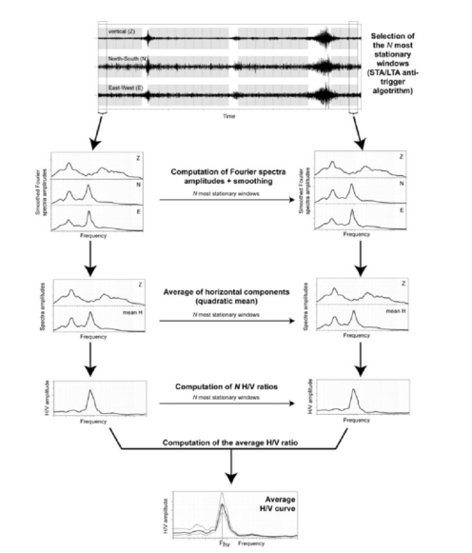
FIGURE 2: Flow chart of HVSR method

jati agung classification of Ground motion map
The seismometer was deployed at 15 stations in Jati Agung district for obtaining microtremor recordings. Distribution of location can be seen in Figure 2. Microtremor signal ware analyzed by HVSR method. Some parameter were inputted in smoothing parameter based on the condition of curve. The majority value was 10 for Konno & Ohmachi smoothing parameter. All of H/V peak from 15 data were reliable peak. Parameter analysis of ground motion is peak ground acceleration (PGA) and vulnerability of seismic (K_{g}). All of these values can be seen in Table 1.
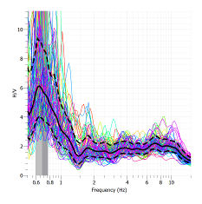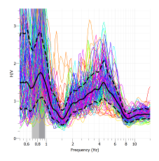
A
B

FIGURE 3: Spectrum of HVSR results A) station T03 B) station T07

TABLE 1. The Results of HVSR Method
Station | PGA (gal) | Kg | GSS (10⁻⁶)
T01 | 12.34638 | 27.6519 | 341.400785
T02 | 13.91497 | 24.92382 | 346.8140976
T03 | 13.45653 | 54.22534 | 729.6846841
T04 | 14.32403 | 27.28414 | 390.8187688
T05 | 14.82664 | 23.65949 | 350.7907167
T06 | 15.09484 | 26.19514 | 395.4114677
T07 | 15.54194 | 3.432212 | 53.34322499
T08 | 15.53131 | 25.88355 | 402.0052739
T09 | 19.7306 | 22.26596 | 439.3208074
T10 | 12.57888 | 36.32959 | 456.9855332
T11 | 22.18974 | 22.02943 | 488.8273892
T12 | 16.82669 | 37.25144 | 626.818392
T13 | 13.89055 | 38.6345 | 536.6544683
T14 | 14.12916 | 36.72581 | 518.9049256
T15 | 20.32767 | 9.775245 | 198.7079871

The calculation of ground shear strain value is been influence by PGA in bedrock. The earthquake that used in PGA calculation is in range 10 years earthquake histories in around of Lampung. Sedimentary layer have plastis characteristic and became surface deformation is crack in γ = 1000 ×10⁻⁶ and sedimentary layer will get masiv deformation (landslide) and liquefaction if γ = 10.000 ×10⁻⁶. The result show that all of the value of ground share strain in the all station less than 1000 ×10⁻⁶. The conclusions of Jati Agung district as the new Town is not disturbed toward ground motion that is caused by earthquake. Figure 3 is map of ground share strain in Jati Agung.
Based on Figure 4, the results of 2D interpretations using surfers provide very good information that in the study area is a very safe area against the impact of earthquakes. These results show that the deformation in the event of an earthquake is very small, this is due to the type of rock found in the study area is rock that has large compacting properties. So, if an earthquake occurs, the shape of the rock or soil structure in the area can reduce oscillations[10] or waves of earthquakes that spread[11;12]. This result has a positive relationship to the geological conditions that exist in the southern Lampung region. The float area has a slight fault or branch fault[13;14]. So that there is a small chance of strengthening the vibration of an earthquake. Besides that, the research area is a region that is quite safe from tsunami waves, because in the west there are high mountains, and there are also small island islands that can reduce tsunami waves from the southwest of the research location (Jati Agung Area).

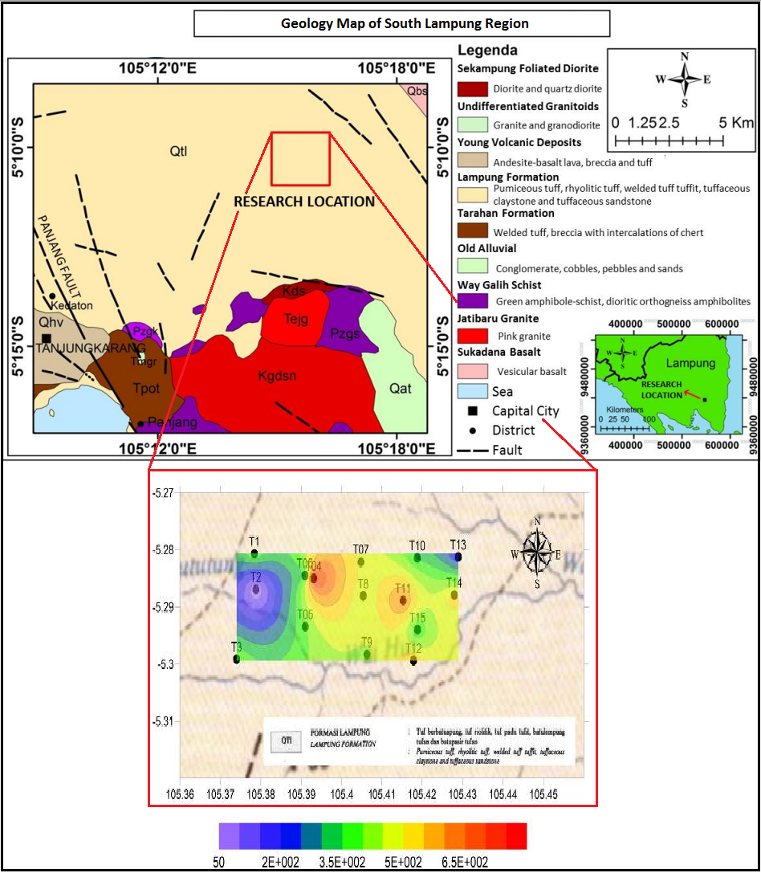
FIGURE 4: Interpretasi 2D menggunakan surfer in this study (Jati Agung Area of South lampung, Indonesia. Source : Update from [13])

CONCLUSIONS

Ground shear strain calculation to identify ground motion that is triggered by earthquake zones in Jati Agung District using HVSR measurement lead to the following conclusion is the highest value of ground shear strain was observed in coordinate (105.3740, -5.299), at 0.00072968, so that it is not prone to deformation and soil movement. So, the area of this study is a very safe area against the impact of earthquakes. Because the deformation in the event of an earthquake is very small, this is due to the type of rock found in the study area is rock that has large compacting properties. Also based on the geography on this research area is a region that is quite safe from tsunami waves, because in the west there are high mountains, and there are also small island islands that can reduce tsunami waves from the southwest of the research location (Jati Agung Area).

Acknowledgments
We acknowledge the support from Institut Teknologi Nasional Yogyakarta of fund in conference and Vico Luthfi Ipmawan as the best colleague.

References

- E Santoso, S. Widiyantoro and I N Sukanta, Studi Hazarda Seismik dan Hubungannya dengan Intensitas Seismik di Pulau Sumatera dan Sekitarnya, Jurnal Meterologi dan Geofisika Vol 12 No 2 pp.129-136
- Z. Umar, S. Pradhan, A. Ahmad, M. N. Jebur, M. S. Tehrany. Earthquake induced landslide susceptibility mapping using an integrated ensemble frequency ratio and logistic regression in West Sumatra Province, Indonesia. (Elsevier, catena, 2014), pp.124-135
- V. L. Ipmawan, I. N. P. Permanasari, and R. N. Siregar, Spatioal Analysis of Seismic Hazard Based on Dynamical Characteristics of Soil in Kota Barum South Lampung. ICOSITER 2018. Journal of Science and Applicative Technology.
- V. L. Ipmawan, I. N. P. Permanasari, and R. N. Siregar, Deternining Soft Layer Thickness Using Ambient Seismic Noise Record Analysis in Kota Baru, South Lampung. Makara journal of Science. PP 39-43.
- Okada, H., & Suto, K. 2003. The Microtremor Survey Method. doi:10.1190/1.9781560801740
- Y Nakamura 1989 QR Railway Technical Research Institute 30 25
- Y Nakamura 1996 Quarterly report of Railway Technical Research Inst. (RTRI) 37 112
- R. Prastowo, O. Trianda, and S. Novitasari, “Identifikasi Kerentanan Gerakan Tanah Berdasarkan Data Geologi Daerah Kalirejo , Kecamatan Kokap , Kabupaten Kulonprogo ,” Kurvatek, vol. 3, no. 2, pp. 31–40, 2018.
- O. Trianda, R. Prastowo, and S. Novitasari, “Identifikasi Ketebalan Lapisan Lapuk di Daerah Kalirejo , Kulonprogo Berdasarkan Pengukuran Mikrotremor dalam Upaya Mitigasi Tanah Longsor,” Seminar Nasional ReTII XIII, vol. XIII, no. November, pp. 246–253, 2018.
- Kasayanond, A., Umam, R., and Jermsittiparsert, K. “Environmental Sustainability and its Growth in Malaysia by Elaborating the Green Economy and Environmental Efficiency,” International Journal of Energy Economics and Policy, 9(5), 465–473, 2019. https://doi.org/https://doi.org/10.32479/ijeep.8310
- Wekke, I, S., Sabara, Z., Samad, M, A., Yani, A., Abbas, T., and Umam, R., “Earthquake, Tsunami, And Society Cooperation: Early Findings In Palu Post Of Indonesia Disaster,” INA-Rxiv. 2019. https://doi.org/10.31227/osf.io/xmcyn
- Wekke, I. S., Rajindra, R., Pushpalal, D., Samad, M. A., Yani, A., and Umam, R. “Educational Institution on Responding Disasters in Palu of Indonesia,” INA-Rxiv. 2019. https://doi.org/10.31227/osf.io/drc8q
- Haerudin, N., Fitriawan, R, H., Siska, D., and Farid, M., “Earthquake Disaster Mitigation Mapping By Modeling Of Land Layer And Site Effect Zone In The Kota Baru of South Lampung,” Jurnal Ilmiah Pendidikan Fisika Al-BiRuNi, 08,(1), 53-67, 2019. https://doi.org/10.24042/jipfalbiruni.v8i1.3705
- Siregar, R, N., and Kurniawan, W, B., “2D Interpretation of Subsurface Hot Spring Geothermal Structure in Nyelanding Village Through Schlumberger Geoelectricity Configuration Method,” Jurnal Ilmiah Pendidikan Fisika Al-BiRuNi , 07,(1), 81-87, 2018. https://doi.org/10.24042/jipfalbiruni.v7i1.2324

