Final Prototype - Documentation - CSCI 331:
Object Oriented Software Development – Spring 2024

Name of Project | VIU course rating system
Team Name | Section 3 Redux
Team Members | Emails
Team member 1 | Replace with Email 1
Team member 2 | Replace with Email 2

How to deploy and run the prototype
Please describe exactly how to deploy and run your prototype.
- Be specific and provide terminal commands.
- Provide screenshots if needed.
Setup

1. Unzip Attached File

Unzip attached file from VIULEARN: 331-Course-Rating-System-main.zip
cd 331-Course-Rating-System-main

2. Create and activate a virtual environment

Windows:
python -m venv venv
venv\Scripts\activate

Mac/Linux:
python3 -m venv venv
source venv/bin/activate

3. Install dependencies

pip install -r requirements

4. Run the app

python3 app.py

5. Open your browser and go to:
http://127.0.0.1:5000
The database will be created automatically on first run with a few default courses already added.

Pages
/ — Home page, lists all courses and their reviews
/createReview — Form to leave a review for a course
/course — Plain list of all courses and reviews
/login — Placeholder login page (not yet implemented)

Use Cases:

Registering/Logging In
1. From the main page, look to the top right of the screen and look for the login and register buttons

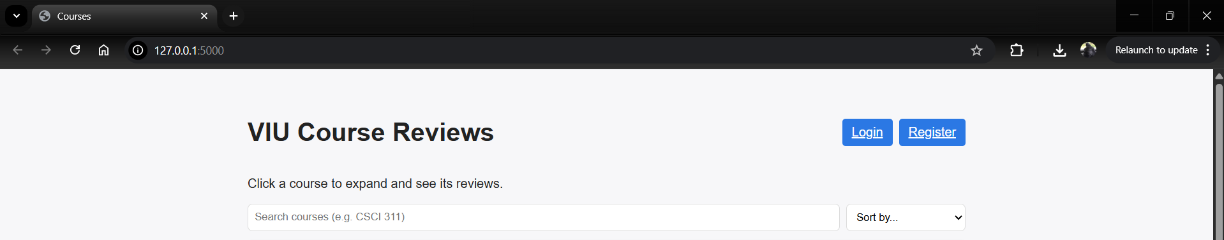

2. Click the register button and fill in the required fields
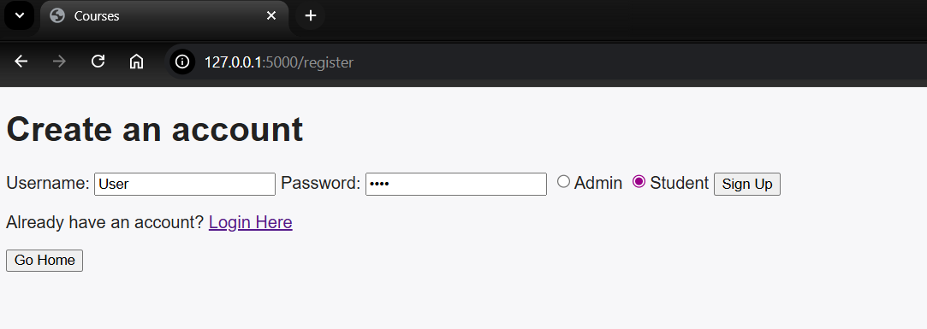

3. Click the sign up button, and it will take you to the login screen, fill in the fields with the username and password you chose
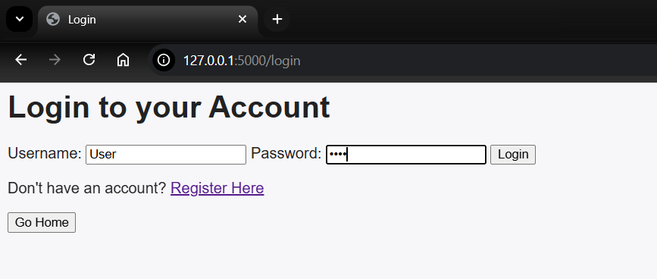

4. Click the login button to be returned to the main page with the ability to create reviews
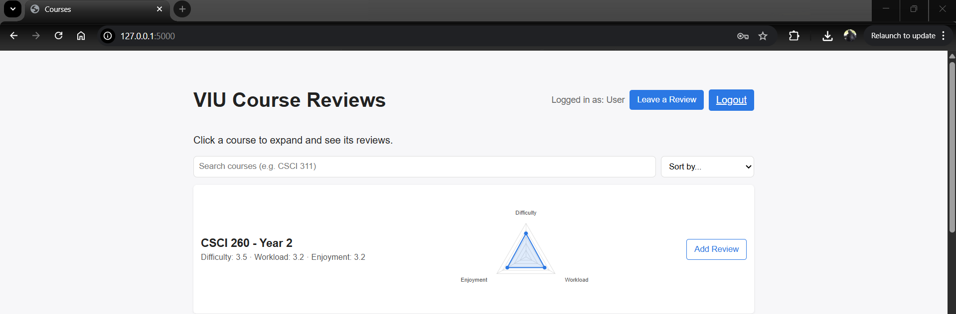

Leaving a Review

1. Once you are logged in, the page will look like the screenshot in part 4 of the Login/Register use case, and click the button either at the top of the page or the button on the right side of the course,

2. After you click the button, the page will have different fields to fill in, as well as a drop-down menu to pick the course, fill in the required fields by clicking the stars to fill in the rating you would give it for each area
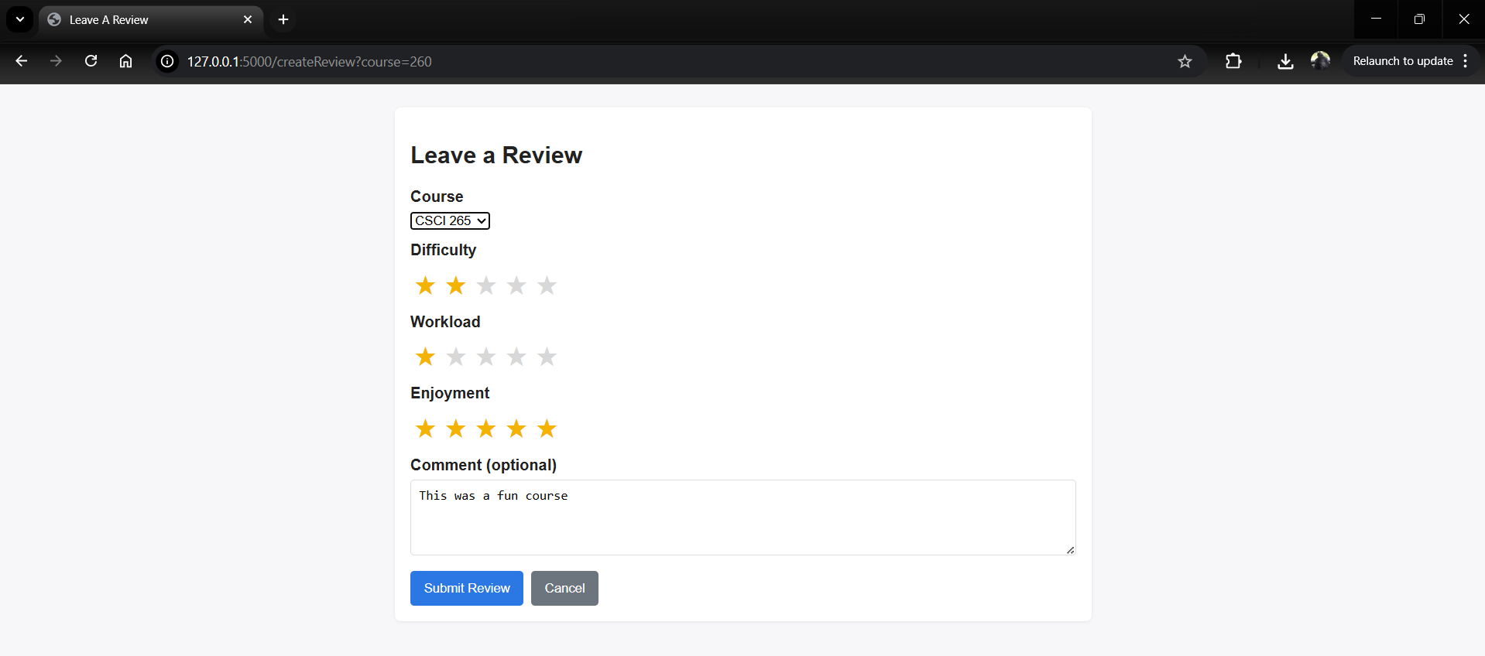

3. Click the submit review button to publish the review, once this is clicked you will be returned to the home page. Once their click on the course to see you review at the bottom of the list of reviews
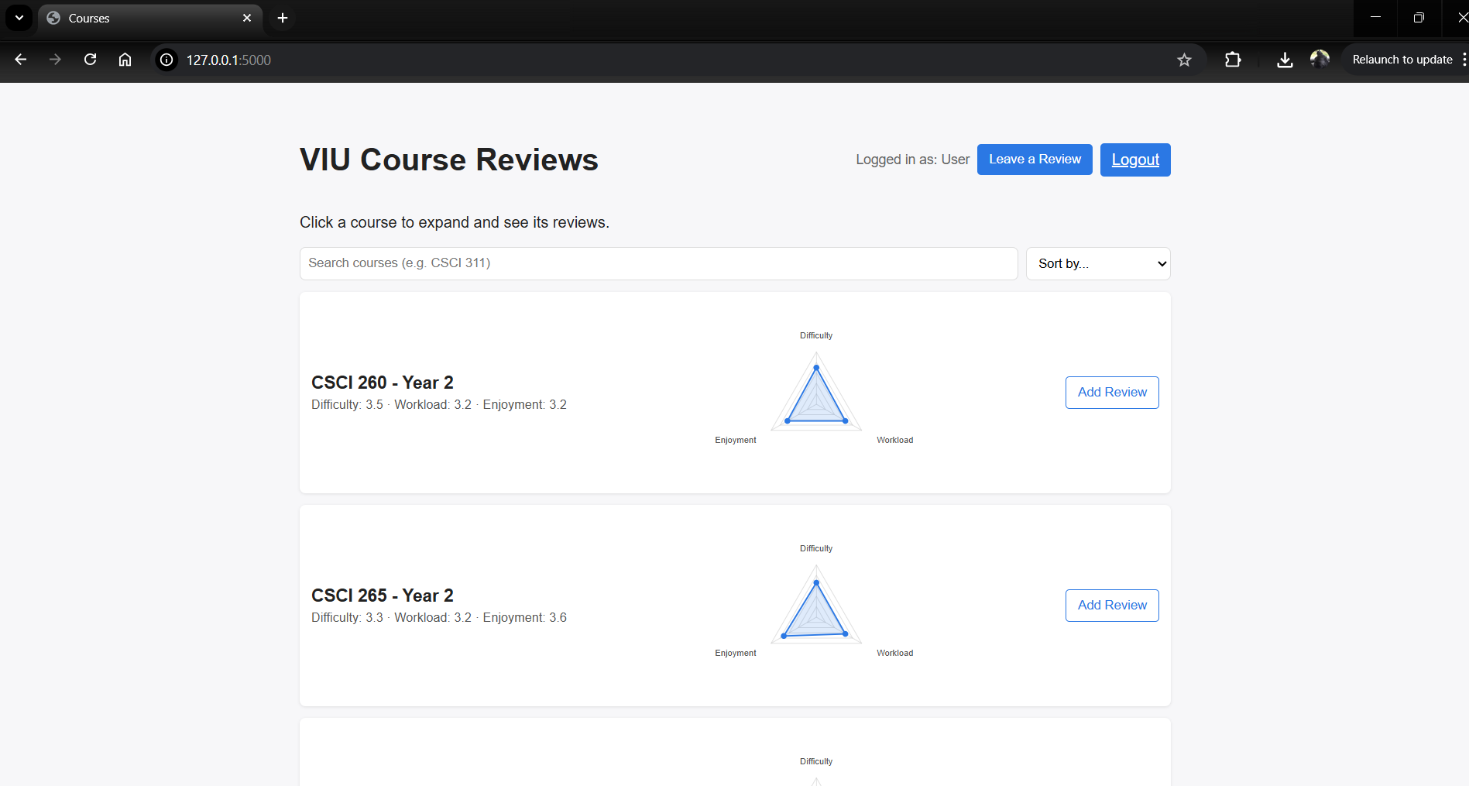

And the clicked Course scrolled to see the new user review at the bottom
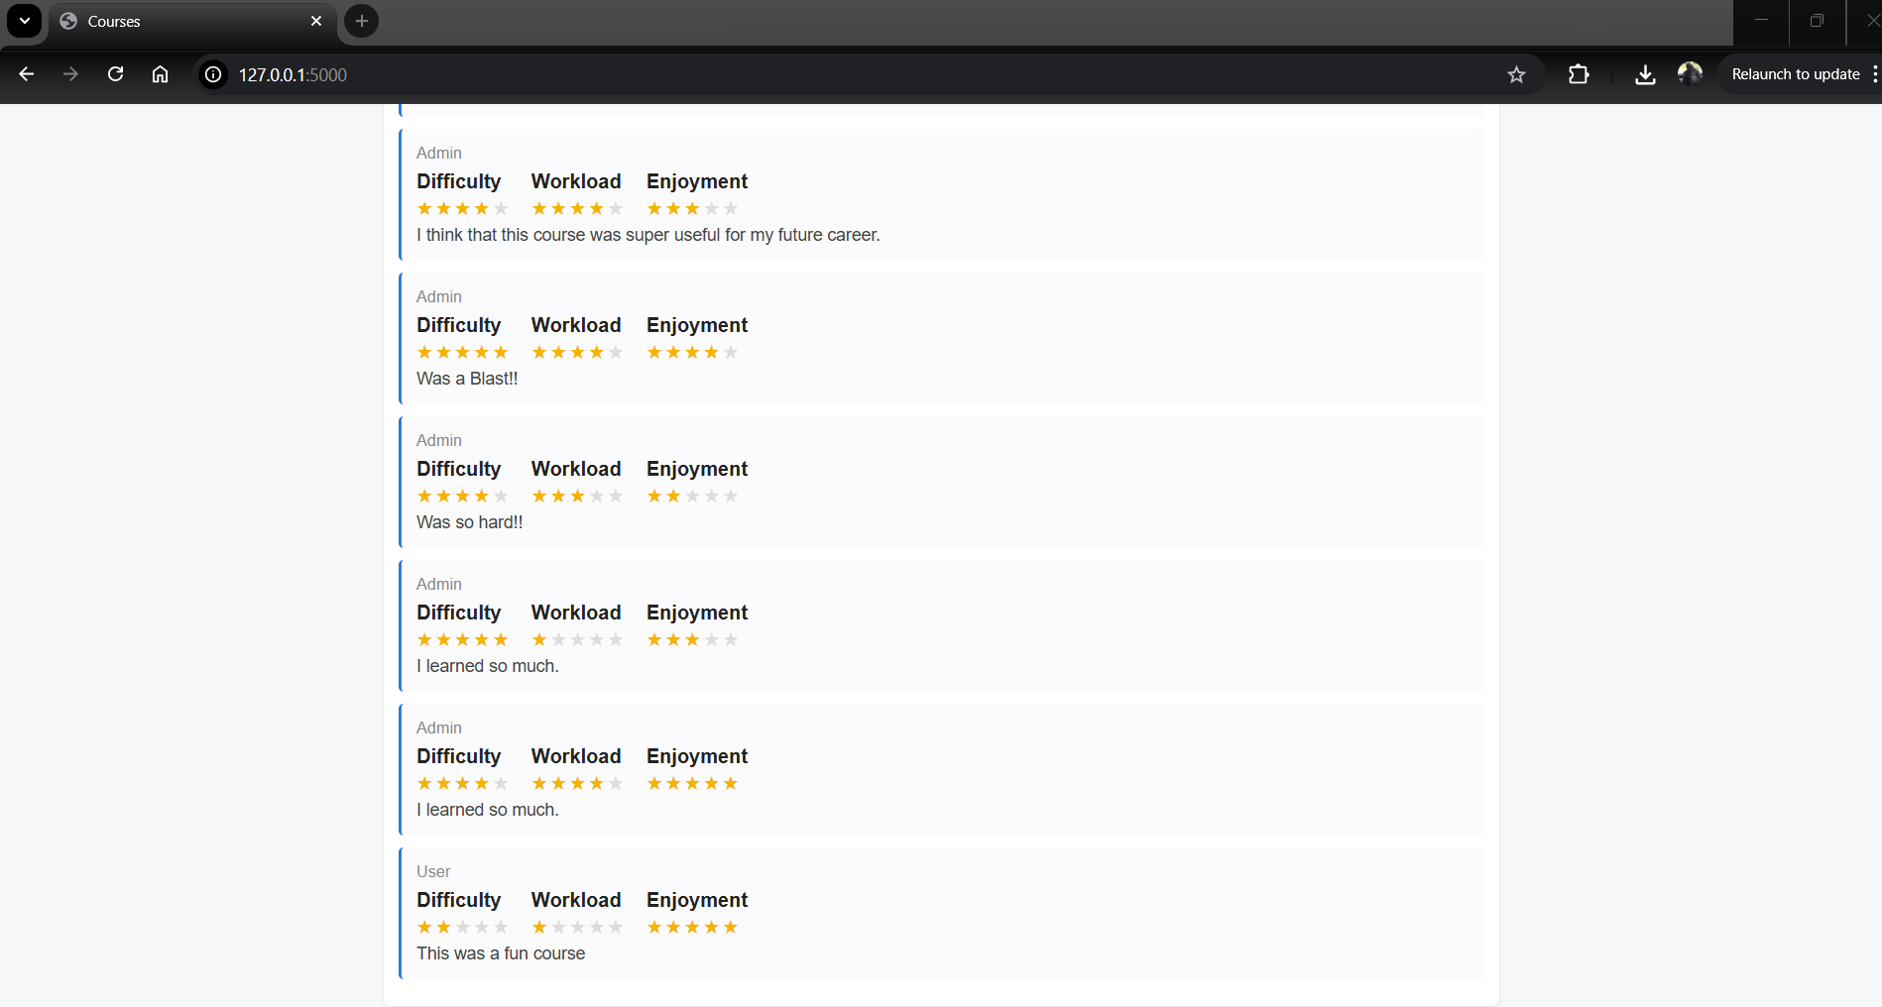

Changes from proposal document
Please describe what has changed since your group submitted the prototype for the project.
- Include all the relevant details on why the project was reformulated or changed.
- How have these changes impacted the final deliverable?
- Be specific and use a numbered list.
- This section should be at most 1 page in length.
- Write the content for this section here…
- Write the content for this section here…
- Write the content for this section here…
- …

