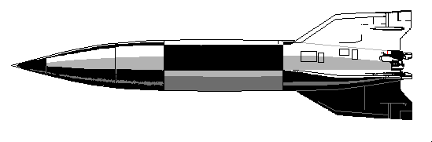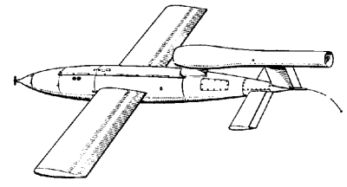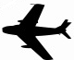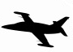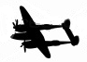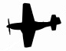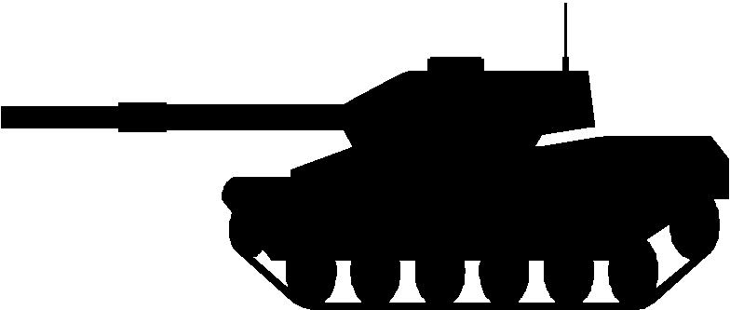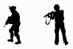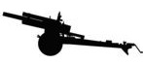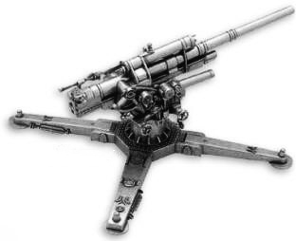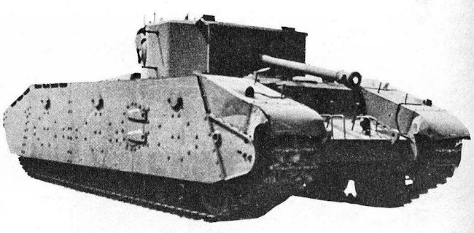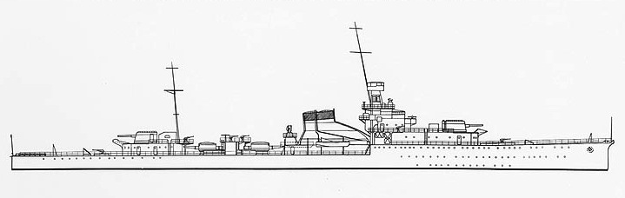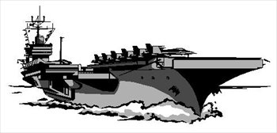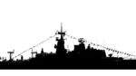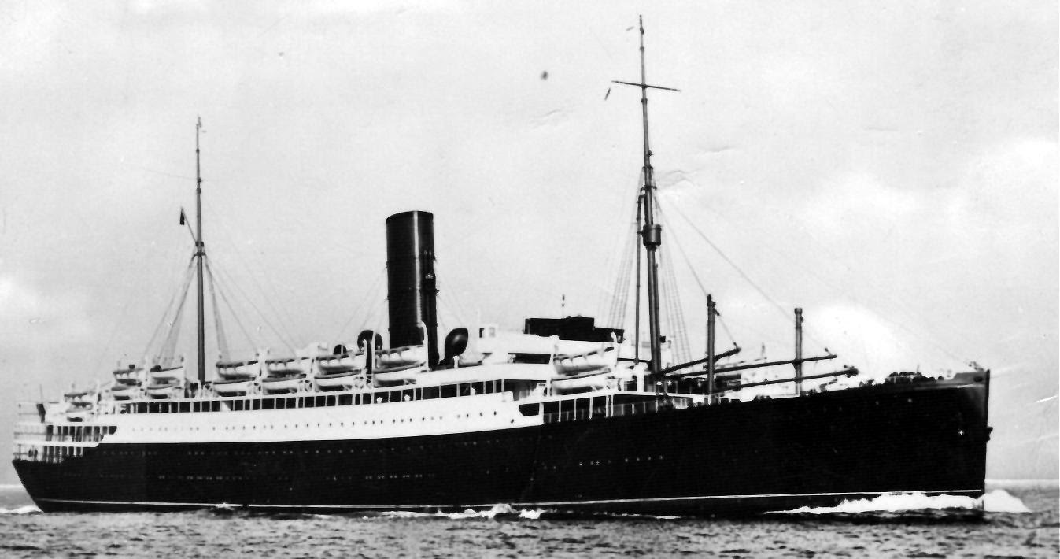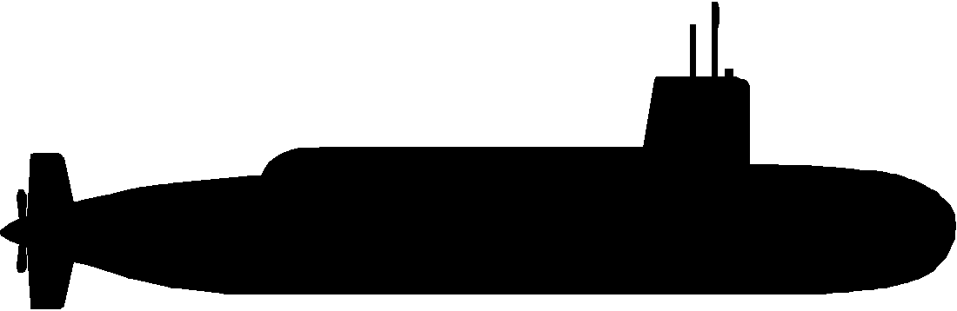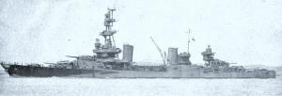

Ballistic Missile

Cruise Missile

Jet Bomber

Jet Fighter

Bomber

Fighter

RADAR Dome

Tank

Infantry

Artillery

AA Gun

Heavy Tank

Tank

Infantry

Ballistic Missile

Cruise Missile

Jet Bomber

Jet Fighter

Bomber

Fighter

RADAR Dome

Tank

Infantry

Artillery

AA Gun

Heavy Tank

Tank

Infantry

Ballistic Missile

Cruise Missile

Jet Bomber

Jet Fighter

Bomber

Fighter

RADAR Dome

Tank

Infantry

Artillery

AA Gun

Heavy Tank

Tank

Infantry

Ballistic Missile

Cruise Missile

Jet Bomber

Jet Fighter

Bomber

Fighter

RADAR Dome

Tank

Infantry

Artillery

AA Gun

Heavy Tank

Tank

Infantry

Ballistic Missile

Cruise Missile

Jet Bomber

Jet Fighter

Bomber

Fighter

RADAR Dome

Tank

Infantry

Artillery

AA Gun

Heavy Tank

Tank

Infantry

Ballistic Missile

Cruise Missile

Jet Bomber

Jet Fighter

Bomber

Fighter

RADAR Dome

Tank

Infantry

Artillery

AA Gun

Heavy Tank

Tank

Infantry

Ballistic Missile

Cruise Missile

Jet Bomber

Jet Fighter

Bomber

Fighter

RADAR Dome

Tank

Infantry

Artillery

AA Gun

Heavy Tank

Tank

Infantry

Ballistic Missile

Cruise Missile

Jet Bomber

Jet Fighter

Bomber

Fighter

RADAR Dome

Tank

Infantry

Artillery

AA Gun

Heavy Tank

Tank

Infantry

Ballistic Missile

Cruise Missile

Jet Bomber

Jet Fighter

Bomber

Fighter

RADAR Dome

Tank

Infantry

Artillery

AA Gun

Heavy Tank

Tank

Infantry

Infantry

Tank

Heavy Tank

AA Gun

Artillery

Infantry

Tank

RADAR Dome

Fighter

Bomber

Jet Fighter

Jet Bomber

Cruise Missile

Ballistic Missile

Ballistic Missile

Cruise Missile

Jet Bomber

Jet Fighter

Bomber

Fighter

RADAR Dome

Tank

Heavy Tank

AA Gun

Artillery

Tank

Infantry

Infantry

Battleship

Aircraft Carrier

Battleship

Battleship

Aircraft Carrier

Battleship

Battleship

Aircraft Carrier

Battleship

Battleship

Aircraft Carrier

Battleship

Destroyer

Destroyer

Destroyer

Destroyer

Destroyer

Transport

Submarine

Cruiser

Transport

Submarine

Cruiser

Transport

Submarine

Cruiser

Transport

Submarine

Cruiser

Transport

Submarine

Cruiser

Destroyer

Destroyer

Destroyer

Destroyer

Destroyer