HeyMac TDMA

Transmit Beacon
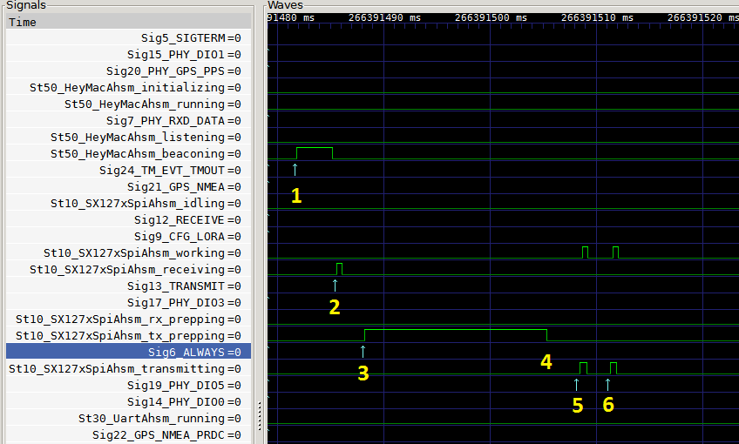
- (T1 = 0.0ms) MacAhsm in Beaconing state, a TMOUT occurs. Beaconing_and_next_tslot() and tx_bcn() post a TRANSMIT event (~3.2ms).
- (T2 = T1 + 3.8ms) SpiAhsm in Receiving state and TRANSMIT occurs. Sets radio to stdby mode. Trans to Tx_prepping. SpiAhsm Entry into Tx_prepping sets chip registers and posts ALWAYS reminder pattern.
- (T3 = T2 + 2.6ms) SpiAhsm in Tx_prepping and ALWAYS occurs. Calculated sleep amount is executed: time.sleep() (~17.1ms). // This amount may be reduced now that it is known.
- (Calc’d TX time) Trans to Transmitting state. Entry into Transmitting sets radio mode to tx.
- (T5 = T3 + 20.1ms) DIO5 indicates ModeReady for freq_synth
- (T6 = T5 + 2.9ms) DIO5 indicates ModeReady for transmit
NOTE: Time from (software setting radio mode to tx) to (hw indication of tx ModeReady) is:
(20.1 – 17.1 + 2.9) = 5.9 ms

Receive Beacon
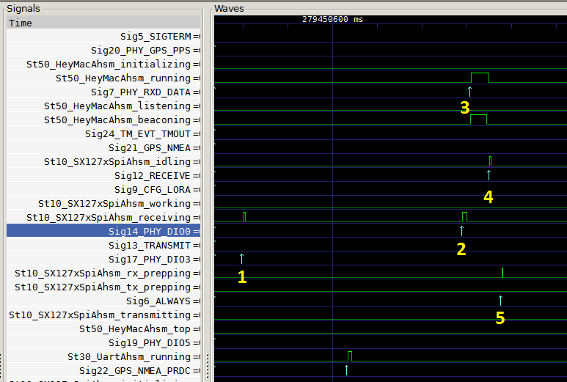
- (T1 = 0.0ms) MacAhsm in Beaconing state, PHY SPI in Receiving state, DIO3 (RX ValidHeader hw pin signal) occurs.
- (T2 = T1 + 49.0ms) PHY SPI in Receiving state and DIO0 (RxDone hw pin signal) occurs. Receiving state checks physical packet, publishes PHY_RXD_DATA
- (T3 = T2 + 1.8ms) MacAhsm in Beaconing state and PHY_RXD_DATA occurs. Running handles it, calls on_rxd_frame(), on_rxd_bcn(), dll_data.update_bcn(); then posts RECEIVE to put radio back into receive mode. // TODO: consider Txing ACK here
- (T4 = T3 + 4.3ms) PHY SPI in Idling state and RECEIVE occurs: transitions to rx_prepping. Entry in rx_prepping: registers set to receive; post ALWAYS reminder pattern.
- (T5 = T4 + 2.6ms) PHY SPI in rx_prepping state and ALWAYS occurs: argument indicates immediate receive, so no sleep; transitions to Receiving state. Entry into Receiving sets radio mode to rx_cont

