Advanced Laboratory

Department of Physics and Astronomy

Stony Brook University

Pre-experiment and mid-experiment evaluation sheet:
You must meet with a staff member before the beginning of each experiment and before the lab period indicated in the middle of the experiment for an evaluation of your preparation and progress. This form should be attached as the first page of your final report. You will be penalized for each section of the report (pre-lab, mid-lab, final) that is not completed on time. You are responsible for relevant parts of the course notes, especially radiation safety.

Muon Lifetime
Student name _____________________________________________________
Partner name _____________________________________________________

Pre-lab discussion:
Be prepared to show that you have read the background material for this experiment by discussing the following questions with the staff:
1. How does a photomultiplier tube work?
2. What are cosmic rays? How do they arrive on earth?
3. How are stopping muons selected in this experiment?
4. What is the minimum radiation dose (in mrem) which causes rapid human death?
5. What is the typical yearly dose humans receive on the surface of the Earth?

Staff comments: _______________________________________________________________

Signature: _________________________________________ Date ________________

Mid-lab report:

Before the 5th lab period of this experiment turn in a brief report (2 or 3 pages) showing:

1. the measured rate of muons that penetrate the detector system and roughly compare it
with expectations (without error analysis) and

2. show a muon decay curve.

Staff comments: _______________________________________________________________________

Signature: _________________________________________ Date ________________

Measurement of the Muon Lifetime

Updated October 2011

Introduction:

Muons are elementary particles [1-3], leptons to be precise, and can have two electrical charges μ⁺ and μ⁻. They make up about 75% of the cosmic ray flux at sea level where they have an average energy of about 2 GeV, with an angular distribution like 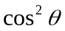 where θ is the angle from the zenith. A fraction of the muons arriving at sea level have small energy and can be stopped in a thin absorber. For this component μ⁺ /μ⁻~ 1. The stopped muons will then decay with some lifetime τ_{μ} , [1-7]. All μ⁺ will decay through the process 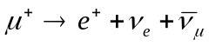. The μ⁻ will decay through a similar process but may also be captured into an atomic orbit like an electron. If captured, the μ⁻ will subsequently interact with the nucleus through the process 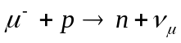. The capture process proceeds more rapidly than the natural decay of the muon and thus effectively shortens the muon lifetime [5]. In this experiment, you will measure the cosmic ray flux and both components of the muon lifetime separately, the short one due to the capture process and the longer one due to the free decay of the μ⁺.

Experimental Method:

You detect an incoming muon which is stopped in some material and measure the time difference between the arrival of the muon in your setup and the appearance of the electron from the muon decay. Measuring many such events gives a time spectrum. The slope of this spectrum on a log plot measures the muon lifetime.

The setup has four large plastic scintillators, shown in Figure 1. S1 is mounted on a copper plate and S2 and S3 are mounted on steel plates. S1, S2, and S3 have the same size and are stacked together. S4 is smaller and mounted on a lighter material (probably wood) such that it can be moved vertically. The electronic readout is shown in Figure 2. Each of the scintillators is read out via a photomultiplier. Charged particles traversing the scintillator produce pulses of light which are transformed into an electrically measurable signal by the photomultipliers. These signals are analyzed by fast electronics, i.e. discriminators and majority logic, and then either counted or used as a start and stop of a time to amplitude converter (TAC). The analog signals from the TAC are then measured with a PC based multi-channel analyzer.

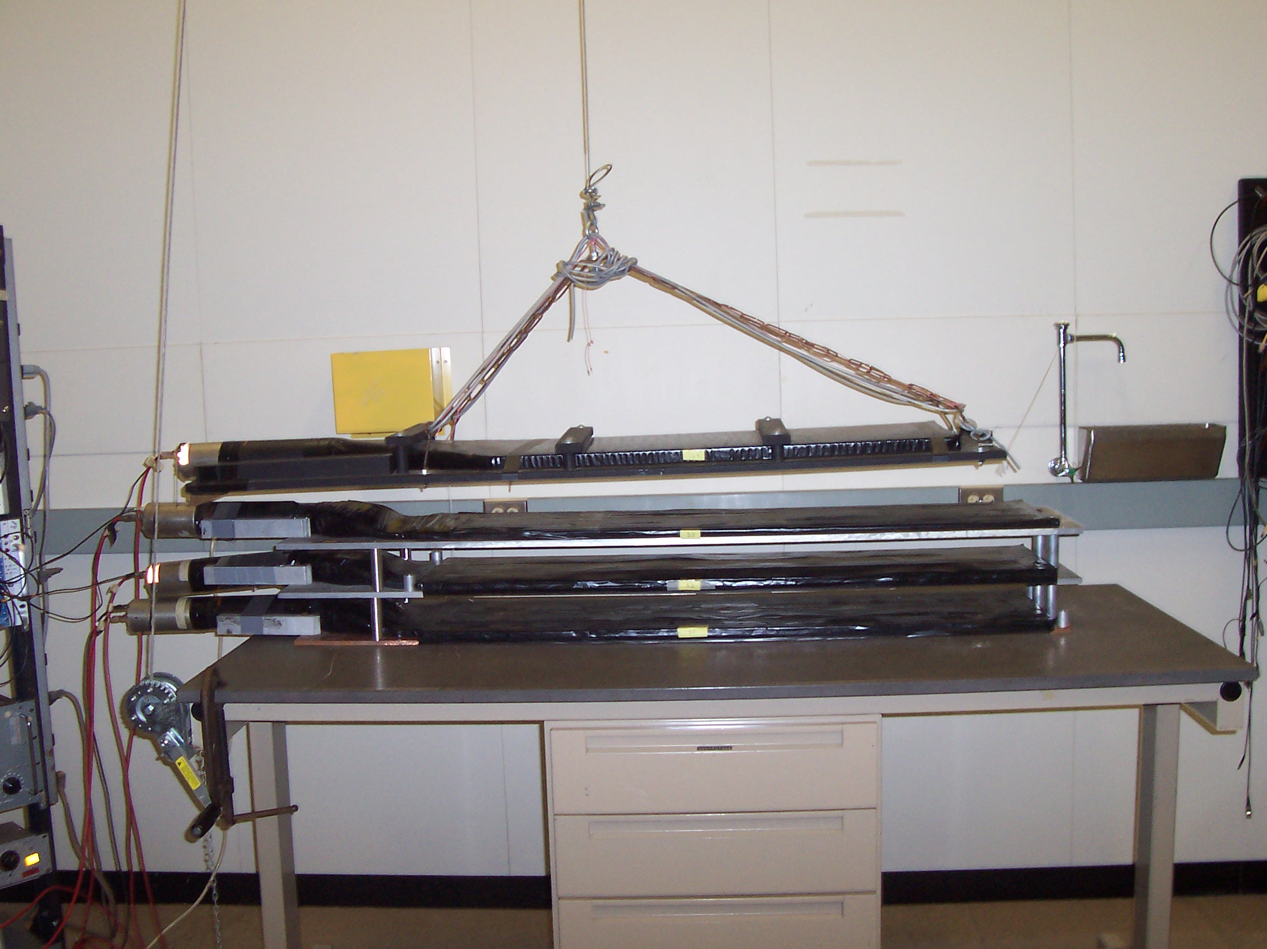
S4
S3
S1
S2

Figure 1: Setup of the four plastic scintillators used in the experiment.
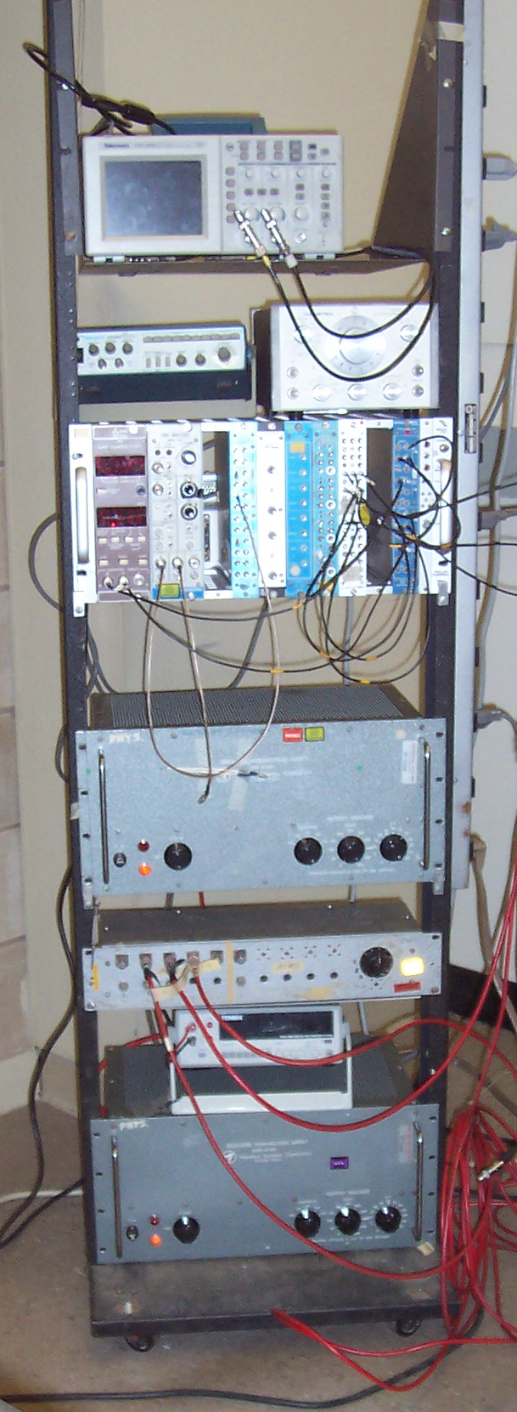

Scope

Pulse Generator

Figure 2: Electronic rack with equipment used in the experiment.
NIM crate

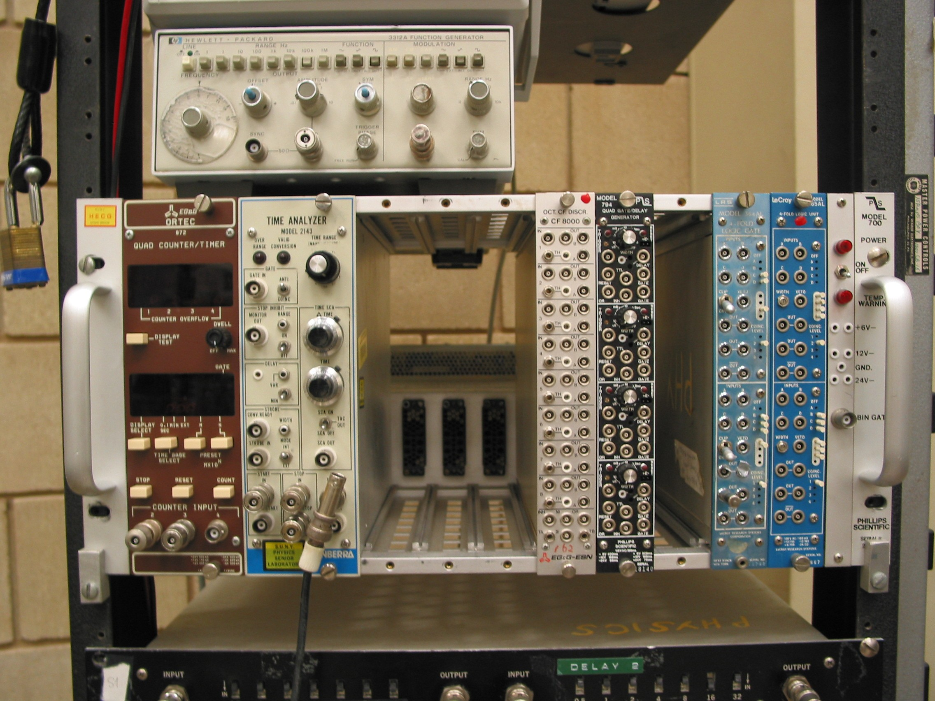
scaler
HV splitter
Multimeter
HV supply
TCA
Discriminator
Coincidence

Experimental Equipment:

A photograph of the electronic rack with the equipment used in this experiment is given in Figure 2. Manuals for most of the equipment are available at the setup. If you do not understand how a certain piece of equipment works, consult these manuals.

High Voltage (HV) system

Single channel HV supply (Northeast Scientific Corporation RE 3002) is used to apply high voltage to the photomultipliers. Two such supplies are currently available.

A homemade HV splitter with monitor switch is used to select individual HV channels for monitoring with a multimeter (Tenma 72-410A True RMS digital multimeter). A potentiometer (turned by a screw driver) allows adjustment of individual channels. Channel 4 from suppply 1 is set at the HV of supply 1. There is one channel powered by supply 2, allowing one channel to be easily changed while the other channels are fixed.

Rack mounted electronic equipment:

NIM crate: Allows modular setup of custom electronics with standard power supply and mechanical support in a rack mounted crate. The following NIM electronic modules are used:

LeCroy LRS 364AL Majority logic gate with veto LRS 365AL Coincidence unit used to require time coincidence
between various scintillator signals.

Ortec CF8000 Discriminator:
Discriminator transforms analog signals from scintillators into logic signals acceptable to the coincidence unit.

Canberra 2143 Time-to-Amplitude Converter:
The TAC transforms time difference between start and stop signal into voltage level which is analyzed by the PCAE card.

Ortec 872 Quad Counter/Timer – We will call this a scaler to differentiate it from a
scintillation counter:
The Scaler is used to measure count rates in the experiment.

Other equipment used in experiment:

Tektronix Storage Oscilloscope TDS 1002, backbone of experiment, which enables you to conveniently and efficiently set up the experiment. Take some time to get used to this scope. It is very powerful. When examining the output of our logic units, you MUST use a 50  terminator (or the unit will appear not to work).

Tektronix CFG453 frequency generator or pulse generator, used for the time calibration of the PCAE card.

The discriminator and logic circuits use NIM logic (0 to -700 mV), which will work with the scaler.

PC computer:

The computer is equipped with a PCAE card which serves as an analog to digital converter (ADC). The PCAE card is operated from DOS environment with software emulating a Multi-Channel-Analyzer (MCA). You will use the MCA to measure the time spectrum of muon decay. Consult the manual to learn about its basic properties. A brief summary of the most important commands is given in the Appendix.

Electronic Setup

Disc.
Disc.
Disc.
S4
PM
S2
PM
S1
PM

HV
delay
Disc.
delay
delay
scaler
coincidence
Figure 3: Typical setup used to measure efficiency of S3 and to measure the flux of cosmic rays. You will measure various rates with different inputs to the coincidence unit enabled.
S3
PM
delay

Part I: Set up scintillators, discriminators, and coincidence units.

1. The high voltage (HV) power supply should be set to give a maximum magnitude of HV to any
counter of 3000V as read from the Tenma meter . (All phtomultiplier high voltages in this
setup are negative -- applied to the photocathode and drive electrons toward the dynodes. The
splitters cannot provide a higher magnitude of voltage than the supply.) In general, the high
voltage should always be kept on. The phototubes are more stable if the HV is never turned off.
If you must turn off the HV, turn it off and on slowly, changing the supply in 500 V steps.

Look at the analog signal from each scintillator with the oscilloscope. Make sure that you will be able to see signals from muons (due to ionization) in all detectors. Place a Cs¹³⁷ source at different locations on each counter to determine the response of the maximum pulses from the source. Calculate the ratio of the pulse height expected from a muon traversing the counter[8] to the maximum pulse you would see from the source. Is the response uniform across each counter? In order to answer this question you may want to measure the rate (above the trigger threshold) with the scope. If not, describe the dependence of the pulse height on location in the counter. Remove the source to be sure you can see the source pulses in addition to the phototube noise. Set up the high voltage for each counter so that the pulse height from the maximum source pulses at the place of the worst response on each counter is greater than 50 mV in magnitude. (The pulses are negative.) Are there dead areas in any of the counters?

2. Next pass the analog signal to its discriminator. Set the discriminator thresholds to -10 mV. Decide what width to choose for the discriminator output signal. Typically it should be 20-40 ns. Explain why you choose the values you set.

3. Cosmic rays: What are singles (mostly noise) counting rates of each counter?
Time the discriminator output for all 3 scintillators to be in coincidence. This is best done by comparing two signals on the oscilloscope using a “persist” of 1 sec. Adjust the delays so that all signals are in coincidence within a few ns. How much jitter do you expect?

Part II: Measure the cosmic ray flux. (Use S2, S3 and S4. S1 is not currently in use.)

- Measure the following coincidence rates with sufficient accuracy:

    - S2⊕S3⊕S4
    - S3⊕S4
    - S2⊕S4
    - S3⊕S2

Verify that random coincidences do not contribute significantly to these rates. (Tip: the scaler can count up to 3 signals simultaneously, if you set up different coincidences you can count for example (i), (ii), and (iii) on the three channels.

- Use (i) and (iii) to determine the efficiency of S3. Furthermore run a high voltage plateau curve for S3. Plot the efficiency as a function of high voltage for S3. (Keep the HV for S2 and S4 constant.) Use (i) and (ii) to do the same thing for S2. This is not a real efficiency measurement for S2, because some muons will stop in the steel supporting S3, and never reach S2. However, the “efficiency” of S2 should still plateau, when the counter becomes fully efficient. Similarly run a high voltage plateau curve for S4. Set the high voltage of each counter initially at the base of its plateau, or 3000 V, whichever is lower. S2 is not only counting muons, it is also counting decay electrons which may come out of the steel with very low energies. So you may want to raise the S2 HV to detect these low energy electrons. It will give you a higher rate and make your experiment collect data faster.

Now that you have determined the final high voltage settings, record them. Recheck the timing (because changes in the HV affect the timing, why?) and make adjustments if necessary. remeasure all of the above singles and coincidence rates.

- With the knowledge of the detector efficiencies (should be greater than 90% if you are on the plateau), and the knowledge that random counts do not contribute significantly, you have measured the total cosmic ray flux in any of these configurations above. Do an error analysis and compare your results with the expectations [9] for at least the triple coincidence. Raise S4 to the ceiling and repeat the measurement. Discuss any discrepancy with expectations. (An accuracy of 30% is sufficient for the absolute rate.)

Part III: Set up the decay time measurement with the TAC and MCA.

1. Setup a coincidence, for instance S2⊕S3⊕S4, to ensure that a muon passed through your setup.
A fraction of these will stop in the steel plate below S2. Those muons will decay and again a
fraction of the decay electrons will hit S2. Set up the TAC such that it measures the time between the muon and the decay electron. You will have to do something (use appropriate delays or the TAC stop inhibit) to be sure that you do not stop on your start pulse. Keep the start and stop cable lengths short and avoid reflections on these cables. Why? Look at the analog output signal of the TAC on the oscilloscope and convince yourself that you understand the TAC. Make sure that the timescale of the TAC is set to about 20 μs.

2. Once you have convinced yourself that the TAC is doing what you expect, connect the TAC output to the computer based MCA (multi-channel analyzer). Take a first low statistics data set to familiarize yourself with the computer program.

3. As a final step before you take data to measure the muon lifetime you need to calibrate the TAC-MCA system. For this purpose you will use a frequency generator. Set the generator in rectangle mode, select a period of 1 μs, and set the amplitude to ~1V. Use the oscilloscope to fine adjust the period. Create a coincidence of S2 and the signal of the frequency generator using the second coincidence unit. Use the this signal as stop for the TAC instead of S2. The MCA measurement will show a “picket fence” with 1 μs spacing. Use this measurement to calibrate the scale. Explain how the calibration works and why this circuit produces all the peaks simultaneously!

Pulse generator
TAC

Start Stop
MCA
S2
Disc.
Disc.
Coincidence
Figure 4: Setup for calibration of the TAC-MCA time scale
4. Once you have reconnected the start and stop signal to the TAC you are ready to take the time spectrum for you muon lifetime measurement. You may want to run overnight.

5. If you are curious and have sufficient time you can also measure the random background by delaying the stop by more than 20 μs relative to the start. The spectrum you get should be consistent with random background. You can also try make two muon lifetime measurements, one using the steel plate as absorber the other one using the copper plate (see above). What difference do you expect?

Data Analysis:

Store the data you have accumulated with the MCA in a format that will allow you to analyze the data on another computer with software of your choice. You will need to fit the data. There are many software packages available for this purpose. For example you can use the EXCEL spread sheet program as described in your laboratory notes, but other programs may be used as well as long as you prove that you understand what they are doing.

The time spectrum has at least three components, a short and a long lifetime exponential decay and a random background which can be described by a constant independent of time (why?). You should be able to fit your data with the following function:

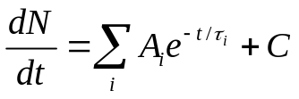 (1)
There are at least two exponential decays, but are there more? What processes do you expect to contribute to your data? Use all the information at your disposal (except the free muon lifetime!) to constrain this fit. In order to get a stable fit you will need to have good starting values for your parameters. You can, for example, use the following procedure to obtain starting values.

- The random coincidence rate (which determines C) can be estimated from the start and stop count rates and the total active time of the TAC.

- When you plot your data on a log plot, exponential decays will appear as straight lines. How many exponential regions can you see in your data? These might give good starting values of some parameters.

Now you can fit the time spectrum with equation (1). Calculate the χ² of your final fit. Explain in your discussion why a shorter life time due to muon capture can be observed when measuring the free decay of the μ⁺. Compare your results to expectations. Determine the uncertainties in all your parameters using the procedures described in the course notes and [10].

References:

Text books:
[1] A. Melissinos, Experiments in Modern Physics ,Academic Press, 1966.
A. Melissinos and J. Napolitano, Experiments in Modern Physics ,Academic Press, 2003.
[2] B.Rossi, Cosmic Rays, McGraw_Hill, 1964.
[3] E. Segre, Nuclei and Particles, Benjamin, 1977.

Scientific publications:
(You can find copies of some of these references at the experiment.)
[4] Conversi and Piccioni, Phys. Rev. 70 (1946) 859 and 874.
[5] J.C. Sens, Phys. Rev. 113 (1959) 679.
[6] G. Bardin et al., Phys. Lett. B137 (1984) 135. This paper gives the best measrements of the
lifetime of both the μ⁺ and the μ⁻ from a single experiment.
[7] For the current world average value of the muon lifetime consult the Particle Data Group site
http://pdg.lbl.gov/index.html click on “Summary Tables”, then “Leptons”. The published reference for this summary is given, but also quote the web site.

Other references:
[8] Energy loss in matter: Consult the Particle Data Group web site
http://pdg.lbl.gov/index.html click on “Reviews, Tables, Plots”, then “Constants, Units, Atomic
and Nuclear Properties”, then “Atomic and Nuclear Properties”. You can find dE/dx in
scintillator. The published reference for these data is given but also quote the web site.
[9] Cosmic ray summary: http://pdg.lbl.gov/2004/reviews/cosmicrayrpp.pdf done by the Particle
Data Group in 2004. The published reference for this review is given, but also quote the web site. [10] Philip R. Bevington and D. Keith Robinson, Data Reduction and Error Analysis 3rd edition
(McGraw-Hill, 2003).

Appendix: Starting up the PC based Multi Channel Analyzer

The PC on the lab table runs Windows 98. After power up you should find a shortcut on the desktop to MS-DOS PCAE, double clicking the icon will start the PCAE program. If for what ever reason the shortcut was lost you can start the PCAE program with run C:PCAE/PCAE.EXE.
The PCAE program emulates a multi channel analyzer on the PC, You will find a detailed description of the program in the users guide which is available at the experiment. The use of the program is rather self-explanatory.

Mode: Make sure that the program is set to PHA mode. To check type ALT M, select PHA and hit enter.

Erase data on screen: To erase data make sure that the program is no longer acquiring data (changed by toggling F1) then type ctrl F2 to erase the data. If this does not work the erase key is disabled. Type F2 to enable the erase key and then ctrl F2 to erase the data.

Store data to file: Type ALT F, the program will give you several options to save the data. If you want to read the data on a different computer, make sure that you select “ASCII File Save”. The program will prompt you for a file name, choose a unique name which contains the date when the file was written. The file will be written to C:PCAE. To save to a floppy use disk a:

Exit to Windows: Type ALT Q, select “exit to DOS”.

