**Baltic Fury 5, Ivan's March Across the Belts**

25 Feb 1994, 2000 Zulu, 2100 Local

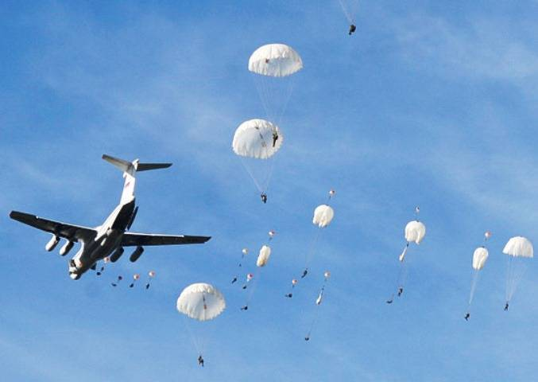

You are the commander the Soviet 38th Guards Airborne Corps. The formation has three Airborne Divisions (7th Guards, 103rd Guards, and 6th Polish) as well as the 6th Guards Motor Rifle Division (MRD), two Air Landing and one Naval Infantry Brigade plus a large slice of supporting troops to add firepower.

However, the initial actions (***this scenario***) will be conduced by your light brigades (and the Pols) to secure a corridor to Jutland. In a move similar to King Charles Gustav’s March across the Belts in 1658, you will rapidly seize a series of key points across the Great and Little Belts of the Danish Archipelago, allowing the two Airborne Divisions to concentrate on seizing the neck of Jutland while ensuring safe passage of the MRD to offloading ports on the mainland.

Your deputy handed you a pirated copy of the film *A Bridge Too Far* as he departed your HQ for the final time. His protests had apparently attracted too much attention from the Z*ampolit.*

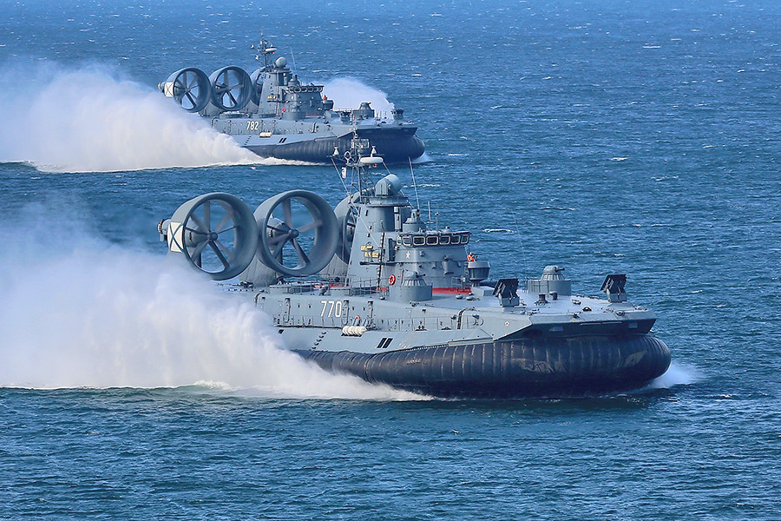

**Baltic Fury #5** Your job is to clear the way for the remainder of the Airborne Corps, including a Motor Rifle Division being sea lifted. The target is Denmark with the aim of knocking that country out of NATO and causing a fracture in the western alliance.

At your disposal are elements of four Brigades including a Naval Infantry force, two Air landing Brigades and the Polish airborne division which is small and of questionable value. These assets and the forces to carry them into battle are to create a carpet of secure areas for the remainder of the Corps which will be conducting a daylight landing in a few hours.