**Indian Ocean Fury #7: Deep Strike**

26 Feb 1994, Zulu, Local

You are commanding the 366th Expeditionary Fighter Wing which is a unique organization in the USAF. You flew into Cairo about ten days ago and have been conducting missions in the Eastern Mediterranean and Red Sea areas since then. Tonight, is something different. This morning you had a phone call from the Chairman of the Joint Chiefs at the Pentagon, not something you expected. Apparently, the Soviets have been helping the Iranians with their nuclear program and the Israelis are more than a little uptight. Since Washington wants to keep Israel from acting independently and causing all sorts of problems with our Arab allies, we have been given a new tasking.

Reinforced with some BONEs and a Blackbird who are flying in from the US, your job is to go deep into Iran and knock out the nuclear facilities – without causing any radioactive fallout of course. Simple!

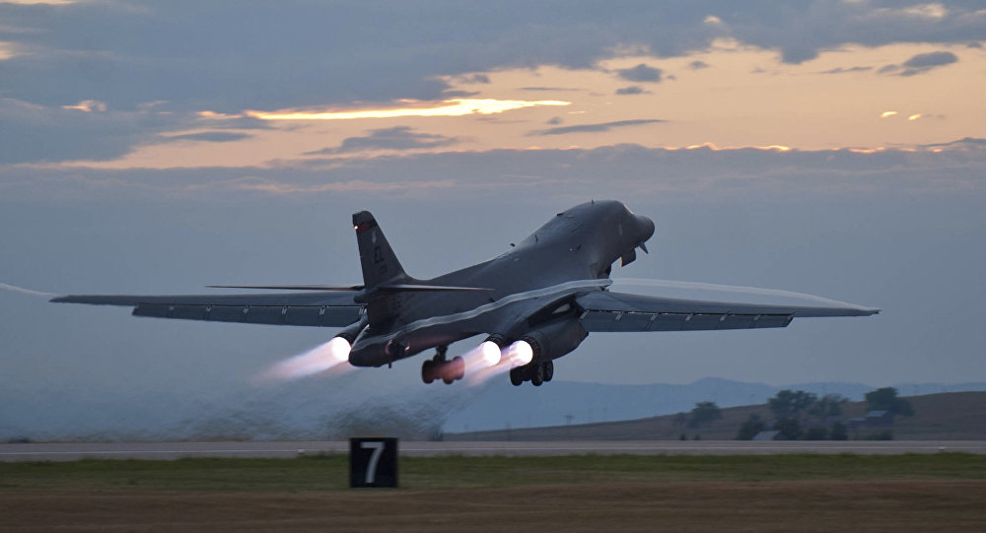

**Indian Ocean Fury #7** Puts you in the position of conducting a long-range precision strike on three nuclear facilities deep within Iran. Unfortunately, some of your assets are less than precise instruments, and the consequence of collateral damage is catastrophic.

As Fury scenarios go, this one is fairly straight forward, however Iran is not defenceless and your assets are not all ideally suited for the task.