**Indian Ocean Fury #8: Red Sea Rumble**

27 Feb 1994, Zulu, Local

You’re commanding a major convoy which originated in the Persian Gulf, transited the newly re-opened Straits of Hormuz and must now pass the Bab el Mandeb (BeM), the narrow gateway between the Red Sea and the Gulf of Aden on its way to bring vital oil and supplies through he Mediterranean to France. In addition to the oil and gas your convoy is currently transporting there are several cargo and container ships either rushing to catch up or waiting to join you at Djibouti.

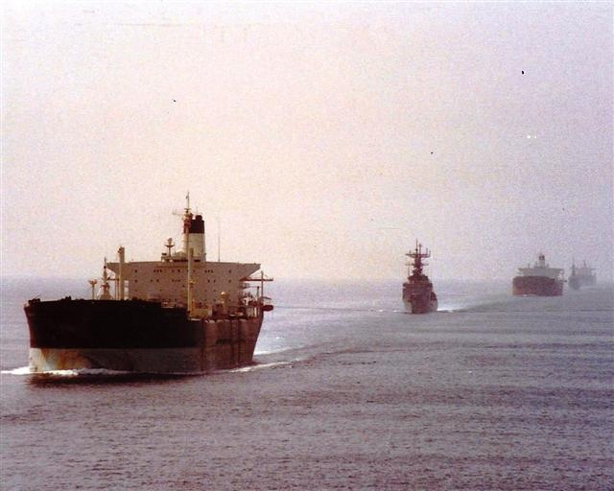

**Indian Ocean Fury #8** provides you with many challenges and hidden dangers. There are many assets available but making sure they are in the right place at the right time to counter the current threat is key.