# **Chapter 5 Supplementary Note**

**The genetic overlap between Alzheimer’s disease, amyotrophic lateral sclerosis, Lewy body dementia, and Parkinson’s disease**

Table of Contents

Chapter 5 Supplementary Note 1

Supplementary Note 3

Genetic correlations between AD and LBD 3

Suggestive loci 3

Investigating the *TMEM175* locus 4

*TMEM175* locus eQTL conditioning analysis 4

Comparison to previous studies 5

Conjunctional FDR analysis 6

Supplementary Methods 7

LBD vs other AD datasets 7

Conjunctional FDR analysis 7

Supplementary Figures 8

References 14

## Supplementary Note

### Genetic correlations between AD and LBD

We obtained six different additional AD GWAS summary statistics resulting in a total of seven AD datasets. Two of these AD datasets did not include proxy cases (IGAP, PGCALZ2noUKB), three included AD and proxy AD cases (Jansen, PGCALZ2, Bellenguez), and two included only proxy AD (MarioniMaternal, UKBJansen) (**Supplementary Methods**). We found that the genetic correlations with LBD were slightly higher in the data which did not contain proxy cases (**Supplementary Table 5.13**; **Supplementary Figure 5.4**). The datasets with proxy and AD cases had slightly higher genetic correlations with LBD than the proxy case datasets alone. However, all of these estimates had very large confidence intervals which all overlapped with each other, suggesting that they are not significantly different from each other. A similar pattern was found in the genetic correlations between ALS and the AD datasets (**Supplementary Figure 5.4**), albeit with a much less difference between the estimates. The opposite pattern was observed for the genetic correlations between PD and the AD datasets (**Supplementary Figure 5.4**), again with a much smaller difference than seen with LBD.

We were interested to see if the choice of AD dataset would affect the local genetic correlation results so we repeated the LAVA analyses between AD and LBD using the other AD datasets which included data from true AD cases (**Supplementary methods**). We found that only *APOE* and *BIN1* had significant local genetic correlations between AD and LBD in two or more other AD datasets (**Supplementary Table 5.13**; **Supplementary Figure 5.5**) after correcting for the total number of loci and datasets tested between AD and LBD (0.05/116=3.45x10-4). Both of these correlations were significant in the original analysis. One further significant local genetic correlation was identified between LBD and the Jansen AD summary statistics in the *SLC24A4/RIN3*, this genetic correlation was nominally significant in the original analysis. We found that while the genetic correlation between LBD and the AD dataset used in our main analyses was higher than expected, this genetic correlation was not significantly higher than estimates obtained using other AD datasets. Additionally, the results we found using the AD dataset in our main analyses were robust to the use of another AD dataset.

### Suggestive loci

To investigate whether there was further sub-threshold overlap between AD, ALS, LBD, and PD, we repeated the FUMA significant loci definition (**Results; Methods**), except we allowed for loci to be defined around variants with suggestive P-values (P<1x10-5). There was a total of 269 suggestive loci across the common factor and the 4 input traits (**Supplementary Table 5.3**), 43 were suggestive in the common factor, 101 were suggestive in AD, 67 were suggestive in ALS, 32 were suggestive in LBD, and 80 were suggestive in PD. In addition to the relationships identified through loci defined with significant variants (P<5x10-8), *TMEM175* was suggestive in ALS and significant in LBD, PD, and the common factor, *SNCA* was suggestive in AD and significant in LBD, PD and the common factor, and *MAPT* was suggestive in AD and significant in PD and the common factor. At this level, the HLA locus, the *SNCA* locus, and *TMEM175* locus were all at least suggestive in three of the four traits; however, no locus was suggestive in all four traits.

In contrast to the analysis at the significant level, not all loci suggestively associated with the common factor were suggestive in at least one of the input traits, and not all loci suggestive in two or more input traits were suggestive in the common factor. Four loci were only suggestive in the common factor, and four loci were suggestive in two or more input traits but not suggestive in the common factor. Of the four common-factor-only loci, two (*SHARPIN* and *TPCN1*) are loci which overlap with loci identified in a recent AD GWAS1. Visual inspection of the four loci that are suggestive in two input traits but not in the common factor suggests that these loci may be separate loci in relative proximity to each other.

We looked at the univariate heritability and genetic correlation of the loci identified as only suggestive in the common factor and the loci which were suggestive in two or more input traits but not the common factor (**Supplementary Table 5.14**) to determine whether these regions were truly shared regions. Of the four loci only associated with the common factor, only one locus (*SHARPIN*) had two traits with local heritability significantly different from 0 (AD: h2liability=0.0013, P=4.04x10-7; PD: h2liability=6.18x10-4, P=6.18x10-5). However, the genetic correlation between AD and PD at this locus was not significantly different from 0 (ρ=0.44, P=0.64). One locus (*EFL1/CPEB1*) that was suggestive in two input traits but not the common factor also had significant univariate heritability in two input traits (AD: h2liability=0.0011, P=8.97x10-5; ALS: h2liability=3.88x10-4, P=5.77x10-6). However, this locus was not even a nominally significant correlation between the two traits (ρ=0.262, P=0.24). This suggests that the suggestive loci only identified in the common factor and the suggestive loci identified in two or more input traits but not the common factor are unlikely to be regions of true overlap.

### Investigating the *TMEM175* locus

The TMEM175 locus was identified as a shared locus for ALS, LBD, and PD through local genetic correlation and conditional analysis. We were interested as to whether the common factor model could help identify potential causal variants in this locus. The lead variant at this locus in the common factor was rs34311866 (P=5.18x10-12). This variant is a missense variant (p.M393T) that causes an amino acid substitution from methionine to threonine in the final exon of *TMEM175*. This variant has been shown to reduce localisation of *TMEM175* on lysosomes2. A different study3 found that p.M393T did not affect lysosome localization of *TMEM175* but did affect GCase activity (a protein encoded by *GBA*) which may mediate the α-synuclein accumulation. A third study suggested that p.M393T lead to reduced proton conductance and lysosome acidification4. There appears to be some evidence for this variant in causing an impact on *TMEM175* that leads to worse α-synuclein clearance, however there is still conflicting evidence about the exact mechanism of effect. Jinn *et al.* (2019)2 performed conditional analysis and found multiple independent variants associated with PD including rs34884217 (p.Q65P).

In our study, rs34311866 was the most significant variant in PD (P=7.97x10-23), the second most significant variant in ALS (P=5.84x10-7), behind rs873786 (P=1.26x10-7), and the fourth most significant variant in LBD (P= 1.40x10-6), behind rs6599388 (P=3.54x10-8), rs35541465 (P=1.55x10-7), and rs11248057 (P=1.55x10-7). The top three variants in LBD are all in high LD (r2>0.7) in the 1000 Genomes European population, but all are in moderate LD (r2~0.4) with the common factor lead variant (rs34311866). The lead variant in ALS (rs873786) is in very low LD with all of the other lead variants (r2<0.05) and was highlighted as an independent variant in Jinn *et al.* (2019). This suggests that there are multiple independent variants in the *TMEM175* for ALS, LBD, PD, but rs34311866 appears to have strong evidence for association with all of them.

### *TMEM175* locus eQTL conditioning analysis

In order to prioritise a specific gene in the *TMEM175* locus, we performed local genetic correlation analysis between ALS and PD conditioned on eQTL data of that locus. Initially, we ran LAVA univariate h2 analyses for all eQTL-gene pairs in the *TMEM175* locus from the 19 brain and neuron eQTL datasets available in the eQTL catalogue5. This identified 82 eQTL-gene pairs with a local observed heritability significantly different from 0 after Bonferroni correction for 978 eQTL-gene pairs. Then we tested for local genetic correlations between these 82 eQTL-gene pairs with ALS, LBD, and PD resulting in 3 significant local genetic correlations after Bonferroni correction for 246 local genetic correlations. Of these 3 significant local genetic correlations (**Supplementary Table 5.11**), two were the same eQTL-gene pair (*SLC26A1* in GTEx_ge_brain_hippocampus) correlated with ALS and PD. We then conditioned the genetic correlation between ALS and PD on the *SLC26A1*-GTEx_ge_brain_hippocampus data, which only slightly decreased the significance of the genetic correlation between ALS and PD (ALS~PD: ρ=0.76, P=3.50x10-7; ALS~PD+eQTL: ρ=0.84, P=1.74x10-5). This result suggests that we were unable to identify an eQTL and gene pair that could explain the association between ALS and PD at this locus.

### Comparison to previous studies

Arneson *et al.* (2018)6 found no genes associated with AD, ALS, and PD; however, the HLA locus was significantly associated with these traits in the datasets used in our analyses. The identification of the HLA region as a region of interest to ALS was first reported in the GWAS catalog in 2021 (van Rheenen *et al*. (2021)7), four years after the analysis (September 2017) of Arneson *et al.* (2018). We were able to identify the overlap at the HLA region between these three traits because the data from van Rheenen *et al*. (2021)7 was included in our study. Arneson *et al.* (2018)6 also identified fewer overlapping genes and gene-sets between ALS and the other two traits, than between AD and PD. We replicated that finding, with the *MAPT*, *SNCA*, and HLA regions being shared in AD and PD, but only the *TNIP1* and HLA regions being shared in AD and ALS, and the *TMEM175* and HLA regions being shared between ALS and PD. Arneson *et al.* (2018)6 highlighted vesicle mediated transport as a gene-set related to AD, ALS, and PD; however, none of the gene-sets with titles containing ‘vesicle mediated transport’ had a significant association with any of the input traits or common factor in this analysis. We identified similar global genetic correlation estimates between AD and ALS and PD and ALS as reported in van Rheenen *et al*. (2021)7. We were unable to replicate their finding of *TSPOAP1-AS1* as a shared locus between AD and ALS but we were able to replicate their finding that the HLA and *GAK/TMEM175* loci were shared between ALS and PD. The data used in van Rheenen *et al*. (2021) overlapped extensively with the data used in this analysis. On the global genetic correlation level, the results suggest that AD and ALS are more genetically correlated than AD and PD; however, this was not reflected as a higher number of shared associated loci.

We were able to replicate the results in Guerreiro *et al*. (2016)8, where we also found a significant global genetic correlation between AD and DLB/LBD, DLB/LBD and PD, but not AD and PD. The genetic correlation estimates were larger in our study (AD~DLB: rg=0.93, SE=0.28; PD~DLB: rg=0.63, SE=0.17) compared to Guerreiro *et al*. (2016)8 (AD~DLB: rg=0.58, SE=0.075; PD~DLB: rg=0.36, SE=0.11). The differences in these estimates may be due to larger standard errors in our study and the use of different phenotypes (Guerreiro *et al*. (2016) investigated DLB, a subtype of LBD). Interestingly, there were strong global genetic correlations between AD and LBD and PD and LBD, but not a global genetic correlation significantly different from 0 between AD and PD. Despite this lack of correlation on a global level, we were able to identify some local genetic correlations between AD and PD. We replicated the finding from Stolp Andersen *et al.* (2022)9, where we found a significant local genetic correlation between AD and PD at the HLA region. We were also able to replicate the overlap between LBD and AD at the *APOE* and *BIN1* loci and the overlap between LBD and PD at the *GBA*, *TMEM175*, and *SNCA* loci identified in Chia *et al.* (2021)10. Overall, we were able to replicate previous positive findings and find additional overlap compared to previous studies, likely due to the increased sample size of the input datasets in our analyses. All of the previous studies mentioned in this section used datasets which were included in our analysis, so our findings cannot be considered an independent replication of previous findings.

### Conjunctional FDR analysis

In order to identify variants that were shared across multiple neurodegenerative diseases, we performed pairwise conjunctional FDR11 analyses across all trait combinations to look for variants with evidence of shared association signal across multiple traits. At a false discovery rate of 0.05, we found 22 loci that were shared across at least two traits; 3 loci shared between AD and LBD, 10 loci shared between AD and ALS, 4 loci shared between AD and PD, 3 loci shared between ALS and LBD, 4 loci shared between ALS and PD, and 7 loci shared between LBD and PD (**Supplementary Table 5.15**; **Supplementary Figure 5.6**). Three loci have variants that were independent variants with conjunctional FDR <0.05 in three or more traits (*TMEM175*, *HLA*, and *MAPT*).

There were five of these variants in the TMEM175 locus (rs73209865, rs6599388, rs6599389, rs34884217, and rs34311866), all of which were shared with ALS, LBD, and PD. Only 2 of these variants were the GWAS lead SNPs (rs6599388 in LBD and rs34311866 in PD), we additionally highlight rs73209865, rs6599389, and rs34884217 as potential causal variants. rs73209865 (PAD=0.23; PALS=2.89x10-6; PLBD=8.45x10-6; PPD=2.13x10-9) is an intronic variant in *GAK*. rs6599388 (PAD=0.36; PALS=7.63x10-6; PLBD=3.54x10-8; PPD=5.99x10-21) is an intronic variant in *TMEM175*. rs6599389 (PAD=0.11; PALS=1.89x10-4; PLBD=9.41x10-5; PPD=2.19x10-11) is also an intronic variant in *TMEM175.* rs34884217 (PAD=0.70 PALS=4.72x10-6; PLBD=8.08x10-5; PPD=2.62x10-5) is a missense variant in *TMEM175* (p.Q65P)*.* Interestingly, the missense allele is associated with a protective effect in ALS, LBD, and PD. This amino acid substitution has been associated with increase proton conductance3,4 and potentially improved lysosomal function. rs34311866 (PAD=0.0041 PALS=5.84x10-7; PLBD=1.40x10-6; PPD=7.97x10-23) is a missense variant in *TMEM175* (p.M393T)*.* As mentioned above, this variant has been shown to have a potential effect of *TMEM175* leading to lysosomal disfunction and α-synuclein accumulation2–4. All of these variants are eQTLs for *TMEM175* in various GTEx tissues12, but these variants appear to be eQTLs for multiple genes in the region across many tissues. The independent variant in the HLA region (rs9268581) was shared between AD, ALS, and PD. The independent variant in the *MAPT* region (rs17573509) was shared between AD, ALS, and PD. However, the LD structure in the *MAPT* and HLA region are complex so there may be further independent causal variants in this region. These shared variants are interesting candidates for follow-up experiments to determine if they are the causal variants in multiple diseases.

Using conjunctional FDR analysis, we identified 4 loci that were shared between at least two traits that were not identified from local genetic correlations or the common factor model (*MAIP1*, *FHIP2A*, *PRKCB*, and *CDH13*). The lead SNP in the *MAIP1* locus (rs3106091) had a conjunctional FDR value of 0.046 with LBD and PD. This variant is located downstream of *MAIP1* and was not suggestive in either LBD or PD (LBD P=2.59x10-4, PD P=5.90x10-4), and no variant in this locus was suggestive in either LBD or PD. MAIP1 encodes a protease predicted to be involved in mitochondrial calcium import and mitochondrial calcium import dysfunction has been linked to neurodegenerative diseases13 but the connection between the lead SNP and *MAIP1* is not clear and the connection between *MAIP1* and neurodegenerative diseases is also not clear. The lead SNP in the *FHIP2A* locus (rs2181563) had a conjunctional FDR value of 0.039 with AD and ALS. This variant is an intron variant in *FHIP2A* and was not suggestive in either AD or ALS (AD P=2.86x10-4, ALS P=1.48x10-4). There does not appear to be any previous literature connecting FHIP2A to neurodegenerative disease. The lead SNP in the *PRKCB* locus (rs11645733) had a conjunctional FDR value of 0.027 with AD and ALS. This variant is an intron variant in *PRKCB* and was not suggestive in AD or ALS (AD P=1.73x10-4, ALS P=9.78x10-5). There were other suggestive variants (rs12923337 P=3.94x10-7) in this locus in ALS. There is some limited evidence that expression changes in *PRKCB* could be related to onset of AD14. The lead SNP in the *CDH13* locus (rs11644204) had a conjunctional FDR value of 0.045 with ALS and LBD. This variant is an intron variant in *CDH13* and was not suggestive in ALS or LBD (ALS P=2.34x10-4, LBD P=1.17x10-5). There were other suggestive variants (rs8058532 P=4.48x10-6) in this locus in LBD. However, we could not find evidence for *CDH13* in ALS or LBD in the literature. The relative high FDR values, the lack of connection from variant to gene function, and the limited literature support for these results suggest that these findings are unlikely to be true pleiotropic regions for neurodegenerative diseases.

## Supplementary Methods

### LBD vs other AD datasets

We obtained summary statistics from 6 AD datasets, in addition to the AD dataset used in our main analyses (PGCALZ2noUKB). Two of the datasets did not include any proxy AD cases (IGAP15, PGCALZ2noUKB), three datasets included both AD cases and proxy cases (Jansen16, PGCALZ217, Bellenguez1), and two datasets only included proxy cases (MarioniMaternal18, UKBJansen16). We then performed LDSC regression as described in the **Methods** section. Then local genetic correlation analyses were performed using LAVA as described in the **Methods** section. The LAVA analyses were restricted to only datasets which included true AD cases and all correlations were tested between LBD and the AD dataset. The Bonferroni corrected threshold for significant local genetic correlations was 3.45x10-4 (0.5/116).

### Conjunctional FDR analysis

We performed conjunctional False Discovery Rate (conjFDR) analyses11 on all pairs of neurodegenerative traits to explore shared genetic variants. The conjFDR approach is based on an empirical Bayesian framework that estimates the posterior probability that a variant is not truly associated with both traits given the univariate associations of the variant with both traits. We performed this analysis using pleioFDR (<https://github.com/precimed/pleiofdr>), where independent variants were identified through pruning which was performed randomly 500 times using the LD estimates from the 1000 Genomes European individuals. A SNP with a conjFDR value <0.05 was considered as a shared SNP. To aid interpretation and visualisation, we grouped shared SNPs into genomic loci and assigned lead SNPs according to the FUMA protocol (<https://github.com/precimed/python_convert>).

## Supplementary Figures

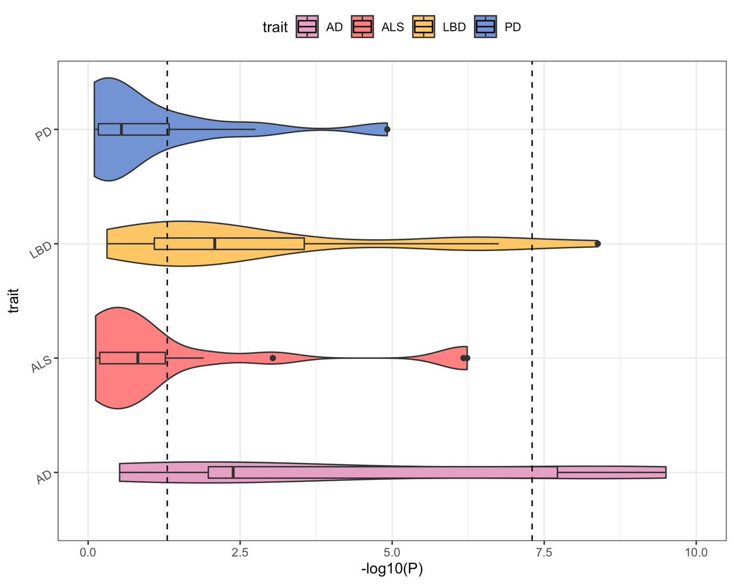

Supplementary Figure 5.1: The P-values of the common factor lead variants in the 4 input traits identifies AD and LBD as having smaller P-values in the common factor lead variants. The first dashed line represents the nominal significance threshold (0.05) and the second dashed line represents the Bonferroni corrected significance threshold (5x10-8). Box plots are within the violin plots, the box displays the first quartile, the median value, and the third quartile. The lines out from the box plot end at the first quartile minus 1.5 times the interquartile range and the third quartile plus 1.5 times the interquartile range. Dots represent P-values of variants where the P-values are outside of the first quartile minus 1.5 times the interquartile range and the third quartile plus 1.5 times the interquartile range.

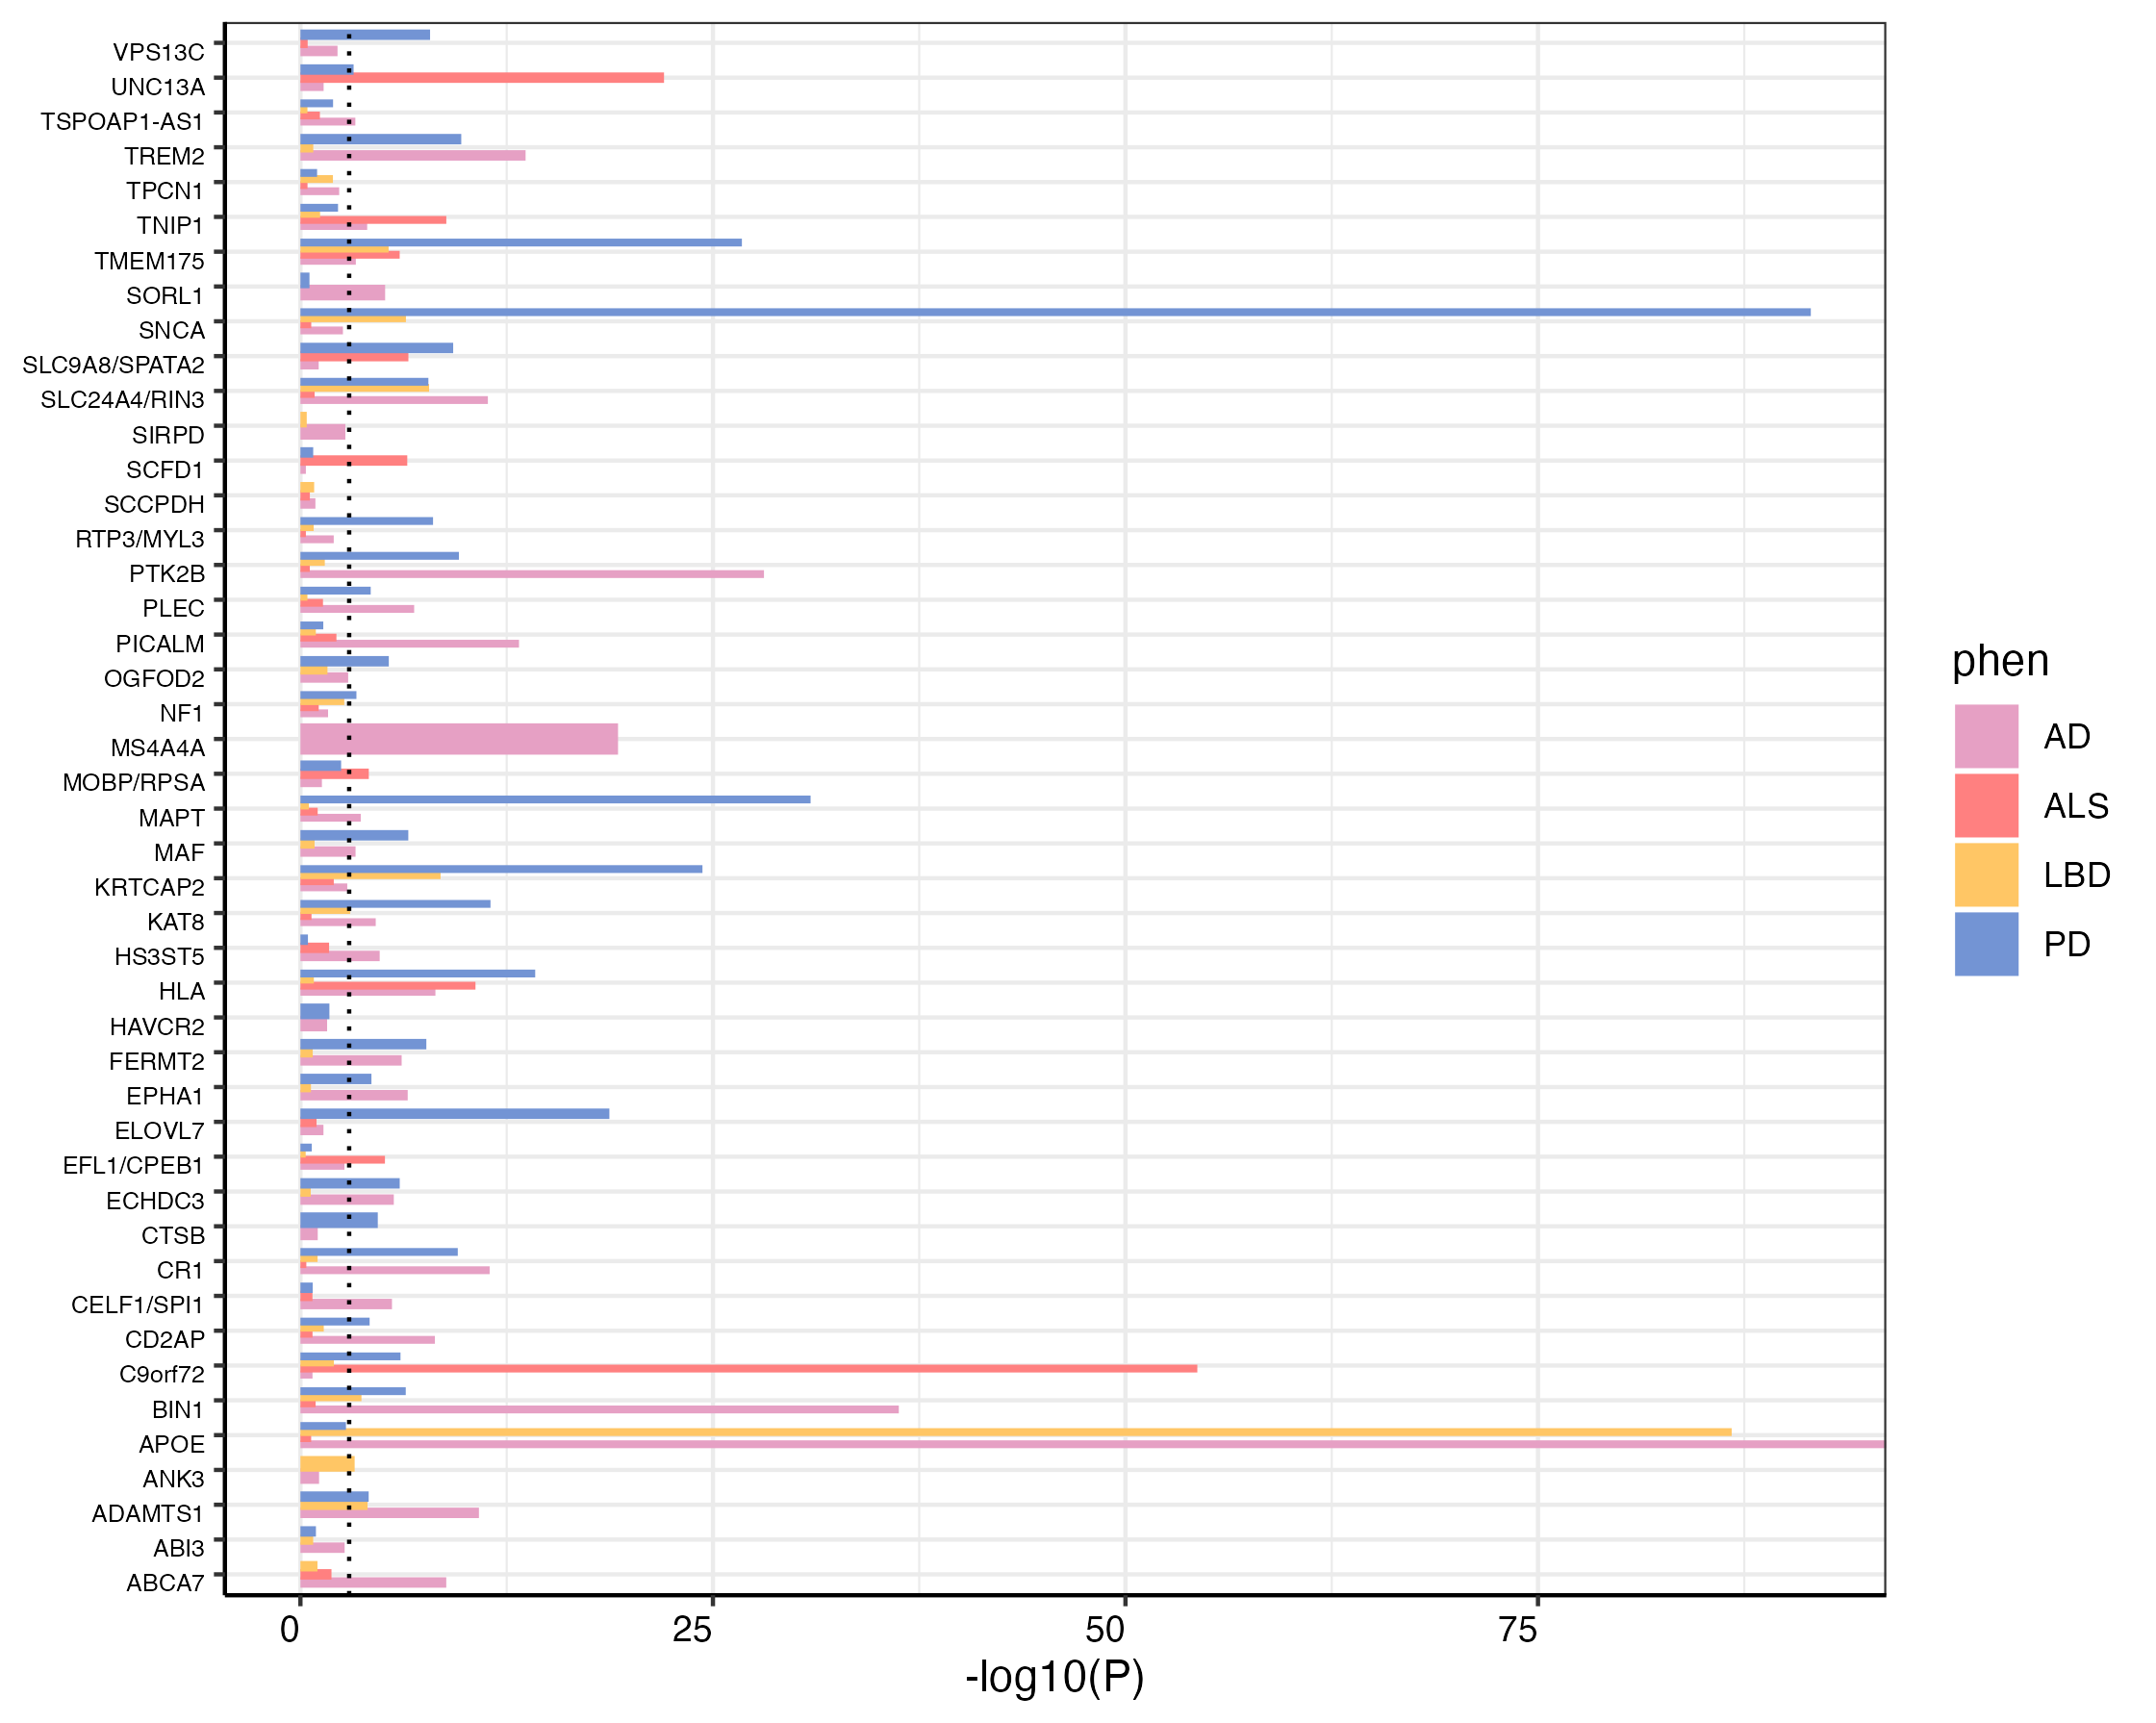

Supplementary Figure 5.2: The P-values of the local heritability estimates for each of the 4 input traits across the 45 loci show traits where the local heritability is significantly different from 0. The dashed line represents the Bonferroni corrected significance threshold (0.05/45 loci). Heritability estimates that could not be estimated due to lack of association signal are not included in the plot.

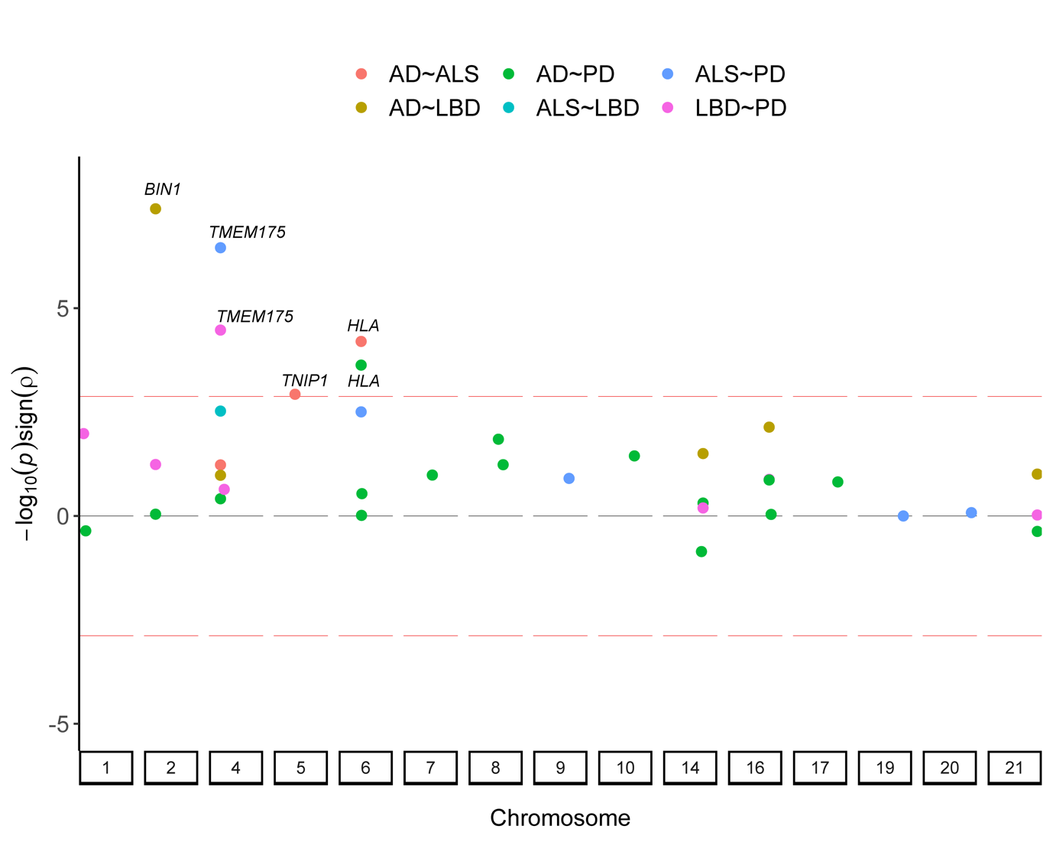

Supplementary Figure 5.3: The bivariate genetic correlation estimates between traits at loci where these traits had significant local heritability highlights 5 regions with significant genetic correlations after Bonferroni correction for 38 genetic correlation tests. One significant local genetic correlation between AD and LBD at the APOE locus had too low of a P-value to be included in this plot. The red lines represent the Bonferroni correction threshold (0.05/38 genetic correlations) multiplied by the direction (sign) of the genetic correlation.

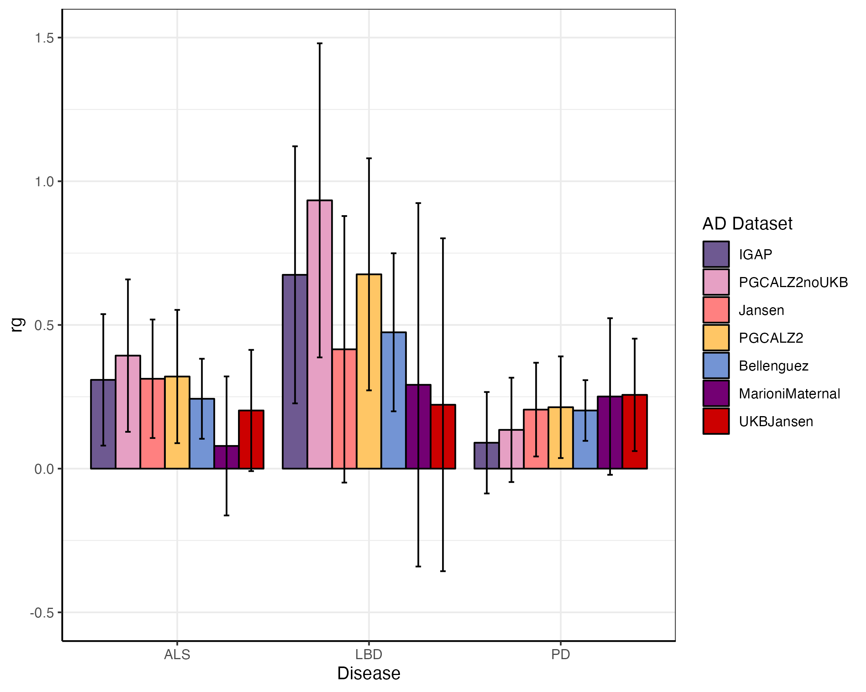

Supplementary Figure 5.4: The LDSC derived global genetic correlation estimates between ALS, LBD, PD, and the 7 AD datasets. The x axis represents the non-AD diseases (ALS, LBD, PD) and the y-axis represents the genetic correlation estimates between these diseases and an AD dataset. The bars are coloured based on which AD dataset was used. The error bars represent the 95% confidence interval. IGAP refers to the data from Kunkle et al. (2019)15 and does not include proxy AD data. PGCALZ2noUKB refers to the AD data included in this study, an inverse-variance meta-analysis of clinical AD data from Wightman et al. (2021)17 excluding the UKB and 23andMe data. Jansen refers to the data from Jansen et al. (2019)16 which included both clinical and proxy AD data. PGCALZ2 refers to the data from Wightman et al. (2021)17 which included both clinical and proxy AD data. Bellenguez refers to data from Bellenguez et al. (2022)1 which included both clinical and proxy AD data. MarioniMaternal refers to the maternal proxy GWAS data from Marioni et al. (2018)18. UKBJansen refers the proxy AD data used in Jansen et al. (2019)16.

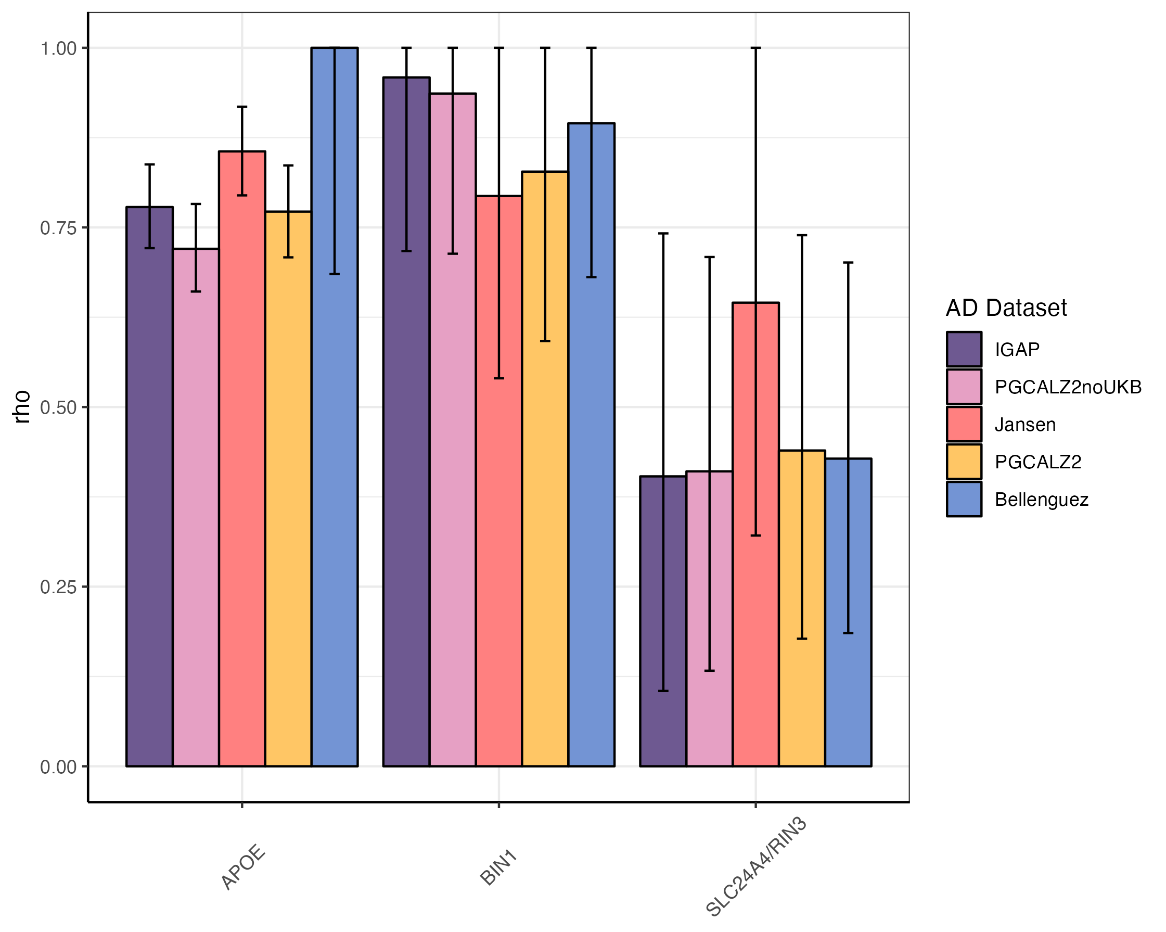

Supplementary Figure 5.5: The local genetic correlations between LBD and other AD datasets derived from LAVA where the genetic correlation is significantly different from 0. The x axis represents the locus and the y-axis represents the genetic correlation estimates between the LBD and an AD dataset. The bars are coloured based on which AD dataset was used. The error bars represent the upper and lower confidence intervals from LAVA. IGAP refers to the data from Kunkle et al. (2019)15 and does not include proxy AD data. PGCALZ2noUKB refers to the AD data included in this study, an inverse-variance meta-analysis of clinical AD data from Wightman et al. (2021)17 excluding the UKB and 23andMe data. Jansen refers to the data from Jansen et al. (2019)16 which included both clinical and proxy AD data. PGCALZ2 refers to the data from Wightman et al. (2021)17 which included both clinical and proxy AD data. Bellenguez refers to data from Bellenguez et al. (2022)1 which included both clinical and proxy AD data.

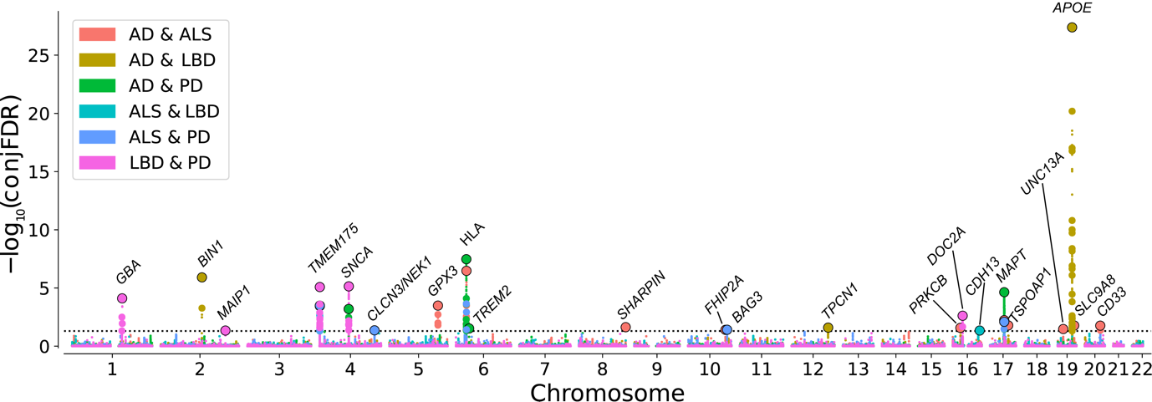

Supplementary Figure 5.6: The conjunctional FDR results for all of the variants shared across the 4 neurodegenerative disorders. The y axis is the -log10 of the FDR value. The dotted horizontal line represents the FDR 0.05 threshold. Lead variants in loci below the FDR 0.05 threshold are surround by a black outline. The point colours represent the pairwise analysis.

## References

1. Bellenguez, C. *et al.* New insights into the genetic etiology of Alzheimer’s disease and related dementias. *Nat. Genet.* **54**, 412–436 (2022).

2. Jinn, S. *et al.* Functionalization of the TMEM175 p.M393T variant as a risk factor for Parkinson disease. *Hum. Mol. Genet.* **28**, 3244–3254 (2019).

3. Krohn, L. *et al.* Genetic, Structural, and Functional Evidence Link TMEM175 to Synucleinopathies. *Ann. Neurol.* **87**, 139–153 (2020).

4. Zheng, W. *et al.* pH regulates potassium conductance and drives a constitutive proton current in human TMEM175. *Sci. Adv.* **8**, eabm1568 (2023).

5. Kerimov, N. *et al.* A compendium of uniformly processed human gene expression and splicing quantitative trait loci. *Nat. Genet.* **53**, 1290–1299 (2021).

6. Arneson, D., Zhang, Y., Yang, X. & Narayanan, M. Shared mechanisms among neurodegenerative diseases: from genetic factors to gene networks. *J. Genet.* **97**, 795–806 (2018).

7. van Rheenen, W. *et al.* Common and rare variant association analyses in amyotrophic lateral sclerosis identify 15 risk loci with distinct genetic architectures and neuron-specific biology. *Nat. Genet.* **53**, 1636–1648 (2021).

8. Guerreiro, R. *et al.* Genome-wide analysis of genetic correlation in dementia with Lewy bodies, Parkinson’s and Alzheimer’s diseases. *Neurobiol. Aging* **38**, 214.e7-214.e10 (2016).

9. Stolp Andersen, M. *et al.* Dissecting the limited genetic overlap of Parkinson’s and Alzheimer’s disease. *Ann. Clin. Transl. Neurol.* **n/a**, (2022).

10. Chia, R. *et al.* Genome sequencing analysis identifies new loci associated with Lewy body dementia and provides insights into its genetic architecture. *Nat. Genet.* **53**, 294–303 (2021).

11. Andreassen, O. A. *et al.* Improved Detection of Common Variants Associated with Schizophrenia and Bipolar Disorder Using Pleiotropy-Informed Conditional False Discovery Rate. *PLOS Genet.* **9**, e1003455 (2013).

12. The GTEx Consortium *et al.* The Genotype-Tissue Expression (GTEx) pilot analysis: Multitissue gene regulation in humans. *Science (80-. ).* **348**, 648–660 (2015).

13. Liao, Y., Dong, Y. & Cheng, J. The Function of the Mitochondrial Calcium Uniporter in Neurodegenerative Disorders. *Int. J. Mol. Sci.* **18**, 248 (2017).

14. Zhou, Z. *et al.* Molecular identification of protein kinase C beta in Alzheimer’s disease. *Aging (Albany. NY).* **12**, 21798–21808 (2020).

15. Kunkle, B. W. *et al.* Genetic meta-analysis of diagnosed Alzheimer’s disease identifies new risk loci and implicates Aβ, tau, immunity and lipid processing. *Nat. Genet.* **51**, 414–430 (2019).

16. Jansen, I. E. *et al.* Genome-wide meta-analysis identifies new loci and functional pathways influencing Alzheimer’s disease risk. *Nat. Genet.* **51**, 404–413 (2019).

17. Wightman, D. P. *et al.* A genome-wide association study with 1,126,563 individuals identifies new risk loci for Alzheimer’s disease. *Nat. Genet.* **53**, 1276–1282 (2021).

18. Marioni, R. E. *et al.* GWAS on family history of Alzheimer’s disease. *Transl. Psychiatry* **8**, 99 (2018).