LOAN PORTFOLIO RISK
REPORTING DASHBOARD
A Business Analysis & Data Analytics Portfolio Project
Harvest Trust Financial (HTF) - Fictional Case Study
Modelled on the real, industry-documented challenges of agricultural lending risk reporting
Prepared by Dwij Siyal, Business Analyst
September 2026

PHASE 1
Project Brief
The business problem, fictional organization, objectives, scope, and success criteria grounded in documented, industry-wide agricultural lending risk challenges.

PROJECT BRIEF
Loan Portfolio Risk Reporting Dashboard
Harvest Trust Financial (HTF) — Fictional Case Study

Document | Project Brief - Loan Portfolio Risk Reporting Dashboard
Prepared by | Dwij Siyal, Business Analyst (Portfolio Project)
Date | August 1, 2026
Version | 1.0
Status | Approved to proceed to Stakeholder Analysis (Phase 2)

Table of Contents

1. Motivation 4
2. Background & Business Problem 4
2.1 Organization 4
2.2 Current State 4
2.3 Why Now 5
3. Project Objective 5
4. Scope 5
4.1 In Scope 5
4.2 Out of Scope 5
5. Stakeholders (High-Level) 6
6. Success Criteria 6
7. Assumptions & Constraints 6
8. High-Level Timeline 7
9. Risks 7
10. References 8

1. Motivation
This project is grounded in a documented, industry-wide problem rather than a hypothetical one. Across agricultural lending, institutions commonly rely on fragmented spreadsheets and periodic manual reviews to track loan performance. Industry research on agricultural lending risk management (LoanPro, 2026 [1]; FarmRaise, 2025 [2]) describes lenders still assembling portfolio risk views by hand, which delays the detection of early warning signs — rising credit utilization, delayed payments to suppliers, deteriorating liquidity, and repeated extensions or carryover financing. By the time these signals surface in a manual report, the window for early intervention has often already narrowed and become more costly.
This pattern is especially relevant to agricultural lenders because farm cash flow is seasonal and sensitive to commodity prices and weather, so risk can build gradually across a growing season before it becomes visible in a static report. A lender that can only see delinquency and concentration trends once a month, after a multi-day manual compilation process, is structurally behind the risk it is trying to manage.
Harvest Trust Financial (HTF) is a fictional Canadian agricultural lending institution created for this portfolio project. HTF's situation is designed to reflect this real, industry-wide pattern not to represent the internal systems of any specific real institution. No claims are made in this project about how any actual company, including Farm Credit Canada, manages its own reporting internally.

2. Background & Business Problem

2.1 Organization
Harvest Trust Financial (HTF) is a mid-sized Canadian agricultural lending institution headquartered in Regina, Saskatchewan, providing term loans and operating lines of credit to farm operations and agribusinesses across Saskatchewan, Alberta, and Manitoba. HTF's loan book spans several agricultural sectors, including grain and oilseed, livestock and dairy, and diversified/mixed farming operations.

2.2 Current State
HTF's Risk Management and Credit teams currently monitor loan delinquency, risk ratings, and portfolio performance through a manual monthly process: analysts export data from the core loan servicing system, reconcile it in Excel, and circulate static reports to leadership. This process has several recurring problems:
- Slow turnaround: compiling the monthly report takes 5–7 business days, so leadership is often reviewing data that is already 1–2 weeks stale by the time it's read.
- Inconsistent definitions: “risk tier” and “past due” are calculated slightly differently across analysts and spreadsheets, undermining trust in the numbers.
- No drill-down: reports are static exports; nobody can filter by region, sector, or risk tier between report cycles without requesting a new manual pull.
- Hidden concentration risk: there is no easy way to see how exposed the portfolio is to a single region or sector (for example, a high share of grain loans concentrated in one area), which matters because a drought or commodity price shock could hit many loans at once.
- Weak audit trail: manual spreadsheet handoffs make it hard to show exactly how a reported number was derived, which matters for internal audit and board-level reporting.

2.3 Why Now
Leadership has asked for a single, trusted, self-serve dashboard that replaces the manual report cycle one with agreed-upon definitions, regular automated refresh, and the ability for stakeholders to explore the data themselves instead of waiting on a scheduled export.

3. Project Objective
Design and deliver a Loan Portfolio Risk Reporting Dashboard, along with the supporting business analysis artifacts, that gives HTF stakeholders self-serve visibility into loan delinquency, risk tier distribution, and portfolio performance by region and sector replacing the manual monthly reporting process.

4. Scope

4.1 In Scope
- A documented business case, stakeholder analysis, and requirements set for the dashboard and its underlying data.
- A synthetic (fictional) loan portfolio dataset, generated in Python, realistic enough to support meaningful analysis.
- A defined data model (tables, relationships, fields) supporting the dashboard.
- A working Power BI dashboard covering delinquency trends, risk tier distribution, and region/sector performance, with filtering and drill-down.
- Standard definitions for key terms (e.g., delinquency buckets, risk tiers) applied consistently across all artifacts.

4.2 Out of Scope
- Live integration with a real core banking or loan servicing system (the dataset is synthetic and static).
- Any real client, loan, or financial data from FCC, or any other real institution.
- Automated regulatory filings or submissions.
- Predictive/ML-based credit scoring models (noted as a possible future enhancement, not part of this project).
- Changes to loan origination or underwriting workflows.

5. Stakeholders (High-Level)
A detailed stakeholder analysis including individual needs, influence, and a RACI breakdown is produced in Phase 2. At a high level, the following roles are involved:
- Chief Risk Officer: executive sponsor; owns portfolio-level risk oversight.
- VP, Credit & Lending Operations: owns lending decisions and delinquency follow-up.
- Regional Credit Managers (SK / AB / MB): manage regional loan books and client relationships.
- Portfolio Risk Analysts: primary dashboard users and maintainers; currently build the manual reports.
- Finance & Treasury: uses portfolio risk data to inform allowance for credit losses (ACL) estimates.
- Internal Audit & Compliance: needs confidence in data accuracy, consistency, and traceability.
- IT / Data Team: supports the underlying data pipeline and Power BI environment.

6. Success Criteria
- Reporting turnaround drops from 5–7 business days to near real-time, self-serve access.
- A single, agreed definition of “risk tier” and “delinquency bucket” is used consistently across the dashboard and all supporting documentation.
- Stakeholders can independently filter and drill down by region, sector, and risk tier without requesting a custom export.
- The dashboard runs on a defined refresh cadence rather than ad hoc manual pulls.
- Risk Management and Credit leads validate that the dashboard reflects what they need to do their jobs (represented in this project by a documented sign-off step).

7. Assumptions & Constraints
- Fictional data only: all organization names, people, and figures are invented for this portfolio project; no real client or proprietary data is used.
- Single-author project: Dwij Siyal performs all BA, data, and development roles that would normally be split across a project team.
- Tooling: dashboard is built in Power BI Desktop; Python (pandas/NumPy) is used for synthetic data generation.
- Timeline: the project is scoped to be completed in roughly 5–7 focused working days.
- Realism target: the synthetic dataset should be plausible enough (realistic field names, distributions, and value ranges) to support credible discussion in a job interview setting.

8. High-Level Timeline
Phase | Deliverable | Focus | Day(s)
1 | Project Brief | Scenario, problem, objective | Day 1
2 | Stakeholder Analysis | Needs, RACI, power/interest | Day 1
3 | Requirements Document | Business / functional / non-functional | Day 2
4 | Synthetic Dataset | Python-generated loan portfolio data | Day 3
5 | Data Model Design | Tables, relationships, fields | Day 4
6 | Power BI Dashboard | KPIs, visuals, filters, DAX | Day 4 – Day 6
7 | Package & Present | PDF portfolio, README, resume bullet | Day 7

9. Risks
Risk | Likelihood | Mitigation
Synthetic data reads as unrealistic or obviously random | Medium | Base distributions on realistic ag-lending patterns (seasonality, sector mix, regional risk); validate outputs before building the dashboard.
Scope creep on dashboard polish at the expense of BA documentation | Medium | Timebox each phase; treat Phase 1–3 artifacts as equally important deliverables to the dashboard itself.
Stakeholder adoption - analysts and managers accustomed to Excel reporting may be slow to trust or switch to a new dashboard | Medium | Involve Regional Credit Managers and Portfolio Risk Analysts early (Phase 2), and require their documented sign-off before the dashboard is considered complete.

10. References
Industry sources used to validate the business problem as a genuine, documented pattern in agricultural lending (not as a claim about any specific real institution's internal systems):
- LoanPro. “Agricultural lending challenges in 2026.” loanpro.io/blog/agricultural-lending/
- FarmRaise. “Risk Management for Lenders: Building Resilient Rural Loan Portfolios.” farmraise.com/blog/2025-risk-management-for-lenders-building-resilient-rural-loan-portfolios
- Farm Credit Canada — public corporate/governance profile, used only for general industry context (structure, scale, sector focus), not for internal process claims. fcc-fac.ca/en/about-fcc/governance

PHASE 2
Stakeholder Analysis
Stakeholder matrix, Power/Interest matrix, and RACI chart mapping who needs this dashboard and how each group should be engaged.

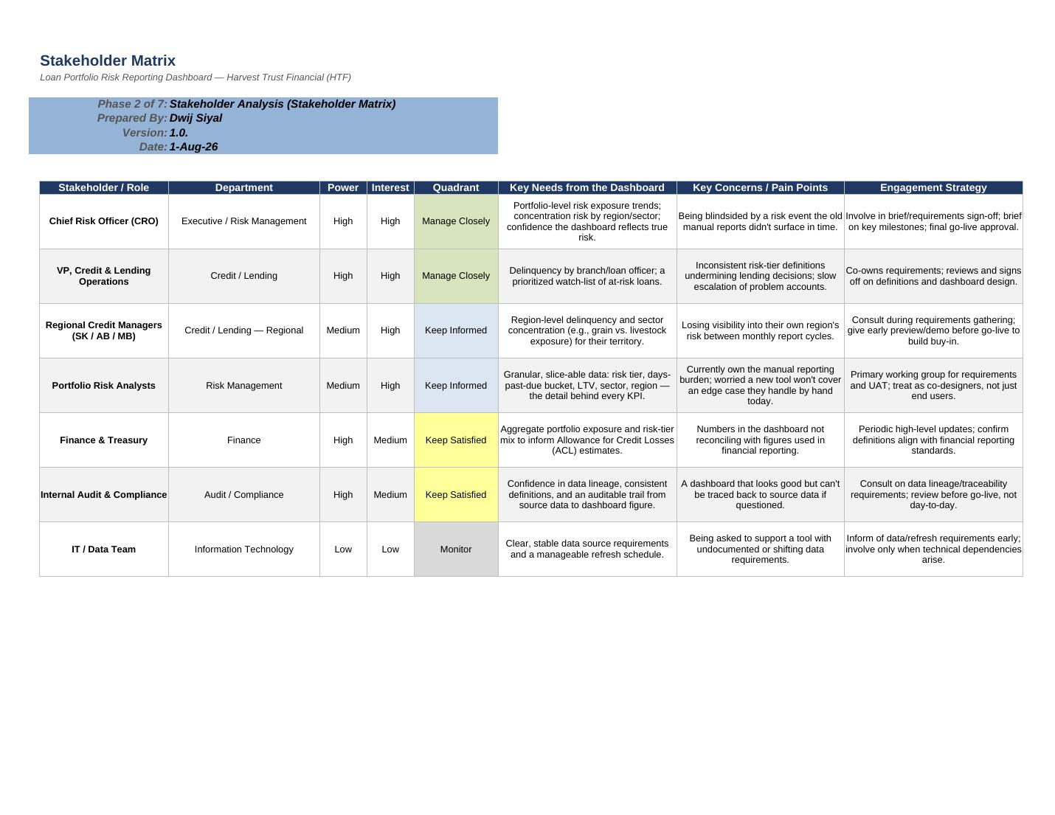

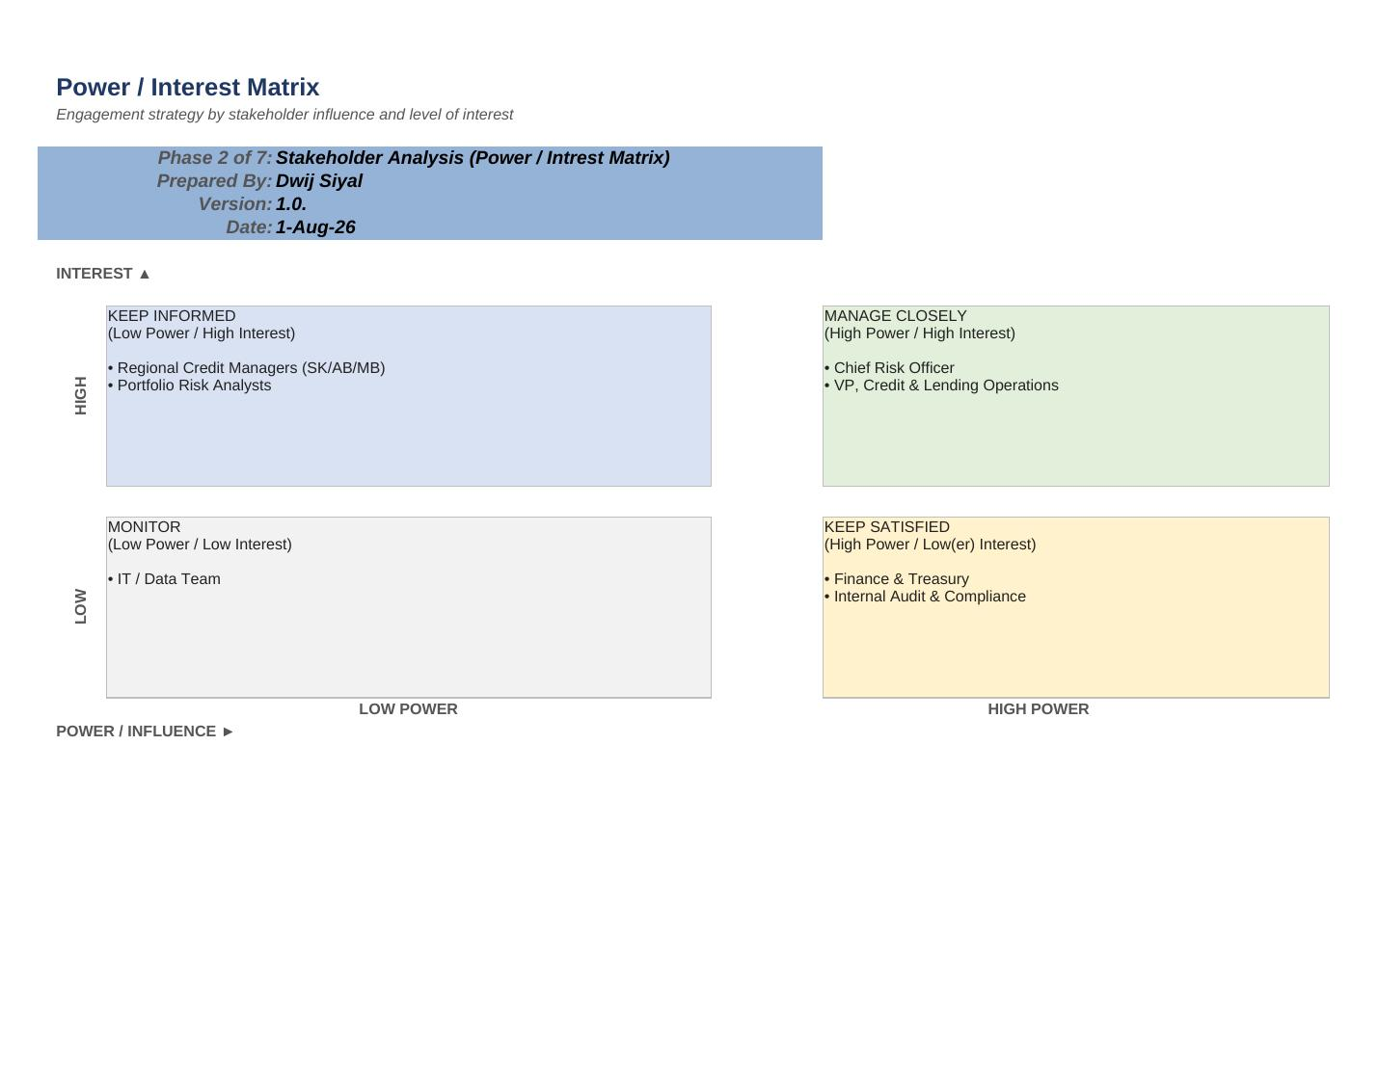

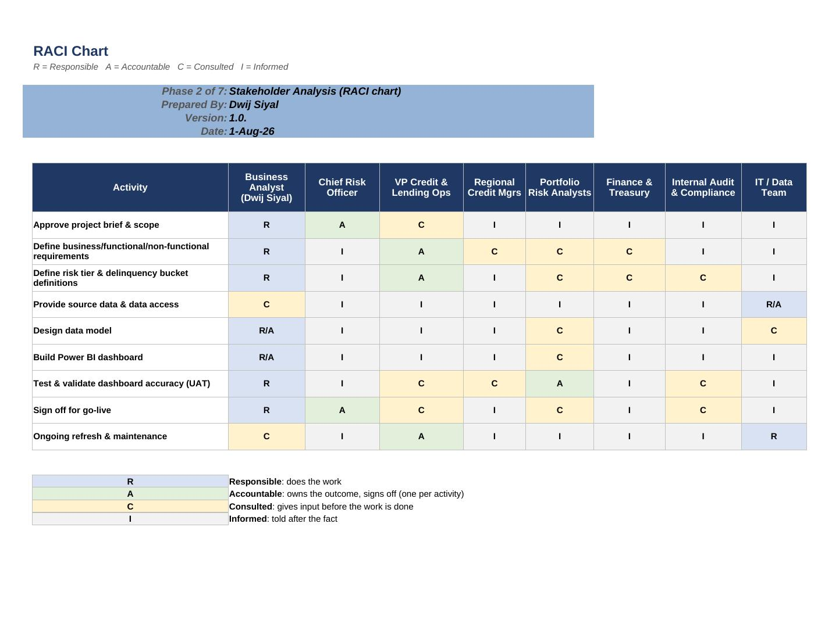

PHASE 3
Requirements Document
Business, functional, and non-functional requirements — MoSCoW-prioritized with full traceability back to the business case.

REQUIREMENTS DOCUMENT
Loan Portfolio Risk Reporting Dashboard
Harvest Trust Financial (HTF) - Fictional Case Study

Phase 3 of 7 | Requirements Document
Prepared by | Dwij Siyal
Date | August 3, 2026
Version | 1.0
Linked Documents | Phase 1: Project Brief · Phase 2: Stakeholder Analysis

Table of Contents

1. Purpose & Approach 15
2. Key Definitions 15
3. Business Requirements 15
4. Functional Requirements 16
5. Non-Functional Requirements 17
6. Traceability Matrix 17
7. Out of Scope / Deferred 18

1. Purpose & Approach
This document translates the business problem and stakeholder needs identified in Phases 1 and 2 into specific, prioritized requirements for the Loan Portfolio Risk Reporting Dashboard. Requirements are grouped into three standard categories: Business Requirements (the underlying business need), Functional Requirements (what the dashboard must do), and Non-Functional Requirements (quality attributes such as performance, usability, and auditability).
Each requirement is prioritized using MoSCoW: Must have (required for the dashboard to meet its objective), Should have (important, included if time allows), Could have (nice to have, lower impact if deferred), and Won't have this round (explicitly deferred, listed in Section 7). Functional requirements are traced back to the business requirement they satisfy so that every feature in the dashboard has a clear reason for existing.

2. Key Definitions
- Delinquency: a loan is delinquent when a scheduled payment has not been received by its due date.
- Days Past Due (DPD) Bucket: loans are grouped by how late the oldest unpaid payment is: Current (0 days), 1–29 days, 30–59 days, 60–89 days, and 90+ days (considered non-performing).
- Risk Tier: a simplified 4-level scale used for dashboard reporting: Tier 1 (Low Risk), Tier 2 (Moderate Risk), Tier 3 (Elevated Risk), Tier 4 (High Risk / Watch List). Real institutions often use finer-grained internal rating scales (e.g., 9–12 point); this project uses a simplified 4-tier scale intentionally, to keep the dashboard readable at a glance.
- Concentration Risk: the share of the total portfolio exposed to a single region or sector; a high concentration means a single shock (e.g., drought, commodity price drop) could affect a large portion of the portfolio at once.
- Watch List: loans that have recently moved into a higher risk tier or delinquency bucket since the last data refresh, surfaced for proactive follow-up.

3. Business Requirements
ID | Requirement | Priority | Primary Stakeholder
BR1 | Reduce reliance on manual, spreadsheet-based reporting for loan portfolio risk monitoring. | Must | VP, Credit & Lending Operations
BR2 | Establish standardized, single-source definitions for risk tier and delinquency bucket, used consistently across all reporting. | Must | Portfolio Risk Analysts / Internal Audit
BR3 | Provide self-serve, near real-time visibility into portfolio performance by region and sector. | Must | Chief Risk Officer
BR4 | Support internal audit and compliance needs for data traceability and lineage. | Should | Internal Audit & Compliance

4. Functional Requirements
ID | Requirement | Priority | Traces to
FR1 | Display top-level portfolio KPIs (total outstanding balance, weighted delinquency rate, active loan count, total watch-list balance) on a summary page. | Must | BR3
FR2 | Allow filtering of all visuals by Region (SK/AB/MB), Sector, and Risk Tier. | Must | BR3
FR3 | Display a delinquency rate trend over the trailing 12 months. | Must | BR3
FR4 | Display portfolio concentration (% of total outstanding balance) by region and by sector. | Must | BR3
FR5 | Categorize every loan into a standard days-past-due (DPD) bucket using a single, documented calculation. | Must | BR2
FR6 | Assign each loan a Risk Tier (1–4) based on a documented, consistent methodology. | Must | BR2
FR7 | Provide drill-through from portfolio/region/sector level down to individual loan-level detail. | Should | BR3
FR8 | Flag loans that moved into a higher risk tier or delinquency bucket since the prior refresh (“Watch List”). | Should | BR1, BR3
FR9 | Refresh underlying data on a defined, documented schedule rather than ad hoc manual pulls. | Must | BR1
FR10 | Allow export of the current filtered data view for offline stakeholder use. | Could | BR3
FR11 | Maintain a visible data dictionary / definitions reference within the dashboard file. | Should | BR2, BR4

5. Non-Functional Requirements
ID | Category | Requirement | Priority
NFR1 | Performance | Dashboard visuals shall render within ~10 seconds under normal filter operations. | Should
NFR2 | Usability / Accessibility | Visuals shall use a consistent, colourblind-safe palette for risk-tier indicators (not relying on red/green alone). | Should
NFR3 | Auditability | Every calculated field (risk tier, DPD bucket, concentration %) shall have its logic documented so a reviewer can trace a figure back to its source fields. | Must
NFR4 | Security / Access | Production use would require role-based, view-only access for most business users. Documented here as a requirement; implementation is out of scope for this single-author fictional build. | Must (documented)
NFR5 | Maintainability | Data model and DAX measures shall be structured (star schema, named measures) so another analyst could maintain the dashboard without rebuilding it. | Should
NFR6 | Tooling / Portability | Solution shall be built entirely in Power BI Desktop without dependency on paid add-ins or external services. | Must

6. Traceability Matrix
A summary view of which functional (and non-functional) requirements satisfy each business requirement used to confirm nothing in scope is unaccounted for, and nothing built lacks a business reason.
Business Requirement | Description | Satisfied By
BR1 | Reduce reliance on manual reporting | FR8, FR9
BR2 | Standardized risk tier & delinquency definitions | FR5, FR6, FR11
BR3 | Self-serve, near real-time regional/sector visibility | FR1, FR2, FR3, FR4, FR7, FR8, FR10
BR4 | Audit & compliance traceability | FR11, NFR3

7. Out of Scope / Deferred
- Predictive or ML-based credit risk scoring (potential future enhancement).
- Real-time (sub-daily) data refresh — this project uses a defined periodic refresh schedule instead.
- Mobile-optimized dashboard layout.
- Automated regulatory filing or submission generation.
- Implementation of production-grade, role-based security (documented as NFR4, not built, given the single-author fictional scope).

PHASE 4
Synthetic Dataset Generation
A fictional, entirely synthetic loan portfolio dataset was generated in Python (pandas/NumPy) to support the dashboard build. The full generation script and resulting CSV files are included in this repository under 04_data/, rather than reproduced in full here.
What was generated:
• 380 borrowers across Saskatchewan, Alberta, and Manitoba, spanning four agricultural sectors (Grain & Oilseed, Livestock, Dairy, Mixed Farming).
• 539 loans (Term Loans, Operating Lines of Credit, Equipment Loans, Farm Mortgages) with realistic principal, rate, and collateral ranges by loan type.
• A 24-month monthly snapshot (9,372 rows) modeling seasonality deliberately — higher delinquency risk in the pre-seeding spring months, lower risk post-harvest — rather than random noise.
• Two validated bugs were caught and fixed during generation: Operating Lines of Credit incorrectly “maturing” after one year (they are revolving, not term, facilities), and a delinquency-rate model with no mean-reversion that drifted from 5% to 18% over two years instead of settling around a stable baseline.

PHASE 5
Data Model Design
The snowflake schema powering the dashboard: an entity-relationship diagram, table relationships, and a complete field-level data dictionary.

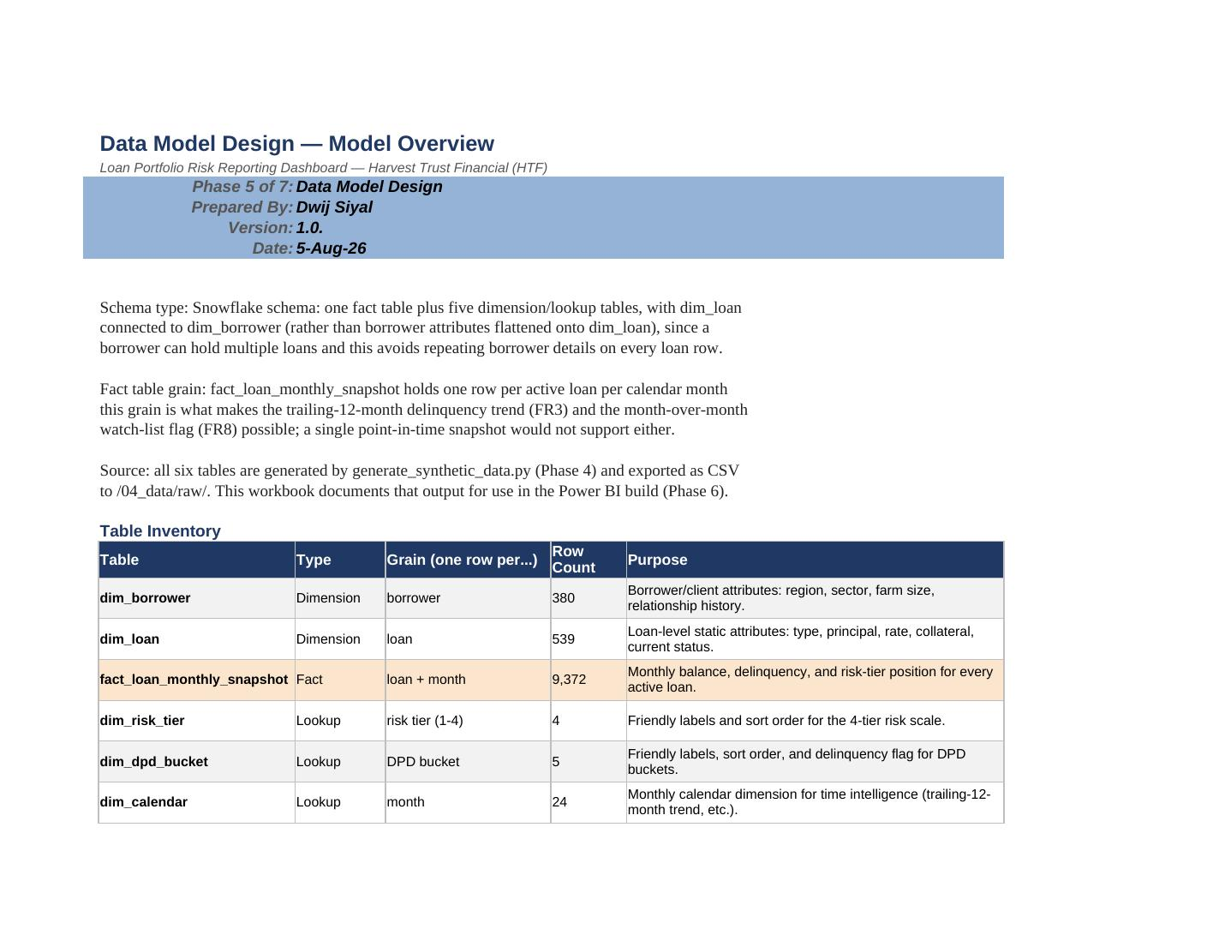

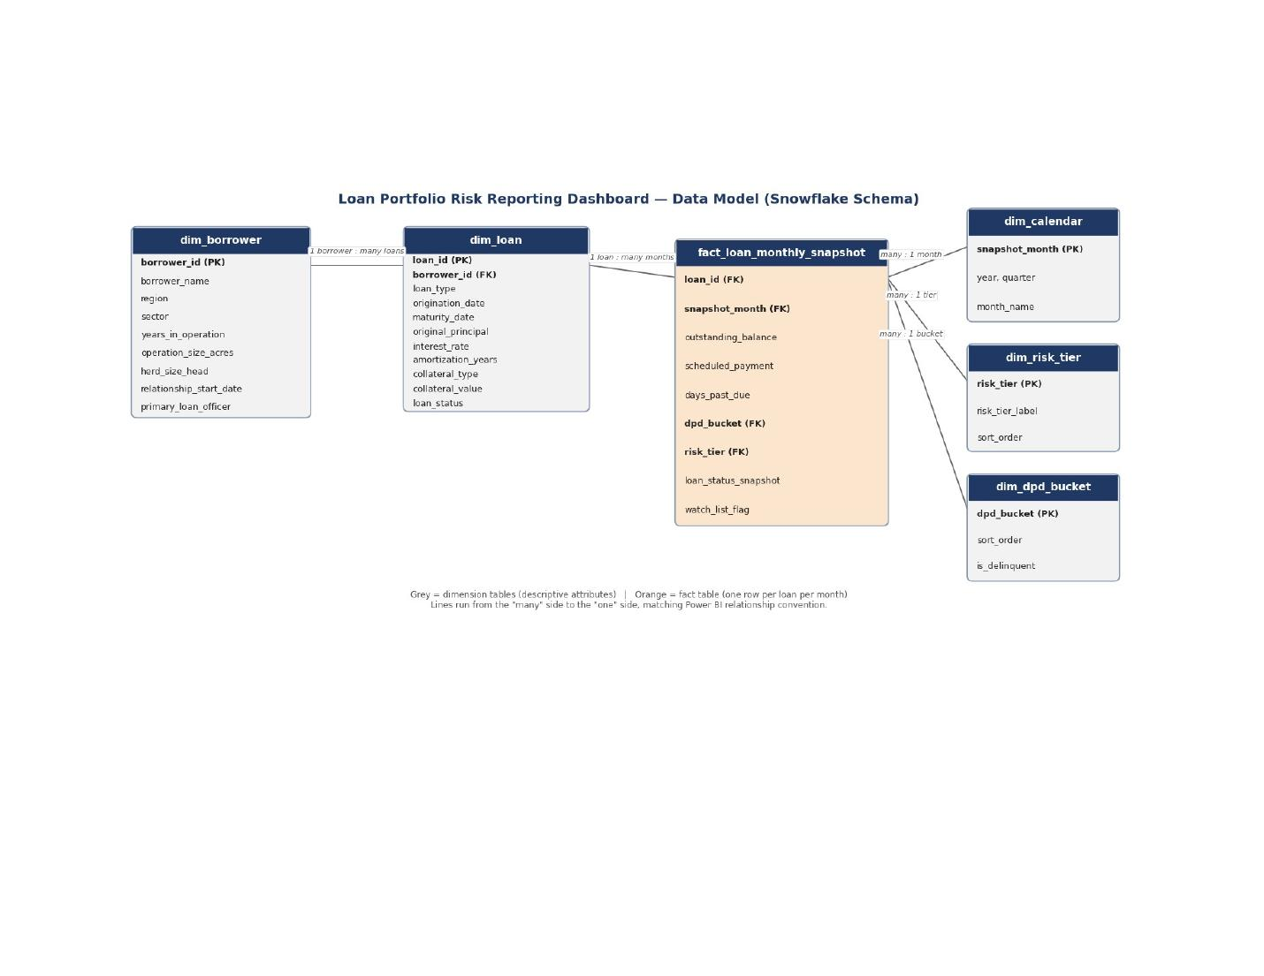

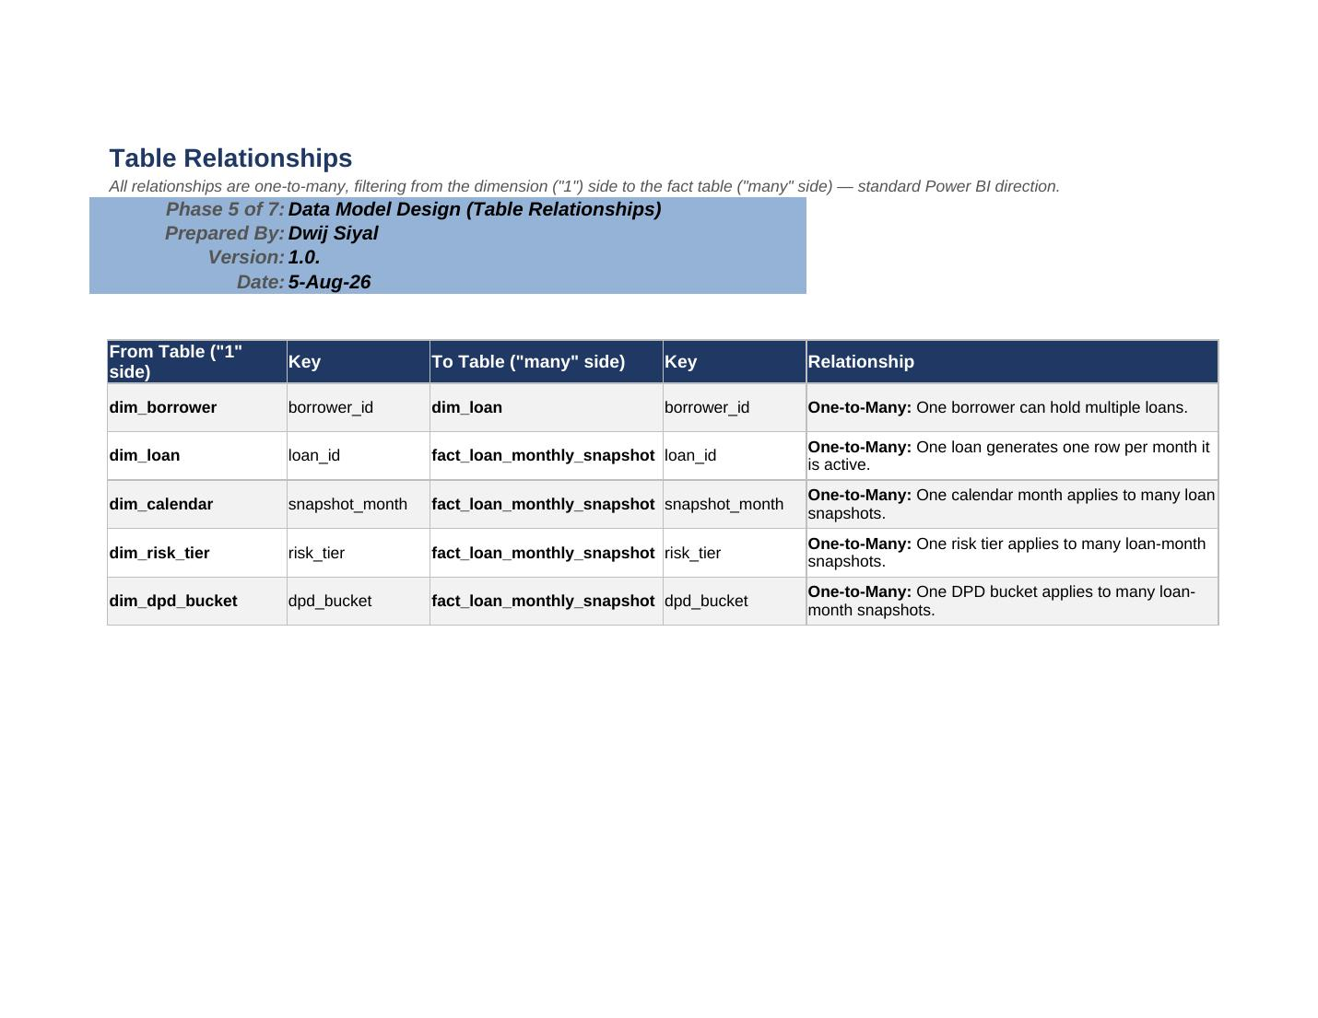

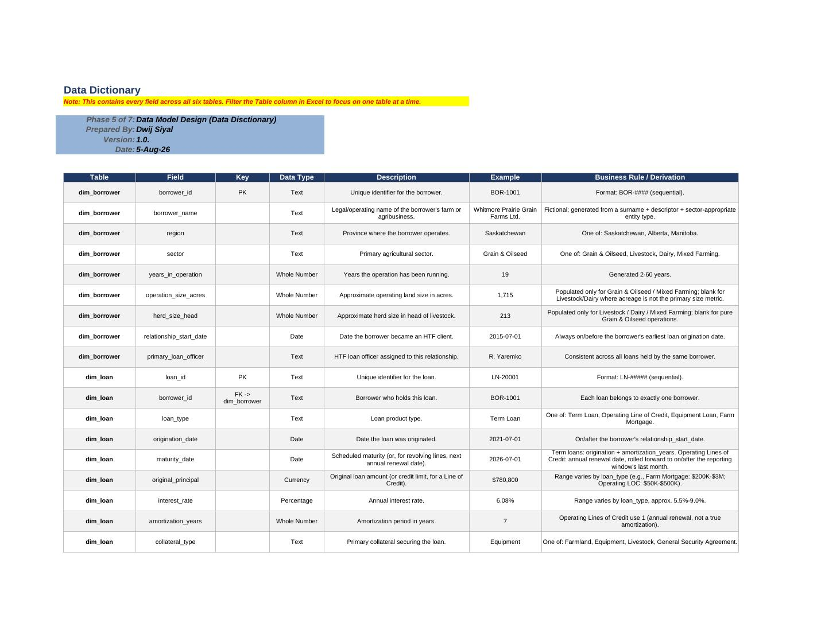

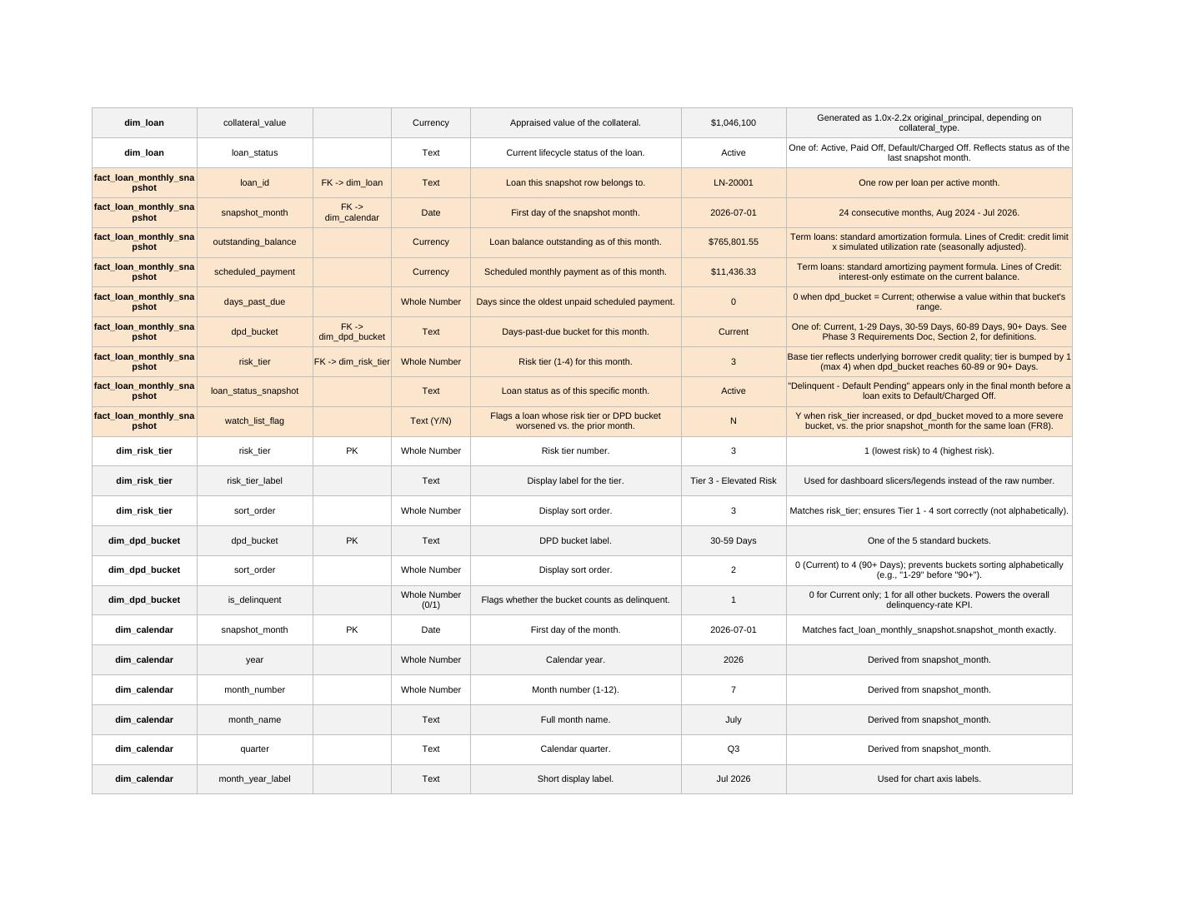

PHASE 6
Dashboard Build Guide
DAX measures, page-by-page visual specifications, filter/slicer design, and colourblind-accessible formatting guidance used to build the Power BI report.

POWER BI DASHBOARD BUILD GUIDE
Loan Portfolio Risk Reporting Dashboard
Phase 6 — Harvest Trust Financial (HTF)

0. Model Setup (Before Building Visuals)
- Sort by Column — set dim_risk_tier[risk_tier_label] to sort by sort_order, dim_dpd_bucket[dpd_bucket] to sort by sort_order, and dim_calendar[month_year_label] to sort by snapshot_month. Without this, buckets and months sort alphabetically instead of chronologically/by severity.
- Hide technical columns — in Model view, right-click sort_order (on both lookup tables) and is_delinquent, and select "Hide in Report View." These exist to drive sorting/logic, not to be picked by end users in a field list.
- Create a Measures table — Home → Enter Data → 0 rows → name it _Measures. All DAX below lives here, not scattered inside fact_loan_monthly_snapshot.
- Set data categories — mark dim_calendar[snapshot_month] as a Date field; mark original_principal, outstanding_balance, scheduled_payment, collateral_value as Currency format (not just Decimal) so cards show "$" automatically.

1. DAX Measures
Grouped by purpose. Two versions of the delinquency-rate logic exist deliberately: a "current" version pinned to the latest snapshot month for KPI cards, and an unpinned version for the trend line chart, where each point should reflect its own month.

1.1 Latest Month Helper
Latest Snapshot Month
Returns whichever month is most recent within the current slicer selection. Used inside every "current state" KPI measure below so cards always show the latest month, even while a trend chart on the same page shows all 24 months.
Latest Snapshot Month =
CALCULATE(
MAX(dim_calendar[snapshot_month]),
ALLSELECTED(dim_calendar)
)

1.2 Core Portfolio KPIs (latest month, or the selected month, for card visuals)
Total Outstanding Balance
Total Outstanding Balance =
CALCULATE(
SUM(fact_loan_monthly_snapshot[outstanding_balance]),
dim_calendar[snapshot_month] = [Latest Snapshot Month]
)
Active Loan Count
Active Loan Count =
CALCULATE(
DISTINCTCOUNT(fact_loan_monthly_snapshot[loan_id]),
dim_calendar[snapshot_month] = [Latest Snapshot Month]
)
Delinquency Rate % (Current)
Weighted by dollar balance, not loan count — a $2M delinquent loan matters more to portfolio risk than a $20K one. This is the version for the summary KPI card.
Delinquency Rate % (Current) =
VAR Latest Snapshot Month = Latest Snapshot Month
VAR TotalBal =
CALCULATE(SUM(fact_loan_monthly_snapshot[outstanding_balance]),
dim_calendar[snapshot_month] = Latest Snapshot Month)
VAR DelinqBal =
CALCULATE(SUM(fact_loan_monthly_snapshot[outstanding_balance]),
dim_calendar[snapshot_month] = Latest Snapshot Month,
dim_dpd_bucket[is_delinquent] = 1)
RETURN DIVIDE(DelinqBal, TotalBal)
NPL Rate % (90+ Days, Current)
Non-performing loan rate — the more severe subset of delinquency. Standard companion metric to the overall delinquency rate in credit risk reporting.
NPL Rate % (Current) =
VAR Latest Snapshot Month = [Latest Snapshot Month]
VAR TotalBal =
CALCULATE(SUM(fact_loan_monthly_snapshot[outstanding_balance]),
dim_calendar[snapshot_month] = Latest Snapshot Month)
VAR NPLBal =
CALCULATE(SUM(fact_loan_monthly_snapshot[outstanding_balance]),
dim_calendar[snapshot_month] = Latest Snapshot Month,
fact_loan_monthly_snapshot[dpd_bucket] = "90+ Days")
RETURN DIVIDE(NPLBal, TotalBal)
Watch List Balance
Watch List Balance =
CALCULATE(
SUM(fact_loan_monthly_snapshot[outstanding_balance]),
dim_calendar[snapshot_month] = [Latest Snapshot Month],
fact_loan_monthly_snapshot[watch_list_flag] = "Y"
)
Watch List Loan Count
Watch List Loan Count =
CALCULATE(
DISTINCTCOUNT(fact_loan_monthly_snapshot[loan_id]),
dim_calendar[snapshot_month] = [Latest Snapshot Month],
fact_loan_monthly_snapshot[watch_list_flag] = "Y"
)

1.3 Trend Measure (unpinned — for the line chart)
Delinquency Rate % (Trend)
No Latest Month override — when placed on a chart with dim_calendar[month_year_label] on the axis, each point naturally computes its own month's rate.
Delinquency Rate % (Trend) =
VAR TotalBal = SUM(fact_loan_monthly_snapshot[outstanding_balance])
VAR DelinqBal =
CALCULATE(SUM(fact_loan_monthly_snapshot[outstanding_balance]),
dim_dpd_bucket[is_delinquent] = 1)
RETURN DIVIDE(DelinqBal, TotalBal)

1.4 Concentration Measures (region/sector, % of total portfolio)
Portfolio Share %
The denominator strips out region and sector filters so each bar shows its share of the WHOLE portfolio, not 100% of itself. This is the concentration-risk metric your Phase 1 brief is built around.
Portfolio Share % =
VAR Latest Snapshot Month = [Latest Snapshot Month]
VAR CategoryBal =
CALCULATE(SUM(fact_loan_monthly_snapshot[outstanding_balance]),
dim_calendar[snapshot_month] = Latest Snapshot Month)
VAR TotalBal =
CALCULATE(
SUM(fact_loan_monthly_snapshot[outstanding_balance]),
dim_calendar[snapshot_month] = Latest Snapshot Month,
ALL(dim_borrower[region]),
ALL(dim_borrower[sector])
)
RETURN DIVIDE(CategoryBal, TotalBal)

1.5 Optional / Bonus Measures (Could Have — skip if short on time)
Weighted Avg Interest Rate
Weighted Avg Interest Rate =
VAR Latest Snapshot Month = [Latest Snapshot Month]
RETURN
DIVIDE(
CALCULATE(
SUMX(fact_loan_monthly_snapshot,
fact_loan_monthly_snapshot[outstanding_balance] * RELATED(dim_loan[interest_rate])),
dim_calendar[snapshot_month] = Latest Snapshot Month),
[Total Outstanding Balance]
)
Delinquency Rate % MoM Change
Uses Target Month as its reference point too, so if you've drilled into a specific past month, the comparison is against the month before THAT one — not always the true latest month.
Delinquency Rate % MoM Change =
VAR Latest Snapshot Month = [Latest Snapshot Month]
VAR PriorMonth = CALCULATE(MAX(dim_calendar[snapshot_month]),
dim_calendar[snapshot_month] < Latest Snapshot Month, ALLSELECTED(dim_calendar))
VAR CurrentRate = [Delinquency Rate % (Current)]
VAR PriorRate =
CALCULATE([Delinquency Rate % (Trend)], dim_calendar[snapshot_month] = PriorMonth)
RETURN CurrentRate - PriorRate

2. Report Pages & Visuals

Page 1 — Portfolio Overview
Purpose: answers "how healthy is the portfolio right now, and is it trending the right way" — the page a CRO opens first. Satisfies FR1, FR3.
- KPI card row (top, 5 cards): Total Outstanding Balance · Active Loan Count · Delinquency Rate % (Current) · NPL Rate % (Current) · Watch List Balance.
- Delinquency Rate Trend — line chart, X-axis = dim_calendar[month_year_label], Y-axis = Delinquency Rate % (Trend). This is the single most important visual on the page — it's what replaces the old static monthly report.
- Risk Tier Distribution — stacked bar or donut, Legend = dim_risk_tier[risk_tier_label] (colorblind-safe palette, see Section 4), Value = Total Outstanding Balance (Current). Shows risk mix by dollars, not loan count.
- Portfolio Concentration by Sector — bar chart, Axis = dim_borrower[sector], Value = Portfolio Share %. This is the concentration-risk visual your Phase 1 brief exists to deliver.

Page 2 — Regional & Sector Analysis
Purpose: lets Regional Credit Managers and the CRO see where risk is concentrated geographically and by sector, together. Satisfies FR2, FR4.
- Region × Sector matrix — Rows = dim_borrower[region], Columns = dim_borrower[sector], Values = Total Outstanding Balance and Delinquency Rate % (Current). Apply conditional formatting (background color scale) to the delinquency column — this is your concentration + risk heat map in one visual.
- Delinquency Trend by Region — line chart, X-axis = month_year_label, Y-axis = Delinquency Rate % (Trend), Legend = region. Shows whether one region is driving portfolio-wide trends.
- Portfolio Concentration by Region — bar chart, Axis = region, Value = Portfolio Share %.
Note: Power BI's built-in Map/Filled Map visuals need Bing/Azure Maps geocoding and can be unreliable for province-level fictional data offline. A bar chart by region is the more reliable choice here and is what the requirements actually call for (FR4 asks for % concentration, not a literal map).

Page 3 — Watch List & Loan Detail
Purpose: the operational page — the specific loans that need follow-up this month. Satisfies FR7, FR8.
- Watch List table — Table visual filtered to watch_list_flag = "Y" and the latest snapshot_month. Columns: loan_id, borrower_name, region, sector, risk_tier_label, dpd_bucket, outstanding_balance, primary_loan_officer. Sort descending by outstanding_balance so the largest at-risk exposures surface first.
- Conditional formatting — background color scale on dpd_bucket (or an icon set) using the same palette as Page 1's risk tier chart, for visual consistency.
- Drillthrough page — add a hidden page named "Loan Detail." Drag loan_id into the Drillthrough filter well. Add card visuals for the loan's static attributes (loan_type, origination_date, original_principal, collateral_type/value from dim_loan) plus a small line chart of that single loan's outstanding_balance and days_past_due over the 24-month window. Right-clicking any loan row on Page 3 (or any table with loan_id) now offers "Drill through → Loan Detail."

Page 4 — Definitions & Data Sources
Purpose: satisfies FR11 (a visible data dictionary within the dashboard file itself, not just in a separate Word doc). Add text boxes reproducing the glossary from the Phase 3 Requirements Document:
- Delinquency, Days Past Due (DPD) Bucket, Risk Tier, Concentration Risk, Watch List — same definitions as Phase 3, Section 2.
- A short note: "Data refreshed monthly. Current data through: " + a card showing [Latest Snapshot Month].
- A note that this is a fictional dataset for portfolio demonstration purposes (keeps the file honest if shared publicly, e.g., on GitHub).

3. Filters & Slicers
Slicer | Field | Sync Across Pages?
Region | dim_borrower[region] | Yes — Pages 1, 2, 3
Sector | dim_borrower[sector] | Yes — Pages 1, 2, 3
Risk Tier | dim_risk_tier[risk_tier_label] | Yes — Pages 1, 2, 3
Snapshot Month | dim_calendar[month_year_label] | Pages 1 & 2 only — Page 3's Watch List is deliberately always "current," not historically filterable, matching how a watch list is used operationally.
Set up sync via View → Sync Slicers. For the Region/Sector/Risk Tier slicers, tick both "Sync" and "Visible" on Pages 1-3; for Snapshot Month, tick "Sync" on Pages 1-2 only, leave Page 3 unticked.

4. Formatting & Color
- Risk tier palette (colorblind-safe, NFR2) — avoid a plain red/green scale, which is indistinguishable to the most common forms of color blindness. Use this 4-color ramp (ColorBrewer-style, ranges from blue through orange to red so severity reads through lightness and hue together, not red/green alone):
Risk Tier | Hex Code | Swatch Meaning
Tier 1 - Low Risk | #2C7BB6 (blue) | Healthy
Tier 2 - Moderate Risk | #ABD9E9 (light blue) | Acceptable
Tier 3 - Elevated Risk | #FDAE61 (orange) | Needs attention
Tier 4 - High Risk / Watch List | #D7191C (red) | Priority follow-up

- Apply consistently — use these exact 4 colors for the Page 1 risk-tier chart legend, and for DPD-bucket conditional formatting on Page 3 (map Current/1-29 to the blue end, 90+ to red).
- KPI cards — use conditional formatting or a callout color on Delinquency Rate % and Watch List Balance cards only if they exceed a threshold you decide (e.g., red text if Delinquency Rate % (Current) > 10%) — optional, but a nice touch that shows the dashboard actively flags problems rather than just displaying numbers.
- Titles & consistency — every visual gets a plain-language title ("Delinquency Rate — Trailing 24 Months", not the raw measure name); keep fonts consistent (Segoe UI, Power BI's default, is fine).

5. Final QA Checklist
- Total Outstanding Balance on Page 1 matches the sum you validated in Phase 4 (~$219M as of the last snapshot month) — if not, check the Latest Snapshot Month / Target Month measures and relationship directions in Model view.
- Clear all slicers and confirm every visual still renders (no blank charts, no #ERROR).
- Select a single past month in the Snapshot Month slicer (e.g., an early month like Aug 2024) and confirm the KPI cards show that month's figures instead of going blank — this is the Target Month fix in action.
- Apply Region = Saskatchewan and confirm every visual updates together (tests slicer sync).
- Right-click a loan on the Page 3 Watch List table and confirm Drillthrough → Loan Detail works and shows that loan's history.
- Check risk tier and DPD bucket sort order render Tier 1→4 and Current→90+, not alphabetically.
- Save as Loan_Portfolio_Risk_Dashboard.pbix.

PHASE 6 (CONT.)
Dashboard Screenshots
The finished Power BI report: four report pages plus a drill through detail view, built from the model and measures documented above.

Portfolio Overview
Executive summary: portfolio KPIs, 24-month delinquency trend, risk tier mix, and sector concentration.

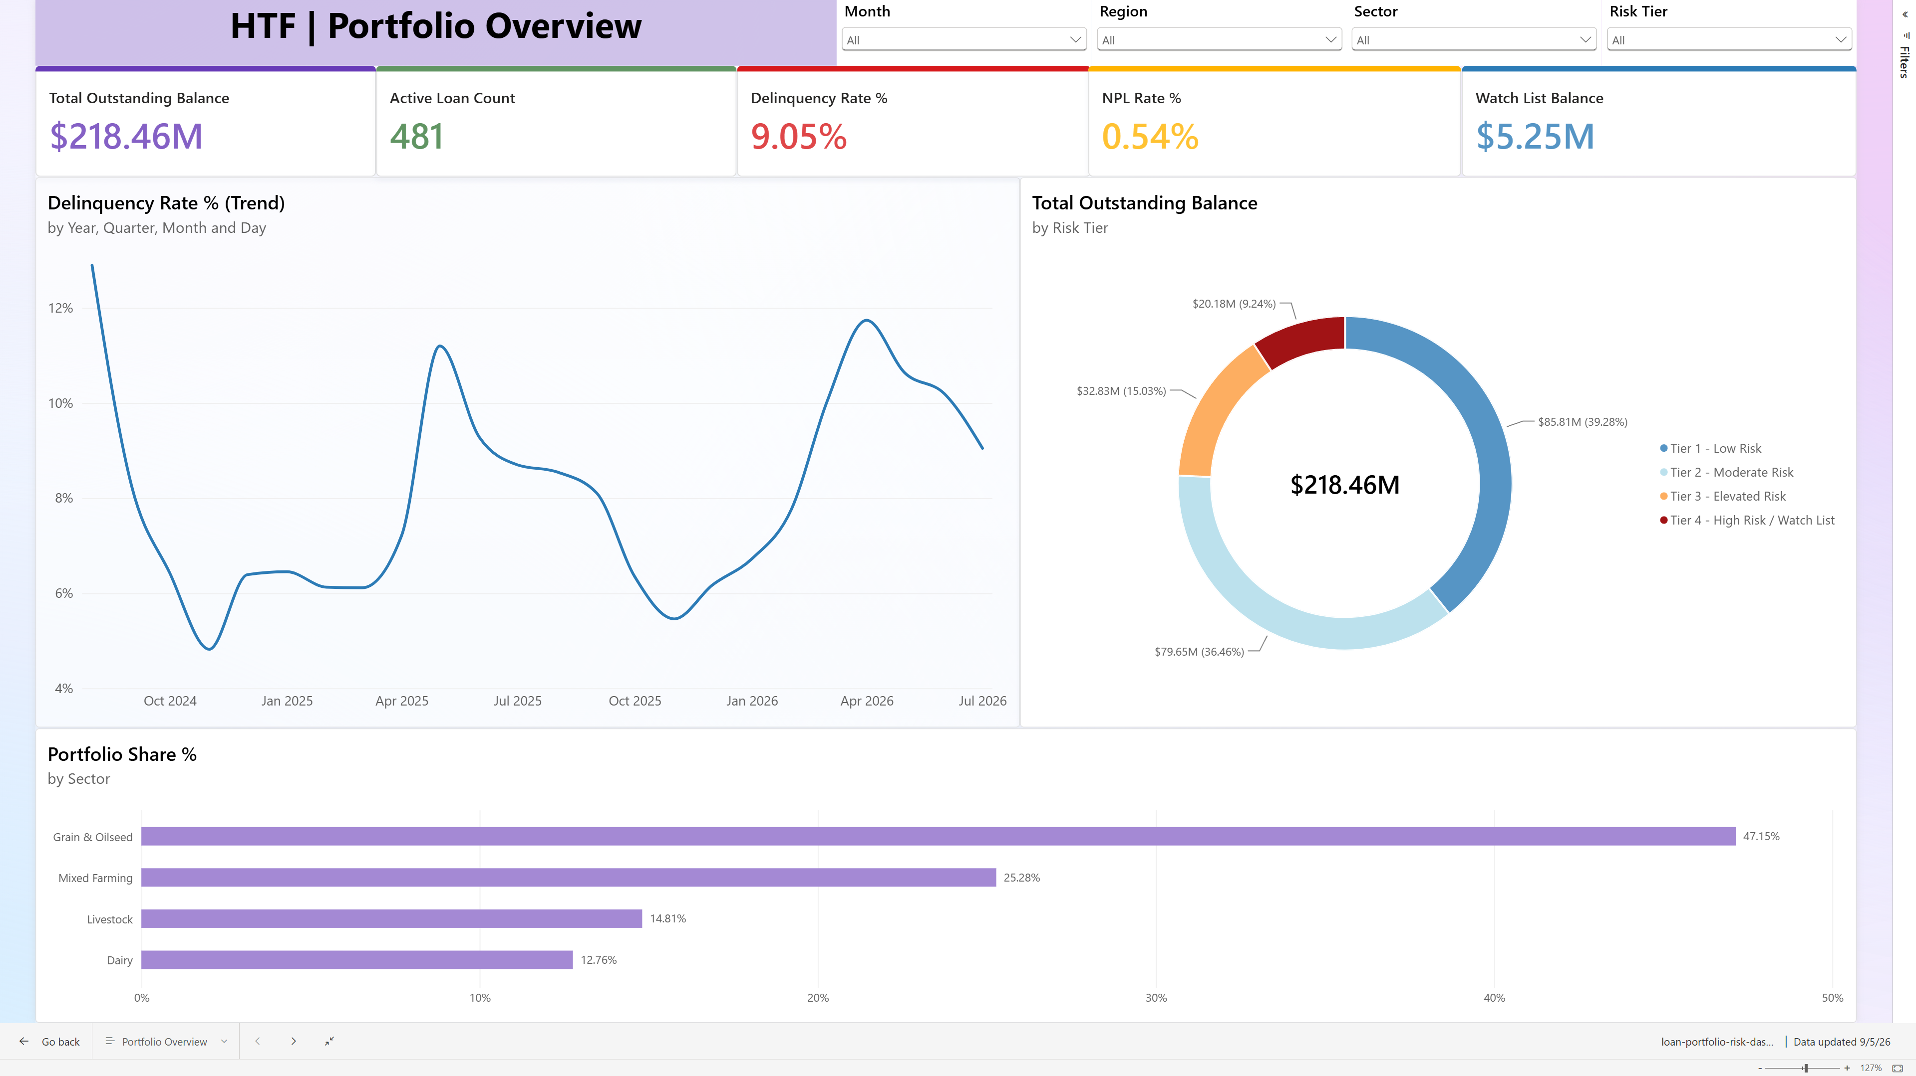

Regional & Sector Analysis
Region x sector risk heat map -- surfaces that Saskatchewan/Livestock carries a 17.82% delinquency rate, well above every other segment.

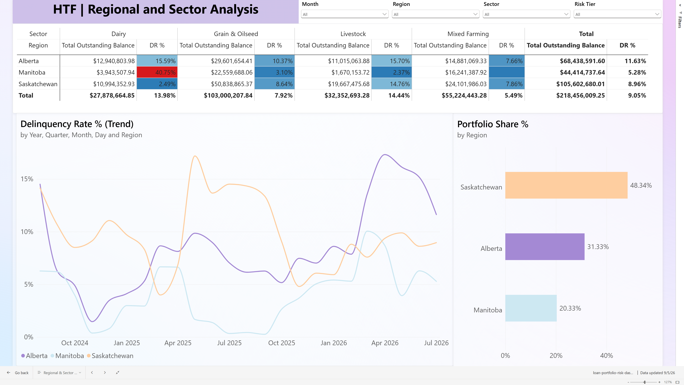

Watchlist & Loan Detail
Loans that moved into a worse risk tier or DPD bucket since the prior month, surfaced for follow-up.

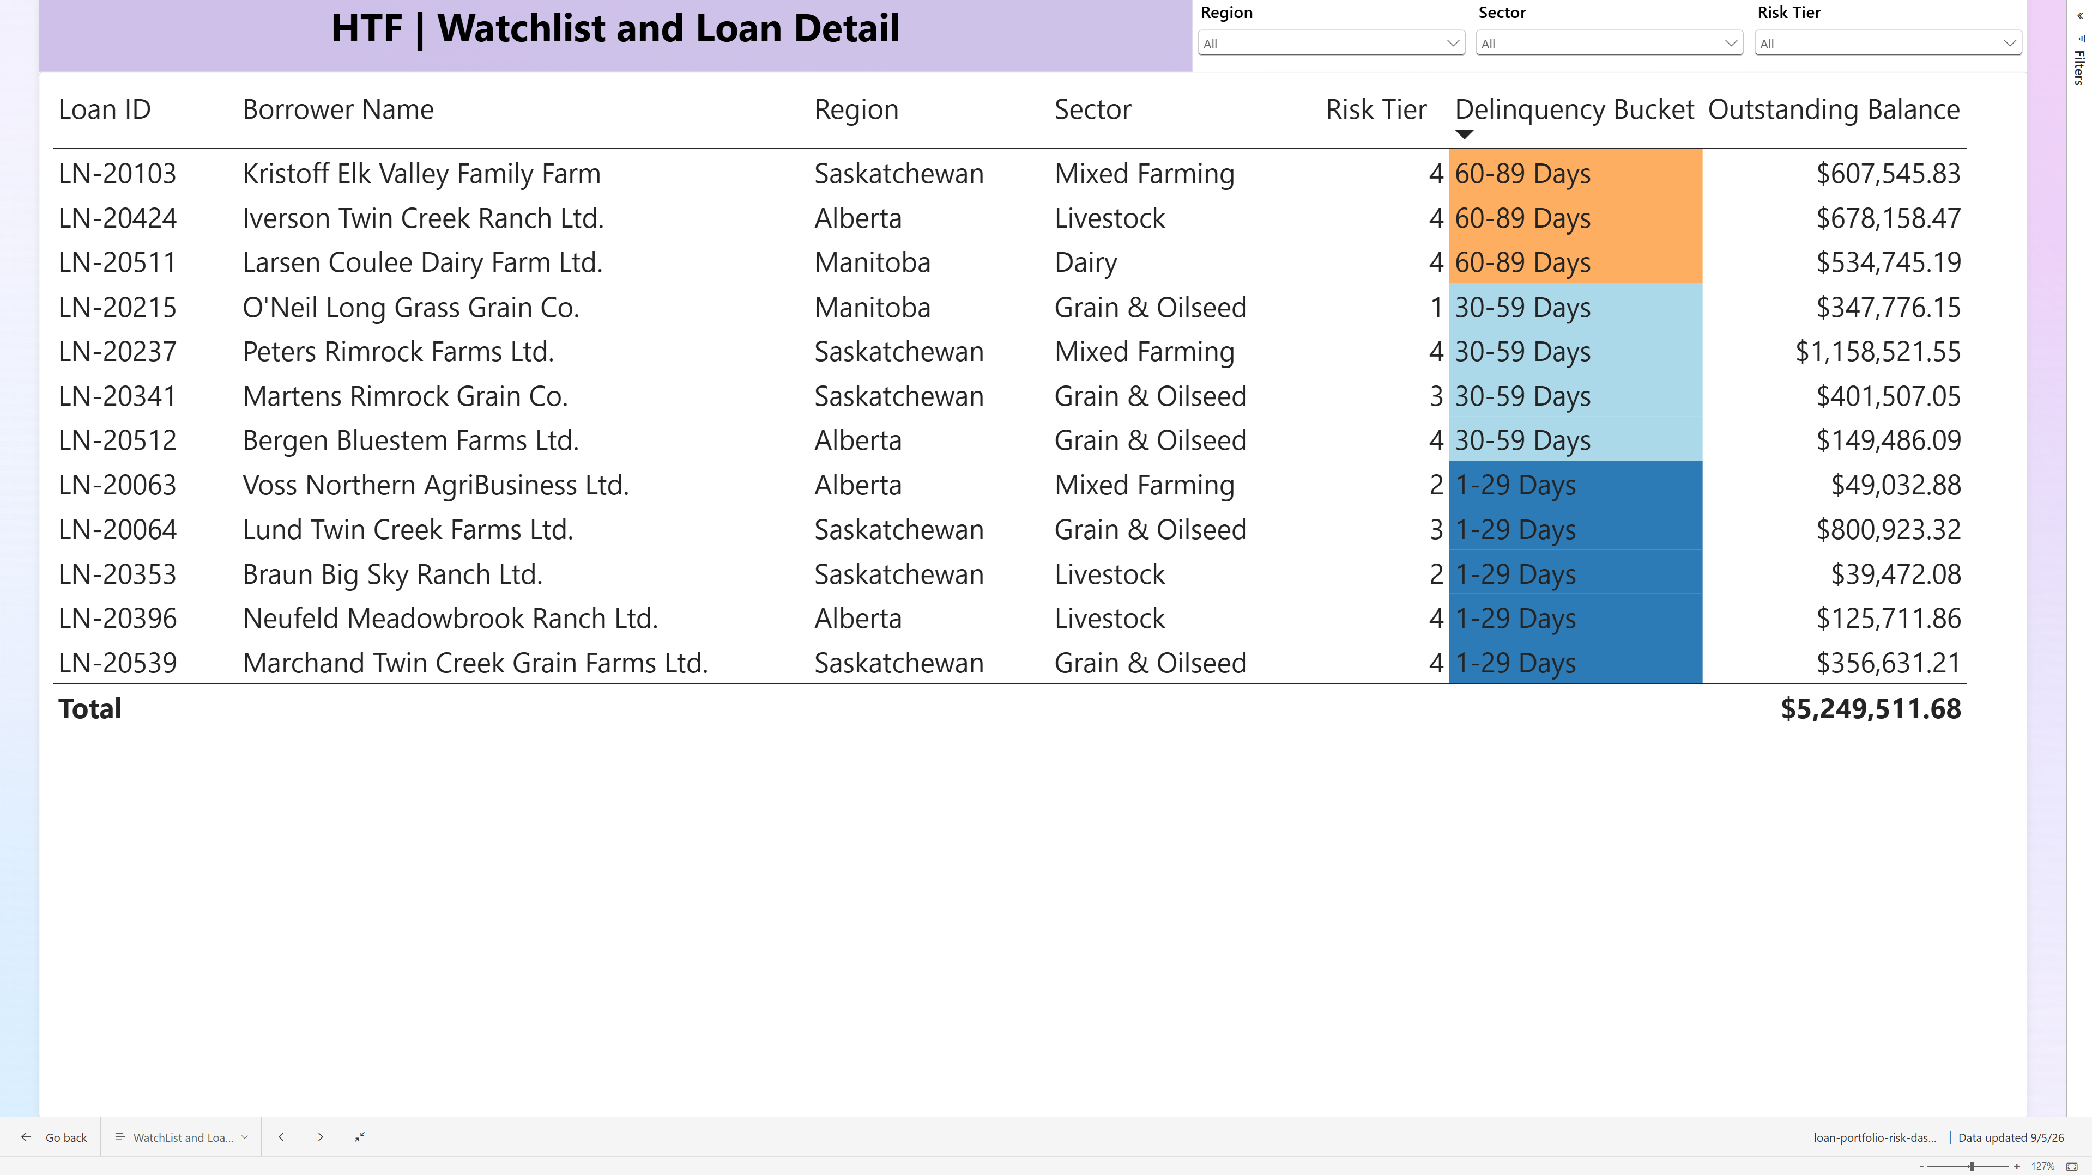

Data & Definitions
Glossary embedded directly in the dashboard file, satisfying the requirement for a visible, single source of truth on key terms.

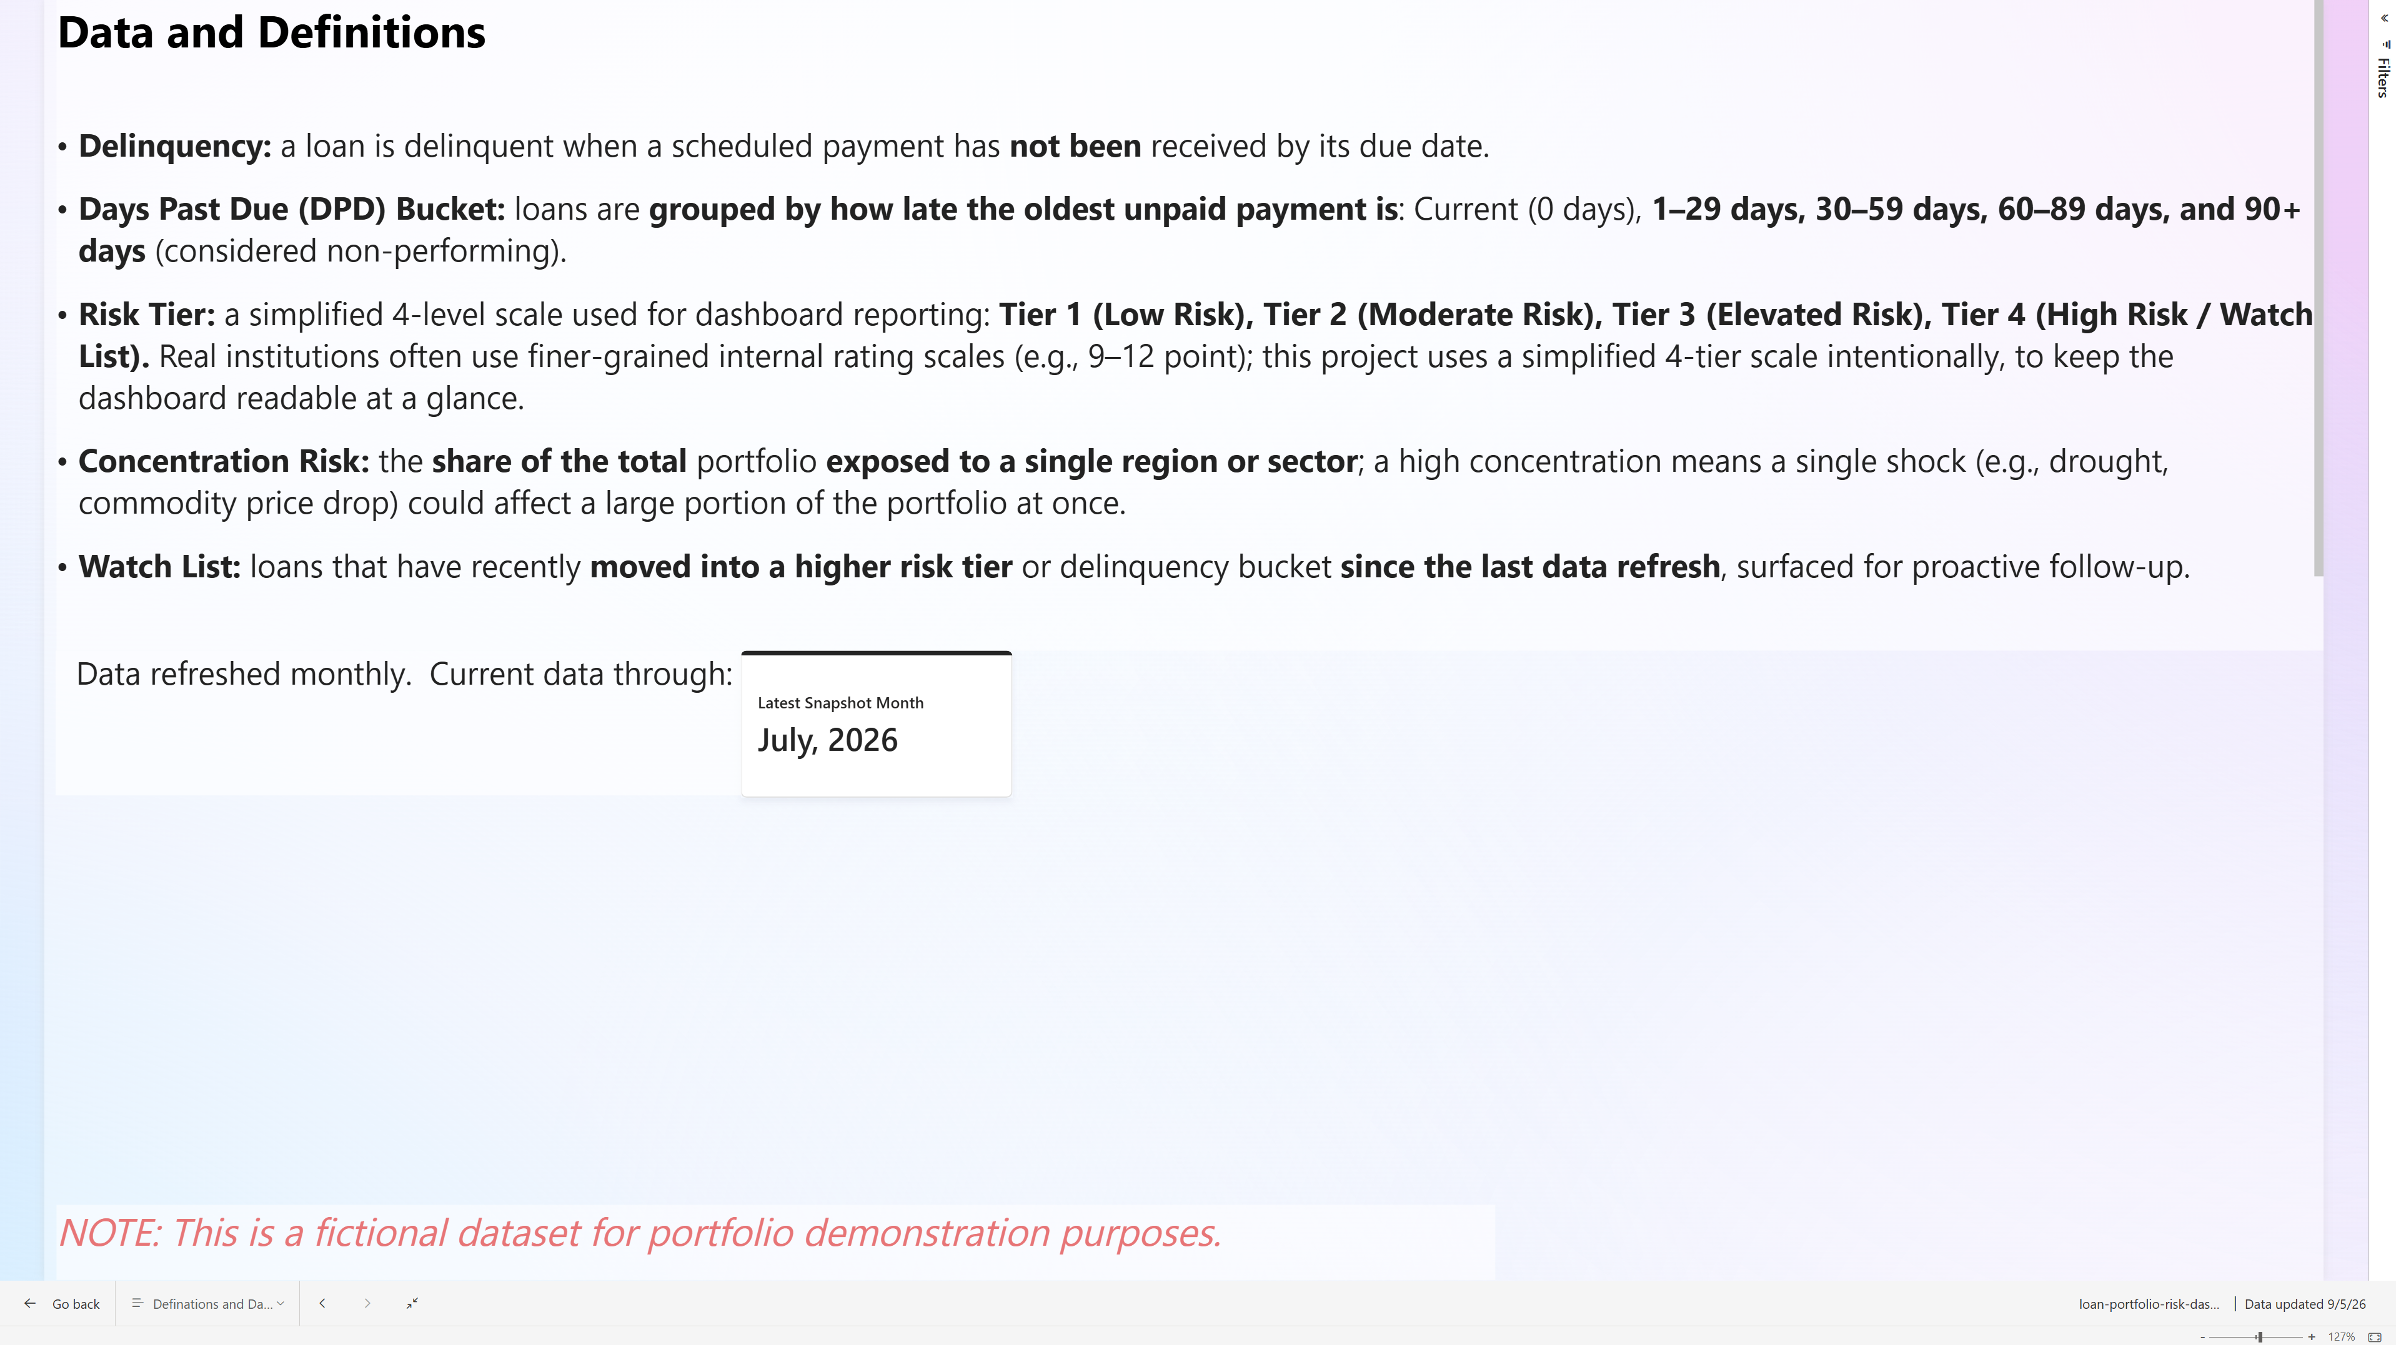

Loan Detail (Drill through)
Right-click any loan on the Watchlist to drill through to its full attributes and 24-month balance history.

