Project name

PIC : Ike

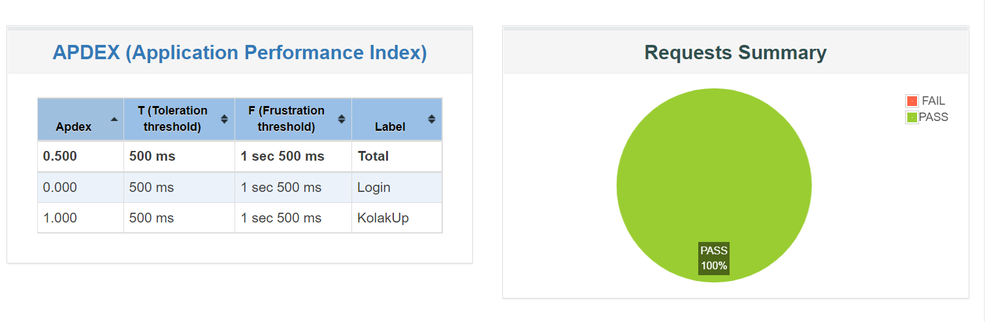

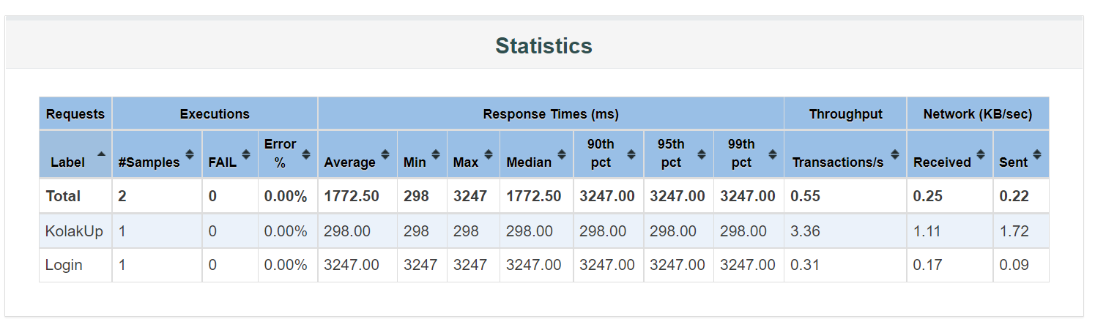

Average response time is around **1772.50**ms for Kolak Project

Meanwhile, average vs 99% percentile for each end point is listed below

KolakUp is 298.00ms vs 298.00ms

Login is 3247.00ms vs 3247.00ms

Error rate is 0.00%

CPU usage

CPU usage vs RPS/throughput.

When we got 3.36 s trx/s we got 30% CPU utilization

When we got 0.31 s trx/s we got 10% CPU utilization

This is means that our application can handle 1980 users per hour maximum.