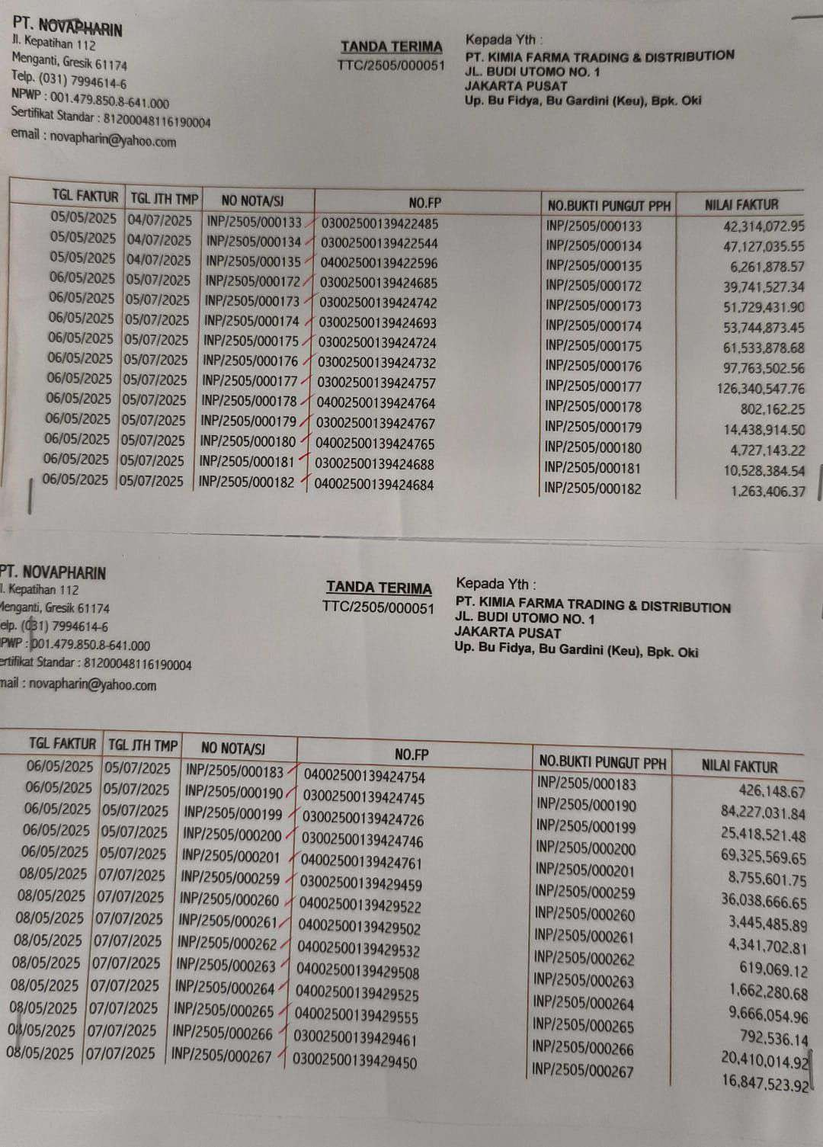

ARIN
t?
Bl 61174
79946146
A479.850.8641.000
Sander : 81,200048116190004
novapharin@yahoo.com

TANDATERIMA
1TC/2505/000051
Kepada Yth
PT KIMiA FARMA TRADING 6 DISTRIBUTION
JL. BUDI UTOM0 NO.1
JAKARTA PUSAT
Up. Bu Ftya, Bu Grini (Ku), Bpk. Oi

TGL FAKTUR TGL ITH IMP |  | NO NOT/SI | NO.FP | NO.BUKTI PUNGUT PH | UN FAKTUR
08/05/2025 /07/07/2025 |  | NP/2505/000268 | 03002500139429447 | 1NP/2505/000268 | 43.806.882.67
08/05/2025 | 07/07/2025 | INP/?2505/000269 NP/2505/0002 70 INP/2505/000271 INP/2505/000272  NP/2505/000400 | 04002500139429586  03002500139429443  03002500139429442  04002500139429471  03002500139434136 | NP/2505/000269 IN/2505/000270 NP/2505/00027 INP/2505/000272  INP/2505/000400 | 350.946.15  11,796.798.30  84.440.404.05  2.442.583.92  14.809.919.69
08/05/2025 | 07/07/2025
08/05/2025 | 07/07/2025
08/05/2025 | 07/07/2025
09/05/2025 | 08/07/2025

I

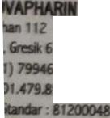
6190004

12
,61174
146
50.8-641.000
11

wapharin(@yahoo.com
TANDA TERIMA
1TC/2505/000051
Kepada Yth:
PT. KIMIA FARMA TRADING & DISTRIBUTION
I
JL. BUDI UTOMO NO. 1 JAKARTA PUSAT
Up. Bu Fidya, Bu Gardini (Keu), Bpi. Old

: SEMBlUN RATUS SAEMNBIL PULUH TUUH JUTA SEMBILAN RATUS EMPAT PULLH
RIBU LIMA RATUS DUA POINT SEMBILN RUPIAH
d9enuan balk -ddoolkouumreen diatas.
997.940,502.90


\

