Array Size (In Thousands) | Bubble Sort Time | Insertion Sort Time | Selection Sort Time
10 | 0.00163263 | 0.225613 | 0.3
25 | 0.00438494 | 0.801347 | 1.36127
50 | 0.0185548 | 2.96708 | 7.29014
75 | 0.0261812 | 10.735 | 13.0974
100 | 0.0370356 | 18.7339 | 20.5055
250 | 0.102815 | 90.5998 | 119.09
500 | 0.215998
1000 | 0.45632
5000 | 1.50057
25000 | 7.30129
100000 | 31.3259
250000 | 122.534
Bubble - 0.0000001371078x^(2) + 0.0003898563157x - 0.0032303118798 * 1
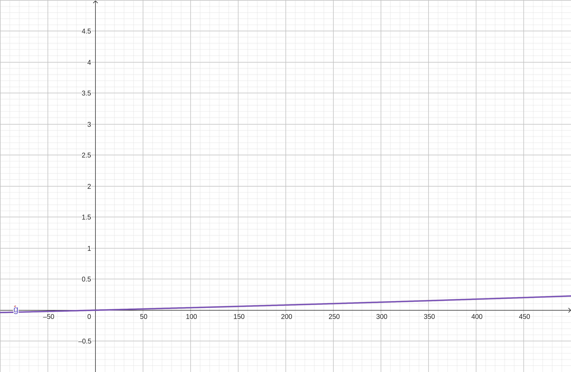
Insertion - 0.0011780931078x^(2) + 0.0750089957539x - 1.6716203591247 * 1
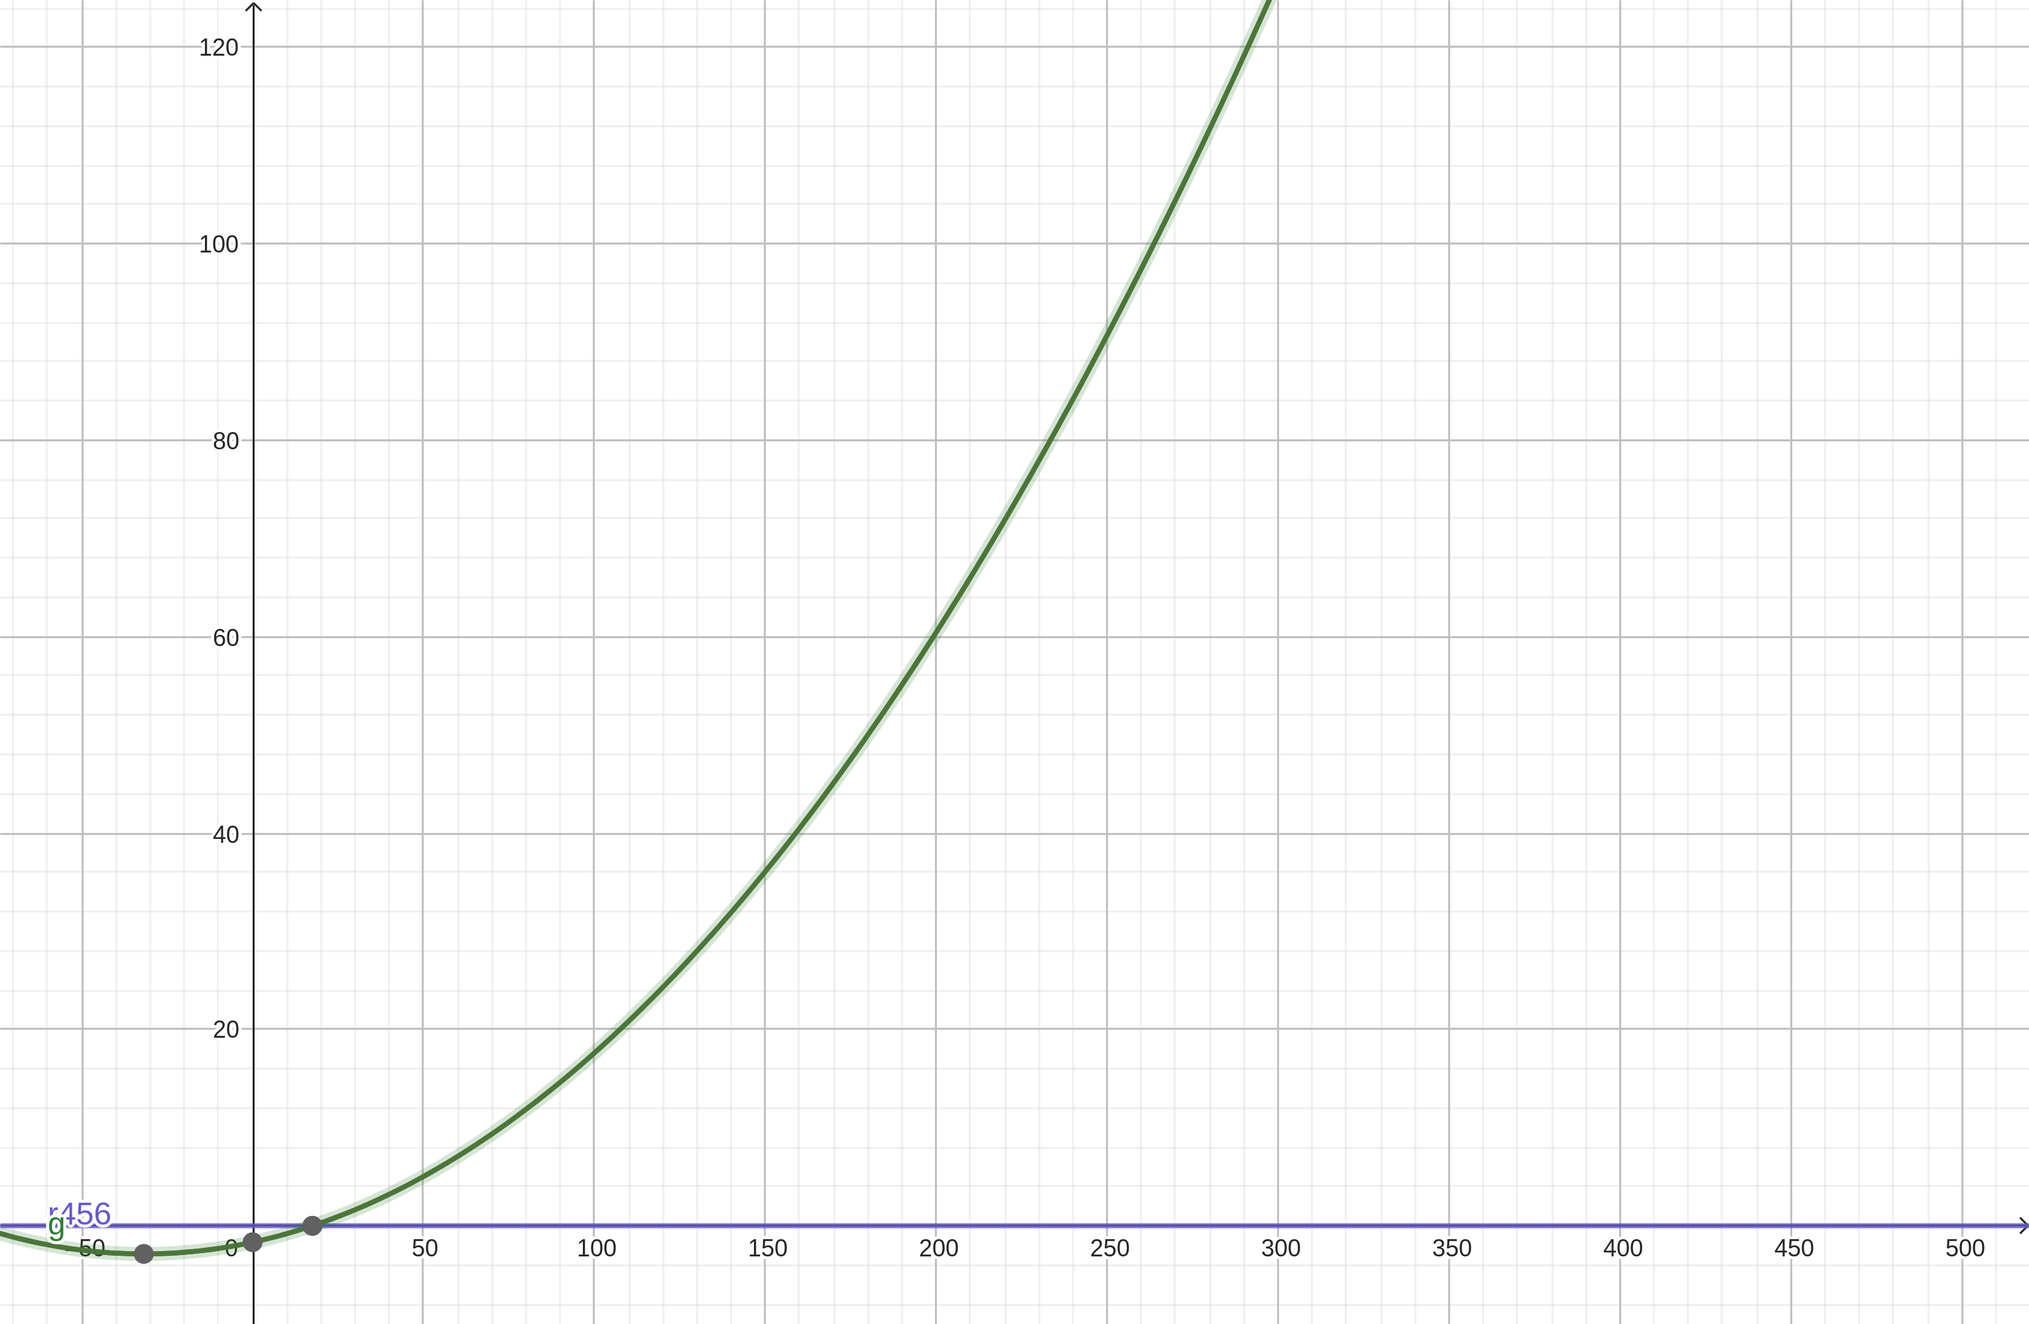
Selection - 0.0017455267799x^(2) + 0.0403689906496x - 0.1570797964468 * 1

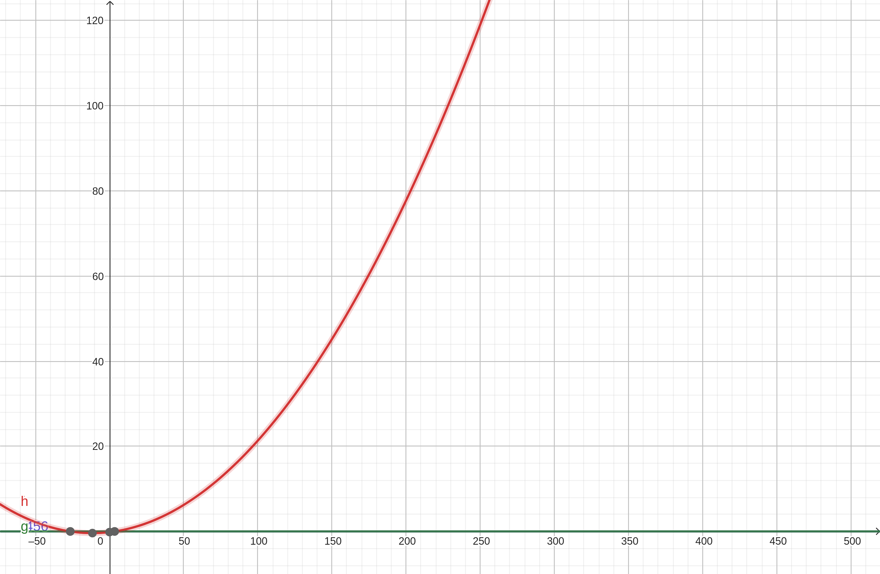
h

Array Size In Millions | Merge Sort | Quick Sort
0.1 | 0.0602754 | 0.0404116
0.2 | 0.143918 | 0.0961964
0.5 | 0.30865 | 0.275071
1 | 0.651294 | 0.588648
2 | 1.20174 | 0.816361
3 |  | 1.00438
At 3mil, merge sort gives a segmentation fault error

Merge - p(x)=0.4086303301906 x log(2,x)+0.4156876021922*1
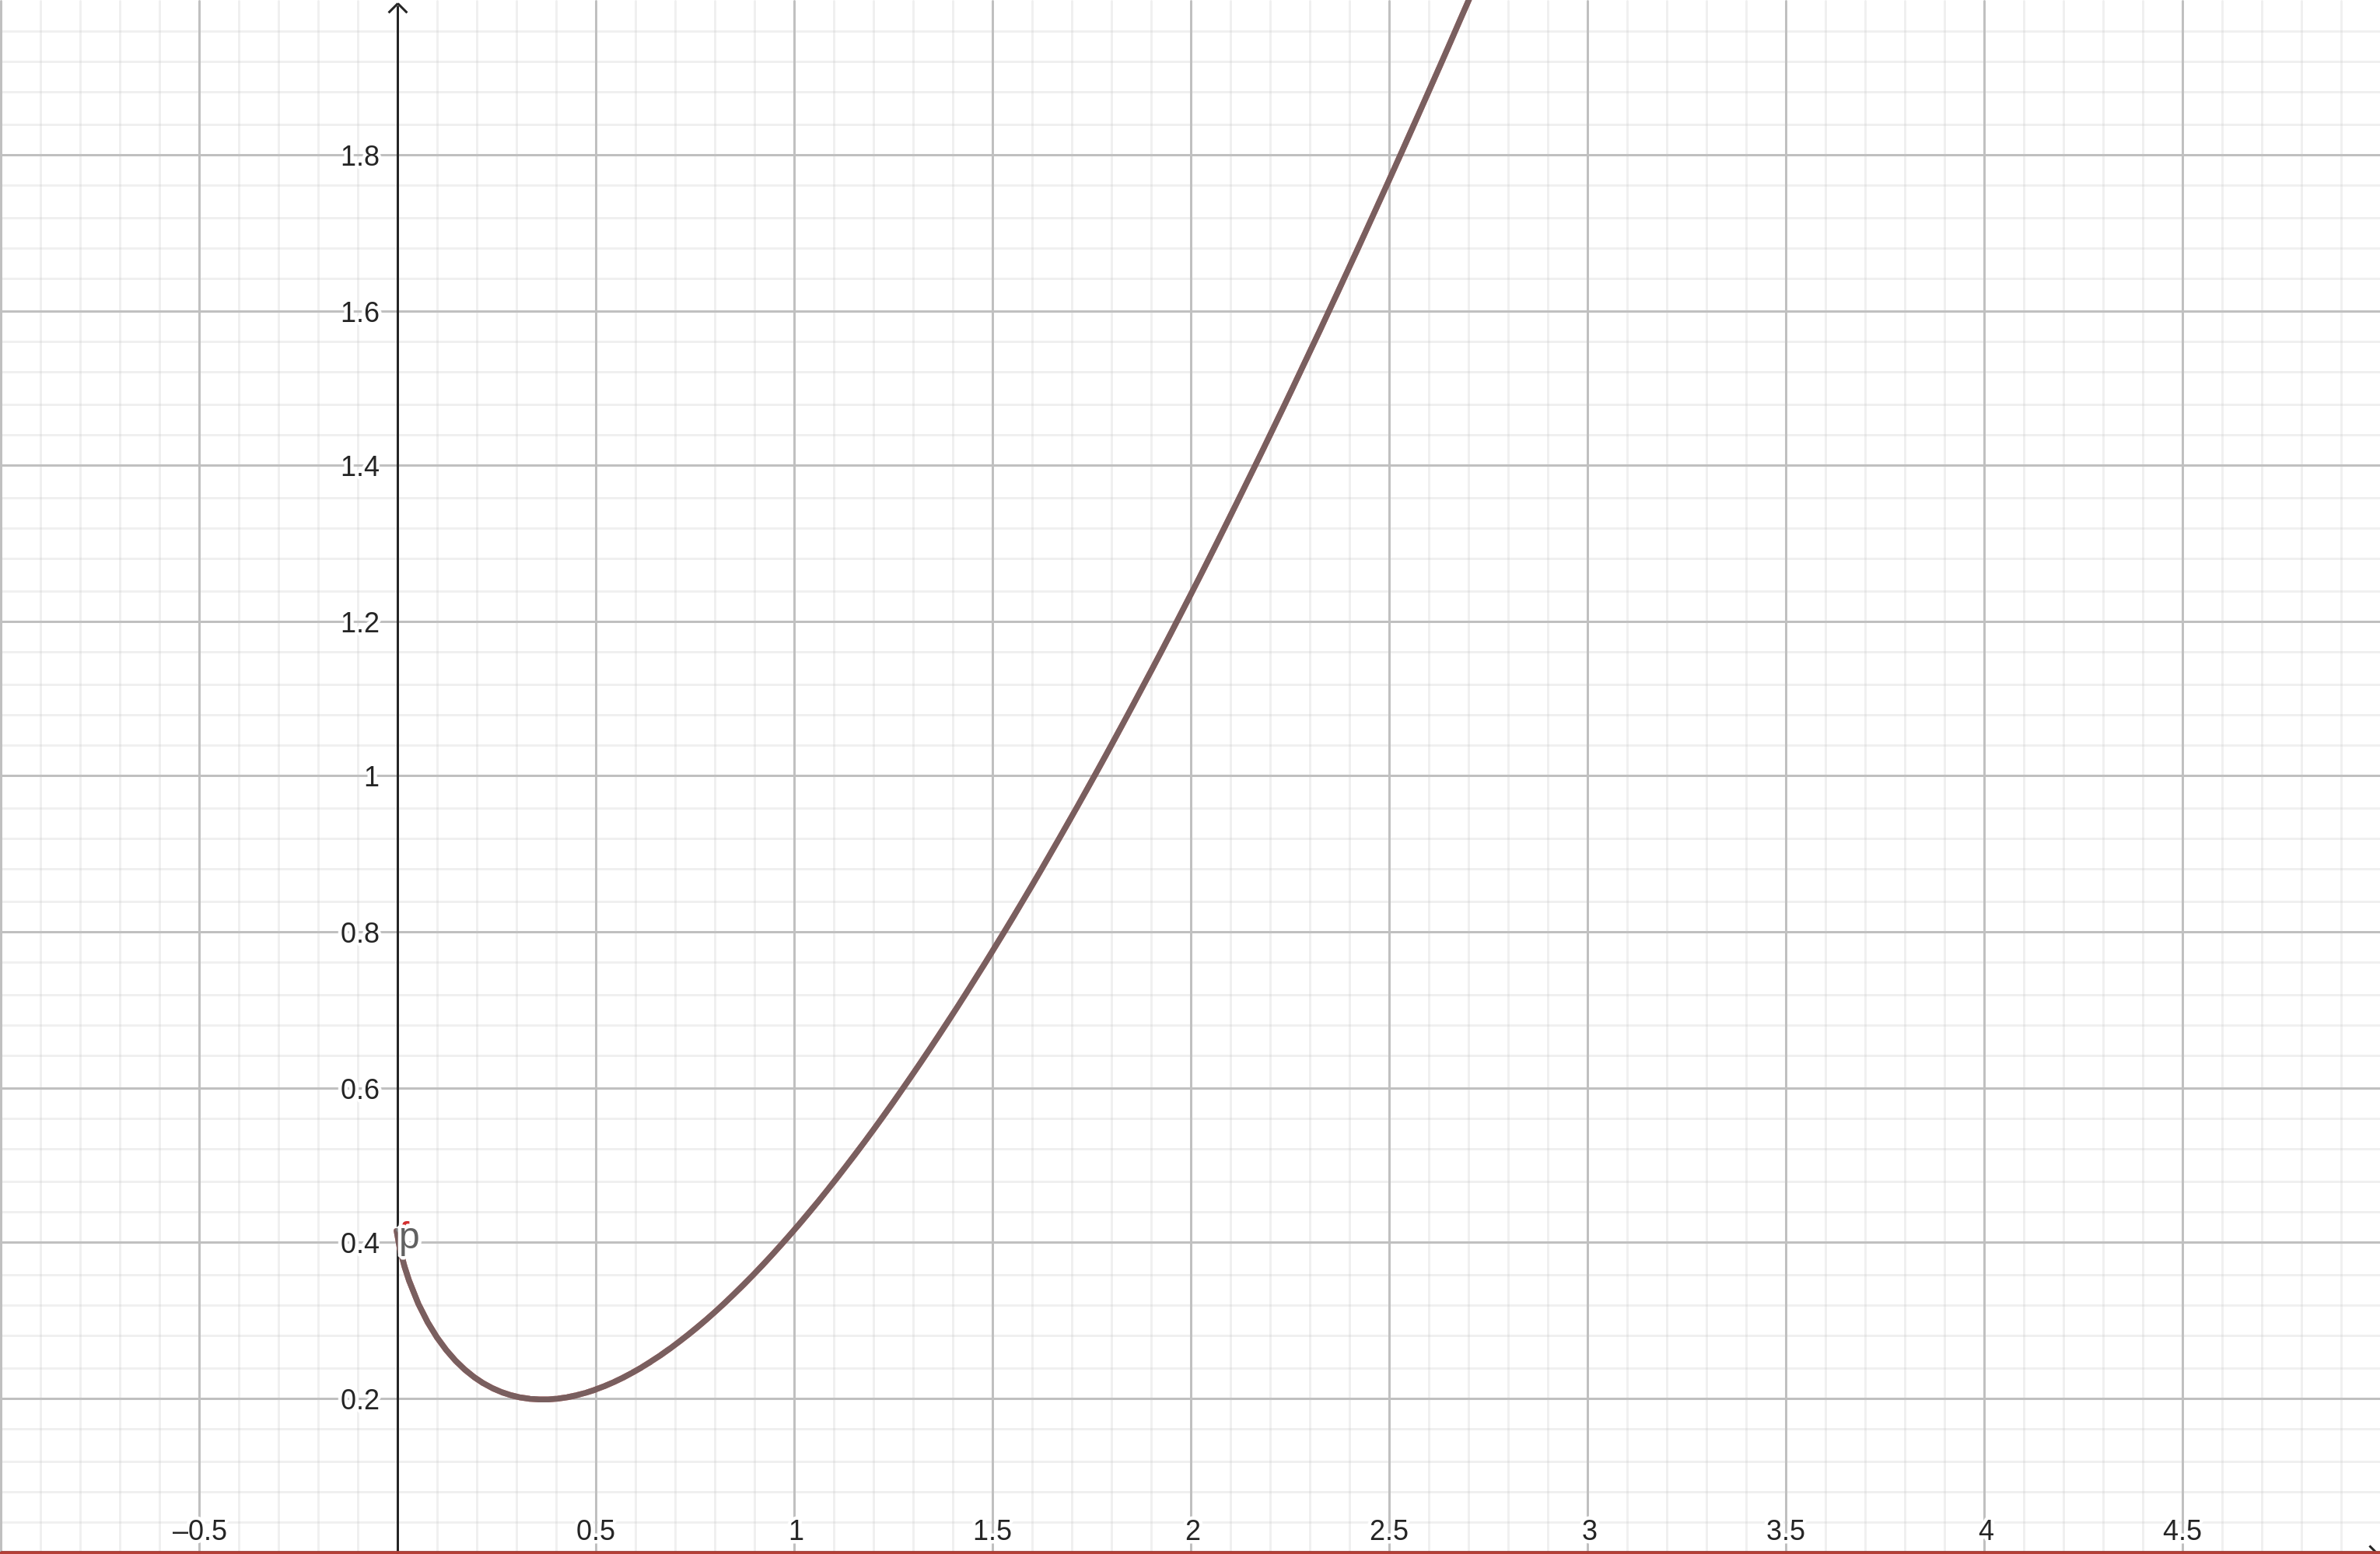
Quick - 0.1641097700031x log(2, x) + 0.320884358885 * 1
