Haze Particles and Mie Scattering – the g Parameter
[INSERT CORRECTED FIGURE 10 HERE]
Corrected Figure 10. Henyey-Greenstein phase function polar plot.
The Henyey-Greenstein eccentricity parameter 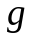 must be in the range 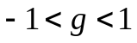. For most haze distributions forward scattering is dominant (positive ). As 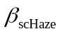 increases, also increases and becomes more monochromatic. A group of typical values derived from empirical measurements [Husar1984] can be seen in Table 1.

Description | 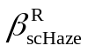 | 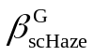 | 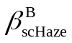
Light haze | 2x10⁻⁵ | 3x10⁻⁵ | 4x10⁻⁵ | 0.07
Heavy haze | 8x10⁻⁵ | 10⁻⁴ | 1.2x10⁻⁴ | 0.2
Light fog | 9x10⁻⁴ | 10⁻³ | 1.1x10⁻³ | 0.4
Heavy fog | 10⁻² | 10⁻² | 10⁻² | 0.5
Corrected Table 1. Typical haze parameter values.

For More Information
[Husar1984] R. B. Husar and J. M. Holloway. The Properties and Climate of Atmospheric Haze. Chapter in Hygroscopic Aerosols, Deepak Publishing, 1984.

