David Willis

Lingma Acheson

CIT 304

3.23.18

Course Project 5

Query 1 – Create a table that will store a customized report showing how many tables, views, indexes, and users are in the database at a particular time (also retrieving a count of the objects and insert the count into a new table that will be created before this runs and the current time the rows are created)

set serveroutput on;

ALTER SESSION SET NLS_DATE_FORMAT = 'DD-MON-YYYY HH24:MI:SS';

CREATE TABLE TABLE_SUMMARY(

TABLE_SUM NUMBER,

VIEW_SUM NUMBER,

INDEX_SUM NUMBER,

USER_SUM NUMBER,

DATE_ROW_CREATED DATE

);

DECLARE

TABLE_SUM NUMBER;

NUM_TABLES NUMBER;

VIEW_SUM NUMBER;

NUM_VIEWS NUMBER;

INDEX_SUM NUMBER;

NUM_INDEXES NUMBER;

USER_SUM NUMBER;

NUM_USERS NUMBER;

BEGIN

SELECT COUNT(*) INTO TABLE_SUM

FROM USER_OBJECTS

WHERE OBJECT_TYPE = 'TABLE';

NUM_TABLES := TABLE_SUM;

DBMS_Output.Put_Line('There are a total of ' || NUM_TABLES

|| ' tables in the database.');

SELECT COUNT(*) INTO VIEW_SUM

FROM USER_OBJECTS

WHERE OBJECT_TYPE = 'VIEW';

NUM_VIEWS := VIEW_SUM;

DBMS_Output.Put_Line('There are a total of ' || NUM_VIEWS

|| ' views in the database.');

SELECT COUNT(*) INTO INDEX_SUM

FROM USER_OBJECTS

WHERE OBJECT_TYPE = 'INDEX';

NUM_INDEXES := INDEX_SUM;

DBMS_Output.Put_Line('There are a total of ' || NUM_INDEXES

|| ' indexes in the database.');

SELECT COUNT(*) INTO USER_SUM

FROM ALL_USERS;

NUM_USERS := USER_SUM;

DBMS_Output.Put_Line('There are a total of ' || NUM_USERS

|| ' users in the database.');

INSERT INTO TABLE_SUMMARY VALUES(NUM_TABLES, NUM_VIEWS, NUM_INDEXES, NUM_USERS, CURRENT_TIMESTAMP);

END;

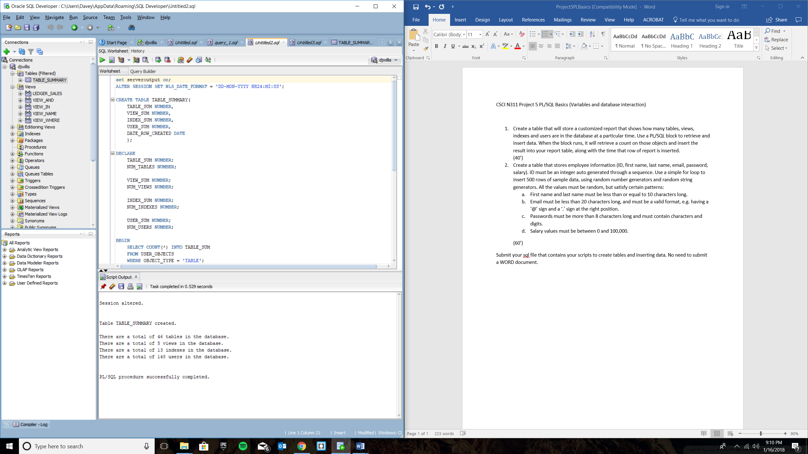

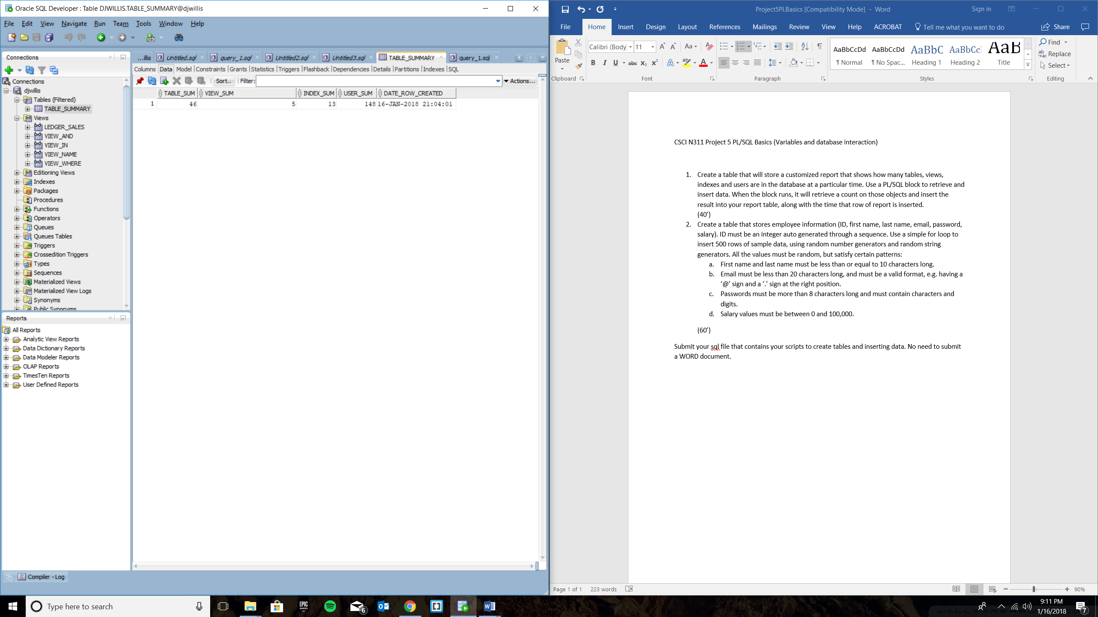

Query 2 – Create a table that stores employee information (ID, first name, last name, email, password, and salary), but the id will be a auto generated via a created sequence (beginning with 1), and a for loop will be created to store random user data (looping 500 times to create 500 rows of random data for the table created before this runs); however, the first name must be 10 characters long, the email must be less than 20 characters long with a valid format (with an @ and .com), the passwords must be more than eight characters long and contain both characters and digits, and lastly, the salary must be between 0 and 100,000

CREATE TABLE EMPLOYEE_INFO (

employee_id int NOT NULL,

employee_first_name VARCHAR(10) NOT NULL,

employee_last_name VARCHAR(10) NOT NULL,

employee_email VARCHAR(19),

employee_password VARCHAR(255),

employee_salary NUMBER,

CHECK (REGEXP_LIKE (employee_email, '^(\S+)\@(\S+)\.(\S+)$')),

CHECK (REGEXP_LIKE (employee_password, '[^0-9]+') AND

LENGTH(employee_password) > 8),

CHECK (employee_salary BETWEEN 0 AND 100000)

);

CREATE SEQUENCE INCREMENT_BY_ONE

MINVALUE 1

START WITH 1

INCREMENT BY 1

NOCACHE;

DECLARE

i int := 1;

RAND_NAME VARCHAR(10);

RAND_NAME_INSERT VARCHAR(10);

RAND_EMAIL VARCHAR(19);

RAND_EMAIL_INSERT VARCHAR(19);

RAND_PASSWORD VARCHAR (255);

RAND_PASSWORD_INSERT VARCHAR(255);

RAND_NUM NUMBER;

RAND_NUM_INSERT NUMBER;

BEGIN

FOR i IN 1 .. 500 LOOP

SELECT dbms_random.string('U', 10) INTO RAND_NAME from dual;

RAND_NAME_INSERT := RAND_NAME;

SELECT ROUND(dbms_random.value(1,100000)) INTO RAND_NUM from dual;

RAND_NUM_INSERT := RAND_NUM;

SELECT dbms_random.string('X', 10) INTO RAND_PASSWORD from dual;

RAND_PASSWORD_INSERT := RAND_PASSWORD;

SELECT dbms_random.string('l', 5) || '@' || dbms_random.string('l', 5) || '.com' INTO RAND_EMAIL from dual;

RAND_EMAIL_INSERT := RAND_EMAIL;

INSERT INTO EMPLOYEE_INFO VALUES(INCREMENT_BY_ONE.nextval, RAND_NAME_INSERT, RAND_NAME_INSERT, RAND_EMAIL_INSERT, RAND_PASSWORD_INSERT, RAND_NUM_INSERT);

END LOOP;

END;

