David Willis

Lingma Acheson

CIT 304

3.30.18

Course Project 6

Query 1 – Use the employee table created in project 5 to create another table inserting all the employee ID numbers (the auto generated sequence), and create a performance review column with a randomly generated review rating from 1 to 5

CREATE TABLE EMPLOYEE_REVIEW (

employee_id int,

employee_review_score NUMBER,

CHECK (employee_review_score BETWEEN 1 AND 5)

);

DECLARE

v_emp_id EMPLOYEE_INFO.employee_id%TYPE;

CURSOR c_emp IS

SELECT employee_id

FROM EMPLOYEE_INFO;

RAND_NUM NUMBER;

RAND_NUM_INSERT NUMBER;

BEGIN

OPEN c_emp;

LOOP

FETCH c_emp INTO v_emp_id;

EXIT when c_emp%NOTFOUND;

SELECT ROUND(dbms_random.value(1,5)) INTO RAND_NUM from dual;

RAND_NUM_INSERT := RAND_NUM;

INSERT INTO EMPLOYEE_REVIEW VALUES(v_emp_id, RAND_NUM_INSERT);

END LOOP;

CLOSE c_emp;

END;

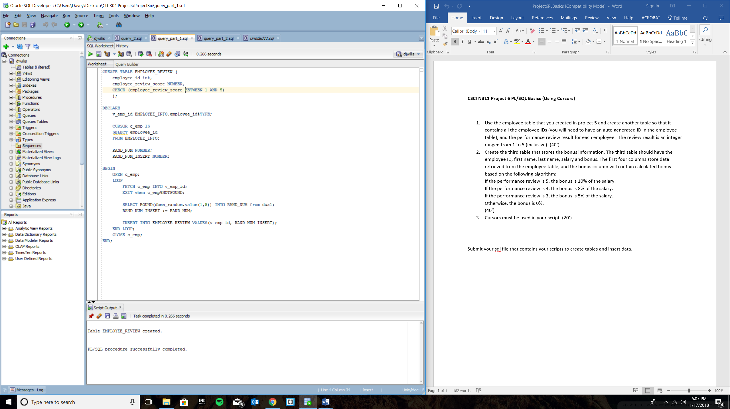

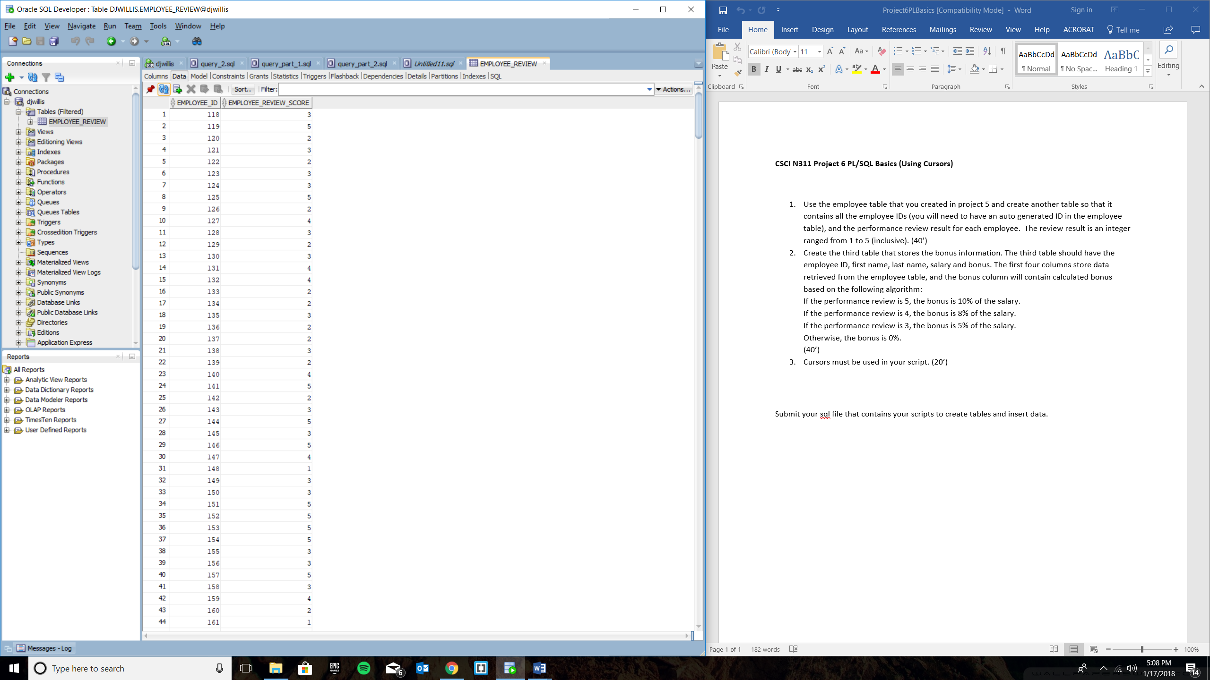

Query Part 2 – Create a third table that will store bonus information, which will include employee ID, first name, last name, salary, and bonus in which the first four columns store data retrieved from the EMPLOYEE table, but the bonus column will contain data based off of the randomly generated performance review from step one of this project. If the performance review equals 5, then the bonus should be 10% of the employee’s salary and inserted into the newly created EMPLOYEE_BONUS column. If the review equals 4, then the bonus should be 8% of the employee salary and inserted into the new table. If the review equals 3, then the bonus should be 5% of the employee salary and inserted into the new table. Lastly, if the review is anything else (or anything below 3), then the bonus should be 0.

CREATE TABLE EMPLOYEE_BONUS (

employee_id int,

employee_first_name VARCHAR(10),

employee_last_name VARCHAR(10),

employee_salary NUMBER,

employee_bonus NUMBER

);

DECLARE

v_emp_id EMPLOYEE_INFO.employee_id%TYPE;

v_emp_first_name EMPLOYEE_INFO.employee_first_name%TYPE;

v_emp_last_name EMPLOYEE_INFO.employee_last_name%TYPE;

v_emp_salary EMPLOYEE_INFO.employee_salary%TYPE;

v_emp_review EMPLOYEE_REVIEW.employee_review_score%TYPE;

CURSOR c_emp IS

SELECT employee_id, employee_first_name, employee_last_name, employee_salary

FROM EMPLOYEE_INFO;

CURSOR c_emp_review IS

SELECT employee_review_score

FROM EMPLOYEE_REVIEW;

bonus_tot NUMBER;

BEGIN

OPEN c_emp;

OPEN c_emp_review;

LOOP

FETCH c_emp INTO v_emp_id, v_emp_first_name, v_emp_last_name, v_emp_salary;

EXIT when c_emp%NOTFOUND;

FETCH c_emp_review INTO v_emp_review;

EXIT WHEN c_emp_review%NOTFOUND;

IF v_emp_review = 5 THEN

bonus_tot := v_emp_salary * .10;

INSERT INTO EMPLOYEE_BONUS VALUES(v_emp_id, v_emp_first_name, v_emp_last_name, v_emp_salary, bonus_tot);

ELSIF v_emp_review = 4 THEN

bonus_tot := v_emp_salary * .08;

INSERT INTO EMPLOYEE_BONUS VALUES(v_emp_id, v_emp_first_name, v_emp_last_name, v_emp_salary, bonus_tot);

ELSIF v_emp_review = 3 THEN

bonus_tot := v_emp_salary * .05;

INSERT INTO EMPLOYEE_BONUS VALUES(v_emp_id, v_emp_first_name, v_emp_last_name, v_emp_salary, bonus_tot);

ELSE

INSERT INTO EMPLOYEE_BONUS VALUES(v_emp_id, v_emp_first_name, v_emp_last_name, v_emp_salary, 0);

END IF;

END LOOP;

CLOSE c_emp;

CLOSE c_emp_review;

END;

