**Piano Inventory app**

The Piano application was built to calculate the monthly payment of the loan based on the chosen down payment, item price, loan duration, interest rate (generated automatically based on the loan duration).

* The application uses db (derby) to create PIANO table that has ProdID, Brand, Model, Price, Year columns. When the table is created the data about Piano is inserted into the table, it’s done by reading the info from the local txt file (BufferedReader was used)
* **paymentSchedule**() method in the pianoorder class includes all logic to retrieve loan monthly payment. Here we use equal principle payment, the principal paid every month will be the same.” The monthly payment will be the principle plus interest accumulated. Interest rate (annually) is decided based on the following table”

|  |  |  |
| --- | --- | --- |
|  | 12 months | 24 months |
| Down payment >= 30% | 4% | 3.5% |
| Down payment >= 50% | 3.5% | 3% |
| Down payment >=70% | 3% | 3% |

**EXAMPLE:**

*“the loan balance will be deducted every month, The for loop is used to calculate the monthly interest and thus the monthly payment.*

*For example, if the initial loan balance is $12000, assume the duration is 12 months, then the principle paid every month will be $1000 (12000/12=1000). Assume the interest rate is 3%, then the first month interest accumulated will be*

*12000*(0.03/12) = 30*

*Where 0.03 is annual interest rate, divided by 12 because we want to calculate the monthly interest. So the first month payment will be :*

*1000 + 30 = 1030*

*The second month balance will be $11000 (12000-1000=11000, you have paid first month principal and interest). The interest accumulated will be*

*11000*(0.03/12) = 27.5*

*So the second month payment will be*

*1000 + 27.5 = 1027.5*

*The following month payment can be calculated based on the same manner, i.e., the principal (which is fixed) plus the monthly interest accumulated (it is changing according to the loan balance).”*

* Loan duration can be 12 months or 24. Down payment cannot be less than 30% or more than 100% (if user enters >100 or <30, the error message will be displayed by using

JOptionPane.showMessageDialog.

* Logic for GUI can be found in the GUI.java class that extends JFrame class and inherits ActionListener.

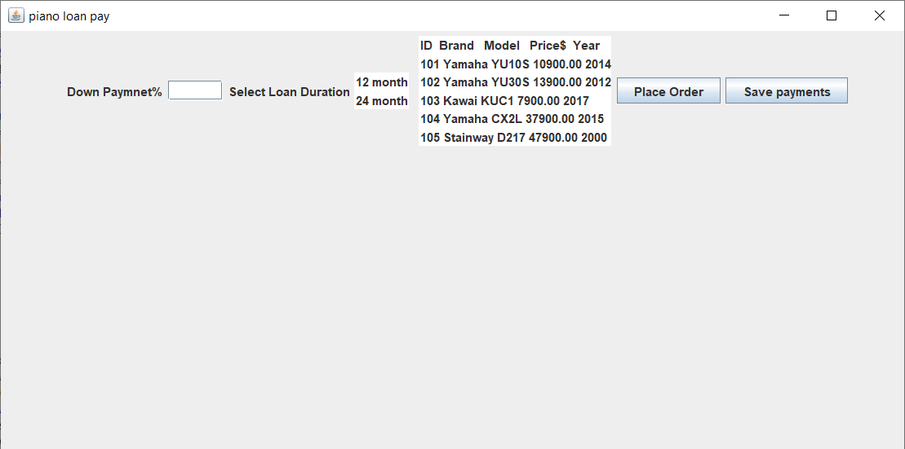

**GUI window**

To build GUI the following JFrame classes were used: JLabel for text, JList to retrieve the table with inserted data (ID, Brand, Model, Price, Year), JButtons to trigger an action (in case with the “place order” button, when it is clicked the loan calculating is perfomed and the result of calculation is displayed in the second JList), JTextField – to type text data…

* PianoDBmanager class is used to retrieve product info from the table and use it into the GUI. The getProd method includes SQL queries to select ID, Brand, Model, Price and Year of the Piano from the Piano table and store it to the ArrayList that is used later to display all data about the table’s items in the Jlist.

Calculation Output

