My Wellness AppProject Notebook

short line

Devin Wing  
11th November, 2020

# Table of Contents

**Table of Contents** **1**

**Application Description** **2**

**New Technologies Implemented** **2**

**Architecture (N-Tier)** **3**

**User Stories (Complete Set)** **4**

Sprint 2 User Stories 5

Sprint 3 User Stories 7

**Wireframe** **9**

**Entity Diagram** **10**

**Sprint 1 Reflection** **11**

**Sprint 2 Reflection** **11**

**Sprint 3 Reflection** **11**

# Application Description

My Wellness App is a one-stop-shop for all things wellness related. Users will be able to customize their dashboard to meet their individual needs by setting themes, reminders, and messages. From the home page users will be able to navigate to three different tabs:

1. Body (exercise plan/ fitness tracker).
2. Mind (things that expand and exercise your mind).
3. You Are What You Eat (diet tracker and diet information).

# New Technologies Implemented

This application will use controls from Syncfusion. This will allow the implementation of more advanced user controls.

# Architecture (N-Tier)

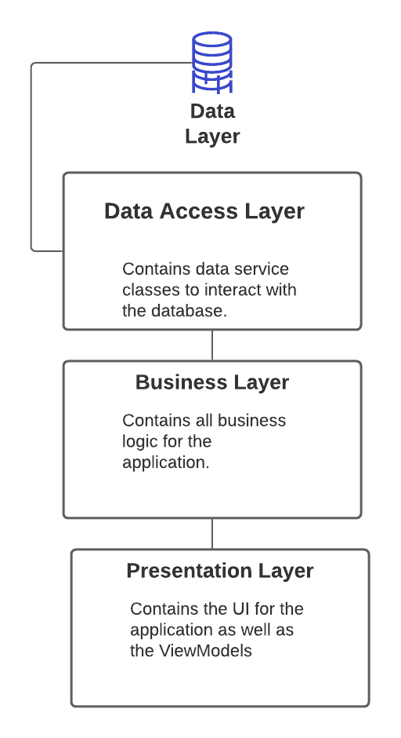

# User Stories (Complete Set)

|  |  |  |  |
| --- | --- | --- | --- |
| **As A...** | **I Want to...** | **So That...** | **Acceptance Criteria** |
| User | Be able to login to My Wellness App | I can view my dashboard and utilize the apps features | 1. A login box that asks for a username and password. 2. Create a new user button. |
| User | Be able to view my dashboard | I can see my task list and navigate to one of the other tabs. | 1. A textbox that displays the user's task list. 2. Add a task button to set tasks. 3. Tabs to navigate to the different sections of the app. |
| User | Be able to sort/ filter my task list | So that I can view certain tasks. | 1. Add sort/ filter functionality |
| User | Be able to add a workout | I can track my progress. | 1. Add a workout window. 2. Add a button to allow users to enter a workout. |
| User | Be able to add a mental activity | I can track my mental health. | 1. Add a Mind window. 2. Add a button that will allow users to enter a mental activity. |
| User | Be able to add a dietary plan | I can track my diet. | 1. Add a diet window. 2. Add a button that will allow users to enter information into the diet tracker. 3. Add a graph to display progress. |

## Sprint 2 User Stories

|  |  |  |  |  |
| --- | --- | --- | --- | --- |
| **As a...** | **I want to...** | **So that...** | **Acceptance Criteria** | **Status** |
| User | Be able to View and sort/ filter my task list | So that I can view certain tasks. | 1. Add view task window 2. Add sort/ filter functionality | Complete   * Tasks were placed in user control instead of a window. |
| User | Be able to view my dashboard | I can see my task list and navigate to one of the other tabs. | 1. A textbox that displays the user's task list. 2. Add a task button to set tasks. 3. Tabs to navigate to the different sections of the app. | Complete   * UserControl was used instead of a TextBox. * Syncfusion Radial Menu was used instead of tabs. |
| User | Be able to view and sort/filter my workouts | I can track my progress. | 1. View a workout window. 2. Add Filter add sort functionality. | Complete   * Window was changed to UserControl. |
| User | Be able to view and sort/filter my Mental activities | Track my mental growth | 1. View mental activities window. 2. Add sort/filter functionality | Incomplete   * Put on hold due to insufficient time. |
| User | Be able to view and sort/filter my Diet | Track my diet | 1. View Diet window. 2. Add sort/filter functionality | Incomplete   * Put on hold due to insufficient time. |
| User | Be able to login to My Wellness App | I can view my dashboard and utilize the apps features | 1. A login box that asks for a username and password. 2. Create a new user button. | Complete |

## Sprint 3 User Stories

|  |  |  |  |  |
| --- | --- | --- | --- | --- |
| **As A...** | **I Want To...** | **So That...** | **Acceptance Criteria** | **Status** |
| User | Add/ edit/ delete a user | I can create/ delete or manage my account | 1. Create user controls for the various CRUD operations. 2. Connect the operations to the database. | Complete   * Add a new user has not been added yet. |
| User | Add/ edit/ delete a workout | I can create/ delete or manage my workouts | 1. Create user controls for the various CRUD operations. 2. Connect the operations to the database. | Complete |
| User | Add/ edit/ delete a Task | I can create/ delete or manage my tasks | 1. Create user controls for the various CRUD operations. 2. Connect the operations to the database. | Complete |
| User | Add/ edit/ delete a Mental Activity | I can create/ delete or manage my mental activities | 1. Create user controls for the various CRUD operations. 2. Connect the operations to the database. | Incomplete   * Put on hold due to insufficient time. |
| User | Add/ edit/ delete a Diet | I can create/ delete or manage my diet | 1. Create user controls for the various CRUD operations. 2. Connect the operations to the database. | Incomplete   * Put on hold due to insufficient time. |

# Wireframe

# 

# 

# Entity Diagram

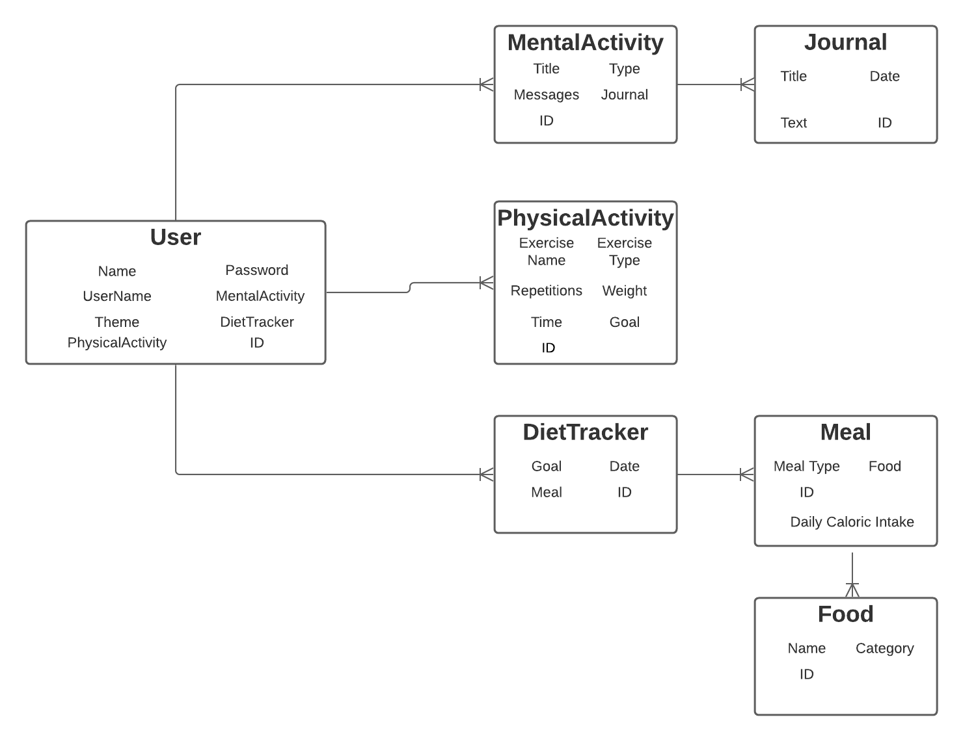

# Sprint 1 Reflection

In this sprint I was tasked with creating a project notebook, a dataset, and a N-Tier template. This sprint wasn’t too difficult, largely because we all had to create those same items for our group master detail app. Having to do that in another project really helps when it comes to this capstone project.

# Sprint 2 Reflection

In this sprint I added UI/UX and developed the backend code. Developing the backend was pretty straightforward due to the fact that I was incharge of developing the backend for our Master Detail App group project. The front-end has been a bit more complicated simply because I am implementing a Syncfusion menu, and I am using UserControls instead of windows.

# Sprint 3 Reflection

In this sprint I added persistence and CRUD operations for my various models. Although I had created the persistence for the team project, it still gave me some issues. The main difference between the two is that this project currently has three models that the database is tracking instead of one. Therefore, it was a bit more work to add all of the CRUD operations for them, and it took some thinking to figure out how to relate each table.

# Sprint 4 Reflection

In this sprint I polished my application and created documentation. This sprint is always difficult because it is hard to say that your app is good, but at some point you have to just “put the pencil down” and call it good. As far as the documentation goes, that was fairly simple due to the fact that we did it in the master detail app. However, this time around I used GitHub Wiki for my documentation.