*main.php*

So as said before, the first and most important task was to create an interactive interface for the software to be put on. The webpage now makes it easier to input your data into *EcoCartographer.* You can see the vehicle selection interface below, in output 4.3.1.

With each vehicle is a different set of values that are needed to calculate the fuel-efficient routes. Some examples of the different values that are hidden beneath the hood in the code are shown in the image below, in output 4.3.2.

With the old software webpage, when the software was done with its calculations, a popup webpage was brought up with directions from your starting point to your destination. Now, with the new and improved software page, you can specify the number of routes you would like as well as have all of the directions on the sidebar to the right. The new setup can be seen in output 4.3.3.

And with the newer version of the software, as mentioned above, you can have multiple routes to get to where you want so that you have the choice to weigh your options. There is now also the additional feature that allows you to take the route that Google Maps plots.

In addition to this new feature, there is also the new “Query ID”. You receive an automatically generated ID that is refreshed every time the webpage is. With this ID, you can find your search results without actually having to input all the data again. There is a link provided where you can input your “Query ID” and put it into your web browser and receive your results.

*Other pages*

The first additional webpage was just to help you use the software. But from that, the website expanded into a webpage where you can access the software page from, a quick reference guide for how to use EcoCartographer, an End-User Documentation, a statistics page, and lastly a contact page. An image of the webpage is shown below.

For this webpage, the CSS was not just written on the same page. The CSS was written into the code as a link so as to avoid cluttering up of the page source. This also enabled us to be more organized. The End-User Documentation was transformed from the earlier version into a sleeker design that was more pleasing to the eye. The final version is longer than the previous version of itself. If compared side by side the similarities can be very easily noted and pointed out.

So as can be seen, both webpages are mostly similar in content but the aesthetics are vastly different. A major difference is that there is a significantly larger amount of information in the final version than the initial page. The color schemes have also changed with the more colorful one from the beginning, and the sleeker and more professional looking design in the final and finished webpage.

In the new webpage, there was the introduction of credits that were on the bottom of the page and were omnipresent in every page. There are also statistics that are a new addition to the webpage. Some example statistics are the average money spent on gasoline and carbon dioxide released into the environment.

**Outputs:**

*Output 4.3.1:*

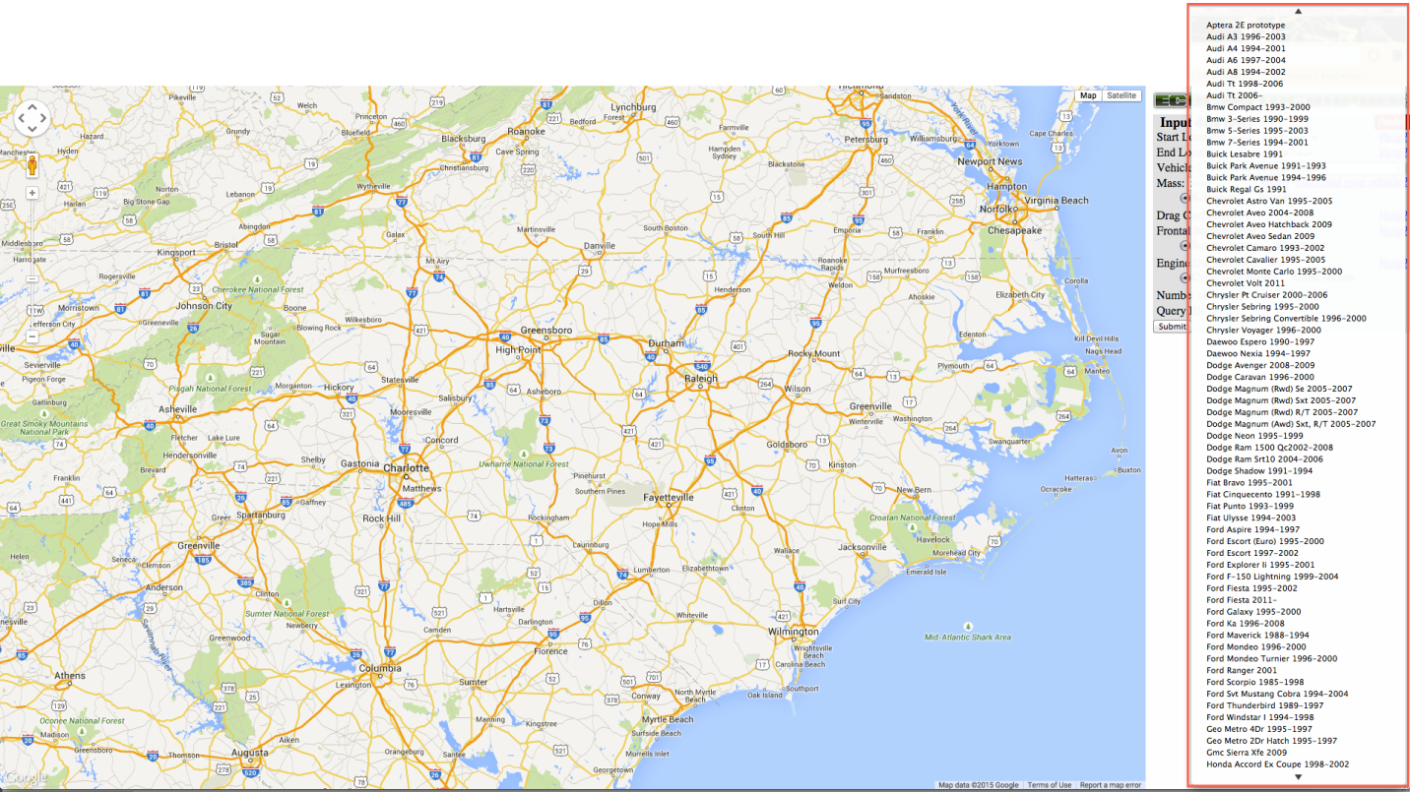

*Output 4.3.2:*

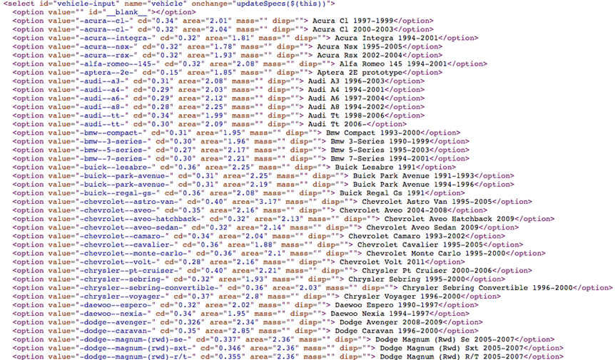

*Output 4.3.3:*

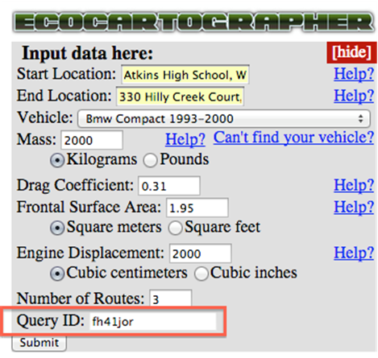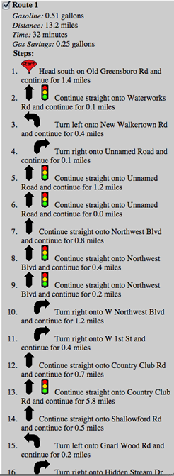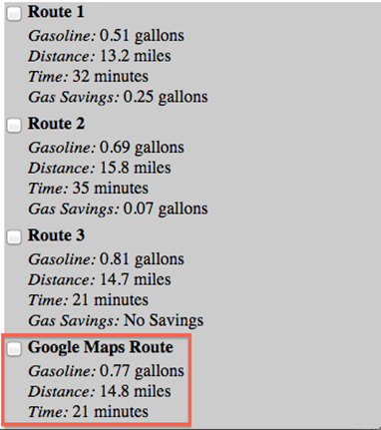

*Output 4.3.4:*

