**Saan Ga? a Smart Tourism Recommender System Using Hybrid Filter in Nasugbu and Lian, Batangas**

**-**

Team sourceCode – Data Dictionary

1. USERS  
   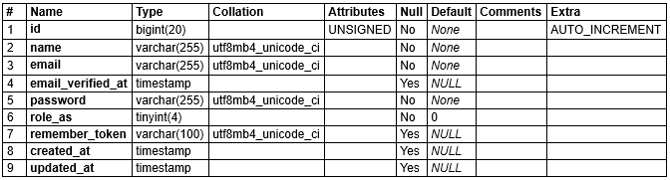
   1. INDEXES  
      
2. CATEGORIES  
   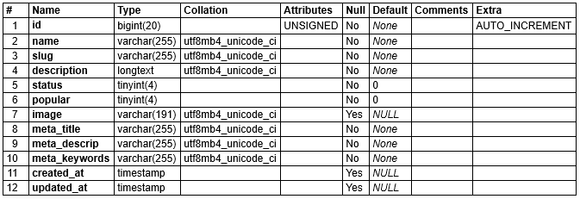
   1. INDEXES  
      
3. ESTABLISHMENT  
   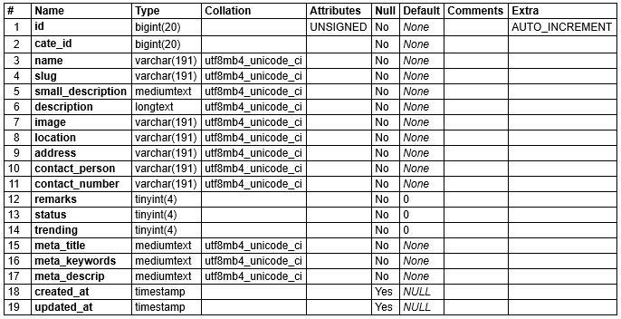
   1. INDEXES  
      