Abstract Ideation

**REPORT TITLE**

IOT Based Accident Detection System

horizontal line

# 

# Problem Statement :-

After an accident, **much time has elapsed** by the time the accident is reported to concerned authorities. Meanwhile, the road gets blocked by vehicles making it very difficult for necessary aid like ambulances and police vehicles to reach the accident spot. This delay is a primary reason for the high death rate in case of accidents.

Road accidents are a major issue that kills more than 1.5 lakhs people yearly in India and approximately 1.3 million people each year globally.

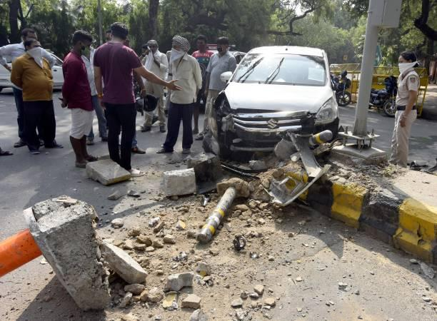

**IRL Existence of problem statement :-**

Number of ‘Traffic Accidents’ in the country have increased from 3,68,828 in 2020 to 4,22,659 in 2021. [Source = https://ncrb.gov.in/sites/default/files/ADSI-2021/adsi2021_Chapter-1A- Traffic-Accidents.pdf]

India: 426 die each day in road accidents; 18 per hour

[Source = https://www.wionews.com/india-news/india-426-die-each-day-in-road-accidents-18- per-hour-513143]

## *Solution proposed:-*

### The proposed solution is an trans-receiver equipped IOT sensing device equipped with necessary equipments, suitable microcontroller and necessary sensors which serves as a plug and play system with automobiles. If the vehicle faces an accident, the sensors detect it and the device sends an SOS message, containing the exact GPS coordinates, last recorded speed and other necessary measured parameters which will be proved as a life saver as this ensures timely availability of ambulance, police and the emergency contacts of the victim. Also, there will be a buzzer, which will get activated as soon as it detects an accident. The driver can reset the device by pressing a reset button in the car, within 10 seconds of the alarm. In case the driver fails to do so, the device assumes that the driver is not in a situation to respond, and therefore sends the SOS message to the Headquarters, where the message is decrypted and required data is sent to the Server.

Also, it is not always feasible for the driver to keep a watch on his phone’s notifications for an accident alert. However, a problem arises if the driver is in close proximity to the car and is unaware of the accident. Hence, an additional layer is added to the device. The car which faced an accident sends short-ranged radio signals, which are received by all such devices within range of the radio signal. As soon as the device in the auto-mobile receives the signals, it makes a beep sound, thereby alerting the driver that an accident has happened nearby.



### 

### Our device also comes with app-support. The app immediately warns nearby vehicles that there is an accident which ensures less traffic jams and controlled traffic flow. Also, vehicles in close proximity will get pop-up messages to clear the road as soon as possible so that Ambulance and police vehicles can reach the site easily. Also, vehicles NOT in close proximity are informed that an accident has occurred and the location is shown. Vehicles which have marked a route which goes through the accident area, are suggested an alternate route to reach their destination.

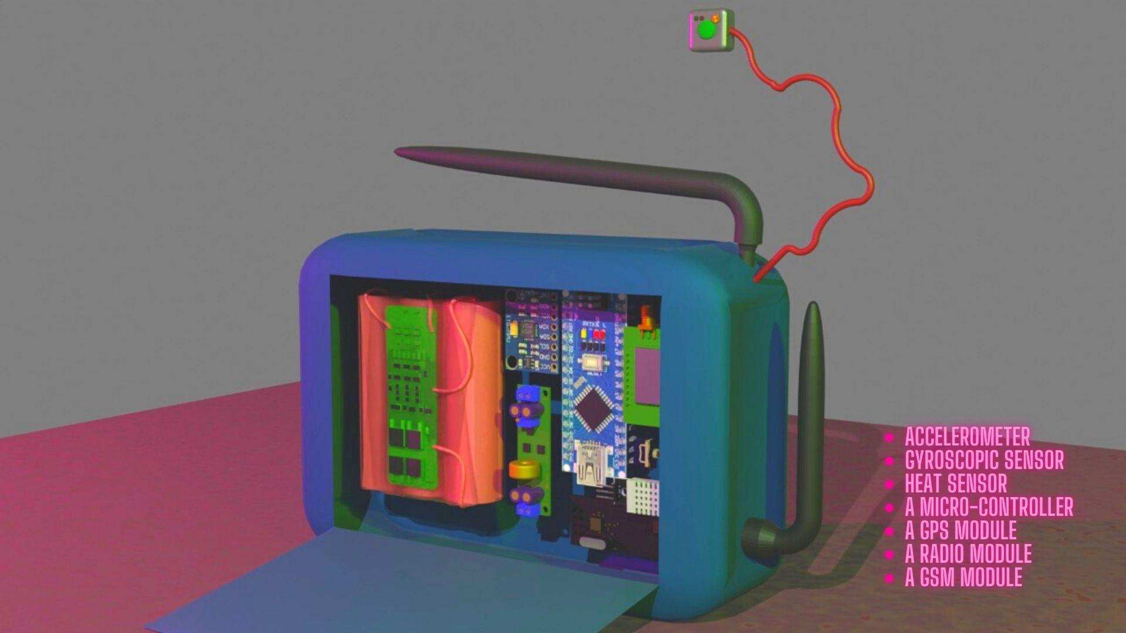

### 

### This product can save lakhs of lives, just by ensuring the victim car gets necessary support on time . Also, it efficiently manages to control a traffic jam within the accident area.

**Besides, the location coordinates of accidents will be stored in the database securely. ML algorithms will be used to identify places which are most prone to accidents. This data will be given to the Govt only for the purpose of pattern study and to take necessary measures to minimize accidents.**

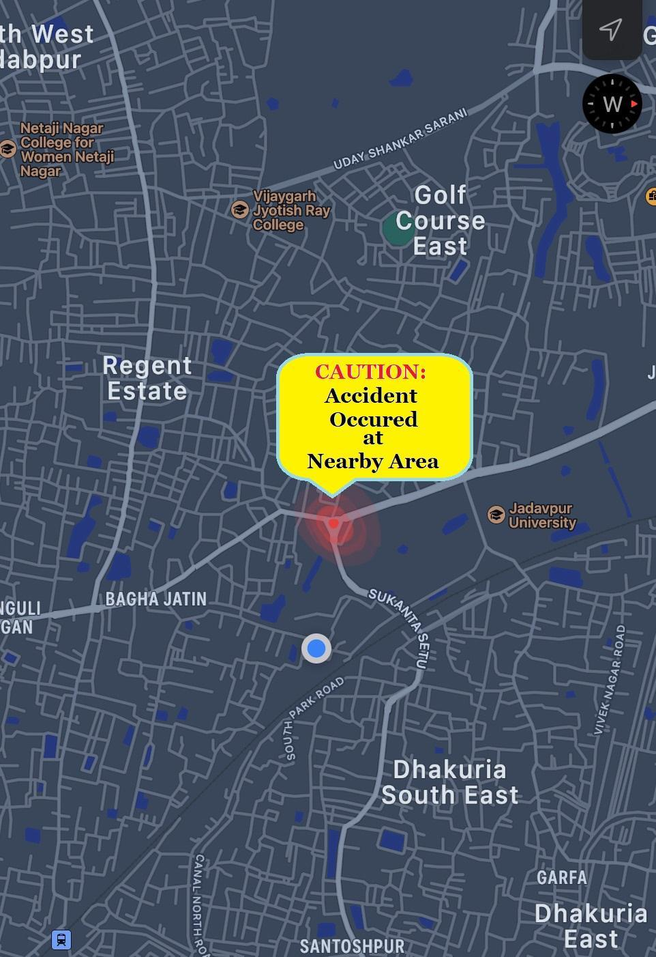

**Components(Hardware)-**

**· Arduino NANO/UNO**

**· MPU6050 Accl & Gyro Sensor**

**· Neo 6-M GPS Module**

**· LIPO Battery**

**· Buck Converter**

**· Miscellaneous components**

**· GSM Module**

**Target audience-**

**This device targets all the common people on the road, using some or the other auto-mobile for transport. This device not only allows the victim to get necessary aids at an earliest, but also diverts the traffic, thereby avoiding a jam and allowing smooth traffic flow throughout.**

**This device aims to reduce the death rate in case of accidents by a great percentage. Also, its data can be used by Govt to study the accident patterns and accident-prone locations and take necessary actions.**

**Big car companies are also our target audience as we can patch up with them and integrate this device with their car models specifically, thereby taking security and post-accident measures to the next level.**

**Presented by :**

**Team DEV HACKS**

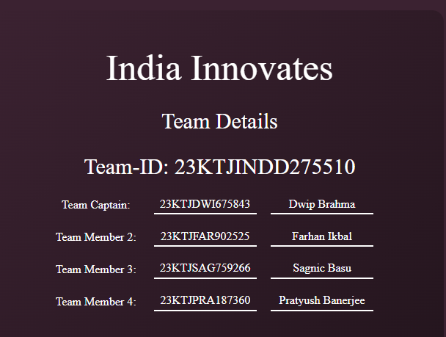

**Thank you**

🎉