TIES 4520 (2018): Guidelines for the Task 1

Your surname:
Your first name:

Task 1-1: Below is RDF data written in N-triples notation. Rewrite it to Turtle notation. Do not use full URIs (e.g. http://family.com/family/hasAge). Instead use qnames (e.g. fam:hasAge) to save space.

Tip: You can use commas (,), semicolons (;), and other abbreviations to save space.

Data in N-triples:
<http://www.smith-family.com/family#Peter> <http://www.smith-family.com/family#hasChild> <http://www.smith-family.com/family#Jane> . <http://www.smith-family.com/family#Peter> <http://www.smith-family.com/family#hasSon> <http://www.smith-family.com/family#Adam> . <http://www.smith-family.com/family#Peter> <http://www.smith-family.com/family#hasFirstname> "Peter" . <http://www.smith-family.com/family#Peter> <http://www.smith-family.com/family#hasSurname> "Smith" . <http://www.smith-family.com/family#Peter> <http://www.smith-family.com/family#hasAge> "67" . <http://www.smith-family.com/family#Jessica> <http://www.smith-family.com/family#hasHusband> <http://www.smith-family.com/family#Adam> . <http://www.smith-family.com/family#Jessica> <http://www.smith-family.com/family#hasChild> <http://www.smith-family.com/family#Bill> .

Solution in Turtle:

Task 1-2: Below there is a graph representing RDF data. There are also reifications with referred statements which are marked by “surrounding clouds” (please notice, it is not a standardized way to represent reification). Rewrite this graph in Turtle notation. Same as in task 1, use qnames, commas (,), semicolons (;) and other abbreviations to save space.

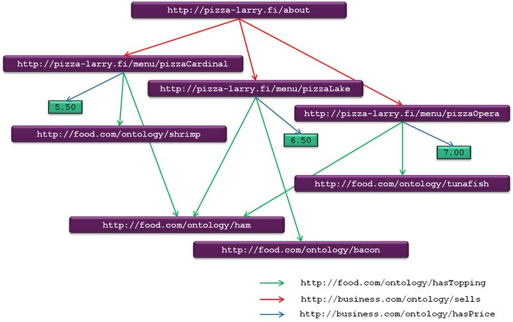
http://pizza-larry.fi/staff/manager
http://business.com/ontology/defines
Solution in Turtle:

Task 1-3: Below you can find RDF data written in Turtle notation. Draw an RDF graph that represents this data. Remember that graphical representation of RDF data is a solid document and should contain all necessary information. You can use any drawing tool you want. Also Microsoft Powerpoint has the option of drawing vector diagrams. There is a “toolkit” provided at http://users.jyu.fi/~olkhriye/ties4520/demos/demo1/toolkit.ppt. After drawing the picture, insert it into this document.

Important: Please do not insert big images. Try to resize the image and convert it to compressed formats like PNG or JPG (not BMP!).

Data in Turtle:
@prefix a: <http://www.books.com/authors/> .
@prefix b: <http://www.books.com/books/> .
@prefix n: <http://www.world.com/nationality/> .
@prefix rdf: <http://www.w3.org/1999/02/22-rdf-syntax-ns#> .

b:hp1 a b:Book , b:FantasyBook ; b:hasTitle "Harry Potter and the Sorcerer's Stone" ; b:hasAuthor a:jkr ; b:hasSequel b:hp2 ; b:isAbout [ a a:Sorcerer ] .

a:jkr a a:Author ; a:firstname "Joanne" ; a:middlename "Kathleen" ; a:surname "Rowling" ; a:nationality n:GB .

HERE PASTE YOUR GRAPH

Files to include in the demo results:
- Task1-instructions.doc (this file)

Send the demo results as an archive to lecturer (oleksiy . khriyenko @ jyu . fi) before the deadline (end of 02.11.2018).

