NEBULA REPORT
Team ANULOG
Dwiti Suchak
Vyom
Abhay

Table of Contents
This field updates automatically in Word and Google Docs. In Word, right-click inside it and choose Update Field (or press F9); in Google Docs, click the table and use the refresh icon.
Right-click and choose Update Field to build the table of contents.

1. Executive Summary

1.1 Project scope and demonstrated capability
Nebula is a Stage-1 automated, simulation-in-the-loop analog receiver
design-space exploration framework. It integrates parameterized CTLE design,
real-SPICE evaluation, S-parameter channel modelling, behavioral one-tap DFE
analysis, PPO and baseline optimizers, staged metric evaluation, caching,
provenance, checkpoints, and reporting. The original engineering problem is
to explore interacting receiver parameters without treating a nominal
simulation or an optimizer score as proof of a complete physical receiver.
The implemented circuit is a one-stage, source-degenerated SKY130 NMOS CTLE.
Its output is evaluated through a behavioral one-tap DFE so that
receiver-level eye metrics can be measured after a four-port channel model.
The project combines this electrical model with an AutoCkt-style PPO search
agent, Random Search, and the Cross-Entropy Method (CEM).
[VERIFIED FROM SOURCE CODE] The primary implementation is distributed across
`circuits/`, `simulator/`, `rl/`, `experiments/`, `analysis/`, and `tests/`.
The principal orchestration entry point is
`experiments/run_autockt_pipeline.py`; the core evaluation function is
`simulator.receiver.evaluate_receiver()`.
The system's design objective is not simply to produce a high reward. A
candidate must survive a sequence of electrical and receiver-level checks,
and the final report distinguishes PASS, FAIL, and NOT CLAIMED. This last
status is important: an unmeasured metric is not converted into a passing
metric by a default value.

1.2 Evidence summary
Metric | Value | Unit | Source | Verification Status | Interpretation
Current regression suite | 632 passed, 2 skipped | tests | Live `pytest` run | [VERIFIED FROM LOGS] | All executed repository tests passed; two were skipped.
v3 training updates | 100 | updates | `results/v3_tt_1000_summary.json` | [VERIFIED FROM RAW SIMULATION DATA] | A completed real-backend training artifact exists.
v3 training evaluations | 692 | evaluations | Same summary | [VERIFIED FROM RAW SIMULATION DATA] | Real-SPICE evaluation count recorded by the artifact.
Historical qualification | 36/36 | conditions | `docs/V3_QUALIFICATION_RESULTS_20260913.md` | [VERIFIED FROM LOGS] | Candidate-fidelity TT/SS/FF qualification for `pipeline_ep0`.
Fair PPO comparison | 0/20 | successes | `results/benchmark_report.json` | [VERIFIED FROM LOGS] | One-seed, budget-matched result; not evidence of general PPO superiority.
Whole-circuit area | Not available | mm² | `analysis/final_specification.py` | [NOT AVAILABLE] | Only partial MOS channel area is computed.
The following nominal values are reported because they are present in the
fresh real-SPICE evidence package, not because they are representative of
every candidate or every operating condition:
Metric | Value | Unit | Source | Verification Status | Interpretation
Eye height | 1.55 | V | `results/llm_wrapper_runs/smoke_evidence_demo.json` | [VERIFIED FROM RAW SIMULATION DATA] | Locked-phase receiver eye result for that run.
Eye width | 0.73 | UI | Same | [VERIFIED FROM RAW SIMULATION DATA] | Unit-interval width for the measured eye.
HD3 | -75.62 | dB | Same | [VERIFIED FROM RAW SIMULATION DATA] | Measured at the documented HD3 test condition.
Input-referred noise | 0.372 | mVrms | Same | [VERIFIED FROM RAW SIMULATION DATA] | Integrated noise over the implemented noise-analysis band.
Observed DFE errors | 0 | count | Same | [VERIFIED FROM RAW SIMULATION DATA] | Zero errors in the finite simulated pattern; not a BER guarantee.
[ENGINEERING INTERPRETATION] These results demonstrate an integrated
evaluation workflow and successful candidate snapshots. They do not establish
silicon behavior, post-layout performance, PCI-SIG compliance, complete-chip
area, or reliable convergence from arbitrary starting points.

1.3 Principal limitations
The current work is explicitly Stage 1. The tail source remains ideal, the
DFE is behavioral, and the resistors and capacitors are represented by ideal
SPICE elements rather than extracted layout devices. The optimizer computes
partial matched-MOS channel area, but not passive area, routing, diffusion,
contacts, guard rings, sampler area, DFE area, or layout overhead.
[REPORTED IN PPT] The presentation states the same limitations, including
behavioral DFE modeling, partial area estimation, incomplete SF/FS coverage,
and lack of continuous tuning proof. [VERIFIED FROM SOURCE CODE] The
repository documentation makes these boundaries more precise and records a
separate 60-condition grid that includes SF and FS. Consequently, the report
uses 36/36 only for the documented TT/SS/FF qualification grid and does not
describe it as full five-corner qualification.

1.4 Requirements-compliance matrix
The matrix below separates implementation from qualification. “Demonstrated”
means the repository contains direct source, test, or artifact evidence for
the stated scope; it does not imply silicon or protocol compliance.
Original requirement | Target/specification | Current implementation or evidence | Status | Limitation or qualification
5-GT/s / 2.5-GHz Nyquist context | 5e9 bit/s NRZ; f_N=2.5 GHz | `simulator/stimulus.py` | Demonstrated | Data-rate context only; not PCI-SIG electrical or protocol compliance.
CTLE peaking | 3–12 dB in intended band | AC metric and hard gate in `simulator/receiver.py` | Demonstrated for evaluated candidates | Continuous tuning across the full band is not established.
One-stage CTLE | Parameterized source-degenerated CTLE | `circuits/blocks/ctle.spice` | Demonstrated | Stage-1 topology with ideal tail source.
Source degeneration | `RDEG |  | CDEG` branches | CTLE netlist and AC bench | Demonstrated | Passive devices are ideal SPICE elements, not extracted layout devices.
One-tap DFE | Previous-decision correction in receiver evaluation | `simulator/receiver_metrics.py` | Implemented but not fully qualified | Behavioral model; no physical sampler/DFE signoff.
Eye width | Implemented threshold above 0.4 UI at candidate fidelity | `dfe_eye_width_ui` metric | Demonstrated for selected nominal runs | Finite pattern and behavioral DFE scope.
Eye height | Implemented threshold above 0.1 V | `dfe_locked_phase_eye_height_v` | Demonstrated for selected nominal runs | Repository convention; original external requirement needs confirmation.
HD3 | Below -30 dB at 100 mVpp differential | `ctle_hd3.cir`, `hd3_db()` | Demonstrated for selected runs | Applies only to the documented 100 MHz test and amplitude.
Input-referred noise | Below 1.5 mVrms over implemented band | `ctle_noise.cir` and integration | Demonstrated for selected runs | Applies only to the documented 10 MHz–5 GHz analysis.
Power | CTLE power between 0 and 15 mW | DC/transient power metrics | Demonstrated for CTLE-level accounting | Total receiver power is unavailable.
Area | 0.05 mm² total-area target | Partial matched-MOS channel-area estimate | Partially demonstrated | Passives, routing, contacts, guard rings, sampler, DFE, and overhead are excluded.
TT/SS/FF/SF/FS | Five process corners | Full 60-point grid is defined | Implemented but not fully qualified | SF/FS completion is unavailable.
Supply variation | 1.71, 1.80, 1.89 V | `PVT_GRID` and qualification grid | Demonstrated for historical TT/SS/FF scope | Not evidence of full five-corner qualification.
Temperature range | 0, 27, 75, 125 °C | `PVT_GRID` | Demonstrated for historical grid scope | Fresh final-fidelity completion is unavailable.
Near-optimality | Prove candidate is near the best feasible design | PPO/RS/CEM comparisons | Not established | No exhaustive optimum, bound, or statistically powered ranking exists.
Runtime reduction | Demonstrate lower cost than exhaustive search | Caching, staging, early rejection, measured runtimes | Partially demonstrated | No controlled end-to-end reduction factor versus an exhaustive baseline.
Human intervention | Eliminate manual engineering decisions | UI, wrapper, checkpoints, reports | Not established | Targets, channel, model, validation scope, and interpretation still require engineering choices.

2. Project Objective and Design Requirements

2.1 Design objective
The objective is to automate the search for a circuit parameter vector
that satisfies receiver-level and circuit-level constraints under a selected
simulation condition. Here, R_LOAD and R_DEG are resistances in ohms,
C_DEG is capacitance in farads, I_TAIL is tail current in amperes,
V_DFE is the behavioral tap voltage in volts, W_MOS and L_MOS are
transistor dimensions in micrometers, and M_MOS is an integer multiplier.
The first two PPO generations expose only the first five entries; v3 exposes
all eight.
[VERIFIED FROM SOURCE CODE] The target specification is represented by four
primary quantities: minimum eye height, minimum eye width, minimum decision
margin, and maximum CTLE power. Additional hard checks include AC peaking,
HD3, noise, and zero observed DFE decision errors when those stages are run.
The optimization problem is therefore constrained rather than a free-form
regression problem. A candidate is acceptable only if the relevant metrics
m_i(θ, c) satisfy their direction-specific limits under condition c:
- m_eye,height(θ, c) ≥ T_eye,height
- m_eye,width(θ, c) ≥ T_eye,width
- m_margin(θ, c) ≥ T_margin
- m_power(θ, c) ≤ T_power
The actual threshold values are read from the target and project contracts;
they must not be inferred from a plot or from a presentation screenshot.
Where a run did not measure a metric, the report status is NOT CLAIMED.

2.2 Receiver-level requirements
Requirement | Meaning | Evidence status
Eye height | Vertical opening of the sampled receiver eye, in volts | [VERIFIED FROM SOURCE CODE] Metric is computed by `receiver_metrics.py`.
Eye width | Horizontal opening normalized to one unit interval | [VERIFIED FROM SOURCE CODE] Metric is computed from sampled phases.
Decision margin | Minimum separation used by the DFE decision process | [VERIFIED FROM SOURCE CODE] Metric is part of the receiver result contract.
CTLE power | Reported CTLE supply power, in watts | [VERIFIED FROM SOURCE CODE] DC stage computes and gates it.
HD3 | Third-harmonic distortion relative to the fundamental, in dB | [VERIFIED FROM SOURCE CODE] Measured by the HD3 bench when enabled.
Input-referred noise | Integrated input-referred noise, in Vrms | [VERIFIED FROM SOURCE CODE] Measured by the noise bench when enabled.
PVT robustness | Repeated qualification over defined corner, voltage, and temperature conditions | [VERIFIED FROM LOGS] Demonstrated for the documented 36-point grid in one historical result.
Total area | Complete physical receiver area | [NOT AVAILABLE] Only partial MOS channel area exists.

2.3 Requirements that remain conditional or unavailable
[ENGINEERING INTERPRETATION] Eye metrics measured after a behavioral DFE are
useful for evaluating the algorithmic receiver contract, but they do not by
themselves demonstrate that a physical sampler, clocking circuit, or DFE can
implement the same correction. Similarly, a CTLE power value is not total
receiver power.
The supplied evidence does not contain a post-layout extraction, a DRC-clean
layout, silicon measurements, or commercial-SPICE cross-validation. It also
does not establish continuous compliance over every frequency in the stated
tuning interval. These items are therefore marked [NOT AVAILABLE] rather than
treated as implied by successful nominal simulations.

2.4 Figure and table plan for this chapter
Recommended figures are a requirements-to-metrics traceability diagram and a
constraint-direction diagram showing lower-bound and upper-bound metrics. The
figure should be generated from `rl/target_spec.py`,
`simulator/receiver.py`, and `analysis/final_specification.py`; no threshold
should be added from the PPT unless it is also present in source code.

3. Evidence Classification

3.1 Evidence hierarchy
This report uses a deliberately conservative hierarchy. Source code defines
what the system is intended to do; raw simulation artifacts show what a
particular run produced; logs establish execution and timing; documentation
explains historical decisions; and the PPT supplies presentation context.
These sources are complementary but are not interchangeable.
Label | Use in this report | Example
[VERIFIED FROM SOURCE CODE] | Directly confirmed from implementation or tests | PPO action deltas, SPICE stage order, PVT grid construction
[VERIFIED FROM RAW SIMULATION DATA] | Read from JSON/JSONL or waveform-derived result artifacts | Eye height, HD3, noise, candidate pass status
[VERIFIED FROM LOGS] | Confirmed by command output or run logs | Live test count, runtime, completed evaluations
[REPORTED IN PPT] | Present in the uploaded slide deck but not independently sufficient | Dashboard screenshots or slide-level summary claims
[ENGINEERING INTERPRETATION] | Reasoned explanation of design significance | Why staged rejection reduces expected runtime
[NOT AVAILABLE] | No traceable evidence exists in the supplied materials | Total receiver area, silicon validation
[REQUIRES FURTHER VERIFICATION] | Evidence exists but is incomplete, historical, or not independently reproduced | Historical qualification at a different fidelity

3.2 Fresh, historical, synthetic, and planned evidence
Results are separated into four categories:
1. Fresh real-SPICE evidence is identified by its raw result artifact or
execution log and includes the current test run and wrapper demonstrations.
2. Historical real-SPICE evidence exists in committed result artifacts
and documentation but was not independently rerun for this report. The
36/36 qualification result is in this category.
3. Synthetic evidence exercises software mechanics without ngspice. It
can show that PPO learns a controlled algebraic landscape, but it cannot
prove circuit performance.
4. Planned or missing evidence identifies work described in plans or
limitations but not supported by a completed artifact.
[VERIFIED FROM SOURCE CODE] The synthetic benchmark is explicitly labelled as
non-circuit evidence in both its implementation and its tests. This prevents
a fast synthetic training curve from being used as a substitute for a real
SPICE result.

3.3 Reproducibility procedure
A reproducible claim in this report must identify, where available:
- repository revision and branch;
- source netlists and model-library identity;
- channel file, port map, and checksum;
- PPO version, checkpoint metadata, exact parameter grids, and seed;
- simulation fidelity and operating condition;
- target specification and metric thresholds;
- result file or live command that produced the value;
- whether the result was fresh, historical, or synthetic.
[VERIFIED FROM SOURCE CODE] `simulator/provenance.py` hashes implementation
and model inputs, and `simulator/ngspice.py` records executable and solver
identity. [VERIFIED FROM SOURCE CODE] v3 checkpoints store a metadata envelope
because the policy cannot safely be interpreted without its state schema and
parameter grid. [ENGINEERING INTERPRETATION] These mechanisms reduce accidental
mixing of incompatible results, although they do not replace independent
reruns.

3.4 Handling discrepancies
The repository contains several result families produced at different times,
fidelities, and interfaces. Values are not merged merely because their labels
look similar. For example, a nominal eye-width value from a fresh wrapper run
is not substituted into a historical PVT table, and a presentation screenshot
is not used to replace a raw JSON artifact.
The PPT was inspected slide by slide, including its embedded images. It is
used as [REPORTED IN PPT] context only. When a slide states “36 tested PVT
conditions,” this report cross-references `QUALIFICATION_PVT_GRID` and states
the precise TT/SS/FF scope. The separate SF/FS corners in the 60-condition
grid remain outside the demonstrated qualification claim.

3.5 Reproducibility table
Evidence item | Repository source | Status | Reproduction note
Source revision | Git branch and HEAD | [VERIFIED FROM LOGS] | `rl-ppo-v2-study`, HEAD `11101a5`.
Unit/regression tests | `tests/` | [VERIFIED FROM LOGS] | `632 passed, 2 skipped, 27 subtests`.
v3 checkpoint | `results/ppo_v3_tt_1000_policy.pt` | [VERIFIED FROM RAW SIMULATION DATA] | Metadata-bearing v3 policy accepted by the v3 loader.
Historical PVT result | `results/v3_qualification_final_20260913.json` | [REQUIRES FURTHER VERIFICATION] | Present and documented, not rerun in this pass.
Synthetic training | `rl/synthetic_benchmark.py` and results | [VERIFIED FROM SOURCE CODE] | Software-mechanics evidence only.
Whole-chip physical area | No complete artifact | [NOT AVAILABLE] | Must not be reconstructed from partial channel area.

4. System Architecture

4.1 Architectural layers
Nebula is organized as a layered pipeline rather than a single monolithic
optimization script:
1. Interface layer. The local web UI and the natural-language wrapper
accept targets, backend choices, checkpoint selections, channel options,
and validation settings.
2. Orchestration layer. `experiments/run_autockt_pipeline.py` validates
the target, generates candidates, filters nominal results, optionally runs
PVT and final measurements, and writes structured outputs.
3. Optimization layer. PPO, Random Search, and CEM produce parameter
candidates under their respective contracts.
4. Evaluation layer. `simulator.receiver.evaluate_receiver()` performs
staged DC, AC, transient, channel, noise, HD3, and receiver analyses.
5. Analysis layer. Specification assessment, PVT selection, comparison
reports, plots, schematic export, and dashboard data consume structured
results rather than re-running simulations.
[VERIFIED FROM SOURCE CODE] The web UI intentionally runs the pipeline in a
subprocess and does not import PPO, simulator, reward, or PVT-selection logic
into the server process. The LLM wrapper also constructs a pipeline command
and consumes its JSON result. This gives the interfaces a common source of
truth and provides process isolation for long-running or native-SPICE work.

4.2 End-to-end data flow
The principal data flow is:
TargetSpec → checkpoint / optimizer → θ → ReceiverEvaluation →
metric assessment → candidate selection → report and netlist.
The candidate vector θ is rendered into SPICE parameters. The
receiver evaluation returns stage results, measured metrics, violations,
warnings, failure stage, runtime, evaluation identity, and provenance. The
pipeline then treats the result as structured data: it does not infer a pass
from a missing value and it does not allow an incomplete PVT run to qualify a
design.

4.3 Failure-aware control flow
Each stage can return success or a structured failure. The receiver stops on a
hard failure, records the stage name, and avoids spending later-stage runtime
on a candidate that has already violated an earlier requirement. Typical
failure labels include `setup`, `dc`, `ac`, `ctle_transient`, `channel`,
`transient`, `noise`, `hd3`, and `internal` at the receiver level; the lower
ngspice contract additionally distinguishes launch, timeout, parsing,
measurement, and model-library failures.
[ENGINEERING INTERPRETATION] Early rejection is both an engineering safety
mechanism and a runtime strategy. It prevents a nominally invalid bias point
from being presented as a meaningful receiver result, while allowing the
optimizer to spend its limited evaluation budget on candidates that reach
informative metrics.

4.4 Architecture evidence table
Layer | Main implementation | Input | Output | Evidence
Web interface | `experiments/web_ui.py` | User configuration | Subprocess request and displayed artifacts | [VERIFIED FROM SOURCE CODE]
Natural-language wrapper | `nebula/llm_wrapper.py` | Text target/request | Validated pipeline arguments | [VERIFIED FROM SOURCE CODE]
Pipeline | `experiments/run_autockt_pipeline.py` | Target, checkpoint, backend, conditions | Candidate and qualification JSON | [VERIFIED FROM SOURCE CODE]
PPO environment | `rl/autockt_env.py` and `rl/trainer.py` | State, action, evaluator result | Transition and reward | [VERIFIED FROM SOURCE CODE]
Receiver evaluator | `simulator/receiver.py` | Parameters and simulation conditions | `ReceiverEvaluation` | [VERIFIED FROM SOURCE CODE]
ngspice adapter | `simulator/ngspice.py` | Rendered netlist and model library | Typed simulation result | [VERIFIED FROM SOURCE CODE]
Analysis/reporting | `analysis/` | Structured result artifacts | Verdicts, plots, summaries, exports | [VERIFIED FROM SOURCE CODE]

4.5 Candidate selection and qualification boundary
Candidate generation and qualification are deliberately separate. PPO may
produce a candidate at a cheaper training fidelity, but the pipeline can
re-evaluate selected designs at candidate or final fidelity and then apply a
PVT condition set. A candidate that passes nominal metrics is therefore not
automatically PVT-qualified.
The output report contains PASS, FAIL, and NOT CLAIMED rows. A PVT row is
only promoted when the required condition set is actually evaluated and the
qualification logic accepts it. Incomplete or failed checks remain visible as
limitations rather than being silently omitted.

5. PCIe Gen-2 Receiver and Channel Model

5.1 Signaling context
[VERIFIED FROM SOURCE CODE] `simulator/stimulus.py` defines the receiver
stimulus bit rate as 5e9 bits/s. For binary NRZ signaling, the unit interval
is the time occupied by one bit:
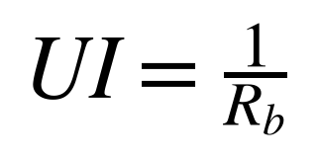
where R_b is the bit rate in bits/s and UI is in seconds. The associated
Nyquist frequency is f_N=R_b/2. For the implemented 5 Gbit/s setting,
f_N is 2.5 GHz by this definition. This is the frequency region in which a
lossy channel and an equalizer must preserve enough signal separation for the
receiver's eye metrics to remain positive.
[ENGINEERING INTERPRETATION] The report uses “PCIe Gen-2-rate” to describe the
implemented 5 GT/s stimulus context, not to claim protocol compliance. A
complete PCIe receiver claim would also require protocol, package, clocking,
jitter, calibration, and compliance-test evidence. Such evidence is not
available in the provided evidence.

5.2 Differential signal path
The implemented signal path is:
v_TX,d(t) → H_CH,d(f) → v_IN,d(t) → CTLE → v_OUT,d(t) →
sampling and DFE → b_hat[k].
Here v_TX,d(t) is the transmitted differential waveform in volts,
H_CH,d(f) is the channel's differential transfer function,
v_IN,d(t) is the filtered receiver input, v_OUT,d(t) is the CTLE
differential output, and b_hat[k] is the binary decision for symbol k.
[VERIFIED FROM SOURCE CODE] `simulator.receiver._run_transient()` first creates
a deterministic NRZ stimulus, filters its differential waveform through the
loaded S4P channel, writes the resulting waveform into a temporary SPICE
stimulus include, and then evaluates `receiver_transient.cir`. The bench
includes 50-ohm source resistance per leg, a differential receiver
termination, optional input capacitance, and the CTLE load capacitance from
the simulation conditions.

5.3 Touchstone S-parameter representation
[VERIFIED FROM SOURCE CODE] `simulator.channel.load_s4p()` reads a Touchstone
1.x four-port file. Each frequency row contains the frequency followed by
the 16 complex S-parameters in full-matrix row-major order. The parser
supports RI, magnitude-angle, and dB-angle formats and requires a declared
reference impedance. The parsed matrix is represented as
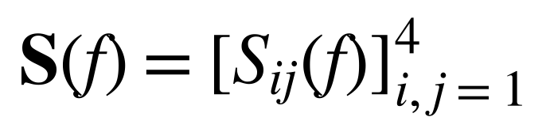
where S_ij is the complex scattering response at frequency f from
source port j to destination port i. Frequencies must be strictly
increasing, and the parser rejects truncated or unsupported data.
The differential transfer is formed from the selected transmit and receive
ports as
The symbols t+ and t- identify the positive and negative transmitter
ports, while r+ and r- identify the corresponding receiver ports. The
factor 1/2 is part of the implemented mixed-mode combination.
[VERIFIED FROM SOURCE CODE] The port map is explicit and validated to use
ports 1, 2, 3, and 4 exactly once. The IEEE/IBM metadata selects physical
ports 1 and 3 for the transmitter pair and 2 and 4 for the receiver pair,
because its documented dominant forward paths are S21 and S43. The synthetic
fixture uses the repository's default mapping unless another map is supplied.

5.4 Channel loss and delay
The channel insertion loss reported by Nebula is

The implementation interpolates the complex transfer by interpolating
magnitude and unwrapped phase separately. [VERIFIED FROM SOURCE CODE]
`S4PChannel.insertion_loss_db()` applies this calculation at requested
frequencies, and the validation path evaluates 1.25 GHz, 2.5 GHz, and 5 GHz.
Bulk delay is estimated from a least-squares line fit to unwrapped phase:
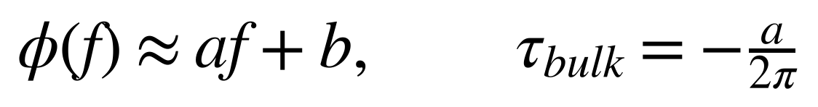
where φ is phase in radians, f is frequency in hertz, a is the
phase slope in radians per hertz, and τ_bulk is delay in seconds.
[VERIFIED FROM SOURCE CODE] The fit uses the 100 MHz to 5 GHz interval and
rejects a material negative delay.
The integer delay alignment is
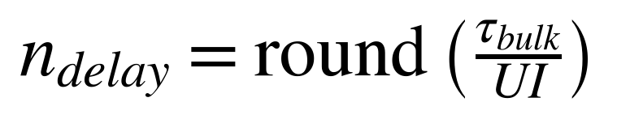
implemented with a round-half-up rule that stabilizes floating-point ties.
The remaining fractional phase is retained as the sampling reference phase.

5.5 Channel validation gates
[VERIFIED FROM SOURCE CODE] `validate_s4p_channel()` applies deterministic
preflight checks before receiver transient evaluation.
Check | Implementation requirement | Unit | Evidence
Reference impedance | Exactly 50 within the implementation tolerance | ohm | [VERIFIED FROM SOURCE CODE]
Frequency coverage | Data extends through at least 5e9 | Hz | [VERIFIED FROM SOURCE CODE]
Finite transfer | All differential-transfer values finite | — | [VERIFIED FROM SOURCE CODE]
Passivity screen | Maximum singular value no greater than 1.01 | dimensionless | [VERIFIED FROM SOURCE CODE]
Delay | No material negative fitted bulk delay | s | [VERIFIED FROM SOURCE CODE]
Causality screen | Negative-time energy ratio no greater than 0.05 | dimensionless | [VERIFIED FROM SOURCE CODE]
The passivity diagnostic computes the largest singular value of the full S4P
matrix over the validation band. The causality diagnostic removes the fitted
transport delay, performs a band-limited inverse real FFT, and compares the
energy in the wrapped negative-time half with total impulse-response energy.
[ENGINEERING INTERPRETATION] These are deterministic integration gates, not a
formal rational-model or VNA signoff. The source code explicitly describes
them as a qualification gate and recommends trusted external modelling tools
for final signoff.

5.6 Available channel evidence
Channel | Role | Evidence status | Limitation
`synthetic_regression.s4p` | Deterministic software regression | [VERIFIED FROM DOCUMENTATION] | Synthetic and not circuit evidence.
`ieee802_ibm_20db_thru.s4p` | Public lossy reference channel | [VERIFIED FROM RAW SIMULATION DATA] | Its metadata states it is not PCIe compliance evidence.
[REPORTED IN PPT] The presentation shows channel and receiver-flow material.
[VERIFIED FROM DOCUMENTATION] The repository sidecar is the controlling
source for channel identity, provenance, port assignment, and compliance
limitations.

6. CTLE Circuit Topology

6.1 Differential-pair structure
[VERIFIED FROM SOURCE CODE] `circuits/blocks/ctle.spice` defines the reusable
`CTLE` subcircuit. It contains two equal load resistors from `vdd` to `outp`
and `outn`, two matched `sky130_fd_pr__nfet_01v8` devices, two identical
source-degeneration branches, and an ideal DC tail-current source.
The differential input and output variables are
The reversed output order is deliberate. [VERIFIED FROM SOURCE CODE] The AC,
transient, and noise benches comment that the common-source pair inverts the
signal and therefore uses `outn-outp` as the logical receiver polarity.

6.2 Implemented circuit parameters
Parameter | Meaning | Range/value | Source file | Engineering role
`RLOAD` | Each drain load resistance | Baseline 1 kΩ; automated legacy range 100 Ω–10 kΩ | `README.md`, `simulator/design_schema.py` | Converts drain current variation into output voltage; trades gain against bandwidth and operating point.
`RDEG` | Each source-degeneration resistance | Baseline 1 kΩ; automated legacy range 10 Ω–10 kΩ | Same | Reduces local feedback-dependent gain and improves linearity; shapes the low-frequency degeneration.
`CDEG` | Capacitor parallel to each degeneration resistor | Baseline 0.5 pF; automated legacy range 10 fF–10 pF | Same | Reduces degeneration at higher frequency and creates the frequency-dependent equalization transition.
`ITAIL_VAL` | Ideal differential-pair tail current | Baseline 100 µA; automated range 10 µA–1 mA | Same | Sets bias current, transconductance, speed, and CTLE power.
`DFE_TAP` | Behavioral feedback tap voltage | -0.4 V to 0.4 V | `ReceiverParameters.validate()` | Compensates the previous-symbol contribution in the software DFE.
`MOS_W` | Matched NMOS width | v3 grid/bounds 0.42–100 µm | `simulator/design_schema.py` | Changes drive strength, capacitance, and partial channel area.
`MOS_L` | Matched NMOS channel length | v3 grid/bounds 0.15–1.0 µm | Same | Changes device electrical behavior and partial channel area.
`MOS_M` | Matched device multiplicity | Integer 1–16 | Same | Represents parallel device instances and affects drive and partial area.
The baseline values above are [VERIFIED FROM DOCUMENTATION] values recorded
by the repository. The automated ranges and validation bounds are
[VERIFIED FROM SOURCE CODE]. A range is not a manufacturability claim: the
project documentation explicitly says the v3 grids are bounded sizing grids,
not proof of DRC closure.

6.3 Small-signal interpretation
For a symmetric differential pair, a simplified small-signal view gives an
output differential gain of the form
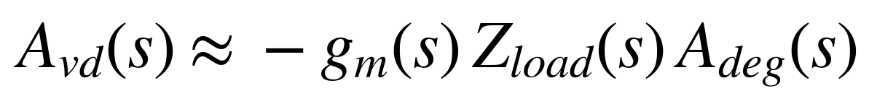
where g_m is effective transconductance in siemens, Z_load is the
frequency-dependent load impedance in ohms, and A_deg represents the
source-degeneration feedback factor. This equation is an engineering model,
not the exact SKY130 compact-model equation used by ngspice.
[ENGINEERING INTERPRETATION] Increasing `RLOAD` can increase low-frequency
voltage gain but also increases the output-node time constant with parasitic
and explicit load capacitance. Increasing `RDEG` strengthens local feedback,
which generally lowers gain and improves linearity. `CDEG` bypasses part of
that degeneration at higher frequency, allowing a controlled transition from
lower low-frequency gain to higher high-frequency gain. The exact result is
determined by the transistor model, bias point, loads, and channel, so these
directions should not be read as monotonic guarantees for every candidate.

6.4 Source degeneration and peaking
The two branches are implemented as
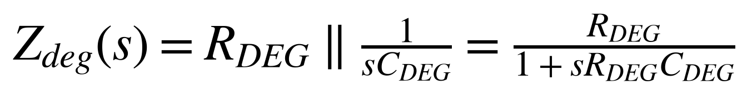
Here s=j2π f, f is frequency in hertz, R_DEG is ohms, and
C_DEG is farads. The characteristic transition frequency of this simple
parallel network is
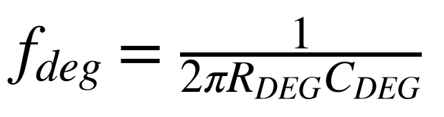
[ENGINEERING INTERPRETATION] This equation explains why the R/C pair is a
natural CTLE control: below the transition, the resistor contributes strong
degeneration; above it, the capacitor lowers the effective degeneration
impedance. The actual response can include additional poles and zeros from
the MOS devices, loads, and wiring represented by the model.
The project does not use “peaking” as an informal visual judgement. It
extracts gain from the AC trace and computes the difference between the peak
gain in the intended 1.25–2.5 GHz band and the gain at 100 MHz:
[VERIFIED FROM SOURCE CODE] `simulator.waveform.ac_metrics()` also classifies
the response as a local peak, controlled shelf, or uncontrolled rise and
checks the out-of-band peak and shelf behavior.

6.5 Tail current and MOS sizing
[VERIFIED FROM SOURCE CODE] The CTLE subcircuit uses an ideal source
`ITAIL tail vss DC {ITAIL_VAL}`. The implementation does not contain a
transistor-level bias generator in this Stage-1 block.
[ENGINEERING INTERPRETATION] For a fixed topology, I_TAIL changes the
available branch current and therefore the MOS operating point and effective
g_m. Higher current can improve speed or linearity but increases static
power. The actual trade-off is evaluated by ngspice rather than assumed from
a hand-derived square-law model.
The matched sizing group is represented by one width, one length, and one
multiplier shared by both devices. The partial channel-area expression used
by v3 is

where the factor 2 represents the two matched transistors and the dimensions
are expressed consistently in the area-reporting calculation. [VERIFIED FROM
SOURCE CODE] This quantity is explicitly partial and is never promoted to a
total-area PASS.

6.6 Circuit and simulation trade-offs
Design change | Intended benefit | Possible cost | Evidence boundary
Increase `RLOAD` | More voltage conversion from drain current | Lower bandwidth or altered output headroom | [ENGINEERING INTERPRETATION] Exact behavior is simulator-dependent.
Increase `RDEG` | More degeneration and potentially improved linearity | Lower gain and altered peaking | [ENGINEERING INTERPRETATION]
Increase `CDEG` | Earlier high-frequency degeneration bypass | Excessive peaking or noise shaping | [ENGINEERING INTERPRETATION]
Increase `ITAIL_VAL` | More bias current and possible speed/linearity improvement | More CTLE power | [ENGINEERING INTERPRETATION]
Increase `MOS_W` or `MOS_M` | More drive and transconductance opportunity | More capacitance and partial area | [ENGINEERING INTERPRETATION]
Increase `MOS_L` | Changes current and intrinsic device behavior | Bandwidth and area trade-offs | [ENGINEERING INTERPRETATION]
The table describes engineering rationale, not guaranteed one-dimensional
monotonicity. [REQUIRES FURTHER VERIFICATION] A complete sensitivity study
with matched real-SPICE perturbations for every geometry and passive variable
is not available in the provided evidence.
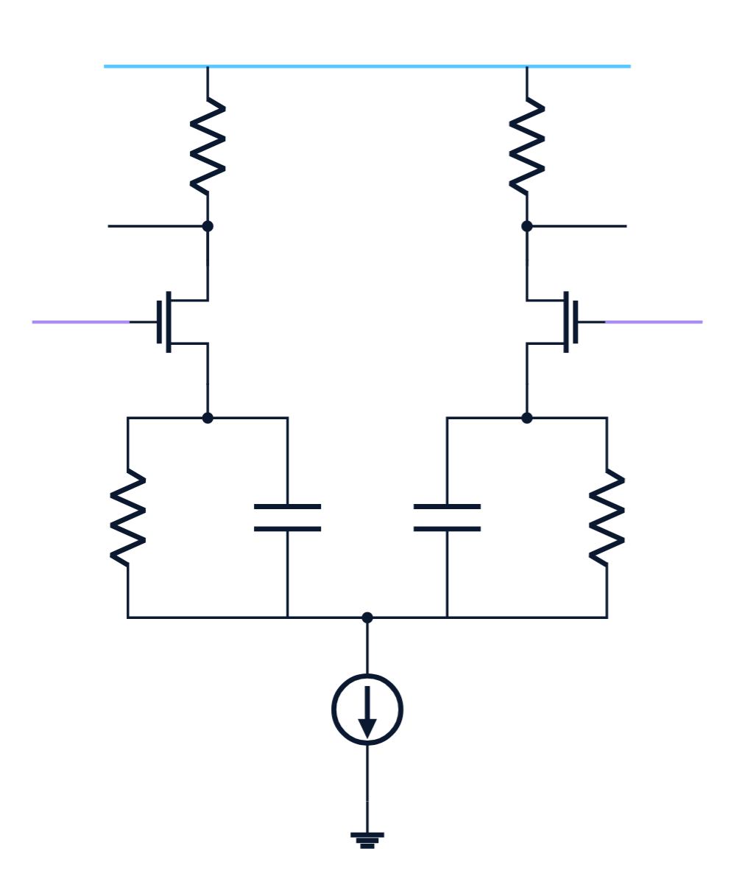
Figure 1. Source-degenerated differential CTLE schematic supplied in the
Nebula presentation. It shows the matched MOS pair, resistive loads, parallel
degeneration R/C branches, and ideal tail-current source. Evidence:
`report_generation/figures/ppt_ctle_topology.png`, extracted from the uploaded
PPT; [REPORTED IN PPT]. The netlist in `circuits/blocks/ctle.spice` remains
the primary implementation evidence.

7. Behavioral One-Tap DFE

7.1 Purpose and model boundary
[VERIFIED FROM SOURCE CODE] `simulator/receiver_metrics.py` implements a
stateful one-tap DFE. The DFE operates on sampled CTLE output values after
the channel and does not instantiate a transistor-level sampler, latch,
feedback amplifier, or physical decision circuit.
The DFE's purpose is to remove an estimated contribution from the preceding
symbol. Let x[k] be the raw sampled voltage in volts, d[k-1] be the
previous binary decision represented as a sign in {-1,+1}, and V_T be
the decision threshold in volts. The implemented correction is
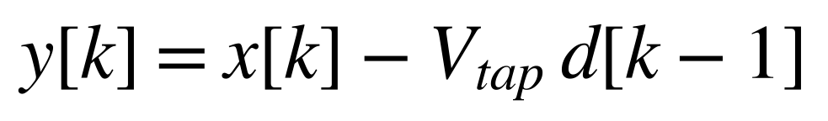
followed by
b_hat[k] = 1 when y[k] ≥ V_T, and b_hat[k] = 0 when y[k] < V_T.
Here V_tap is `dfe_tap_v`, y[k] is the corrected sample, and b_hat[k]
is the binary decision. [VERIFIED FROM SOURCE CODE] The default threshold is
zero volts and the initial previous bit is validated to be either zero or
one.

7.2 Training and decision-directed operation
Nebula uses a hybrid mode. During the known training region, the expected bit
is used to update the previous-symbol feedback state. After `training_stop`,
the DFE uses its own decision, creating decision-directed feedback.
If b[k] is the expected bit, its sign is
s[k] = +1 when b[k] = 1, and s[k] = -1 when b[k] = 0.
The signed margin recorded by the implementation is
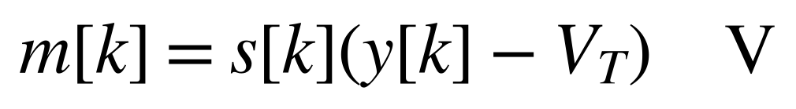
Positive m[k] means the corrected sample is on the expected side of the
threshold. [VERIFIED FROM SOURCE CODE] The DFE result records corrected
samples, decisions, expected bits, margins, error indices, error count, and
error-propagation events.

7.3 Phase selection
The receiver does not assume that the center of the nominal UI is optimal
after channel delay and CTLE filtering. `choose_sampling_phase()` evaluates a
grid of phases from 0 to one UI using the transient time step. For each phase,
it samples the waveform, applies the DFE while all phase-training feedback
symbols are known, and scores the phase using the tenth percentile of the
training-region signed margins:
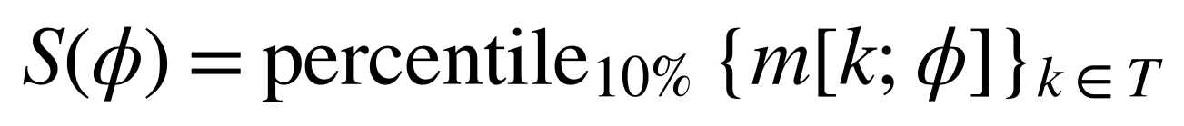
Here φ is phase in seconds, T is the phase-training index
set, and S(φ) is in volts. [VERIFIED FROM SOURCE CODE] The selected
phase maximizes S(φ). Plateaus are resolved using the longest contiguous
best run and a reference phase derived from the channel delay.
[ENGINEERING INTERPRETATION] Using a lower-tail percentile rather than only a
mean margin makes phase selection sensitive to the weaker part of the
training distribution. It is still a finite-pattern heuristic, not an
eye-opening theorem or a clock-recovery implementation.

7.4 Eye height and eye width
For each candidate phase, the implementation separates corrected samples
belonging to logical ones and zeros. The vertical DFE eye height is computed
from the tenth percentile of the one samples and the ninetieth percentile of
the zero samples:
The best phase is the phase with the largest finite H_eye. A phase is
considered open when its height is at least the configured minimum height.
The implementation then finds the contiguous open region containing the
locked phase and converts its number of phase samples to unit intervals:
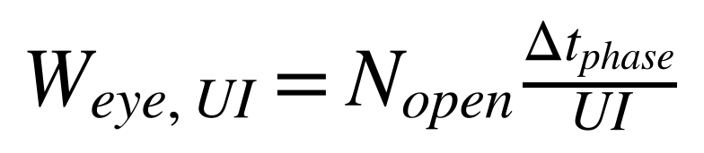
Here N_open is the contiguous sample count and Δ t_phase is the
phase-step duration in seconds. [VERIFIED FROM SOURCE CODE] At candidate
fidelity and above, the receiver requires locked-phase eye height above 0.1 V
and eye width above 0.4 UI. Those thresholds are implementation gates, not a
claim that they are a complete PCIe compliance specification.

7.5 Error count and decision margin
For the measured region M, the implementation records
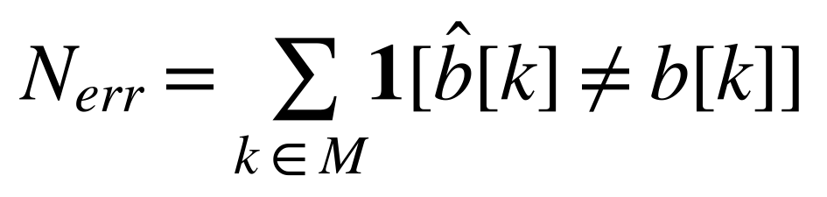
and
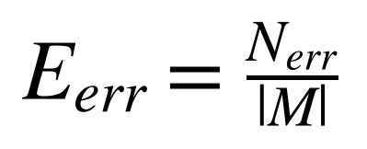
The reported minimum decision margin is
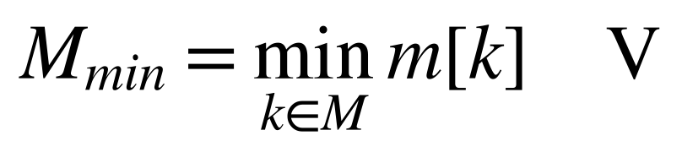
[VERIFIED FROM SOURCE CODE] The transient stage rejects a candidate if the
post-warm-up error count is nonzero or if the minimum margin is not positive.
Zero observed errors means only that the finite simulated pattern contained
no observed decision errors under the tested condition. [ENGINEERING
INTERPRETATION] It is not a measured bit-error rate at an extrapolated target
confidence and does not prove long-run or silicon BER.

7.6 Behavioral-model assumptions and limitations
The model assumes a known deterministic stimulus, an idealized sampling
operation, a scalar one-tap correction, a fixed threshold, and a feedback
state that switches from known training bits to hard decisions. It does not
model transistor noise, clock jitter, sampler kickback, comparator offset,
metastability, finite feedback delay, adaptation dynamics, mismatch, or
physical DFE power and area.
[VERIFIED FROM SOURCE CODE] The generated eye artifact labels the CTLE trace
as a continuous transistor-level CTLE output and the DFE points as behavioral
one-tap corrected samples; it explicitly states that the DFE plot is not a
transistor-level DFE waveform. [REPORTED IN PPT] The presentation shows the
behavioral DFE boundary as a project limitation. A transistor-level DFE
implementation is not available in the provided evidence.

8. SPICE Benchmarks and Simulation Metrics

8.1 Netlist templating and model use
[VERIFIED FROM SOURCE CODE] Each bench is a parameterized ngspice template.
`simulator.ngspice.run_simulation()` renders placeholders for the model
library, process corner, temperature, CTLE block path, stimulus include, and
output file. The request carries typed parameters and expected output
artifacts. A temporary run directory isolates generated files, and the result
contract records status, measurements, runtime, errors, return code, failure
stage, failure code, artifacts, and provenance.
The shared CTLE bench parameters include supply voltage V_DD in volts,
input common-mode voltage V_CM in volts, output load capacitance C_LOAD
in farads, source resistance per leg in ohms, differential termination in
ohms, and input parasitic capacitance in farads. Exact defaults are read from
`SimulationConditions` and the bench templates; a value not present in the
relevant artifact is not inferred here.

8.2 DC operating-point benchmark
`ctle_dc.cir` performs an `.op` analysis and prints input, output, source,
tail, and supply-current quantities. [VERIFIED FROM SOURCE CODE] The receiver
uses these measurements to form DC metrics and checks output offset, branch
current balance, output common-mode behavior, rail headroom, and CTLE power.
The DC power relationship represented by the evaluator is

where I_VDD is the ngspice supply-current sign convention and the leading
minus sign converts the source current convention into consumed power.
[ENGINEERING INTERPRETATION] DC screening is placed first because a failed
bias point makes later AC and transient metrics difficult to interpret. The
DC result is also not total receiver power: the Stage-1 circuit contains an
ideal tail source and does not include a physical sampler or physical DFE.

8.3 AC transfer benchmark
`ctle_ac.cir` applies a differential small-signal excitation with opposite
AC polarity on the two inputs, sweeps logarithmically from 1 MHz to 20 GHz,
and writes transfer magnitude, phase, input magnitude, and output magnitude.
[VERIFIED FROM SOURCE CODE] The logical differential transfer is
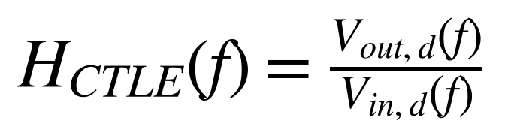
and gain in decibels is
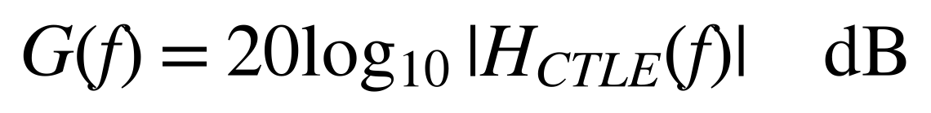
The parser interpolates gain at 1 MHz, 10 MHz, 100 MHz, 1.25 GHz, 2.5 GHz,
and 5 GHz. It identifies the peak in the intended 1.25–2.5 GHz band and
computes CTLE peaking relative to 100 MHz. It additionally checks whether an
out-of-band peak is excessive and whether the 2.5–5 GHz shelf is controlled.
The phase trace is unwrapped and converted to group delay using
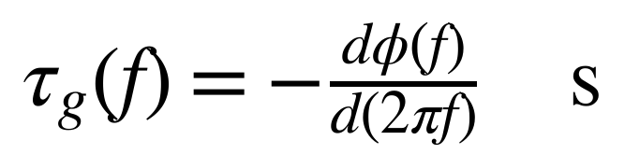
The implementation records mean and span over 100 MHz to 5 GHz and emits a
warning if the span exceeds the documented implementation threshold.

8.4 CTLE transient diagnostic
`ctle_transient.cir` uses a channel-free terminated differential waveform to
check that the CTLE produces a nonzero output swing and receives the expected
terminated input amplitude. [VERIFIED FROM SOURCE CODE] The evaluator parses
`vin_diff` and `vout_diff`, verifies the input peak-to-peak excursion, and
rejects zero output swing.
This is a diagnostic rather than the final receiver metric. It isolates the
CTLE and its termination from channel filtering and DFE sampling, allowing a
failure to be assigned to the local circuit before a more expensive channel
transient is attempted.

8.5 Channel-driven transient benchmark
`receiver_transient.cir` writes the input differential voltage, output
differential voltage, both output nodes, and supply current. The evaluator
filters the generated NRZ waveform through the channel before writing the
stimulus include. It then aligns the waveform by integer bulk delay, selects
a fractional sampling phase, applies the behavioral DFE, and computes eye,
margin, error, delay, loss, and average transient-power metrics.
[VERIFIED FROM SOURCE CODE] The transient configuration changes by fidelity:
SCREENING uses 32 bits, TRAINING uses 128 bits, CANDIDATE uses 512 bits, and
FINAL uses 1024 bits. Warm-up and tail symbols are excluded from the measured
region. The measured bit count can therefore be lower than the requested
stimulus count after warm-up, tail, and channel-delay removal.
The average transient power is computed as

over the valid measurement interval. Output rail excursions are also checked
against the nominal supply and ground with the implementation's interpolation
tolerance.

8.6 Input-referred noise benchmark
`ctle_noise.cir` runs ngspice noise analysis with the differential output
observation and a differential test source. The output includes input-noise
spectral density and output-noise spectral density. [VERIFIED FROM SOURCE CODE]
`integrated_input_noise()` integrates the square of the input-referred
density over frequency:
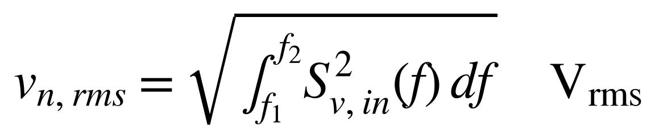
where S_v,in(f) is input-referred noise density in V/√(Hz),
f_1 and f_2 are the analysis limits in hertz, and trapezoidal numerical
integration is used. The implemented bench spans 10 MHz to 5 GHz. The noise
stage rejects values at or above 1.5 mVrms.
[ENGINEERING INTERPRETATION] This is an integrated small-signal noise result
for the modeled CTLE and test source. It does not include unmodeled physical
DFE, clock, package, or post-layout noise contributions.

8.7 HD3 benchmark
`ctle_hd3.cir` applies a differential sinusoidal input and records the output
differential waveform. The bench uses a 100 MHz fundamental and a differential
peak-to-peak amplitude supplied by the evaluator. [VERIFIED FROM SOURCE CODE]
At candidate fidelity one amplitude is used; at final characterization the
implementation evaluates 0.05 V, 0.1 V, and 0.2 V differential peak-to-peak
amplitudes. The reported gate metric is the 0.1 V case.
After discarding the first 100 ns, `hd3_db()` fits the output to fundamental,
second-harmonic, third-harmonic, DC, and slow-drift basis functions. If A_1
and A_3 are the fitted fundamental and third-harmonic amplitudes in volts,
the reported distortion is
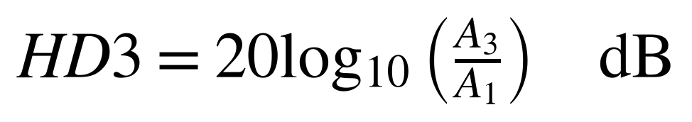
The implementation requires steady-state duration, sufficient Nyquist margin,
and a well-conditioned fit. The gate requires the 100 mVpp result to be below
-30 dB.
[ENGINEERING INTERPRETATION] HD3 measures one specified sinusoidal operating
condition. It is not a broadband linearity proof, and the documented bench
frequency is not a sweep across the CTLE peaking band. [REQUIRES FURTHER
VERIFICATION] A full-amplitude, full-band distortion characterization is not
available in the provided evidence.

8.8 Metric extraction and failure semantics
Analysis | Raw output | Extracted metric | Failure examples | Evidence
DC | Printed operating-point values | Bias, current, common-mode, power | Missing model, invalid bias, current imbalance | [VERIFIED FROM SOURCE CODE]
AC | `wrdata` transfer trace | Gain, phase, peaking, shelf, group delay | Missing trace, invalid magnitude, uncontrolled response | [VERIFIED FROM SOURCE CODE]
CTLE transient | `vin_diff`, `vout_diff` | Input/output swing | Small input or zero output | [VERIFIED FROM SOURCE CODE]
Channel | Touchstone matrix | Loss, delay, singular value, causality ratio | Wrong impedance, insufficient bandwidth, non-passive/noncausal screen | [VERIFIED FROM SOURCE CODE]
Receiver transient | Output nodes and supply current | Eye, width, margin, errors, average power | Error, nonpositive margin, rail excursion, insufficient eye | [VERIFIED FROM SOURCE CODE]
Noise | Input/output noise spectra | Integrated input-referred Vrms | Missing trace or threshold violation | [VERIFIED FROM SOURCE CODE]
HD3 | Differential transient | Third/fundamental ratio | Insufficient cycles, ill-conditioned fit, threshold violation | [VERIFIED FROM SOURCE CODE]

8.9 Reproducible benchmark flow
The benchmark flow is deterministic at the software level when its parameter
vector, model library, simulator, channel, stimulus, fidelity, and conditions
are held constant. [VERIFIED FROM SOURCE CODE] The evaluator records checksums
for the CTLE block, all bench files, implementation modules, model-library
dependencies, channel, and simulator identity. Temporary waveform artifacts
are parsed into scalar metrics and normally discarded, except when an explicit
eye capture is requested.
The exact raw AC, noise, and HD3 traces for every historical result are not
all retained as standalone report-ready plots. [NOT AVAILABLE IN THE PROVIDED
EVIDENCE] Where only scalar result JSON is present, this report does not
invent a waveform plot.

9. Hierarchical Evaluation Pipeline

9.1 Evaluation contract
[VERIFIED FROM SOURCE CODE] `simulator.receiver.evaluate_receiver()` is the
controlling implementation for one candidate evaluation. Its inputs are a
`ReceiverParameters` object, `SimulationConditions`, an
`EvaluationFidelity`, a channel path and port map, SKY130 configuration,
ngspice configuration, and an optional evaluation cache or eye-capture object.
Its output is a `ReceiverEvaluation` containing the stage sequence, success
status, measured metrics, violations, warnings, failed stage, runtime,
evaluation identity, and provenance.
The evaluator is hierarchical because it increases computational and signal
fidelity only after earlier checks succeed. Conceptually, for stages
s_1,…,s_n:
E(θ, c) is the failure record at stage s_j, if s_j is the first failed
stage; otherwise E(θ, c) is the complete metric vector, if all required
stages succeed.
Here θ is the parameter vector and c is the operating condition.
[ENGINEERING INTERPRETATION] This ordering avoids spending transient, noise,
HD3, or PVT runtime on a candidate whose bias or AC response is already
invalid.

9.2 Fidelity levels
[VERIFIED FROM SOURCE CODE] `EvaluationFidelity` defines SCREENING, TRAINING,
CANDIDATE, and FINAL. The receiver uses these levels to select transient bit
counts and to enable later stages.
Fidelity | Transient request | Channel/receiver role | Noise and HD3 role
SCREENING | 32 bits | Early local circuit screening | Not enabled by the receiver stage list
TRAINING | 128 bits | RL rollout evaluation and channel/receiver metrics | Not enabled by the receiver stage list
CANDIDATE | 512 bits | Candidate qualification metrics | Noise and one-amplitude HD3 enabled
FINAL | 1024 bits | Final nominal characterization | Noise and three-amplitude HD3 characterization enabled
The requested bit count is not necessarily the measured bit count. Warm-up,
tail, and integer channel delay are excluded from the valid measurement
window. [VERIFIED FROM SOURCE CODE] The historical qualification document
reports 960 measured bits for a nominal 1024-bit request. This is a measured
artifact-specific result, not a universal count for every condition.

9.3 Stage order and stopping behavior
[VERIFIED FROM SOURCE CODE] The runner list is constructed in this order:
1. setup and parameter/condition/model validation;
2. DC operating point;
3. AC response;
4. channel-free CTLE transient;
5. channel diagnostics at TRAINING and above;
6. noise and HD3 at CANDIDATE and above;
7. channel-driven receiver transient and DFE metrics at TRAINING and above.
Each stage returns a `StageResult`. A failed stage stops the sequence and
sets `failed_stage`. A simulator failure, parser error, invalid model path,
channel preflight failure, or hard metric violation is represented as
structured data rather than as an invented metric value.

9.4 Setup and validation
`ReceiverParameters.validate()` checks the legacy passive/current variables,
DFE tap bounds, and v3 geometry bounds. `SimulationConditions.validate()`
checks process-corner type, temperature, supply, common-mode voltage, load,
termination, and nonnegative input parasitic capacitance. SKY130 model-library
resolution and ngspice identity are checked before the first bench runs.
[VERIFIED FROM SOURCE CODE] A setup failure returns a failed evaluation with a
specific failure code such as invalid parameter, missing model library,
missing ngspice executable, or channel error. This is important to PPO and to
reporting: the simulator failure is observable as a failure stage, not
silently treated as an electrical zero.

9.5 Nominal filtering and PVT selection
[VERIFIED FROM SOURCE CODE] The pipeline's nominal feasibility filter runs
before PVT qualification. Only nominally feasible candidates are sent into
the more expensive condition sweep. The PVT selector can rank candidates
using nominal validity and available PVT results, but it cannot promote a
candidate for conditions that were not evaluated.
[ENGINEERING INTERPRETATION] This separation is a practical compromise:
candidate generation needs a cheaper feedback loop, while final acceptance
needs broader condition coverage. It also creates a reporting obligation:
nominal PASS, candidate-fidelity PASS, and PVT-qualified are different
claims and must remain separately labelled.

9.6 Stage-result table
Stage | Main source | Inputs | Outputs | Failure consequence
Setup | `receiver.py`, `config.py`, `ngspice.py` | Parameters, conditions, model/tool paths | Validated run context | No simulation; structured setup failure
DC | `ctle_dc.cir` | Bias and model parameters | Operating point, power, headroom | Later stages skipped
AC | `ctle_ac.cir`, `waveform.py` | Differential AC source | Gain, peaking, shelf, group delay | Later stages skipped
CTLE transient | `ctle_transient.cir` | Short NRZ waveform | Input/output swing | Later receiver work skipped
Channel | `channel.py` | S4P and port map | Loss, delay, passivity, causality diagnostics | Receiver transient skipped
Noise | `ctle_noise.cir` | Small-signal noise setup | Integrated input-referred noise | Candidate rejected if threshold fails
HD3 | `ctle_hd3.cir` | Sinusoidal input | Third-harmonic ratio | Candidate rejected if threshold fails
Receiver transient | `receiver_transient.cir` | Channel-filtered waveform | Eye, DFE, errors, margin, power | Candidate rejected if hard gates fail
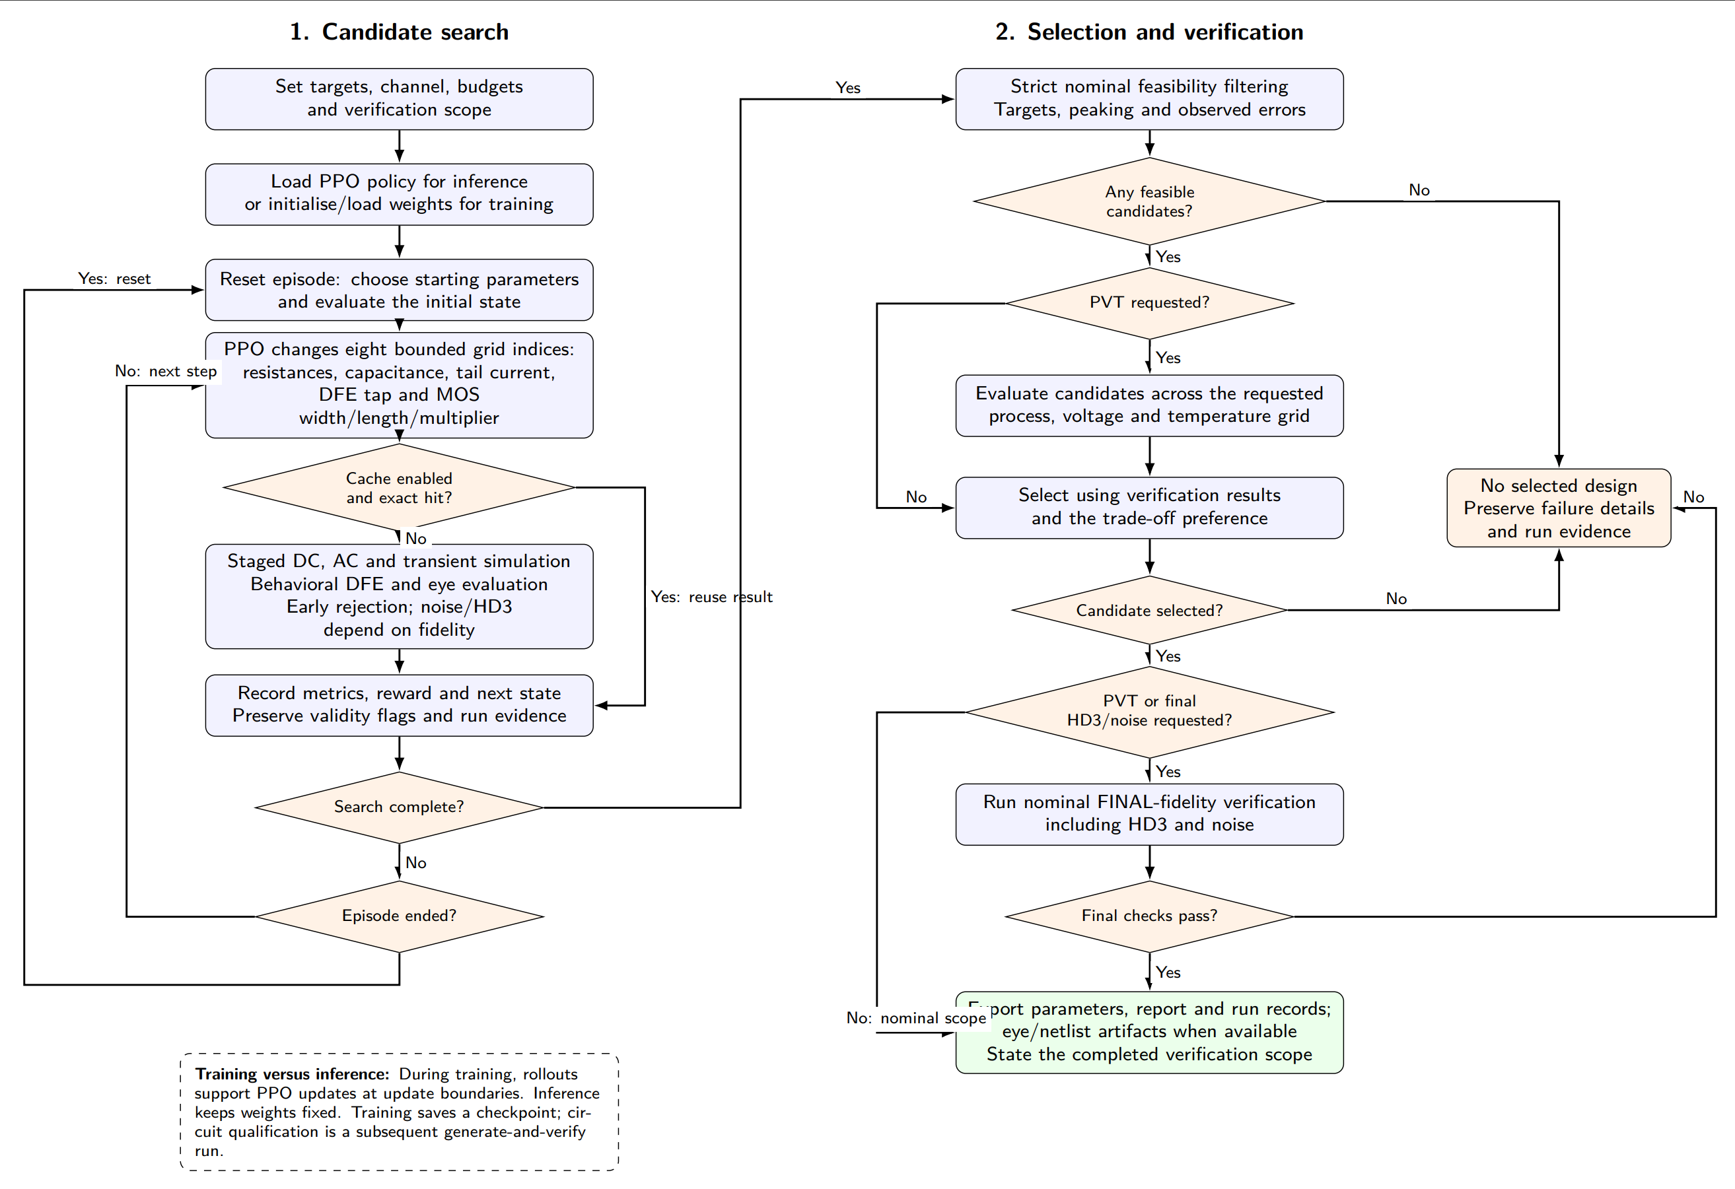
Figure 2. Optimization, nominal filtering, PVT, final HD3/noise, and
reporting flow shown in the supplied presentation. Evidence:
`report_generation/figures/ppt_optimization_flow.png`, extracted from the
uploaded PPT; [REPORTED IN PPT]. The Python implementation is the controlling
source for the exact stage behavior.

9.7 Engineering contributions
[VERIFIED FROM SOURCE CODE] The engineering work represented in the repository
includes the following concrete components:
- a parameterized SKY130 CTLE subcircuit and reusable SPICE benches;
- Python netlist rendering, ngspice process control, waveform parsing, and
structured failure contracts;
- four-port S-parameter parsing, differential-transfer formation, channel
passivity/delay/causality screens, and waveform filtering;
- behavioral one-tap DFE sampling, phase selection, eye metrics, margins, and
finite-pattern error counting;
- PPO v1, the validity-aware and reward-structured v2 changes, and the
versioned eight-parameter v3 contract;
- Random Search and CEM implementations with result consolidation;
- content-addressed evaluation caching, dependency hashing, provenance,
checkpointing, resumable training, and event/run-graph records;
- strict PASS/FAIL/NOT CLAIMED reporting, schematic export, dashboard
integration, and the natural-language orchestration wrapper;
- unit, integration, synthetic-mechanics, artifact-integrity, and optional
real-ngspice tests.
[ENGINEERING INTERPRETATION] These contributions form an evaluation and
design-space exploration framework. They do not by themselves constitute a
fully physical receiver, a layout database, or an optimizer optimality proof.

10. Parameter Space and Design Constraints

10.1 Versioned parameter schema
[VERIFIED FROM SOURCE CODE] `simulator.design_schema.py` defines one ordered
legacy schema for v1/v2 and one expanded ordered schema for v3. The physical
parameter vector is mapped to discrete grids by `rl.parameter_grid.py`; the
optimizer therefore operates on grid indices rather than arbitrary floating
point values.
Parameter | Meaning | Range/Value | Scaling | Engineering role
`rload_ohm` | Drain-load resistance | 100 to 10,000 Ω | Logarithmic | Gain, bandwidth, output operating point
`rdeg_ohm` | Source-degeneration resistance | 10 to 10,000 Ω | Logarithmic | Local feedback, linearity, peaking
`cdeg_f` | Degeneration capacitance | 10 fF to 10 pF | Logarithmic | Frequency-dependent degeneration bypass
`itail_a` | Tail current | 10 µA to 1 mA | Logarithmic | Bias, transconductance, power
`dfe_tap_v` | Behavioral DFE tap | -0.4 to 0.4 V | Linear | Previous-symbol correction
`mos_width_um` | Matched transistor width | 0.42 to 100 µm | Linear | Drive, capacitance, partial area
`mos_length_um` | Matched transistor length | 0.15 to 1.0 µm | Linear | Device behavior and partial area
`mos_multiplier` | Matched parallel-device multiplier | Integer 1 to 16 | Discrete integer | Drive and partial area
The first five rows are [VERIFIED FROM SOURCE CODE] legacy bounds. The last
three are v3 bounds. [VERIFIED FROM SOURCE CODE] Both MOS devices receive the
same v3 geometry values; independent unmatched widths or lengths are not
exposed by the schema.

10.2 Grid representation
The v1/v2/v3 environments use parameter grids with an ordered index for each
parameter. For a logarithmically scaled variable x with bounds x_min and
x_max, a normalized position can be represented as
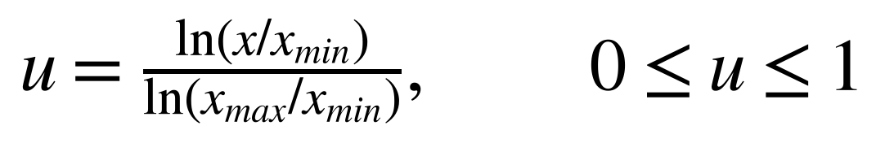
For a linearly scaled variable,
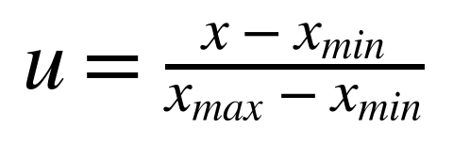
The exact grid-point count and arrays are checkpoint/runtime-contract data.
[VERIFIED FROM DOCUMENTATION] The v3 default grid has 21 points for the
continuous variables, rounds MOS width and length to 0.001 µm, and uses the
integers 1 through 16 for the multiplier. [REQUIRES FURTHER VERIFICATION]
Any claim about a candidate outside the checkpoint's stored exact arrays
requires checking that checkpoint rather than assuming the default grid.

10.3 Action reachability
The default action is not a direct physical assignment. It selects an index
delta, which is clipped to the grid:
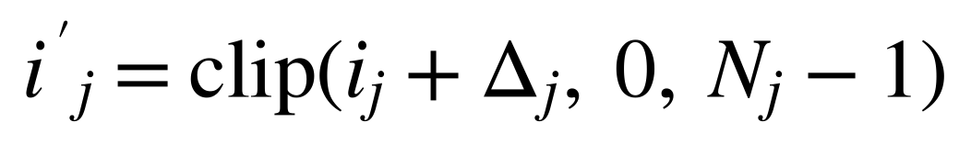
where i_j is the current index, N_j is the number of grid points, and
Δ_j ∈ {-1,0,+2} by default. [VERIFIED FROM SOURCE CODE]
`rl.autockt_action.apply_action()` uses three independent Discrete(3) choices,
one per parameter, and clips at the bounds. A boundary action can therefore
request movement without changing the applied index.
[ENGINEERING INTERPRETATION] The asymmetric `+2` step can reach farther in a
short horizon than a symmetric one-step action, but it also makes local
movement directionally uneven. The repository includes an optional symmetric
ablation using `(-1,0,+1)`; the default historical contract remains
`(-1,0,+2)`.

10.4 Constraint types
The parameter bounds are not the same as electrical acceptance criteria. The
former define what the optimizer may request; the latter are evaluated by
SPICE and receiver analysis. The distinction is:
Constraint | Type | Example consequence
Parameter bounds | Search-domain constraint | Invalid geometry is rejected before simulation
Grid membership | Representation constraint | Candidate must correspond to a stored index
DC/AC gates | Electrical validity constraint | Candidate stops before receiver transient
Eye/DFE gates | Receiver constraint | Candidate fails on errors, margin, height, or width
Area status | Reporting constraint | Partial area cannot qualify total-area target
PVT coverage | Qualification constraint | Unrun conditions cannot count as passes

10.5 Parameter-space limitations
[VERIFIED FROM DOCUMENTATION] v3 adds grouped MOS sizing but does not add
physical sampler, physical DFE, passive geometry, or layout variables. The
search space is therefore a transistor-level CTLE parameter space embedded in
a behavioral receiver evaluation, not a complete transceiver layout search.
[NOT AVAILABLE IN THE PROVIDED EVIDENCE] A DRC-feasible geometry grid,
extracted parasitic model, passive density model, or layout-aware area
constraint is not supplied.

11. PPO v1: Baseline Formulation

11.1 PPO role in Nebula
Proximal Policy Optimization is used as a sequential candidate generator. At
each environment step, a policy maps the current state to independent action
choices, the environment applies grid-index deltas, the receiver simulator
evaluates the resulting circuit, and the reward is returned to the trainer.
The policy is not a circuit surrogate. [VERIFIED FROM SOURCE CODE] Every
training step passes through `ReceiverRLAdapter` and then the real evaluator
when the real backend is selected. The policy chooses which designs to try;
ngspice determines their measured metrics.

11.2 v1 state vector
[VERIFIED FROM SOURCE CODE] `rl.autockt_state.build_state()` constructs a
13-element v1 state from three concatenated components:
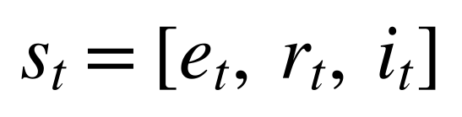
where e_t is the four-element achieved-versus-target error vector, r_t is
the four-element target-versus-global-reference vector, and i_t contains
the five parameter indices. The normalized error function is
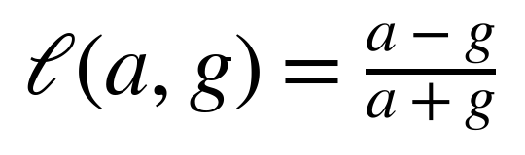
with a small denominator guard in Nebula. Here a is achieved metric value,
g is the target value, and the result is dimensionless. For the smaller-is-
better power specification, the signed error is reversed so that larger
positive values consistently indicate better satisfaction.
The direct state-builder documentation retains raw index semantics, while the
environment applies a normalized-index adaptation before passing indices into
the state construction path. [VERIFIED FROM SOURCE CODE] This distinction is
part of the project's AutoCkt compatibility notes and must not be collapsed
into a claim that every direct caller sees the same representation.

11.3 v1 action space
[VERIFIED FROM SOURCE CODE] v1 has five independent `Discrete(3)` heads.
Choice 0, 1, or 2 selects the default index delta -1, 0, or +2. The complete
action is therefore
The grid update and clipping equation is the one in Section 10.3. The action
mechanics are discrete, but `indices_to_normalized_action()` converts the
resulting physical grid values into the continuous [-1,1] encoding expected
by the existing receiver adapter.

11.4 v1 reward
[VERIFIED FROM SOURCE CODE] `rl.autockt_reward.autockt_reward()` uses the
signed relative errors of the four target metrics. It sums only negative
unsatisfied contributions and returns a terminal bonus when the total reaches
the documented threshold:
r_t is defined piecewise:
- r_t = the sum of negative excess errors, Σ e_j for j with e_j < 0,
when that sum is less than -0.02;
- r_t = 10.0, otherwise for a successful evaluation;
- r_t = -1.0, if the evaluation fails.
The values -0.02, 10.0, and -1.0 are source-code constants. The last branch
is a Nebula adaptation for structured simulator failures, not a claim about
the original AutoCkt implementation.

11.5 PPO policy and value networks
[VERIFIED FROM SOURCE CODE] `rl.ppo_agent.py` defines a policy network with
two hidden layers of 64 units each and tanh activations, followed by one
three-logit categorical head per parameter. The value network has a separate
two-layer tanh body and a scalar output. The source labels the 64-unit,
two-layer shape as AutoCkt-replicated, while the remaining optimizer and
network details are explicitly labelled unverified from the original AutoCkt
source.
The policy produces categorical distributions
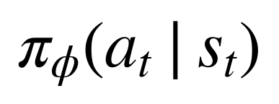
and the value network estimates
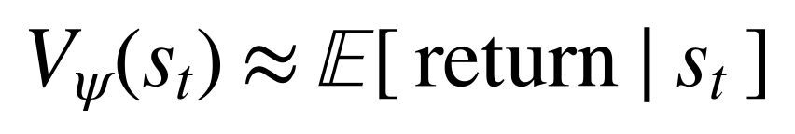
Here φ and ψ are policy and value parameters. The exact PPO
hyperparameters not established by AutoCkt source are not restated as if
they were original-project constants. [NOT AVAILABLE IN THE PROVIDED
EVIDENCE] The original AutoCkt source does not pin every value used by the
Nebula standalone implementation.

11.6 Advantage estimation and clipping
[VERIFIED FROM SOURCE CODE] `rl.trainer.py` collects transitions and
`rl.ppo_agent.py` computes generalized advantage estimates with separate
terminated and truncated semantics. A conventional form is
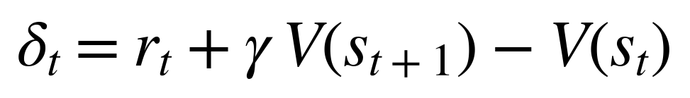
and
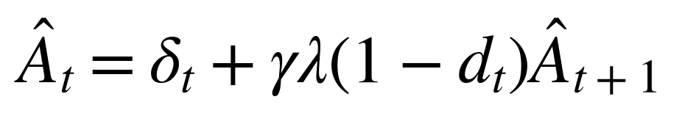
where r_t is reward, γ is discount, λ is the GAE parameter,
and d_t is one only when the episode truly terminates. For a horizon or
budget truncation, the implementation can bootstrap from the reached state's
value instead of treating the artificial boundary as a terminal zero.
The PPO policy-ratio objective uses the standard clipped form
where r_t(φ) = π_φ(a_t|s_t) / π_φ_old(a_t|s_t) and ε
is the clipping parameter. [VERIFIED FROM SOURCE CODE] The implementation
contains this PPO update structure; exact constants should be taken from the
source file for any numerical reproduction.

11.7 Episode termination and failure handling
[VERIFIED FROM SOURCE CODE] The environment returns `done=True` on terminal
reward success and a separate `truncated=True` flag for horizon or shared
evaluation-budget exhaustion. A failed SPICE stage produces a structured
failure and reward rather than an uncaught simulator exception in the normal
environment path.
[ENGINEERING INTERPRETATION] This distinction matters because PPO's value
target should not treat “ran out of allowed steps” as equivalent to “the
design is physically terminal.” It also prevents a shared training budget
from producing fabricated transitions after the final permitted simulation.

11.8 v1 trade-offs and evidence limits
The v1 contract is compact and retains compatibility with the historical
five-parameter workflow. Its weaknesses are also explicit: a failed early
stage can provide little metric information, unmeasured quantities are not
distinguished in the original state representation, and a fixed initial
state can limit the observed learning problem.
[VERIFIED FROM DOCUMENTATION] The fair no-warm-start PPO benchmark recorded
0/20 successes at the selected budget, with all episodes failing at DC. This
is evidence about that configuration, not proof that PPO cannot solve the
design problem under another horizon, target distribution, or state/reward
contract.

12. PPO v2: State and Reward Improvements

12.1 Motivation and compatibility policy
PPO v2 is an additive, opt-in improvement. [VERIFIED FROM DOCUMENTATION]
The project preserves v1 behavior when the new environment arguments are
omitted. This allows historical v1 checkpoints and result files to remain
interpretable while v2 studies the effect of improved simulator information.
The central diagnosis was a reward-information problem: if every sampled
episode fails before the four target metrics are genuinely measured, a single
failure reward does not tell the policy whether one candidate was closer than
another. A second diagnosis was the state-information problem: filling
unmeasured metrics with zero can make “not evaluated” resemble “measured zero.”

12.2 Corrected reset evaluation
[VERIFIED FROM SOURCE CODE] v2 adds `evaluate_on_reset`. When enabled, the
environment evaluates the actual starting circuit before returning the initial
state. The state therefore reflects measured starting behavior rather than an
artificial all-zero metric dictionary.
This option is intentionally separate from the one-time initial-index
randomization feature. The reset contract can preserve a fixed initial grid
index for compatibility, while still evaluating that actual point. A reset
evaluation consumes simulator budget, so it is not enabled silently for all
historical runs.

12.3 Validity-aware state schema
[VERIFIED FROM SOURCE CODE] `rl.autockt_state_v2.py` extends the v1 state with:
- one validity flag;
- two early-stage margin dimensions for `ctle_power_w` and `peaking_db`;
- a one-hot failure-stage vocabulary.
The documented dimension is
The validity flag is not a recomputed guess. It decodes the validity half of
the existing adapter observation. The failure-stage one-hot vector includes
success, unevaluated reset, setup, DC, AC, CTLE transient, channel, transient,
noise, HD3, internal, and the synthetic out-of-region label.
For a metric m, the validity component is
q_m = 1 when m was genuinely measured, and q_m = 0 when m was not
available.
[ENGINEERING INTERPRETATION] This lets the policy distinguish a measured
zero from an unavailable value and distinguish an early DC failure from a
late transient near-miss. It does not create a measurement that the
simulator never produced.

12.4 Structured reward v2
[VERIFIED FROM SOURCE CODE] `rl.autockt_reward_v2.reward_v2()` retains the v1
success contract but adds explicit reward components and available-metric
tracking. A failure with no reliable target metrics receives the structural
floor `NO_INFORMATION_FLOOR_V2 = -20.0`. The source explains that this is a
floor for missing information, not a tuned circuit-performance result.
The v2 reward separates two concepts:
1. `autockt_terminal_success`, which preserves the v1 tolerance-based
terminal criterion; and
2. `strict_target_pass`, which checks raw target boundaries independently.
For a valid near-miss, the reward can retain measured constraint margins. For
a strict pass, the source adds a bounded overshoot bonus with
`OVERSHOOT_BONUS_SCALE = 0.1` and `OVERSHOOT_BONUS_CAP = 2.0`.
[VERIFIED FROM SOURCE CODE] These coefficient values are source constants.
They are not presented as experimentally optimized hyperparameters.

12.5 Early-stage information
DC and AC stages can produce genuine power and peaking measurements even when
the full eye metrics are absent. v2 exposes those measurements as early-stage
margins only when they are present in the metrics map. It does not use a
fabricated zero for a transient-only metric after a DC failure.
This preserves the failure boundary:
[VERIFIED FROM SOURCE CODE] The module documentation explicitly ties this
behavior to the receiver's existing stage results and validity flags.

12.6 v1, v2, and v3 comparison
Feature | PPO v1 | PPO v2 | PPO v3 | Evidence
Optimized parameters | 5 | 5 | 8 | [VERIFIED FROM SOURCE CODE]
State dimension | 13 | 27 | 52 | [VERIFIED FROM SOURCE CODE] / documentation
Reset measurement | Optional historical behavior; default no evaluation | Opt-in actual reset evaluation | Versioned v3 contract | [VERIFIED FROM SOURCE CODE]
Validity mask | Not represented in v1 state | Explicit validity information | Per-metric validity plus v3 features | [VERIFIED FROM SOURCE CODE]
Failure-stage encoding | Not represented in v1 state | One-hot stage vocabulary | Retained and extended in v3 state | [VERIFIED FROM SOURCE CODE]
Reward | Flat failure reward and terminal bonus | Structured valid/failure reward | Strict receiver reward plus partial-area regularizer | [VERIFIED FROM SOURCE CODE]
Checkpoint contract | Historical bare state dictionary | Compatibility-preserving legacy form | Metadata-bearing versioned export | [VERIFIED FROM SOURCE CODE]
The v3 column is included for continuity; its full geometry and runtime
contract are developed in Section 13. [REQUIRES FURTHER VERIFICATION] The
state dimensions are implementation contract values and should be checked
against the exact checkpoint metadata when loading an individual artifact.

12.7 Evidence and limitations
The v2 design directly addresses observed information loss and simulator
failure handling. It does not demonstrate, by itself, that real-circuit PPO
outperforms Random Search or CEM. A controlled ablation file exists and the
test suite verifies its mechanics, but broad statistical conclusions require
the recorded seed count, budget, target pool, and backend to be reported with
each result.
[NOT AVAILABLE IN THE PROVIDED EVIDENCE] A multi-seed, matched-budget real-
SPICE study proving a statistically reliable v2 improvement over v1 is not
available as a completed general claim.

13. PPO v3: Expanded Sizing and Runtime Contract

13.1 Motivation for v3
[VERIFIED FROM DOCUMENTATION] PPO v3 expands the optimization space from the
five legacy variables to eight variables by adding a matched MOS width,
matched MOS length, and integer MOS multiplier. This is a meaningful model
change, not a relabeling of the v1/v2 checkpoint. The v3 contract therefore
uses a new state/action/checkpoint schema and rejects incompatible legacy
policies.
[ENGINEERING INTERPRETATION] The expansion addresses a physical limitation of
the earlier search: passive degeneration, load, bias, and behavioral DFE
settings could be adjusted, but transistor geometry remained fixed. It also
increases the search difficulty because each geometry changes both electrical
behavior and partial area.

13.2 v3 state construction
[VERIFIED FROM SOURCE CODE] `rl/autockt_v3.py::build_state_v3()` combines the
following state groups:
- target error and target-reference vectors;
- eight normalized parameter indices;
- normalized values for the v3 metric vocabulary;
- per-metric availability flags;
- one-hot failure-stage identity;
- channel loss features at 1.25, 2.5, and 5 GHz and fitted bulk delay;
- a normalized partial MOS channel-area feature;
- an explicit false total-area-valid flag.
The documented v3 dimension is 52. The exact composition is checkpoint
contract data and is not silently inferred when loading a policy. The channel
features are calculated from the selected channel path and port map, so a
policy's state includes information about the channel under which it is being
evaluated.

13.3 v3 reward and termination
[VERIFIED FROM SOURCE CODE] `reward_v3()` requires successful evaluation,
valid target metrics, all target specifications satisfied, CTLE peaking in
the 3--12 dB band, and zero measured DFE decision errors. It adds a small
partial-MOS-area regularizer only when that metric is available. The area
term is not a feasibility gate.
The strict success condition can be represented as
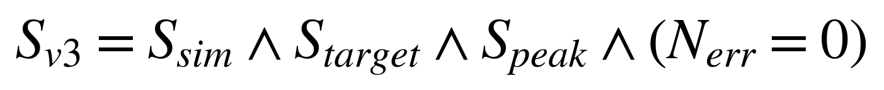
where S_sim means required simulation stages completed, S_target is
the strict target assessment, S_peak is the peaking-band condition, and
N_err is the measured finite-pattern error count.
[ENGINEERING INTERPRETATION] Separating reward shaping from final area
qualification is important. A smaller partial MOS channel area may influence
ranking during learning, but the system must not convert it into a complete
0.05 mm² receiver-area claim while passive and physical DFE areas are absent.

13.4 Checkpoint compatibility
[VERIFIED FROM SOURCE CODE] v3 inference exports contain metadata describing
the state schema, reward schema, ordered parameters, grids, action deltas,
channel contract, and toolchain context. The runtime contract checks these
fields before inference. A bare v1/v2 state dictionary is rejected under v3
rather than being interpreted with the wrong input dimension or parameter
meaning.
Checkpoint type | Metadata requirement | Loading status
Legacy v1/v2 policy | Historical bare state dictionary | Valid only under compatible legacy loading path
v3 inference policy | Metadata-bearing policy export | Accepted by v3 contract when fields match
v3 full checkpoint | Policy, value, optimizer, RNG, counters, grids, toolchain | Resumable only under compatible runtime contract
[VERIFIED FROM RAW SIMULATION DATA] `results/ppo_v3_tt_1000_policy.pt` is a
genuine metadata-bearing v3 policy associated with the real-backend summary
`results/v3_tt_1000_summary.json`. [VERIFIED FROM LOGS] Direct loading and
candidate generation succeeded under the v3 compatibility check.

13.5 Resumption and reproducibility
[VERIFIED FROM DOCUMENTATION] Full v3 checkpoints preserve policy and value
weights, optimizer state, Python/NumPy/Torch random state, target/reset RNG,
update and evaluation counters, training settings, exact grids, channel
checksum/map, and toolchain identity. The in-memory evaluation cache is not
serialized, so resuming can repeat simulator work.
The distinction between `--updates` and `--max-evaluations` is material:
updates represent additional learning iterations, while the total evaluation
budget includes work already performed before resume. [ENGINEERING
INTERPRETATION] This prevents a resumed run from accidentally receiving a
new unreported simulation budget merely because its update count is reset.

13.6 v3 evidence and limits
The real v3 artifact records 100 updates and 692 evaluations with seed 101.
That demonstrates an executed real-backend training workflow. It does not,
without a matched multi-seed study, demonstrate convergence, superiority, or
generalization.
[NOT AVAILABLE IN THE PROVIDED EVIDENCE] The literal original shell command
used to produce the historical v3 checkpoint is not recorded. A reconstruction
from embedded metadata is possible, but it must remain labelled as a
reconstruction rather than an original command transcript.

14. Random Search and CEM Baselines

14.1 Purpose of baseline comparison
Random Search and CEM provide non-PPO references for the same design space.
They are useful only when parameter order, bounds, evaluation fidelity,
target, budget, initialization, and success definition are comparable.
[VERIFIED FROM SOURCE CODE] The repository retains separate implementations
and result schemas for both baselines.

14.2 Random Search
[VERIFIED FROM SOURCE CODE] `experiments/receiver_search.py` samples each
normalized parameter independently from a uniform interval:
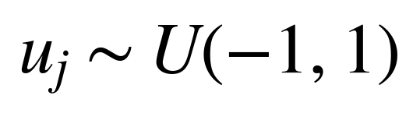
where u_j is the normalized coordinate for parameter j. The coordinate is
then decoded using the parameter's linear or logarithmic scaling. The method
does not learn from earlier candidates.
[ENGINEERING INTERPRETATION] Random Search has broad coverage and simple
reproducibility, but it spends evaluations without using measured gradients,
failure stage, or local response. In a sparse feasible region, success
probability depends strongly on the initial distribution and budget.

14.3 Cross-Entropy Method
[VERIFIED FROM SOURCE CODE] `experiments/train_cem.py` samples a population
from a factorized Gaussian in normalized coordinates. The documented defaults
include initial mean zero, initial standard deviation 0.15, population five,
and elite count two for the relevant CEM configuration. After scoring a
population, the elite mean and standard deviation are updated, with a
standard-deviation floor retained by the implementation. A single-elite
fallback shrinks the spread by the documented factor.
For normalized coordinate vector u ∈ R^d,
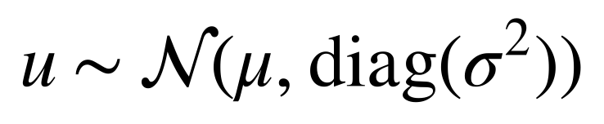
and for elite set E,
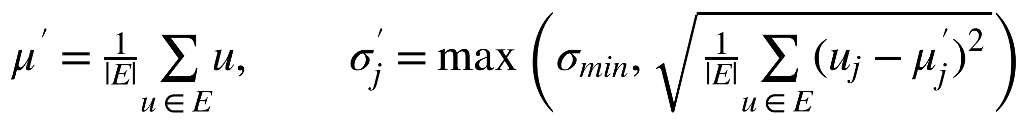
The equations describe the implemented family of update; exact population,
elite, and fallback values are controlled by the source and run configuration.

14.4 Comparison evidence
Optimizer | Search method | Budget | Best result | Runtime | Evidence
Random Search | Independent uniform normalized samples | 20 candidates in fair trial | 1/20 success | Not available in the comparison table | [VERIFIED FROM LOGS]
CEM | Gaussian population and elite update | 20 candidates in fair trial | 0/20 success | Not available in the comparison table | [VERIFIED FROM LOGS]
PPO | Sequential discrete policy actions | 20 candidates in fair trial | 0/20 success | Not available in the comparison table | [VERIFIED FROM LOGS]
CEM, warm-started | CEM near verified design | 13/30 planned before incomplete stop | 8/13 success | Not available in the comparison table | [VERIFIED FROM LOGS] Not comparable to uniform Random Search.
[VERIFIED FROM DOCUMENTATION] The fair head-to-head is one seed and carries a
statistical-power caveat. The warm-started CEM result is not a fair advantage
claim because initialization and completion differ.

14.5 Baseline limitations
[ENGINEERING INTERPRETATION] A 0/20 result can reflect reachability, short
horizon, early DC failure, target difficulty, or insufficient budget. It is
not enough to conclude an algorithm is intrinsically incapable. A stronger
comparison requires multiple independent seeds, identical ordered schemas,
matched evaluation budgets, raw metrics for every candidate, wall-clock
timing, and predeclared success criteria.
[NOT AVAILABLE IN THE PROVIDED EVIDENCE] A statistically powered, multi-seed,
real-SPICE comparison establishing a reliable ordering among PPO, Random
Search, and CEM is not present.

15. Caching, Provenance, Checkpoints, and Run Graphs

15.1 Content-addressed evaluation cache
[VERIFIED FROM SOURCE CODE] `simulator.cache.EvaluationCache` stores scalar
evaluation results under content-derived identifiers. The receiver identity
includes parameters, operating conditions, fidelity, implementation hashes,
bench hashes, channel identity, model-library dependencies, simulator identity,
and channel port map where relevant.
Conceptually,
where H is the stable fingerprint function and the I terms are content
identities. A cache hit is safe only when all those inputs match.
[VERIFIED FROM SOURCE CODE] Cache writes use an atomic lock-file protocol.
Malformed or obsolete cache entries are treated as misses rather than fatal
results. Eye-capture evaluations bypass the scalar cache because they require
additional bounded waveform data.

15.2 Provenance
`simulator.provenance.py` records Git identity, SHA-256 file hashes, model
dependency closure, ngspice executable/version, solver selection, and schema
versions. [VERIFIED FROM SOURCE CODE] The evaluator hashes all bench files and
the implementation modules that control receiver metrics. The purpose is to
prevent a result produced by one code/model/toolchain state from being
mistaken for a result produced by another.

15.3 Checkpoint contents
Checkpointing operates at two levels:
- inference-only policy exports for candidate generation;
- full training checkpoints for resume.
[VERIFIED FROM SOURCE CODE] Full checkpoints preserve optimizer and RNG state
as well as model weights and runtime contract information. v3 inference
requires metadata, whereas historical bare policy files remain part of the
legacy compatibility surface.

15.4 Run graphs and structured events
[VERIFIED FROM DOCUMENTATION] The UI and training path write per-step events
and execution graphs containing reset calls, actions, parameter changes,
stages, cache origins, failures, skipped stages, selection, verification, and
artifacts. JSON retains the complete graph; the visual overview is limited to
180 nodes.
[ENGINEERING INTERPRETATION] A run graph complements scalar metrics by
showing why a candidate reached or failed a stage. It is especially useful
for distinguishing a policy decision, cache reuse, simulator failure, and
qualification rejection.

15.5 Artifact integrity
[VERIFIED FROM SOURCE CODE] The Phase 2 artifact package includes a SHA-256
ledger and a test that compares every archived member with the recorded digest.
The repository also preserves crash logs, JSONL experiment records, plots,
schematics, and checkpoint files rather than replacing historical failures
with later successful runs.

16. Nominal Real-SPICE Results

16.1 Fresh measured result
[VERIFIED FROM RAW SIMULATION DATA] The fresh evidence file
`results/llm_wrapper_runs/smoke_evidence_demo.json` records the following
nominal result for the selected design and its stated TT/1.8 V/27 °C context.
Metric | Value | Unit | Source | Verification Status | Interpretation
Eye width | 0.73 | UI | `smoke_evidence_demo.json` | [VERIFIED FROM RAW SIMULATION DATA] | Exceeds the implemented candidate gate for that run.
Locked-phase eye height | 1.55 | V | Same | [VERIFIED FROM RAW SIMULATION DATA] | Vertical opening at selected phase.
Decision margin | 0.7294 | V | Same | [VERIFIED FROM RAW SIMULATION DATA] | Minimum signed sampled margin.
CTLE power | 1.206 | mW | Same | [VERIFIED FROM RAW SIMULATION DATA] | CTLE-level power, not total receiver power.
AC peaking | 3.599 | dB | Same | [VERIFIED FROM RAW SIMULATION DATA] | AC metric in the implemented peaking definition.
HD3 | -75.62 | dB | Same | [VERIFIED FROM RAW SIMULATION DATA] | 100 mVpp nominal HD3 result.
Input-referred noise | 0.372 | mVrms | Same | [VERIFIED FROM RAW SIMULATION DATA] | Integrated noise over the implemented band.
DFE errors | 0 | count | Same | [VERIFIED FROM RAW SIMULATION DATA] | Zero in the finite measured pattern.
Partial MOS channel area | 3.113×10^-6 | mm² | Same | [VERIFIED FROM RAW SIMULATION DATA] | Explicitly partial; not total-area evidence.

16.2 Result interpretation
[ENGINEERING INTERPRETATION] The nominal result demonstrates that one
metadata-compatible v3 policy can generate a candidate that reaches the
receiver-level gates and can be refined with noise and HD3 measurements. It
does not show that every policy rollout succeeds, that the design is best, or
that the nominal point remains valid over untested corners.
[VERIFIED FROM LOGS] The fresh nominal-only pipeline runtime was 330.67 s and
the smoke-evidence run with additional HD3/noise and PVT-smoke work was
1056.52 s. These times are run-specific and should not be generalized to all
machines or all candidates.

16.3 Historical specification artifact
[VERIFIED FROM RAW SIMULATION DATA] `results/design_a_final_specification.json`
contains PASS rows for measurable eye, power, peaking, HD3, and noise metrics,
while the transistor channel-area row is marked NOT CLAIMED for the complete
area requirement. This artifact is authoritative for its design and run
context; it is not evidence that total receiver area was measured.

16.4 Nominal result boundaries
The result is conditioned on the selected model library, channel, source and
termination settings, stimulus, fidelity, target, and checkpoint. [REQUIRES
FURTHER VERIFICATION] A result copied without those fields is not fully
reproducible. No silicon or post-layout measurement is associated with the
nominal JSON file.

16.5 User-supplied wrapper execution screenshot
[REPORTED IN PPT] A user-supplied screenshot titled by the user as proof of
the working wrapper shows a completed real-backend v3 execution. The visible
console record reports exit code 0, runtime 412.90 s, checkpoint
`results/ppo_v3_tt_1000_policy.pt`, and the following selected parameters and
measured rows:
Metric | Visible value | Unit | Visible status | Evidence interpretation
`rload_ohm` | 2457.14 | ohm | Selected parameter | [REPORTED IN PPT] Screenshot value; repository artifact remains the primary source.
`rdeg_ohm` | 485.714 | ohm | Selected parameter | [REPORTED IN PPT]
`cdeg_f` | 4.85714e-13 | F | Selected parameter | [REPORTED IN PPT]
`itail_a` | 0.00067 | A | Selected parameter | [REPORTED IN PPT]
`dfe_tap_v` | 0.0571429 | V | Selected parameter | [REPORTED IN PPT]
`mos_width_um` | 10.378 | um | Selected parameter | [REPORTED IN PPT]
`mos_length_um` | 0.15 | um | Selected parameter | [REPORTED IN PPT]
`mos_multiplier` | 1 | integer | Selected parameter | [REPORTED IN PPT]
Eye width | 0.76 | UI | PASS | Visible wrapper result; differs from other run artifacts and is not merged with them.
Eye height | 1.545 | V | PASS | Visible wrapper result; DFE/receiver metric as labelled by the wrapper.
Margin | 0.7281 | V | PASS | Visible wrapper result.
Power | 0.001206 | W | PASS | Visible CTLE power row, not total receiver power.
Peaking | 3.599 | dB | PASS | Visible AC metric.
HD3 | n/a | — | NOT CLAIMED | Screenshot explicitly says not executed, not a pass.
Input-referred noise | n/a | — | NOT CLAIMED | Screenshot explicitly says not executed, not a pass.
PVT | n/a | — | NOT CLAIMED | Screenshot explicitly says not executed, not a pass.
[Figure unavailable: source image not found in the available project evidence]
Figure 3. User-supplied wrapper console output showing a successful real-
backend v3 pipeline invocation, selected circuit parameters, measured nominal
PASS rows, and explicit NOT CLAIMED rows for unrequested HD3, noise, and PVT.
Evidence: user-supplied attachment “Pasted text #1”; the binary image was
not available as a local project asset, so no image is embedded above. This
screenshot's text transcript proves a completed wrapper invocation and its
displayed verdicts; it does not independently prove the underlying raw
waveform or model-library provenance.
[ENGINEERING INTERPRETATION] The screenshot is useful interface evidence
because it shows the wrapper returning a structured result rather than merely
printing a generic success message. Its values must remain a separate run
snapshot unless matched to a raw JSON artifact by checkpoint, target, channel,
conditions, and evaluation identity.
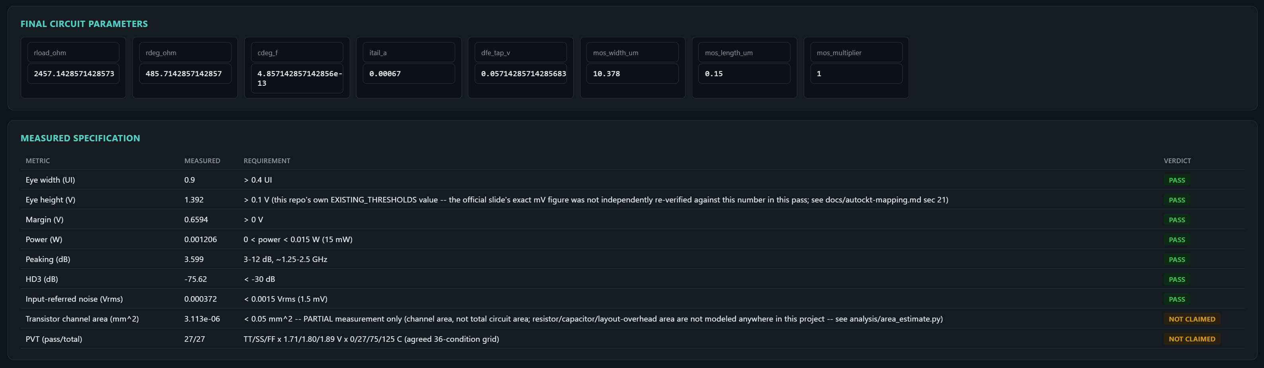
Figure 4. Dashboard final-parameter cards and measured-specification
table from a captured Nebula run — the one supplied image that shows genuine
application interface chrome (labelled parameter fields and a verdict table),
as distinct from the regenerated analysis charts in Section 19. Evidence:
`report_generation/figures/ppt_final_parameters_specification.png`, extracted
from the uploaded PPT; [REPORTED IN PPT]. The visible PASS/NOT CLAIMED rows
are interface output for that captured run and are not merged with the fresh
JSON result table above.

Final Selected Candidate
The table below records the candidate visible in the supplied working-wrapper
execution screenshot. It is kept separate from the fresh JSON result because
the screenshot reports a different eye width and runtime and does not expose
all provenance fields.
Field | Value | Unit/status | Evidence
`R_LOAD` | 2457.14 | ohm | [REPORTED IN PPT] User-supplied wrapper screenshot
`R_DEG` | 485.714 | ohm | [REPORTED IN PPT]
`C_DEG` | 4.85714e-13 | F | [REPORTED IN PPT]
`I_TAIL` | 0.00067 | A | [REPORTED IN PPT]
`V_DFE` | 0.0571429 | V | [REPORTED IN PPT]
`W_MOS` | 10.378 | um | [REPORTED IN PPT]
`L_MOS` | 0.15 | um | [REPORTED IN PPT]
`M_MOS` | 1 | integer | [REPORTED IN PPT]
Optimizer/checkpoint | PPO v3 / `results/ppo_v3_tt_1000_policy.pt` | — | [REPORTED IN PPT]
Random seed | Unavailable in the screenshot | — | [NOT AVAILABLE IN THE PROVIDED EVIDENCE]
Channel | Unavailable in the screenshot | — | [NOT AVAILABLE IN THE PROVIDED EVIDENCE]
Model library | Unavailable in the screenshot | — | [NOT AVAILABLE IN THE PROVIDED EVIDENCE]
Supply | Unavailable in the screenshot | — | [NOT AVAILABLE IN THE PROVIDED EVIDENCE]
Temperature | Unavailable in the screenshot | — | [NOT AVAILABLE IN THE PROVIDED EVIDENCE]
Simulation fidelity | Unavailable in the screenshot | — | [NOT AVAILABLE IN THE PROVIDED EVIDENCE]
Wrapper runtime | 412.90 | s | [REPORTED IN PPT]
Eye height | 1.545 | V | PASS shown; DFE/receiver metric
Eye width | 0.76 | UI | PASS shown; DFE/receiver metric
HD3 | Unavailable; NOT CLAIMED | — | [REPORTED IN PPT] Not executed
Input-referred noise | Unavailable; NOT CLAIMED | — | [REPORTED IN PPT] Not executed
Power | 0.001206 | W | PASS shown; CTLE-level power
Partial MOS channel area | 3.113e-06 | mm² | Explicitly partial area
PVT status | Unavailable; NOT CLAIMED | — | [REPORTED IN PPT] Not executed
[ENGINEERING INTERPRETATION] This is a selected candidate snapshot, not a
universal final-design claim. Complete area, total receiver power, SF/FS PVT,
HD3, and noise cannot be inferred from the screenshot's nominal PASS rows.

17. PVT Qualification Results

17.1 Condition sets
[VERIFIED FROM SOURCE CODE] The full grid is
with corners TT, SS, FF, SF, FS; supplies 1.71, 1.80, and 1.89 V; and
temperatures 0, 27, 75, and 125 °C. The agreed qualification grid is
using TT, SS, and FF. The minimal historical grid contains 27 TT/SS/FF
conditions with the documented temperature subset.

17.2 Historical finalist result
[VERIFIED FROM DOCUMENTATION] The dated v3 qualification artifact reports:
Design | Nominal status | Corner result | Status | Verification
`pipeline_ep0` | PASS at nominal 512 and 1024-bit contexts | 36/36 | Qualified for the documented grid | [VERIFIED FROM RAW SIMULATION DATA] Historical
`pipeline_ep1` | PASS at nominal contexts | 18/36 | Rejected by PVT | [VERIFIED FROM RAW SIMULATION DATA] Historical
The corner ranges recorded for `pipeline_ep0` include HD3 from -79.8428 to
-69.6987 dB, input-referred noise from 0.000328262 to 0.00048729 Vrms, eye
height from 1.27665 to 1.65185 V, eye width from 0.71 to 0.78 UI, CTLE power
from 0.0011457 to 0.0012663 W, and zero observed errors across the reported
conditions. [VERIFIED FROM RAW SIMULATION DATA] These values are historical
candidate-fidelity results, not a fresh final-fidelity rerun.

17.3 Qualification semantics
A PVT pass is a conjunction over the evaluated condition set:
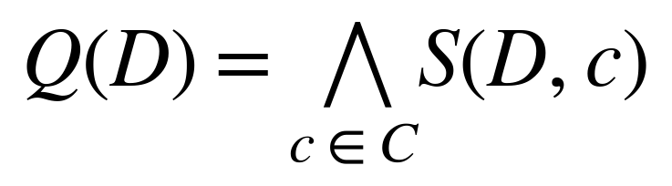
where D is a design, C is the required condition set, and
S(D,c) is the strict stage and metric success for condition c. If a
condition is not run, it cannot contribute a PASS. If a run is interrupted or
times out, the condition remains incomplete or failed according to the result
contract.
[VERIFIED FROM DOCUMENTATION] The historical artifact records 36/36 on the
TT/SS/FF grid. [NOT AVAILABLE IN THE PROVIDED EVIDENCE] A completed full
60-condition qualification is not present.

17.4 Fresh final-fidelity status
[VERIFIED FROM LOGS] A recorded final-fidelity run completed and passed three
of 36 conditions before it was stopped. The measured pace
was approximately eight minutes per condition. This is evidence of runtime
cost and partial progress, not a complete final-fidelity qualification.

17.5 Why both 27 and 36 appear in the evidence
The 27-point and 36-point results are different condition sets, not duplicate
claims. [VERIFIED FROM RAW SIMULATION DATA] The preserved
`design_a_pvt_minimal27.jsonl` and `_rerun.jsonl` files each contain 27
conditions covering TT/SS/FF, 1.71/1.80/1.89 V, and temperatures 0, 27, and
125 °C. The 75 °C row is absent from that minimal set.
[VERIFIED FROM RAW SIMULATION DATA] The v3 qualification artifact contains 36
required conditions covering the same three process corners and supply values,
but temperatures 0, 27, 75, and 125 °C. The historical `pipeline_ep0` result
is therefore 36/36 on the four-temperature TT/SS/FF grid. The 27-condition
heatmaps describe the separate minimal historical grid and should not be
read as 36-point qualification or as five-corner 60-point qualification.
[VERIFIED FROM SOURCE CODE] The full defined grid adds SF and FS and contains
60 conditions. No artifact in the provided evidence establishes 60/60.

18. PPO Learning and Optimizer Comparison

18.1 Training evidence
[VERIFIED FROM RAW SIMULATION DATA] The v3 summary records a completed real-
backend training run with seed 101, 100 updates, and 692 evaluations. Its
best-reward and candidate information are preserved in the summary JSON.
[ENGINEERING INTERPRETATION] This proves that the training loop can execute
through real evaluation and save a usable v3 policy. It does not establish
that the policy converged globally or that learning caused the eventual
success rather than the initialization, target, action reachability, or
selection process.

18.2 Fair comparison
Optimizer | Search method | Budget | Best result | Runtime | Evidence
PPO | Sequential discrete policy | 20 | 0/20 | Not recorded in comparison summary | [VERIFIED FROM LOGS]
Random Search | Uniform normalized sampling | 20 | 1/20 | Not recorded in comparison summary | [VERIFIED FROM LOGS]
CEM | Gaussian elite update | 20 | 0/20 | Not recorded in comparison summary | [VERIFIED FROM LOGS]
[VERIFIED FROM DOCUMENTATION] The study used one seed and carries an explicit
low-statistical-power caveat. The correct conclusion is that PPO superiority
was not demonstrated under this setup, not that PPO is universally inferior.

18.3 Unseen-target and frozen-policy evidence
[VERIFIED FROM RAW SIMULATION DATA] The controlled unseen-target artifact
records regression described as one win, six ties, and three losses for the
trained policy comparison. The project therefore does not claim reliable
generalization to unseen targets.
[VERIFIED FROM DOCUMENTATION] The v3 midpoint comparison evaluates frozen
policies and excludes pretraining cost. It is evidence about a specific
frozen-policy experiment, not a multi-seed learning comparison.

18.4 Learning conclusion
The defensible claim is narrow: Nebula implements PPO training, preserves
versioned checkpoints, and has real-backend training and inference evidence.
The evidence does not support a stronger claim that PPO is the most efficient
optimizer, generalizes reliably, or removes the need for baseline search.

What the Optimizer Experiments Establish
[VERIFIED FROM SOURCE CODE] PPO, Random Search, and CEM are integrated into
the same broader receiver-evaluation workflow. [VERIFIED FROM LOGS] The fair
head-to-head record is PPO 0/20, Random Search 1/20, and CEM 0/20 under one
seed and a matched small budget. A separate warm-started CEM result is not
comparable to the unbiased trial.
These experiments establish implementation and feasibility evidence: each
optimizer can consume the project parameter schema and submit candidates to
the evaluation pipeline. They do not establish PPO superiority, near-
optimality, or global optimality. The comparison is limited by seed count,
evaluation budget, incomplete raw-data availability for some historical runs,
initialization asymmetry in non-controlled trials, and statistical power.
[ENGINEERING INTERPRETATION] The correct use of the comparison is to test
whether the optimizer integrations work and whether feasible designs can be
found under stated budgets. A conclusive optimizer ranking would require
matched multi-seed real-SPICE experiments, identical initialization policy,
raw metrics for every request, wall-clock measurements, and a predeclared
statistical analysis.

19. Eye Diagrams, AC Response, HD3, and Noise

19.1 Eye artifacts
[VERIFIED FROM RAW SIMULATION DATA] The repository contains
`results/v3_tt_1000_eye.png`, SVG, and bounded eye-source JSON artifacts. The
source data distinguish a continuous transistor-level CTLE output eye from
behavioral DFE corrected samples. The DFE panel must not be captioned as a
transistor-level waveform.
The eye artifact is generated after selection when eye capture is requested;
training does not capture and render eyes for every PPO step. Missing waveform
data are reported as not produced rather than fabricated.

19.2 AC response
[VERIFIED FROM SOURCE CODE] AC data are produced by the logarithmic 1 MHz to
20 GHz bench and reduced to scalar gains, peaking, response class, shelf
metrics, and group-delay metrics. The historical tuning artifact reports
three target frequencies, with one of three measured points within ±5%.
Target | Measured | Within ±5% | Evidence
1.25 GHz | 1.320527183368927 GHz | No | [VERIFIED FROM RAW SIMULATION DATA]
1.875 GHz | 1.908910958457706 GHz | Yes | [VERIFIED FROM RAW SIMULATION DATA]
2.5 GHz | 2.295117021187582 GHz | No | [VERIFIED FROM RAW SIMULATION DATA]
This is sampled nominal tuning evidence. [REQUIRES FURTHER VERIFICATION]
Continuous tuning compliance and receiver/noise/HD3 compliance at every
tuning setting are not demonstrated.

19.3 HD3 and noise evidence
Metric | Value | Unit | Condition | Source | Verification
HD3 | -75.62 | dB | Nominal, 100 mVpp differential | `smoke_evidence_demo.json` | [VERIFIED FROM RAW SIMULATION DATA]
Input-referred noise | 0.372 | mVrms | Nominal, 10 MHz–5 GHz | Same | [VERIFIED FROM RAW SIMULATION DATA]
Historical HD3 range | -79.8428 to -69.6987 | dB | 36 candidate-fidelity conditions | v3 qualification artifact | [VERIFIED FROM RAW SIMULATION DATA]
Historical noise range | 0.328262 to 0.48729 | mVrms | 36 candidate-fidelity conditions | Same | [VERIFIED FROM RAW SIMULATION DATA]

19.4 Figure status
The eye PNG/SVG is available. [NOT AVAILABLE IN THE PROVIDED EVIDENCE] A
retained raw AC trace suitable for a new report-specific gain curve is not
available for every result discussed. Dashboard screenshots of the rendered
eye, PVT page, and run graph are not available as browser screenshots in the
supplied evidence (see §20.3–§20.4). The supplied PPT/evidence package
does contain regenerated analysis charts covering AC response, PVT
heatmaps, temperature sensitivity, and metric/runtime evolution, built from
stored 27-corner and per-request result data; these are included in the
report-local `figures/` directory with captions and are labelled as
presentation/regenerated-artifact evidence rather than fresh reruns. Several
of the supplied filenames (for example the two containing the word
"dashboard") do not describe an application screenshot — each image was
opened and inspected directly before captioning, and captions below describe
what is actually visible, not what the filename implies.
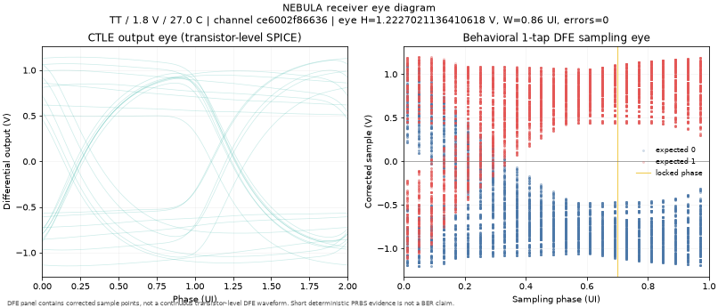
Figure 5. Repository-backed receiver eye artifact separating the
transistor-level CTLE output eye from the behavioral one-tap DFE sampling eye.
Evidence: `results/v3_tt_1000_eye.png`; [VERIFIED FROM RAW SIMULATION
DATA]. The DFE panel contains corrected sample points, not a physical DFE
waveform.
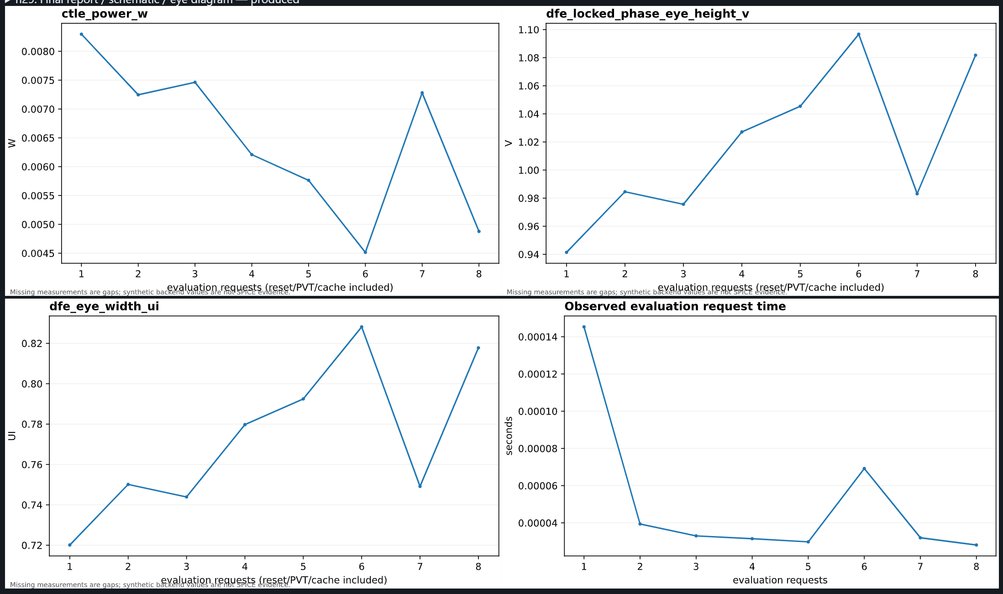
Figure 6. Captured metric and evaluation-time plots (CTLE power, locked-
phase eye height, eye width, and observed request time) against successive
evaluation requests, including reset/PVT/cache-hit requests. Evidence:
`report_generation/figures/ppt_metric_and_runtime_plots.png`; [REPORTED IN PPT].
The source image's own caption states that missing measurements and synthetic
values are not SPICE evidence; the visible header strip indicates the image
was cropped from a larger produced-report/schematic view.
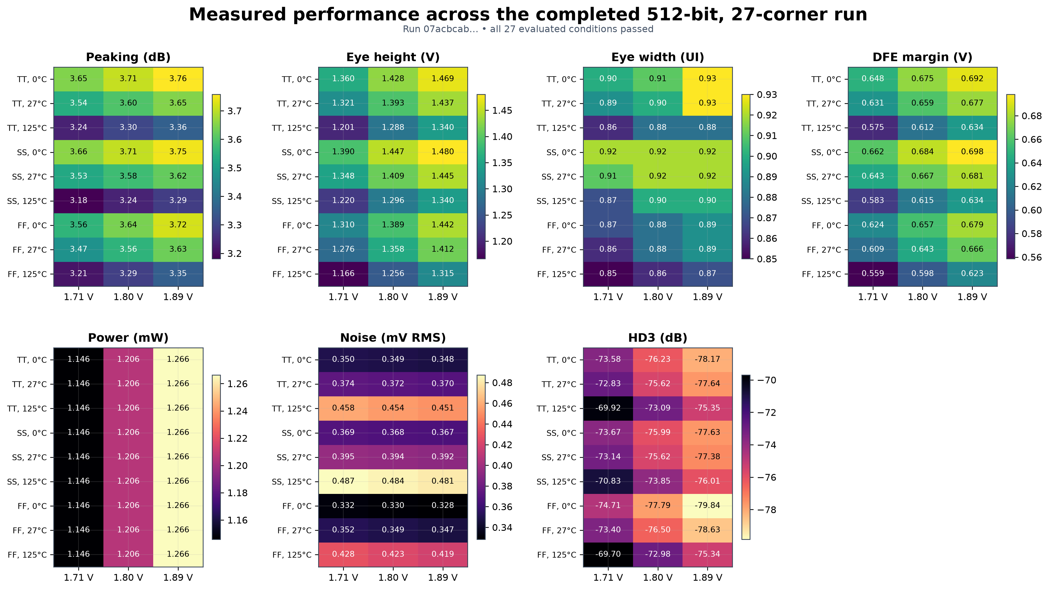
Figure 7. Regenerated 27-condition (TT/SS/FF x 1.71/1.80/1.89 V x 0/27/125
degC) performance heatmaps for peaking, eye height, eye width, DFE margin,
power, noise, and HD3, titled "Measured performance across the completed
512-bit, 27-corner run" in the source image. Evidence:
`report_generation/figures/ppt_dashboard_overview.png`; [REPORTED IN PPT].
Despite its filename, this image is a regenerated analysis chart, not an
application/dashboard screenshot — confirmed by direct inspection. It is
evidence of the 27-point grid only, not of SF/FS coverage or the full
60-condition grid, and not of a completed FINAL-fidelity rerun. Two further
supplied images (`ppt_ac_corner_sensitivity.png`, `ppt_ac_peak_sensitivity.png`)
regenerate the peaking/peak-frequency slice of this same 27-condition data
from separate snapshots and are consistent with the values shown here; they
are not reproduced as separate figures to avoid near-duplicate content, but
remain available in `report_generation/figures/` as supplementary evidence.
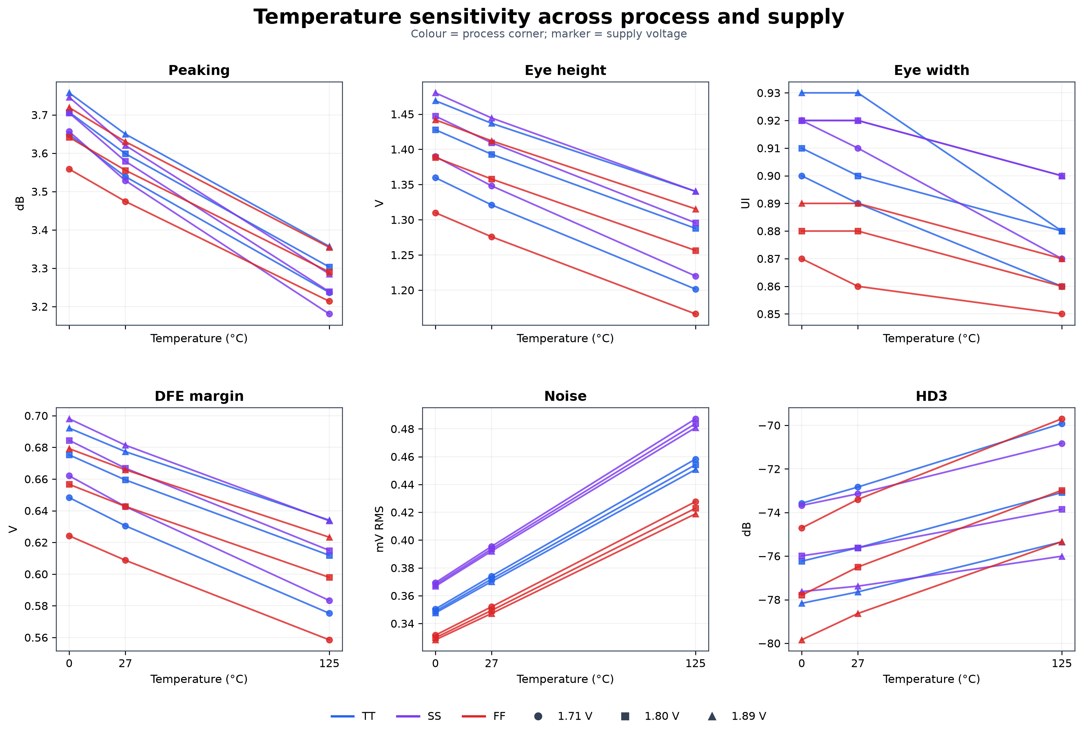
Figure 8. Regenerated temperature sensitivity of peaking, eye height, eye
width, DFE margin, noise, and HD3 across the TT/SS/FF corners and three
supply voltages, at 0/27/125 degC. Evidence:
`report_generation/figures/ppt_dashboard_detail.png`; [REPORTED IN PPT].
Despite its filename, this image is also a regenerated analysis chart, not an
application/dashboard screenshot. It is drawn from the same 27-condition
result set as Figure 7 and does not extend coverage to 75 degC, SF, or FS.
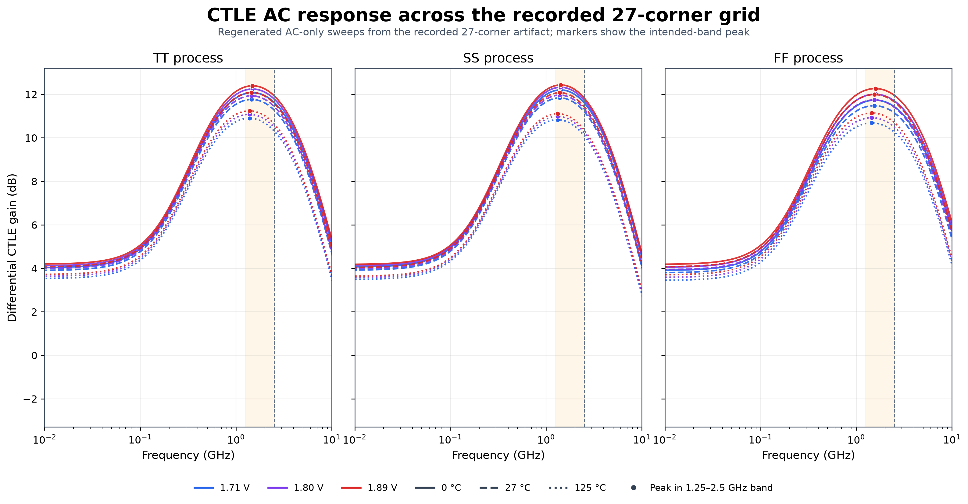
Figure 9. AC gain-versus-frequency curves for the TT/SS/FF corners at
three supply voltages and three temperatures, regenerated from the recorded
27-corner artifact, with the intended 1.25-2.5 GHz band and peak marked.
Evidence: `report_generation/figures/ppt_ac_response_27_corners.png`;
[REPORTED IN PPT]. This is regenerated historical-artifact evidence, not a
fresh rerun; a second, separately regenerated version of the same underlying
chart type is also present in `figures/` (`ppt_temperature_sensitivity.png`,
which — despite its filename — is confirmed by inspection to be an AC
response chart, not a temperature-sensitivity chart) and is not reproduced
here to avoid duplicating Figure 9.

20. Dashboard and LLM Wrapper

20.1 Dashboard architecture
[VERIFIED FROM SOURCE CODE] `experiments/web_ui.py` exposes a local interface
for selecting backend, checkpoint, RL version, channel, target, PVT options,
HD3/noise options, and output artifacts. It launches the pipeline as a
subprocess instead of importing the core simulator and policy code into the
web server.
The UI supports circuit generation and PPO checkpoint training. It exposes
run graphs, plots, JSON results, schematics, and eye artifacts when those
artifacts were produced by the underlying run.

20.2 Natural-language wrapper
[VERIFIED FROM SOURCE CODE] `nebula/llm_wrapper.py` parses a user request,
constructs the pipeline command, runs it as a subprocess, and returns the
structured output. Deterministic parsing is available through the local
parser; an optional Anthropic provider is also implemented with fallback
behavior.
The wrapper does not run a separate metric model. It does not calculate eye
height, invent a PVT verdict, or replace the deterministic final-specification
assessment. [ENGINEERING INTERPRETATION] This division keeps natural-language
convenience separate from electrical truth.

20.3 Interface evidence
Interface feature | Evidence | Status
Generate and verify circuits | `experiments/web_ui.py` and wrapper outputs | [VERIFIED FROM SOURCE CODE]
Train a v3 checkpoint | UI command construction and training path | [VERIFIED FROM DOCUMENTATION]
Download graphs and JSON | Results and graph artifacts | [VERIFIED FROM RAW SIMULATION DATA]
Final-parameter and measured-specification card view | Figure 4 (§16.5) | [REPORTED IN PPT]
Browser screenshot of the control panel (target/backend/channel/checkpoint selectors) | No such screenshot found in the supplied evidence | [NOT AVAILABLE IN THE PROVIDED EVIDENCE]
Browser screenshots for every screen (run graph, PVT screen, rendered eye) | No complete screenshot set | [NOT AVAILABLE IN THE PROVIDED EVIDENCE]
LLM-generated electrical verdict | Not used; deterministic pipeline remains authoritative | [VERIFIED FROM SOURCE CODE]

20.4 What the supplied images establish
Every image supplied for this report was opened and inspected directly before
being described here. Two of the supplied filenames contain the word
"dashboard" (`ppt_dashboard_overview.png`, `ppt_dashboard_detail.png`), which
could be read as implying a captured application screenshot showing the
control panel described in `experiments/web_ui.py` (target selection, backend
selection, channel choice, checkpoint selection). Direct inspection shows
neither image is that: both are regenerated matplotlib analysis charts (the
27-condition PVT heatmap grid and the temperature-sensitivity chart reproduced
as Figures 7 and 8 in §19.4). No browser screenshot of the control panel
itself is present in the supplied evidence. [NOT AVAILABLE IN THE PROVIDED
EVIDENCE] This is recorded as missing evidence, not implied by a filename.
[REPORTED IN PPT] The one supplied image that does show genuine application
interface chrome is `ppt_final_parameters_specification.png` (Figure 4,
§16.5): labelled parameter fields and a measured-specification table with
PASS/NOT CLAIMED verdicts. It establishes that the interface can render a
final-parameter card and a verdict table for a captured run. It does not
establish that every other displayed chart in this report was generated by
that same run, that any browser view was captured during the wrapper
screenshot's 412.90 s execution, or that the LLM itself designed or validated
a transistor circuit. [VERIFIED FROM SOURCE CODE] The repository remains the
primary evidence that the wrapper shells out to
`experiments.run_autockt_pipeline` and that the deterministic pipeline
computes metrics and verdicts.

21. Verification and Test Coverage

21.1 Live regression status
[VERIFIED FROM LOGS] The live command `python -m pytest -q tests/` completed
with 632 passed, 2 skipped, and 27 subtests passed. Older documents report
419 and 582 tests because the suite grew; those historical counts are not used
as the current total.

21.2 Test categories
Area | Representative tests | What is checked
Circuit and parser | `test_ctle.py`, `test_parser.py`, `test_ngspice.py` | Parameter handling, parsing, simulator contracts
Receiver | `test_receiver_components.py`, `test_evaluate_pvt_grid.py` | Stage metrics and PVT control flow
PPO v1/v2 | `test_autockt_rl.py`, `test_rl_ppo_v2.py` | Legacy behavior, validity, reward, truncation
Checkpoints | `test_rl_checkpoint.py`, `test_v3_integration.py` | Save/load, compatibility, metadata
Synthetic learning | `test_synthetic_benchmark.py`, `test_rl_ppo_v2_ablation.py` | Mechanics without ngspice
Baselines | `test_train_cem.py`, `test_benchmark_report.py` | Search mechanics and result consolidation
PVT and qualification | `test_pvt_sweep.py`, `test_qualification_sequence.py` | Condition sets, stopping, qualification gates
Reporting/UI | `test_final_specification.py`, `test_v3_dashboard.py`, `test_web_ui.py` | Verdicts, plots, interface command construction
Artifact integrity | `test_artifact_integrity.py` | SHA-256 package membership and contents

21.3 What tests do not prove
[ENGINEERING INTERPRETATION] Unit and integration tests prove contracts and
control flow, not physical validity over all parameter values. Synthetic PPO
tests prove learning mechanics on the controlled synthetic landscape, not
analog circuit optimization. The optional SKY130 integration test depends on
local model-library configuration and can be skipped.
[NOT AVAILABLE IN THE PROVIDED EVIDENCE] Tests do not substitute for silicon,
post-layout extraction, jitter tolerance, mismatch/Monte Carlo, or a complete
PCIe compliance test suite.

22. Limitations and Missing Evidence

22.1 Physical-model limitations
- The DFE is behavioral, not transistor-level. [VERIFIED FROM SOURCE CODE]
- The tail current source is ideal in the Stage-1 CTLE. [VERIFIED FROM SOURCE CODE]
- Passive devices are ideal SPICE R/C elements, not layout-extracted devices.
[VERIFIED FROM SOURCE CODE]
- Physical sampler, clocking, DFE power, and DFE area are absent. [VERIFIED
FROM DOCUMENTATION]
- Total circuit area and total receiver power are not available. [NOT
AVAILABLE IN THE PROVIDED EVIDENCE]

22.2 Validation limitations
- The public IEEE/IBM channel is not PCI-SIG compliance evidence. [VERIFIED
FROM DOCUMENTATION]
- SF and FS corners exist in the 60-point grid but are not part of the
demonstrated 36-point qualification. [VERIFIED FROM SOURCE CODE]
- The final-fidelity 36-condition rerun for the fresh design is incomplete.
[VERIFIED FROM LOGS]
- Zero finite-pattern errors are not a BER guarantee. [VERIFIED FROM
DOCUMENTATION]
- Continuous tuning, jitter, mismatch, and Monte Carlo signoff are not
demonstrated. [NOT AVAILABLE IN THE PROVIDED EVIDENCE]

22.3 Optimization limitations
- Fair PPO superiority is not demonstrated. [VERIFIED FROM LOGS]
- Multi-seed real-SPICE optimizer statistics are missing. [NOT AVAILABLE IN
THE PROVIDED EVIDENCE]
- Arbitrary-start reliable convergence is not demonstrated. [VERIFIED FROM
DOCUMENTATION]
- Surrogate-assisted and multi-actor PPO are not implemented. [VERIFIED FROM
DOCUMENTATION]

22.4 Evidence-management limitations
- Some historical training commands are not recorded verbatim. [NOT
AVAILABLE IN THE PROVIDED EVIDENCE]
- Hardware CPU/GPU details are not supplied for all historical runs. [NOT
AVAILABLE IN THE PROVIDED EVIDENCE]
- No browser screenshot of the dashboard control panel (target, backend,
channel, or checkpoint selection) is present; two supplied files whose
names suggest a dashboard capture are, by direct inspection, regenerated
analysis charts rather than application screenshots (§19.4, §20.4). [NOT
AVAILABLE IN THE PROVIDED EVIDENCE]
- The Phase 2 artifact count and later checksum-ledger count differ by one
file and were not independently reconciled. [REQUIRES FURTHER VERIFICATION]

23. Conclusions and Required Next Work

23.1 Failed Approaches and Lessons Learned
The repository preserves several negative or incomplete outcomes that are
useful engineering evidence rather than defects to hide.
Observed failure or gap | Lesson | Required next experiment
Fair PPO trial reached 0/20 while Random Search reached 1/20 | PPO's current action reachability, horizon, initialization, and state/reward contract do not prove an advantage | Matched multi-seed, budget-matched real-SPICE comparison
Many candidates failed at early DC/AC stages | Early rejection is necessary, but early failures can provide little learning signal | Measure failure-stage distributions and compare v1/v2/v3 reward/state contracts
Historical 36/36 result covers TT/SS/FF only | Passing the agreed grid is not five-corner qualification | Complete SF/FS conditions in the defined 60-point grid
Area is only matched-MOS channel area | Partial geometry cannot support total-area compliance | Add passive, sampler, DFE, routing, and layout-overhead models
DFE remains behavioral | Receiver eye evidence does not prove a physical DFE | Implement and simulate a transistor-level sampler/DFE
Only one of three tuning targets met the recorded ±5% criterion | Nominal sampled tuning is not continuous tuning compliance | Run receiver/noise/HD3 checks across the required frequency range
Long runs are expensive and crash logs are preserved | Runtime and native-tool stability affect reproducibility | Record machine/toolchain data and run controlled repeated evaluations
[VERIFIED FROM DOCUMENTATION] These observations come from preserved result
files, audit documents, and source-level failure handling. [ENGINEERING
INTERPRETATION] Each next experiment is a proposed closure step, not a claim
that the current repository already performs it.

23.2 Conclusions
Nebula demonstrates a functioning, versioned analog-design automation flow:
target specification enters a PPO or baseline search, candidates are mapped
to a parameterized SKY130 CTLE, ngspice produces staged measurements, a
behavioral DFE produces receiver-level metrics, and a deterministic reporting
layer records PASS, FAIL, or NOT CLAIMED.
[VERIFIED FROM SOURCE CODE] The project has clear ownership boundaries among
optimization, simulation, analysis, and interfaces. [VERIFIED FROM RAW
SIMULATION DATA] Real-SPICE nominal and historical qualification artifacts
exist. [VERIFIED FROM LOGS] The current software regression suite passes.
The strongest defensible result is therefore an integrated Stage-1
demonstration, not a complete physical receiver product. One historical
candidate passed the agreed 36-condition TT/SS/FF grid at candidate fidelity,
while another finalist failed part of that grid. Fresh nominal evidence
shows successful eye, power, HD3, noise, and finite-pattern error metrics for
one selected run. Neither result establishes total chip area, physical DFE
operation, silicon performance, or PCIe compliance.

23.3 Required next work
The following work is required to strengthen the engineering claim:
1. Implement a physical sampler and transistor-level DFE, including power and
area accounting.
2. Replace ideal passive assumptions with documented PDK or extracted layout
models.
3. Complete a defensible total-area model and retain the `NOT CLAIMED` gate
until all blocks and layout overhead are represented.
4. Run matched, multi-seed, budget-matched PPO/Random Search/CEM comparisons
with wall-clock and raw metric records.
5. Complete the full 60-condition PVT grid, or explicitly redefine the
qualification requirement with external approval.
6. Add PRBS15, jitter, mismatch, Monte Carlo, and long-run error testing.
7. Establish continuous tuning evidence across the required frequency range.
8. Obtain approved PCIe channel and compliance-test evidence.
9. Record original training commands, machine information, and complete
dashboard screenshots for future reproducibility.
[VERIFIED FROM DOCUMENTATION] These are repository-documented deferred items.
They are proposals for completion, not claims that the current repository
already implements them.

References
Internal repository documents cited in this report
- `docs/V3_QUALIFICATION_RESULTS_20260913.md` — historical 36-condition PVT qualification results for `pipeline_ep0`/`pipeline_ep1` (§16, §17).
- `docs/AGREED_QUALIFICATION.md` — agreed qualification scope and simulated-bit-count record (§16, Appendix E).
- `docs/FINAL_TECHNICAL_AUDIT.md` — second qualified/near-qualified design record and SIGSEGV crash-log references (§16, §21).
- `docs/RL_PPO_V2_STUDY.md` — PPO v2 root-cause and state/reward design notes (§12).
- `docs/V3_TRAINING_AND_RUN_GRAPHS.md` — v3 training/run-graph documentation and an older test-suite snapshot (§13, §21, Appendix F).
- `docs/PHASE7_COMPLETION_REPORT.md` — an older test-suite snapshot (§21).
- `docs/stage1-decisions.md` — deferred Stage-2 scope (§23).
- `artifacts/PHASE2_ARTIFACT_INDEX.md` — Phase 2 artifact package file count, used in the file-count discrepancy note (Appendix F).
- `results/ppo_v3_tt_1000_policy.pt`, `results/v3_tt_1000_summary.json` — genuine v3 checkpoint and training summary (§13, §18).
- `results/benchmark_report.json` — fair PPO/Random Search/CEM head-to-head comparison (§14, §18).
- `results/baseline_comparison_summary.json` — non-controlled Random Search/CEM comparison (§14).
- `results/v3_qualification_final_20260913.json` — historical PVT qualification artifact (§17).
- `results/llm_wrapper_runs/smoke_evidence_demo.json` — fresh real-SPICE nominal and smoke-evidence run (§16, §19).
Primary source modules cited throughout — see Appendix A for the full index; principal entry points are `experiments/run_autockt_pipeline.py`, `simulator/receiver.py::evaluate_receiver`, `simulator/config.py`, `simulator/design_schema.py`, `rl/autockt_v3.py`, `nebula/llm_wrapper.py`, and `analysis/final_specification.py`.
External standards and tools referenced for context
- SkyWater Foundry / Google open-source SKY130 process design kit — source of the `sky130_fd_pr__nfet_01v8` device model used in `circuits/blocks/ctle.spice` (§6). Cited as the device-model source only; this report makes no claim of PDK-vendor validation or sign-off.
- ngspice, the open-source circuit simulator invoked via `simulator/ngspice.py` (§8–§9, §15). The supplied evidence does not pin a specific ngspice release number.
- Touchstone (SNP) S-parameter file format — used for the four-port channel models parsed by `simulator/channel.py` (§5).
- IEEE 802.3 — source naming convention for the supplied `ieee802_ibm_20db_thru.s4p` reference channel (§5); its own metadata states it is not PCIe compliance evidence, and this report repeats that caveat rather than asserting protocol conformance.
- PCI Express (PCIe) Gen-2 signaling context (5 GT/s, 2.5 GHz Nyquist) — used only to justify the bit-rate default in `simulator/stimulus.py` (§2, §5). This report does not cite a specific PCI-SIG specification revision and makes no claim of electrical, protocol, or compliance-test conformance to it (§22).

24. Appendices

Appendix A. Source and artifact index
Evidence group | Primary paths
CTLE netlist | `circuits/blocks/ctle.spice`
SPICE benches | `circuits/benches/`
Receiver evaluator | `simulator/receiver.py`
Channel parser | `simulator/channel.py`
Waveform metrics | `simulator/waveform.py`
DFE and eyes | `simulator/receiver_metrics.py`
Parameter schema | `simulator/design_schema.py`, `simulator/config.py`
PPO v1/v2/v3 | `rl/autockt_*.py`, `rl/ppo_agent.py`, `rl/trainer.py`
Pipeline | `experiments/run_autockt_pipeline.py`
Baselines | `experiments/receiver_search.py`, `experiments/train_cem.py`
Analysis/reporting | `analysis/`
Tests | `tests/`
Fresh results | `results/llm_wrapper_runs/`, `report_generation/verified_results.md`
Historical qualification | `results/v3_qualification_final_20260913.json`, `docs/V3_QUALIFICATION_RESULTS_20260913.md`
Report-local figures | `report_generation/figures/` | PPT-derived figures and repository eye artifact

Appendix B. Evidence-status vocabulary
Label | Meaning
[VERIFIED FROM SOURCE CODE] | Direct implementation or test evidence
[VERIFIED FROM RAW SIMULATION DATA] | Value read from a result artifact
[VERIFIED FROM LOGS] | Value confirmed by command or run logs
[REPORTED IN PPT] | Presentation context not sufficient by itself
[VERIFIED FROM DOCUMENTATION] | Explicit project documentation evidence
[ENGINEERING INTERPRETATION] | Technical interpretation, not a raw measurement
[NOT AVAILABLE IN THE PROVIDED EVIDENCE] | No supplied supporting artifact
[REQUIRES FURTHER VERIFICATION] | Partial, historical, or unresolved evidence

Appendix C. Important numerical results
Metric | Value | Unit | Source | Verification Status | Interpretation
Fresh eye height | 1.55 | V | `smoke_evidence_demo.json` | [VERIFIED FROM RAW SIMULATION DATA] | Nominal selected run
Fresh eye width | 0.73 | UI | Same | [VERIFIED FROM RAW SIMULATION DATA] | Nominal selected run
Fresh CTLE power | 1.206 | mW | Same | [VERIFIED FROM RAW SIMULATION DATA] | CTLE-level only
Fresh HD3 | -75.62 | dB | Same | [VERIFIED FROM RAW SIMULATION DATA] | 100 mVpp nominal test
Fresh noise | 0.372 | mVrms | Same | [VERIFIED FROM RAW SIMULATION DATA] | 10 MHz–5 GHz integration
Historical PVT | 36/36 | conditions | v3 qualification artifact | [VERIFIED FROM RAW SIMULATION DATA] | TT/SS/FF candidate fidelity
Fair PPO | 0/20 | successes | benchmark report | [VERIFIED FROM LOGS] | One-seed comparison
Live tests | 632 passed, 2 skipped | tests | pytest output | [VERIFIED FROM LOGS] | Current regression result

Appendix D. Figure register
Figures are numbered in document order. "Content verified by direct
inspection" means the image file was opened and viewed during this reporting
pass and its caption describes what is actually visible, independent of its
filename.
Figure | Section | Content | Source file | Status
1 | 6 | CTLE schematic (matched MOS pair, loads, RC degeneration, tail source) | `figures/ppt_ctle_topology.png` | Supplied PPT asset; content verified by direct inspection
2 | 9 | Optimization and verification flow (candidate search; selection and verification) | `figures/ppt_optimization_flow.png` | Supplied PPT asset; content verified by direct inspection
3 | 16 | Working-wrapper console result (text transcript only; no image file) | User-supplied attachment "Pasted text #1" | Image not mounted as a local project asset; see unavailable-figure notice
4 | 16 | Final circuit-parameter cards and measured-specification table (PASS/NOT CLAIMED) | `figures/ppt_final_parameters_specification.png` | Supplied PPT asset; the one image confirmed to show genuine application interface chrome
5 | 19 | Receiver eye diagram (CTLE output eye and behavioral DFE sampling eye) | `results/v3_tt_1000_eye.png` | Repository-backed raw artifact
6 | 19 | Metric and runtime plots vs. evaluation request index | `figures/ppt_metric_and_runtime_plots.png` | Supplied PPT asset; content verified by direct inspection
7 | 19 | 27-condition PVT performance heatmaps (peaking, eye height, eye width, DFE margin, power, noise, HD3) | `figures/ppt_dashboard_overview.png` | Supplied asset; filename says "dashboard" but content verified by direct inspection to be a regenerated analysis chart, not an application screenshot
8 | 19 | Temperature sensitivity (peaking, eye height, eye width, DFE margin, noise, HD3 vs. temperature) | `figures/ppt_dashboard_detail.png` | Supplied asset; filename says "dashboard" but content verified by direct inspection to be a regenerated analysis chart, not an application screenshot
9 | 19 | AC gain vs. frequency across the 27-corner grid (TT/SS/FF) | `figures/ppt_ac_response_27_corners.png` | Supplied PPT asset; content verified by direct inspection
Supplementary, non-figure-numbered images present in `report_generation/figures/`
but not separately reproduced as report figures (to avoid near-duplicate
content already covered by Figures 7 and 9): `ppt_ac_corner_sensitivity.png`
and `ppt_ac_peak_sensitivity.png` (peaking/peak-frequency slices of the same
27-condition data as Figure 7, from separate regeneration passes) and
`ppt_temperature_sensitivity.png` (a second, separately regenerated AC
response chart of the same type as Figure 9, despite its filename). All three
were opened and inspected directly; none contradicts the figures above.

Appendix E. Reproduction checklist
1. Use the repository revision and compatible Python environment.
2. Configure `NGSPICE_EXECUTABLE` and `SKY130_MODEL_LIBRARY`.
3. Select the correct RL version and metadata-compatible checkpoint.
4. Record target values, channel path, port map, fidelity, PVT condition set,
seed, horizon, and evaluation budget.
5. Run the requested pipeline and retain JSON/JSONL outputs and provenance.
6. Treat synthetic backend results as software-mechanics evidence only.
7. Do not promote partial area, incomplete PVT, or finite-pattern zero errors
into stronger claims.
8. Compare any new result with the source-linked evidence tables before
updating a conclusion.

Appendix F. Unavailable information register
The following remain explicitly unavailable in the provided evidence:
- complete receiver/chip area;
- total receiver power;
- transistor-level sampler and DFE results;
- post-layout extraction and DRC closure;
- silicon or commercial-SPICE cross-validation;
- full five-corner 60-condition completed qualification;
- multi-seed statistically powered optimizer superiority;
- guaranteed BER, jitter, mismatch, and Monte Carlo signoff;
- continuous tuning compliance;
- complete dashboard screenshot set;
- original v3 training command and all machine specifications.
These omissions are limitations of the evidence base, not values to be
estimated from unrelated artifacts.

Appendix G. Evidence and Reproducibility Notes
The report distinguishes source-code contracts, raw result artifacts, command
logs, historical documentation, and presentation screenshots. Source code
defines implemented behavior; raw JSON/JSONL and waveform artifacts support
measured values; logs support execution and timing; documentation records
historical scope and limitations; screenshots support only what is visibly
shown. These evidence classes are not interchangeable.
Reproducible claims should identify the repository revision, netlists and model
library, channel and port map, checkpoint/schema, seed, fidelity, operating
condition, target, result artifact, and whether the evidence is fresh,
historical, or synthetic. `simulator/provenance.py`, the ngspice wrapper, and
v3 checkpoint metadata implement much of this identity tracking. Missing
fields remain unavailable rather than being reconstructed from screenshots.
[Figure unavailable: the complete combined CTLE schematic-and-parameter image
supplied in the final review message is not mounted as a local project asset.
The report includes the available CTLE schematic figure and the source-backed
parameter table separately in Section 6.]
The 27-point and 36-point PVT artifacts are intentionally reported as
different grids: 27 points use TT/SS/FF with 0/27/125 °C, while 36 points use
TT/SS/FF with 0/27/75/125 °C. The defined 60-point grid adds SF and FS. This
distinction is part of the evidence record, not a presentation preference.

