* Source Code (mt19aie323-helloiitj.py) :- This program created in python which prints "Hello IITJ" 5 times in every 2 seconds.
* 2) Dockerfile :- The second step is to create a file including all the command which will be used to execute source code on any of the platform. This file contains given commands on this implementation

FROM python:3

RUN mkdir WORK_REPOSITORY

RUN cd WORK_REPOSITOY

WORKDIR /WORK_REPOSITOY

ADD mt19aie323-helloiitj.py .

CMD ["python", "-u", "mt19aie323-helloiitj.py"]

* Build the image using given command

docker build -t mt19aie323-helloiitj .

* Run the docker image

docker run mt19aie323-helloiitj

We can see created docker image (**mt19aie323-helloiitj**) in VM

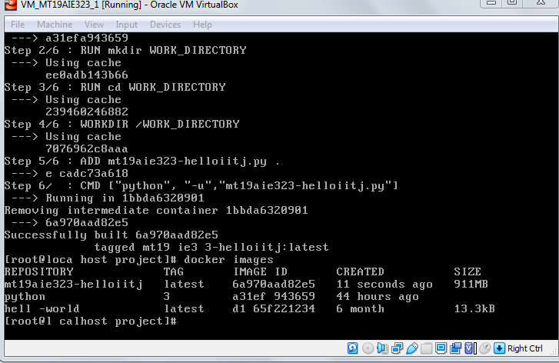

Run the document images and it will display what was expected from the program.

