IndiaWorks Unified SaaS - Business Requirements Document (BRD)
Employer Subscription + Job Promotion + Candidate Marketplace
IndiaWorks | Unified SaaS Architecture v7
Generated 25 September 2026
Baseline: v5 Unified SaaS + v6 Product/Technical Review + v7 Five-Candidate Commercial Gate

1. Executive Summary
IndiaWorks is a two-sided hiring SaaS marketplace for India. Candidates use a low-friction mobile OTP flow to discover and apply to relevant jobs. Employers create verified organisations, subscribe on a trial/monthly/yearly basis, publish structured jobs, search relevant candidate profiles, reveal permitted candidate contact details, and optionally promote job visibility. The commercial model is organisation-centric and entitlement-based; it does not sell unrestricted raw candidate database exports.
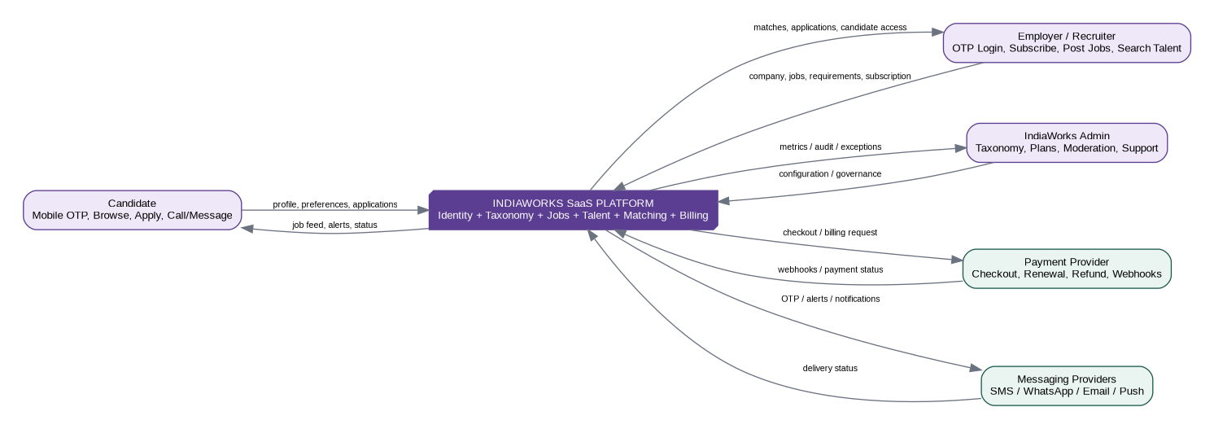
Business context / DFD Level 0

2. Source Baseline and Design Continuity
Source artifact | What is retained
Employer/Auth/Job Posting Taxonomy GraphQL Architecture v3 | Multi-tenant organisation model, structured taxonomy, job requirements, candidate search, contact policy, privacy/audit boundary.
Candidate Onboarding & Application Architecture v4 | Mobile OTP, progressive profile, jobs feed/search, soft-vs-hard application gating, application snapshot/event model, direct employer contact policy, alerts and candidate discoverability.

3. Business Vision
- Enable enterprises, startups, MSMEs and businesses to hire frontline, skilled, service, gig and professional talent using structured requirements rather than unstructured CV search.
- Enable candidates to reach jobs with minimal onboarding friction and to control whether their profile is discoverable beyond jobs they applied to.
- Monetise employer access through trial, monthly and yearly subscriptions plus controlled job-promotion/add-on products.
- Create a reusable India-specific occupation, skills, credentials, geography and engagement taxonomy that powers both job posting and candidate matching.
- Provide measurable hiring outcomes: search-to-contact, application-to-shortlist, time-to-fill, hires, and promoted-job lift.

4. Actors and Stakeholders
Actor | Primary goals | Commercial / access relationship
Candidate | Find nearby/relevant work, apply quickly, contact employer where allowed, receive alerts. | Free user; no subscription required.
Employer Owner/Admin | Create organisation, subscribe, manage recruiters, jobs, billing and usage. | Pays for organisation plan/add-ons.
Recruiter | Post jobs, search candidates, shortlist, reveal contact, manage applications. | Consumes organisation entitlements.
Billing Admin | Manage plan, invoices, payment method and renewals. | Organisation role.
IndiaWorks Admin | Manage plans, taxonomy, moderation, support, audit and analytics. | Platform operator.
Payment Provider | Collect subscription/add-on payments and emit payment/renewal/refund events. | External integration.
Messaging Provider | OTP, alerts and transactional notifications. | External integration.

5. Business Model
Pricing amounts are intentionally configuration, not schema. The platform supports three core billing modes and optional add-ons:
Offering | Billing behavior | Typical entitlement pattern
Trial | Free evaluation/trial entry point. Candidate access is hard-gated after five lifetime distinct candidate unlocks unless the organisation upgrades. | 5 distinct candidate unlocks (reset NONE), masked browsing, limited active jobs/seats/promotion as configured.
Monthly | Recurring monthly subscription. | Monthly-reset usage limits and/or included credits.
Annual | Recurring yearly subscription, usually discounted commercially. | Annual commitment; usage can reset monthly or annually by entitlement definition.
Add-on | One-time or recurring purchase. | Extra contact reveals, promotion credits, recruiter seats, API/export package.

6. End-to-End Business Flows

6.1 Employer commercial flow
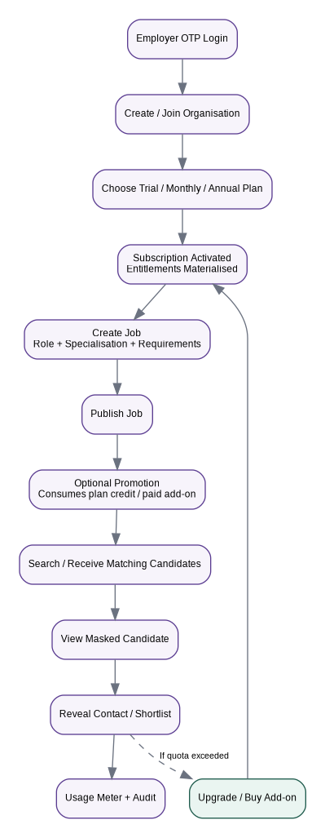

6.2 Candidate flow
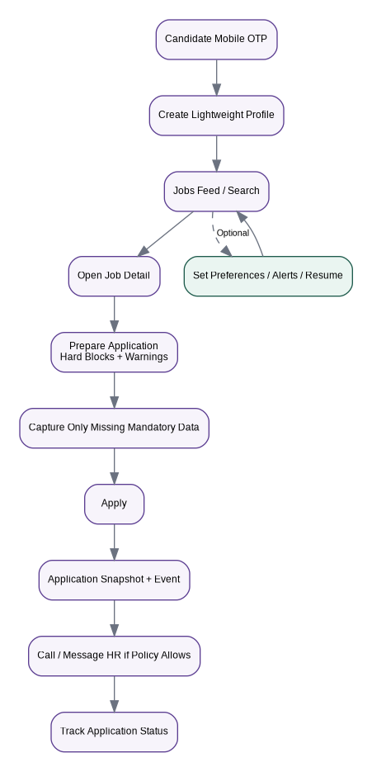

7. Business Requirements
ID | Area | Requirement | Priority
BR-001 | Candidate access | Candidates shall authenticate using mobile OTP and reach the jobs feed without mandatory full-profile completion. | MUST
BR-002 | Employer access | Employers shall authenticate using verified mobile or email OTP and operate within an organisation tenant. | MUST
BR-003 | Organisation tenancy | Subscriptions, usage, jobs and recruiter permissions shall belong to an organisation, not an individual recruiter. | MUST
BR-004 | Plan catalogue | IndiaWorks shall support configurable Trial, Monthly and Annual plans. | MUST
BR-005 | Entitlements | Each plan shall define feature access and limits including active jobs, candidate searches, CANDIDATE_UNLOCK, contact reveals, recruiter seats and promotion credits. | MUST
BR-006 | Billing lifecycle | The platform shall handle trial, active, past-due, cancelled, expired and suspended subscription states. | MUST
BR-007 | Structured jobs | Employers shall post jobs using canonical Role/Specialisation/Work Context plus independent engagement, work mode, geography, compensation and requirements. | MUST
BR-008 | Candidate discovery | Subscribed employers shall search only candidates permitted by candidate discoverability/consent and plan entitlements. | MUST
BR-009 | Masked results | Candidate search results shall mask contact PII until a permitted reveal/contact action. | MUST
BR-010 | Contact metering | Contact reveal/contact initiation shall be auditable and consume entitlements exactly once using idempotency. | MUST
BR-011 | Job promotion | Employers shall promote eligible published jobs using plan credits or paid add-ons. | SHOULD
BR-012 | Promotion fairness | Promotion shall boost only jobs that already pass eligibility and relevance rules; it shall not bypass hard requirements. | MUST
BR-013 | Application | Candidates shall apply with minimum friction; soft preference mismatches warn but do not block. | MUST
BR-014 | Hard eligibility | Only explicit legal, safety or genuinely mandatory credential requirements should block application. | MUST
BR-015 | Application history | The system shall preserve application status history and apply-time snapshots. | MUST
BR-016 | Direct contact | Candidate call/message actions shall obey each job contact policy and window. | SHOULD
BR-017 | Candidate alerts | Candidates may opt into job alerts independently from authentication consent. | SHOULD
BR-018 | Taxonomy governance | Taxonomy and external mappings shall be versioned and administratively governed. | MUST
BR-019 | Usage transparency | Employer admins shall see plan limits, current usage, renewal/trial date and upgrade options. | MUST
BR-020 | Auditability | Candidate access, reveals, exports, plan changes, payment status changes and administrative overrides shall be auditable. | MUST
BR-021 | Privacy | Candidate talent-pool discoverability shall be a separate purpose/consent from applying to one job. | MUST
BR-022 | Notifications | OTP, billing, job/application and alert communications shall respect channel preferences and purpose. | MUST
BR-023 | Admin operations | Admins shall configure plans, entitlements, promotion products, taxonomy and moderation controls without code changes where practical. | SHOULD
BR-024 | Analytics | The platform shall measure funnel metrics without exposing unnecessary candidate PII. | SHOULD
BR-025 | Extensibility | The commercial layer shall not require separate schemas for blue/white/grey/service/gig workers. | MUST

8. Core Business Rules
- A candidate is free to browse/apply; employers fund the marketplace.
- A plan is a versioned commercial product. Entitlements are features/limits attached to a plan version.
- Publishing a job requires a valid organisation membership and an entitlement permitting an additional active job.
- Candidate search and contact reveal are separate entitlements. Search does not automatically grant contact access.
- One contact reveal should be idempotently metered per configured policy (for example per candidate per organisation, or per candidate/job pair). This policy is configuration and must be explicit.
- Job promotion has a defined start/end window and boost weight. Promotion is never a substitute for candidate/job eligibility.
- Applications remain valid historical records even if the employer subscription later lapses; employer access to new candidate discovery may be restricted.
- Candidate discoverability defaults to APPLIED_JOBS_ONLY; broader talent-pool visibility is separately consented.
- Payment-provider state is external evidence; IndiaWorks maintains its own canonical subscription state and reconciles webhooks idempotently.

9. Success Metrics
Metric family | Examples
Acquisition | Employer signup-to-trial, candidate OTP completion, recruiter activation.
Monetisation | Trial-to-paid conversion, monthly/annual mix, ARPA, add-on revenue, renewal/churn.
Hiring | Time to first qualified candidate, time to first contact, time to fill, application-to-shortlist, shortlist-to-hire.
Marketplace quality | Eligible match rate, candidate response/contact rate, job freshness, duplicate/fraud rate.
Promotion | Promoted-job impressions, qualified views, applications, contacts and incremental lift vs baseline.
Candidate experience | Job view-to-apply, application completion, alert engagement, withdrawal rate.

10. Scope and Release Boundaries
MVP | Later / optional
OTP auth; organisations/RBAC; trial/monthly/yearly plans; entitlements; structured jobs; candidate feed/search; applications; employer talent search; masked cards; contact reveal; promotion credits; payment webhooks; basic admin/audit. | Advanced ATS integrations; bulk API; AI-generated job descriptions; automated verification partners; ML learning-to-rank; payroll; background checks; interview video; referral marketplace.

11. Risks and Controls
Risk | Control
Subscription logic scattered across resolvers | Central EntitlementService; GraphQL resolvers call it rather than implementing plan rules.
Paid promotion harms relevance | Apply eligibility/relevance first; bounded promotion boost second; log ranking reason.
Candidate PII scraping | Mask by default; entitlement-gated reveal; rate limits; audit; export controls.
Taxonomy fragmentation | Versioned canonical taxonomy + aliases; no UI-label-as-schema shortcuts.
Candidate onboarding abandonment | Progressive capture; just-in-time fields; resume optional.
Payment webhook duplication/out-of-order delivery | Webhook inbox + idempotency key + provider event timestamp/version reconciliation.

12. Reference Lineage
This BRD is derived from the two approved IndiaWorks source artifacts above. External regulatory and market references already captured by those artifacts remain applicable, including NCO/NIC/NSQF taxonomy sources, NCS jobseeker/employer flows, UIDAI offline identity-verification guidance and India DPDP privacy requirements. The unified document does not replace legal review for production launch.

v7 commercial gate - five free candidates
Rule: A verified organisation/legal entity receives five lifetime free DISTINCT candidate unlocks. The sixth distinct candidate requires a paid monthly/yearly/add-on CANDIDATE_UNLOCK entitlement.
Rule | v7 behavior
Masked discovery | Applicant/search result cards and candidate counts are visible in masked form without consuming an unlock.
Consumption key | Only first full-profile access of a distinct (OrganisationId, CandidateProfileId) consumes candidate access.
Scope | The five free candidates are shared by every recruiter, every job and every candidate-access surface in the organisation.
No reset | Free allowance never resets by month, billing period, new recruiter, new job, device, cancellation or re-sign-up.
Duplicate candidate | Re-opening the same candidate or finding the same candidate against another job does not consume again.
Privacy first | Consent/application context, discoverability and candidate-organisation block rules are evaluated before payment/entitlement.
Paid access | Paid plan/add-on entitlements can grant further CANDIDATE_UNLOCK units or unlimited access.
Contact | Candidate contact reveal remains separately consent checked, entitlement checked and audited.
Abuse control | Commercial identity fingerprint/risk controls prevent recreating organisations purely to regain five free candidates.

v6 product/technical gap review integrated into v7
Area | Business decision
Authentication | One UserAccount may be both candidate and employer. Sessions are persistent/revocable and users switch active persona.
Employer team | Organisation invitations, seat limits and RBAC are explicit lifecycle concepts.
Job lifecycle | Job status and moderation status are independent; only published+approved+unexpired jobs are discoverable.
Job details | Compensation, shift/timing, benefits, location, skills, credentials, contact windows and interview information are structured.
Filters | Role, location/radius, work mode/type, experience, education/course, pay, shift, freshness, urgency, language/skills/credentials/assets, benefits and trust/source are independent facets.
Alerts | Saved filter, alert schedule and delivery history/deduplication are separate entities.
Share | Stable public/deep links use public code/slug and attribution rather than only a share event.
Employer CRM | EmployerCandidateRelationship persists across jobs; Application remains candidate-to-job.
Trust & safety | Report/block/moderation flows are first-class business requirements.

Updated business acceptance scenarios
- Candidate can complete OTP and browse/filter jobs without completing a full profile or resume.
- Employer can post a structured job and see masked applicants/candidate search results.
- Organisation unlocks distinct candidates 1 through 5 free; the sixth returns a visible upgrade paywall when no paid entitlement exists.
- Two recruiters in the same organisation cannot each obtain a separate set of five free candidates.
- A candidate already unlocked through Job A is still unlocked when found through Job B and does not consume another unit.
- After payment, entitlement is activated by reconciled provider state and the protected candidate action can be retried successfully.
- Paid promotion never overrides hard eligibility, candidate privacy/block state or job moderation state.

Updated release dependency
S0 Foundation -> S1 Identity/Tenancy/Free Allowance -> S2 Billing/Entitlement/Paywall -> S3 Employer Job Authoring -> S4 Candidate Discovery/Application -> S5 Applicant CRM + Paywall -> S6 Paid Candidate Database -> S7 Alerts/Promotion -> S8 Trust/Admin/Analytics -> S9 Hardening/UAT/Launch.

