IndiaWorks Unified SaaS - Data Flow Diagrams (DFD)
v7 | Five-candidate commercial gate + unified employer/candidate flows
  - Generated 25 September 2026

1. DFD Level 0 - Context
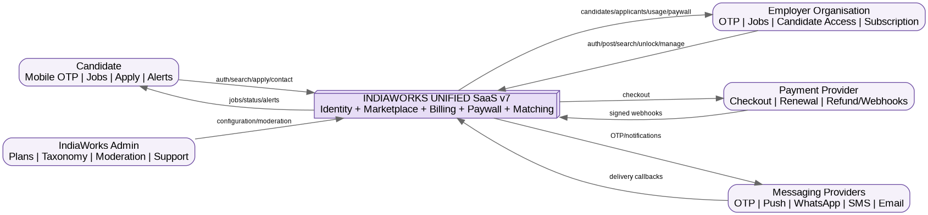
External actors and IndiaWorks system boundary.

2. DFD Level 1 - Platform Processes
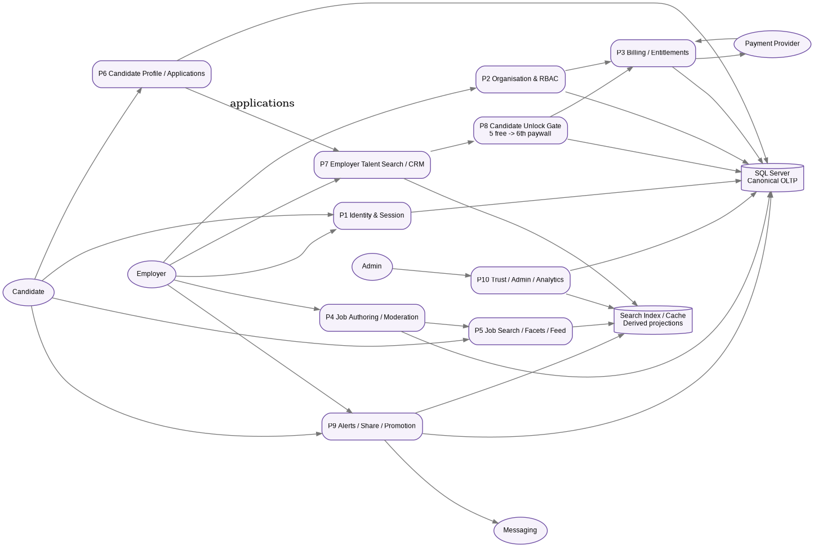
Logical processes, canonical SQL store and derived search/index store.

3. DFD Level 2 - Organisation Candidate Unlock / Paywall
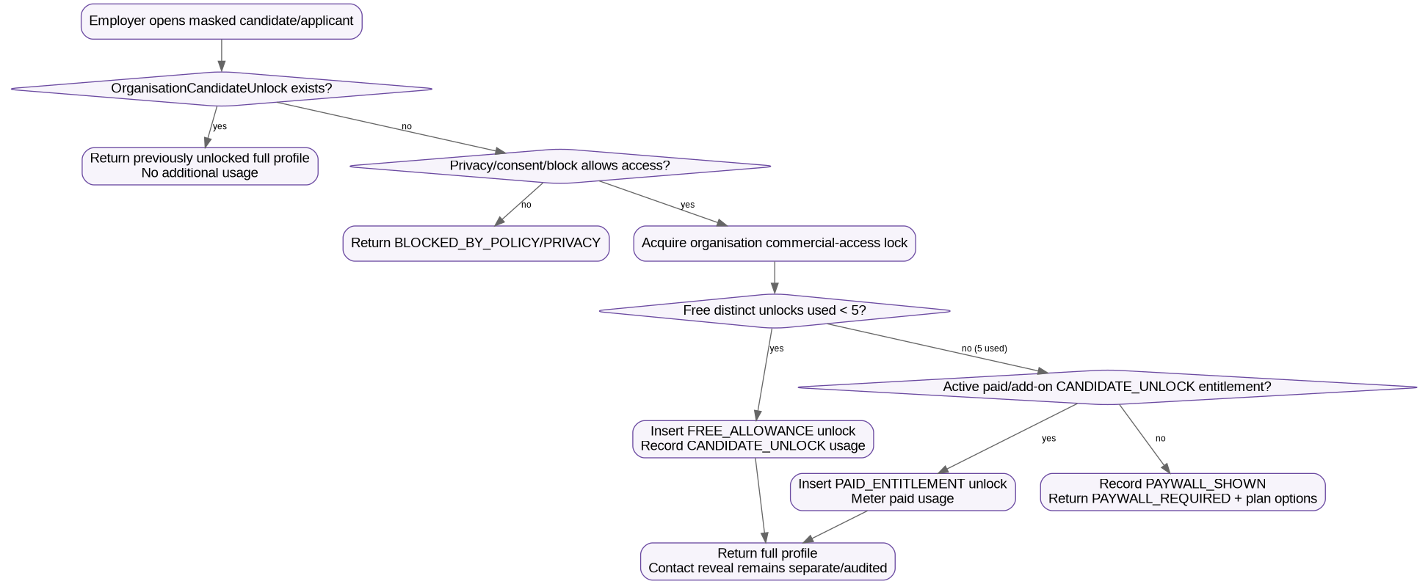
The first five distinct candidate unlocks are free organisation-wide; the sixth requires paid entitlement.

4. Candidate Flow
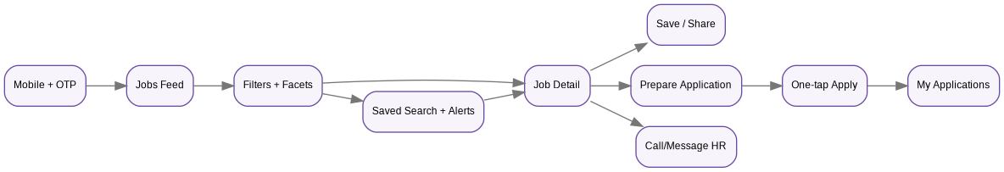
OTP -> feed -> filters -> job detail -> save/share/apply/contact/alerts.

5. Employer Flow
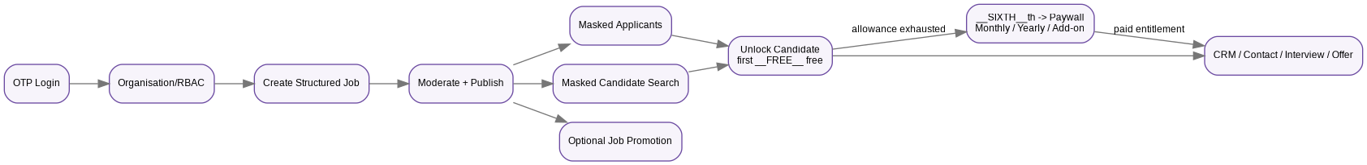
OTP -> organisation -> job -> applicants/search -> five-free gate -> paywall/paid access -> CRM.

6. Principal data stores
Store | Data owned | Important v7 rule
D1 Identity | UserAccount, identifiers, OTP audit, UserSession/UserDevice | One identity can have candidate and employer personas.
D2 Organisation | Organisation, membership, invitations, verification | Organisation/legal entity is paywall scope.
D3 Billing | Plans, versions, entitlements, subscription, usage, invoices/webhooks | CANDIDATE_UNLOCK free=5 reset NONE; paid rules centrally resolved.
D4 Jobs | JobPosting and structured requirements, schedule, compensation, moderation | Search-critical job details are structured.
D5 Candidate | CandidateProfile, occupations, skills, credentials, preferences, consent | Progressive/low-friction candidate profile.
D6 Applications/CRM | Applications/snapshots/events + EmployerCandidateRelationship | Candidate-to-job and organisation-to-candidate are separate.
D7 Candidate Access | OrganisationCandidateUnlock, CandidateContactReveal, CandidatePaywallEvent | Distinct full-profile value event and contact audit.
D8 Alerts/Share | SavedJobSearch, alert runs/deliveries, public/share links | Watermark/dedupe and stable deep links.
D9 Search index | JobSearchDocument, CandidateSearchDocument | Derived; excludes contact/identity PII.

7. Trust boundaries and order of checks
- Authentication/session -> organisation RBAC -> candidate privacy/block -> commercial entitlement/paywall -> resource mutation.
- Search indexes are not the authority for consent, billing or contact reveal; final protected actions re-check canonical state.
- Payment provider events enter through signed/idempotent webhook inbox before subscription/entitlement state changes.
- Messaging provider callbacks update delivery state but do not directly mutate candidate/job business state.
- Admin overrides of free candidate allowance, moderation or trust state are privileged and audited.

