IndiaWorks Unified SaaS - Technical Architecture & Data Design
DFD, database domains, GraphQL, entitlements, search, security and deployment
IndiaWorks | Unified SaaS Architecture v7
Generated 25 September 2026
Baseline: v5 Unified SaaS + v6 Product/Technical Review + v7 Five-Candidate Commercial Gate

1. Architecture Principles
- SQL Server is the canonical transactional store; search projections/indexes are derived and rebuildable.
- GraphQL is product-facing and does not expose database tables directly.
- Organisation is the SaaS tenancy/billing boundary; UserAccount is the identity boundary.
- Subscription authorization is centralized in EntitlementService.
- Occupation taxonomy remains independent from collar market tags, industry, engagement and work mode.
- Candidate privacy is enforced before commercial entitlement; payment never overrides candidate consent.
- Eligibility filtering precedes semantic relevance and promotional boost.
- Write-side domain events use an outbox/inbox pattern for payment, search-index and messaging reliability.

2. System Context / DFD Level 0
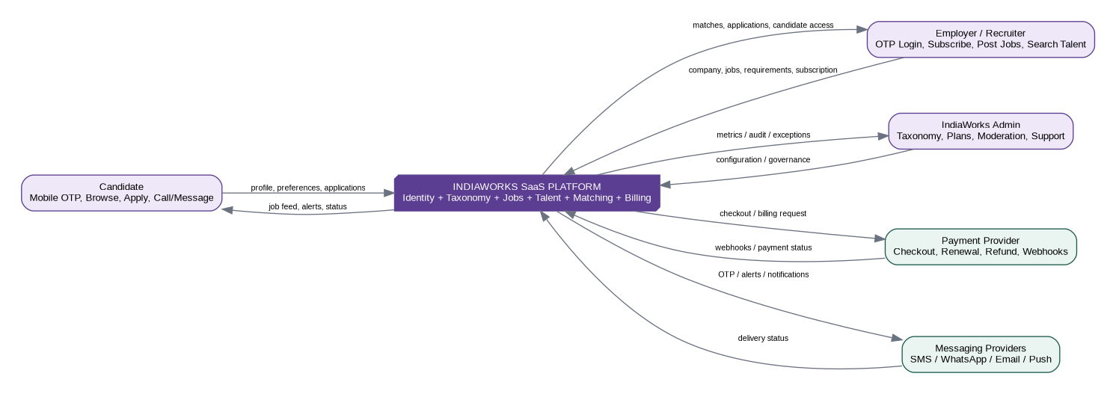

3. DFD Level 1
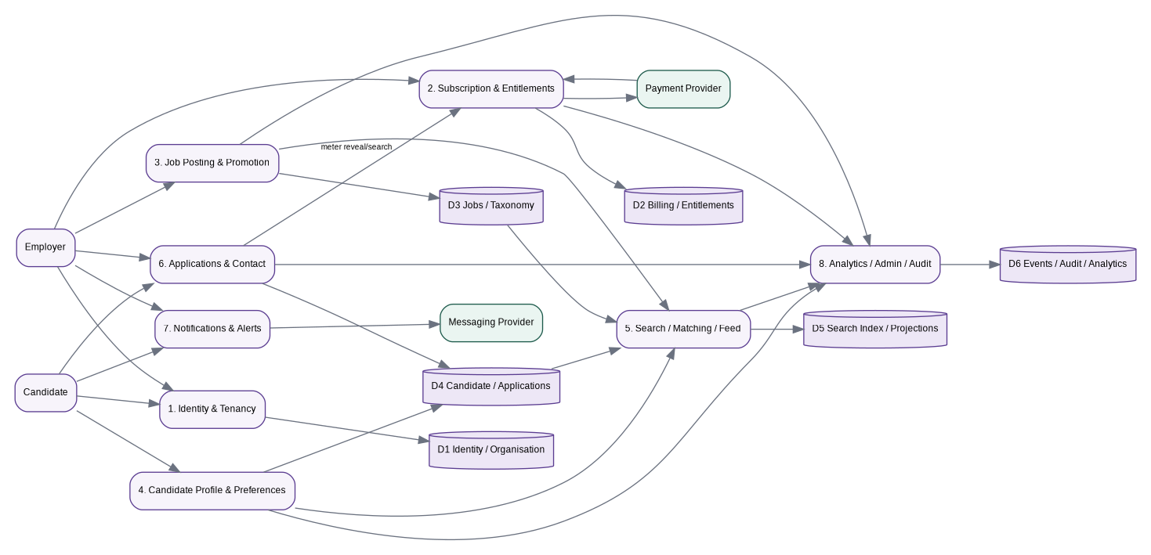

4. Logical Component Architecture
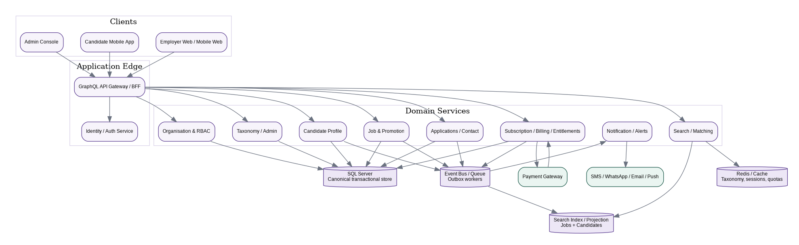

5. Domain Boundaries
Domain | Owns | Does not own
Identity | UserAccount, LoginIdentifier, OTP/session security. | Organisation subscription or candidate work profile.
Organisation | Organisation, memberships, identifiers, locations, RBAC. | Candidate profile.
Taxonomy | TaxonomyVersion, JobFamily, Role, Specialisation, WorkContext, Skill, CredentialType, AssetType. | Employer/candidate transactional state.
Billing | Plan, PlanVersion, Entitlements, Subscription, Usage, Invoice/Payment metadata, provider webhooks. | Job ranking or candidate consent.
Jobs | JobPosting and structured requirements, compensation, schedule, contact policy. | Candidate employment history.
Promotion | PromotionProduct, JobPromotion, promotion attribution. | Eligibility truth.
Candidate | CandidateProfile, occupations, skills, credentials, assets, preferences, consent. | Organisation plan.
Applications | CandidateApplication, snapshots, answers, events, employer workflow. | Billing plan definitions.
Matching/Search | Derived JobSearchDocument/CandidateSearchDocument and ranking logic. | Canonical PII.
Notification | Alert subscriptions/preferences and delivery jobs. | Authentication truth.
Audit/Analytics | Access logs, event facts, operational metrics. | Business source-of-truth records.

6. Unified Database Relationship
UserAccount
├─ LoginIdentifier / OtpChallenge
├─ OrganisationMembership ── Organisation ── OrganisationSubscription
│ ├─ JobPosting ── JobPromotion
│ ├─ SubscriptionUsageEvent
│ └─ CandidateAccessAudit
└─ CandidateProfile
├─ CandidateOccupation / Skill / Credential / Asset / Preference / Consent
├─ CandidateApplication ─────────────── JobPosting
├─ JobAlertSubscription
└─ CandidateContactEvent
SubscriptionPlan -> SubscriptionPlanVersion -> PlanEntitlement
OrganisationSubscription -> UsageEvent / BillingInvoice / PaymentTransaction
JobPosting -> Role/Specialisation/WorkContext + requirement tables
CandidateProfile -> Candidate search projection (derived)
JobPosting -> Job search projection (derived)

7. SaaS/Billing Data Model
Entity | Key fields / purpose
SubscriptionPlan | Stable product identity: STARTER/PRO/BUSINESS etc; marketing name and availability.
SubscriptionPlanVersion | Immutable price/interval/config version: TRIAL/MONTHLY/YEARLY, currency, amount, effective dates.
EntitlementDefinition | Feature/quota code such as ACTIVE_JOBS, CANDIDATE_SEARCH, CONTACT_REVEAL, RECRUITER_SEAT, PROMOTION_CREDIT, EXPORT, API_ACCESS.
PlanEntitlement | Limit/feature value for a plan version; reset cadence and enforcement mode.
OrganisationSubscription | Current subscription state, provider refs, trial/period dates, cancellation behavior.
EntitlementUsageEvent | Immutable metering event with quantity, reference, period and idempotency key.
PaymentProviderCustomer | Maps organisation to external billing customer id.
BillingInvoice | Provider invoice/order reference, total, currency, state, due/paid dates.
PaymentTransaction | Attempt/refund/payment evidence; no card secrets.
BillingWebhookInbox | Raw verified provider event metadata + processing state/idempotency.

8. Promotion Data Model
Entity | Purpose
PromotionProduct | Configurable placement type, duration, credit cost/price, max boost and eligibility policy.
JobPromotion | Job + product + start/end + status + source (included credit/add-on/admin).
PromotionAttributionEvent | Impression/view/apply/contact attribution for measurement.

9. Entitlement Evaluation
authorizeEmployerAction(orgId, userId, entitlementCode, quantity, reference):
1. Verify active OrganisationMembership + RBAC permission.
2. Resolve effective subscription (trial/paid/admin grant).
3. Resolve immutable plan version + entitlement definition.
4. Compute current usage window and remaining quantity.
5. If feature disabled -> DENY.
6. If hard numeric limit exceeded -> DENY + upgrade metadata.
7. If action is meterable -> reserve/record usage using idempotency key.
8. Write audit/usage event and return allowance + remaining/resetAt.

10. Candidate Access Order of Operations
Candidate visibility/consent
↓
Employer organisation membership/RBAC
↓
Subscription/entitlement
↓
Rate-limit / anti-abuse policy
↓
Mask or reveal fields
↓
CandidateAccessAudit + EntitlementUsageEvent
Privacy comes before monetisation: a paid plan never overrides candidate discoverability or consent.

11. Search and Matching Architecture
Projection | Contains | Excludes
JobSearchDocument | Job id, taxonomy ids, structured requirement facets, compensation, geo, freshness, promotion metadata. | Employer secrets, raw sensitive identifiers.
CandidateSearchDocument | Candidate id, discoverability flag, taxonomy roles, structured skills, coarse geo/radius, availability, verification flags. | Phone/email, raw Aadhaar/PAN, credential numbers, unnecessary PII.
Use CDC/outbox-driven projection updates. Search results return ids + ranking/match reasons; GraphQL hydrates authoritative details from SQL with batching/DataLoader. Cursor/keyset pagination is required for large result sets.

12. GraphQL Architecture
Surface | Representative operations
Public/identity | plans, requestCandidateOtp, verifyCandidateOtp, requestEmployerOtp, verifyEmployerOtp.
Employer SaaS | myOrganisations, subscription, entitlementUsage, startTrial, createCheckout, changePlan, cancelSubscription.
Employer jobs | createJobPosting, publishJob, pauseJob, closeJob, promoteJob, myJobs.
Employer talent | candidateSearch, jobCandidateMatches, candidateProfileMasked, revealCandidateContact, shortlistCandidate.
Candidate | meCandidate, jobFeed, jobSearch, prepareJobApplication, applyToJob, myApplications, alerts, contactEmployer.
Admin | plan/taxonomy/promotion configuration, moderation, reconciliation and audit queries through privileged schema/policies.

13. Event Catalog
Event | Producer | Consumers / purpose
USER_OTP_VERIFIED | Identity | Provision candidate/employer session; analytics.
ORGANISATION_CREATED | Organisation | Default settings; analytics.
SUBSCRIPTION_STARTED | Billing | Refresh entitlements; notifications.
SUBSCRIPTION_RENEWED | Billing | Open new usage window; notifications.
SUBSCRIPTION_PAST_DUE | Billing | Apply grace/restriction policy.
JOB_PUBLISHED | Jobs | Index job; recommendation fanout.
JOB_UPDATED | Jobs | Re-index job.
JOB_PROMOTION_STARTED | Promotion | Ranking metadata/index update.
CANDIDATE_PROFILE_UPDATED | Candidate | Re-index searchable candidate.
APPLICATION_SUBMITTED | Applications | Notify employer; metrics.
APPLICATION_STATUS_CHANGED | Applications | Notify candidate; metrics.
CANDIDATE_CONTACT_REVEALED | Talent access | Meter usage; audit.

14. Security and Privacy
- OTP challenges are hashed, short-lived, attempt-limited and rate-limited by destination/device/IP risk signals.
- Access tokens are short-lived; refresh tokens are revocable/rotatable. Employer requests require organisation membership context.
- Sensitive organisation/candidate identifier values are encrypted; searchable uniqueness uses keyed/hash representations where appropriate.
- No Aadhaar/PAN/credential numbers are copied into search projections or analytics events.
- Candidate contact reveal is purpose-limited, auditable and metered; bulk export is a distinct entitlement/policy.
- Payment card/bank secrets remain with the payment provider; store only provider tokens/ids and payment status metadata.
- Use row-level application authorization in services; do not rely on GraphQL field omission alone.
- Administrative overrides require explicit role, reason and audit record.

15. Non-Functional Requirements
NFR | Target / requirement
Availability | Target 99.9% for core API at MVP; isolate provider outages with queues/retries.
Latency | P95 feed/search <= 700 ms from warm region under target load; simple mutations <= 1 s excluding external payment/OTP providers.
Scalability | Stateless GraphQL/API tier; independent search workers; horizontal scale.
Consistency | Strong consistency for billing/entitlement meter, publish/apply/reveal; eventual consistency acceptable for search index/analytics.
Idempotency | Required for payment webhooks, apply, reveal/meter, promotion purchase/activation and other retry-prone writes.
Observability | Correlation id; structured logs; metrics for auth, billing, GraphQL latency, search latency, queue lag and conversion funnels.
Recovery | Automated SQL backups/PITR per deployment environment; replayable outbox/inbox where feasible.
Data retention | Policy-driven by record type/purpose; audit/billing retention separate from discoverability.

16. Deployment Topology
- CDN/WAF -> GraphQL/API application tier.
- Identity/auth module/service and organisation/RBAC module.
- Billing/entitlement module with payment-provider adapter and webhook endpoint.
- Job/candidate/application domain modules; can begin as a modular monolith and split later by load/team boundaries.
- SQL Server primary transactional database.
- Redis for rate limits, taxonomy/entitlement cache and short-lived coordination.
- OpenSearch/Elasticsearch-compatible or equivalent search engine for job/candidate projections.
- Queue/event bus and background workers for indexing, notifications, billing reconciliation and analytics.
- Object storage for resume/evidence artifacts, never as the source of profile truth.

17. Recommended Delivery Phases
Phase | Scope
P0 - Foundation | Taxonomy v2 + unified identity + organisation + candidate profile; schema migrations; feature flags.
P1 - Marketplace MVP | Employer trial, job post/publish, candidate OTP/feed/apply, applications, basic billing status.
P2 - Talent SaaS | Candidate search projection, consent/discoverability, masked profiles, contact reveal + metering.
P3 - Monetisation | Monthly/yearly checkout, renewal webhooks, plan dashboard, add-ons, promotion credits.
P4 - Scale/Quality | Advanced matching explanations, moderation/fraud, analytics, ATS/API, richer verification.

18. Source Lineage
The database and GraphQL designs intentionally extend, rather than replace, IndiaWorks Employer/Auth/Job Posting v3 and Candidate Onboarding/Application v4. The associated .sql and .graphql deliverables in this v7 bundle contain the integrated starter contracts.

v7 commercial gate - five free candidates
Rule: A verified organisation/legal entity receives five lifetime free DISTINCT candidate unlocks. The sixth distinct candidate requires a paid monthly/yearly/add-on CANDIDATE_UNLOCK entitlement.
Rule | v7 behavior
Masked discovery | Applicant/search result cards and candidate counts are visible in masked form without consuming an unlock.
Consumption key | Only first full-profile access of a distinct (OrganisationId, CandidateProfileId) consumes candidate access.
Scope | The five free candidates are shared by every recruiter, every job and every candidate-access surface in the organisation.
No reset | Free allowance never resets by month, billing period, new recruiter, new job, device, cancellation or re-sign-up.
Duplicate candidate | Re-opening the same candidate or finding the same candidate against another job does not consume again.
Privacy first | Consent/application context, discoverability and candidate-organisation block rules are evaluated before payment/entitlement.
Paid access | Paid plan/add-on entitlements can grant further CANDIDATE_UNLOCK units or unlimited access.
Contact | Candidate contact reveal remains separately consent checked, entitlement checked and audited.
Abuse control | Commercial identity fingerprint/risk controls prevent recreating organisations purely to regain five free candidates.

20. v7 candidate-access database design
Entity | Key columns / purpose
OrganisationCommercialAccessState | OrganisationId PK, commercial identity fingerprint, FreeCandidateUnlockLimit=5, grant/revoke metadata, rowversion.
OrganisationCandidateUnlock | Unique OrganisationId+CandidateProfileId; source FREE_ALLOWANCE/PAID_ENTITLEMENT/ADD_ON/ADMIN; first job/user/time; usage-event link.
CandidatePaywallEvent | PAYWALL_SHOWN/CHECKOUT_STARTED/PAYMENT_COMPLETED/UNLOCK_RETRIED with freeUsed/freeLimit and correlation id.
EntitlementDefinition | Add CANDIDATE_UNLOCK. FREE_EVALUATION plan uses limit 5, reset NONE.
EntitlementUsageEvent | Immutable usage record; unique org+entitlement+idempotency key; paid unlock usage and other metered actions.

Concurrency rule
Candidate unlock must execute inside an application-service transaction. First check unique OrganisationCandidateUnlock; then lock organisation commercial access/entitlement state, evaluate free/paid allowance, insert unlock and usage event atomically. The unique (OrganisationId, CandidateProfileId) constraint is the final database guard against duplicate consumption.

21. v7 candidate access order of operations
1. Authenticate employer session and resolve active organisation membership/RBAC.
2. Evaluate candidate privacy/application/discoverability and CandidateOrganisationBlock.
3. Check whether OrganisationCandidateUnlock already exists; if yes return full profile without metering.
4. Evaluate organisation free distinct-candidate usage. If below five, create FREE_ALLOWANCE unlock.
5. If five are already used, resolve active paid/add-on CANDIDATE_UNLOCK entitlement.
6. If paid entitlement allows, create PAID_ENTITLEMENT/ADD_ON unlock and usage event.
7. Otherwise write CandidatePaywallEvent(PAYWALL_SHOWN) and return PAYWALL_REQUIRED with plan choices.
8. Only after candidate is unlocked may contact reveal be evaluated; contact remains separately consent/entitlement audited.

22. GraphQL v7 extensions
Surface | Purpose
candidateAccessStatus(organisationId) | Free limit/used/remaining, paidAccessActive, paywallActive and candidate-unlock entitlement usage.
jobApplicantsV7 | Masked applicant cards + access state + shared organisation access status.
unlockCandidateProfile | Single authoritative value-event mutation; returns FREE_UNLOCKED/PAID_UNLOCKED/PAYWALL_REQUIRED/etc.
MaskedCandidateCard.accessDecision | Allows UI to show already-unlocked/free/paywall state without exposing full profile.
revealCandidateContact | Separate post-unlock operation; privacy and CONTACT_REVEAL policy remain authoritative.

23. Search/filter architecture
Job filters and candidate filters are projection-backed. jobSearchFacets must not issue high-cardinality OLTP joins on each mobile filter change. Cache by normalized filter hash + geography + taxonomy version + index version. Candidate search projection excludes phone/email, raw Aadhaar/PAN and credential numbers.
Job filter family | Indexed fields
Taxonomy | familyId, roleId, specialisationId, workContextIds, aliases/search terms
Geo | city/district/PIN/lat/lng, distance/radius
Work | workMode, engagementType
Experience/Education | experience ranges/policy, education level, course
Pay | monthlyEquivalentMin/max, payFrequency, bonus/incentive flags
Schedule | shiftType, start/end, night/rotational
Freshness/Urgency | publishedAt, lastRefreshedAt, hiringUrgency
Capabilities | skills, languages, credential/asset requirements
Employer | verified flag, sourceType, sector, industry, employeeBand
Benefits/Contact | benefit codes, immediate call/WhatsApp capability

24. Session/persona architecture
A single UserAccount can own a CandidateProfile and multiple OrganisationMemberships. AuthSession activePersona is a session context, not a permanent identity type. UserSession persists refresh-token hash/device/persona and supports token rotation, logout, revoke-other-sessions and sensitive-identifier-change revocation.

25. Alerts, sharing and deep links
SavedJobSearch stores a versioned canonical JobSearchInput. JobAlertSubscription stores channel/frequency/quiet hours; JobAlertRun stores watermarks; JobAlertDelivery stores per-job/channel dedupe and provider status. JobPublicLink/JobShareLink uses stable HTTPS public code/slug and native app links/universal links with mobile-web fallback.

26. Employer-candidate CRM model
CandidateApplication is Candidate<->Job. EmployerCandidateRelationship is Organisation<->Candidate across jobs. OrganisationCandidateUnlock is commercial access. CandidateContactReveal is PII/contact access. CandidateOrganisationBlock is the safety boundary. Keeping these separate prevents subscription logic from corrupting hiring workflow semantics.

27. Release/dependency architecture
S0 Foundation -> S1 Identity/Tenancy/Free allowance provisioning -> S2 Billing/Entitlement/Five-free gate -> S3 Job Authoring -> S4 Candidate Discovery/Apply -> S5 Applicant CRM + Paywall -> S6 Paid Talent Search -> S7 Alerts/Promotion -> S8 Trust/Admin/Analytics -> S9 Hardening/UAT/Launch. The v7 backlog CSV has been topologically validated and priority-ordered inside each sprint.

28. v7 source lineage
Source | Integrated into v7
Unified SaaS v5 | Two-sided SaaS, entitlements, promotion, unified employer/candidate architecture.
Product/Technical Review v6 | Sessions/personas, filters/facets, alerts, deep links, CRM, trust/safety, moderation and SQL corrections.
v7 commercial decision | Five lifetime free distinct candidates per organisation/legal entity, sixth-candidate paywall, candidate-unlock entity/API and sprint dependency restructure.

