Assignment-1

Connect and disconnect with login Access

* What happens when you login a non-existent users or username?
  + Provide Screenshot and What you understand, explain in short brief?

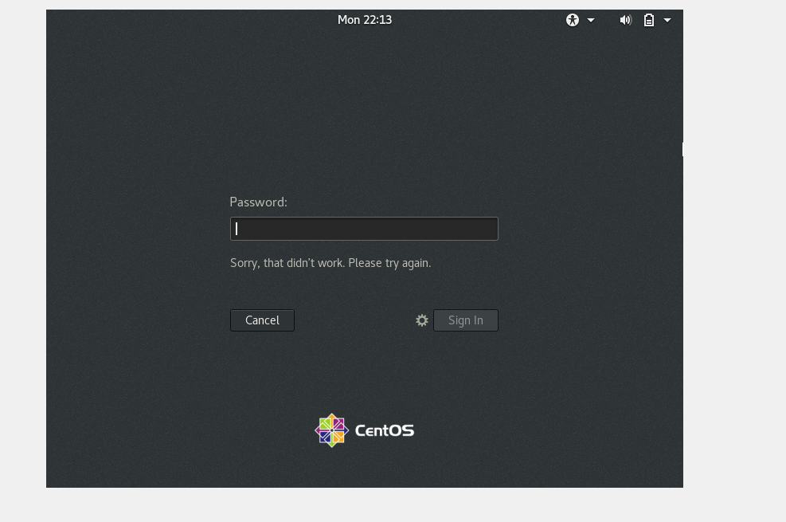

That means this user is not configured with centOS hence cannot access it.

Assignment-2

Password changing

* Login into your account and then change password?
  + Change your password into ***IneuR0n#42*** and hit the **Enter** key
    - Explain what happen and give screenshot?

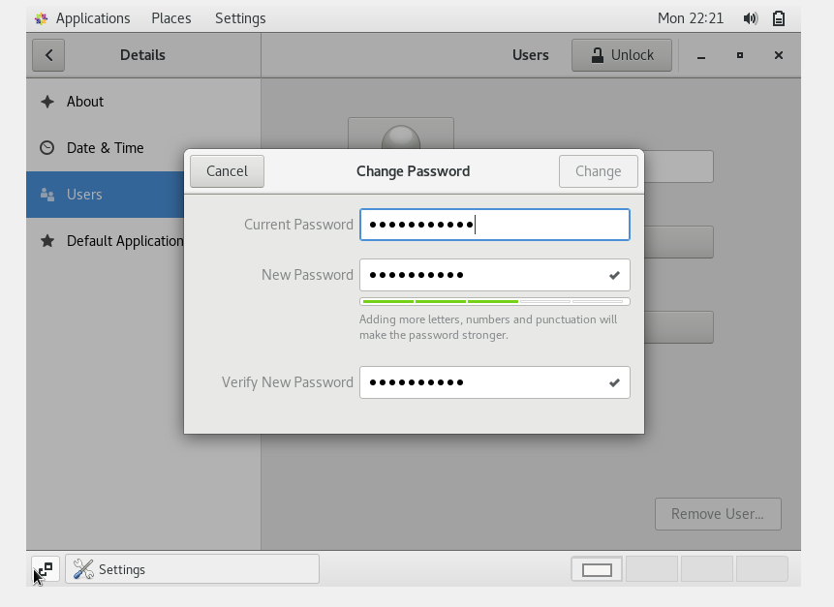

I observed that “Change” option was disabled after giving the new password.

* + Try again to change password but use like password ***1234*** or ***abcd***
    - Explain what happen and give screenshot?

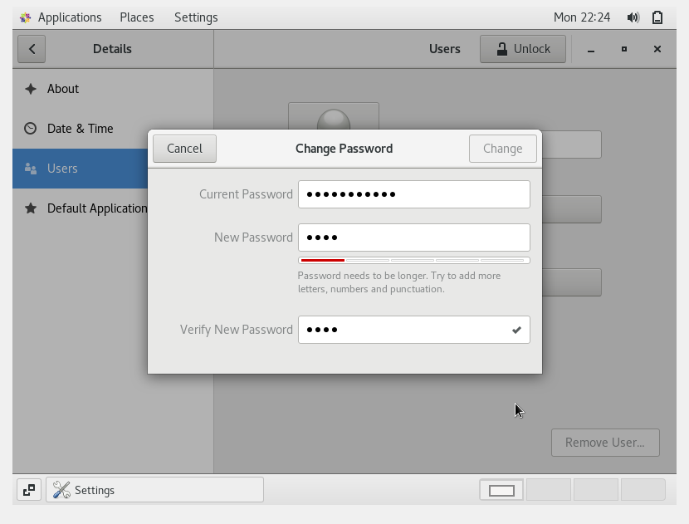

I observed that still the “Change” option was disabled.

* + Try again to change password but now don’t use any password just hit **Enter** key
    - Explain what happen and give screenshot?

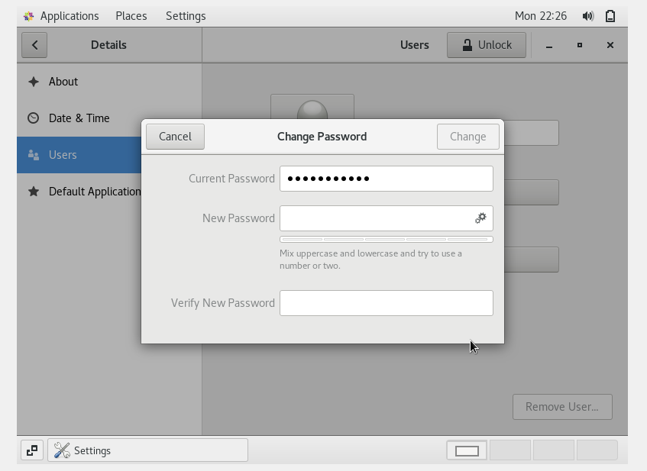

I observed that still the “Change” option was disabled.

Assignment-3

Working with Directories

* Enter the command **cd /** and then **ls** and then hit **Enter** key
  + Take screenshot and explain what output we got?

Ans: I got “No such file or directory

--------------------------------------------------------------

* Enter the command now **cd /home** and then hit **Enter** key
  + Do **ls,** provide screenshot and explain what is **/home** directory used for?
* Ans: A **home directory(/home)** is the directory or folder commonly given to a user on a network or Unix or Linux variant operating system. With the home directory the user can store all their personal information, files, login scripts, and user information

-------------------------------------------------------------------------------------------------------

* Enter **cd ..** and hit **Enter** key [ *Note: here we have space after cd then use double dot*]
  + Check what happen and give screenshot?

Ans: “cd..” will the current directory to the parent directory

--------------------------------------------------------------------------------------------------------------------------

* Now enter **cd /var/www/html** and then type **cd** and hit **Enter** key
  + Explain what happen and give screenshot?

Ans: It says” No such file or directory”.

--------------------------------------------------------------------------------------------------------------------------

* Now type **cd /root** and then hit **Enter** key

Do **ls,** check any output we have on screen if yes then take screenshot?

Ans: It says Permission denied and by doing ls it shows all the available directories.

Screenshot:

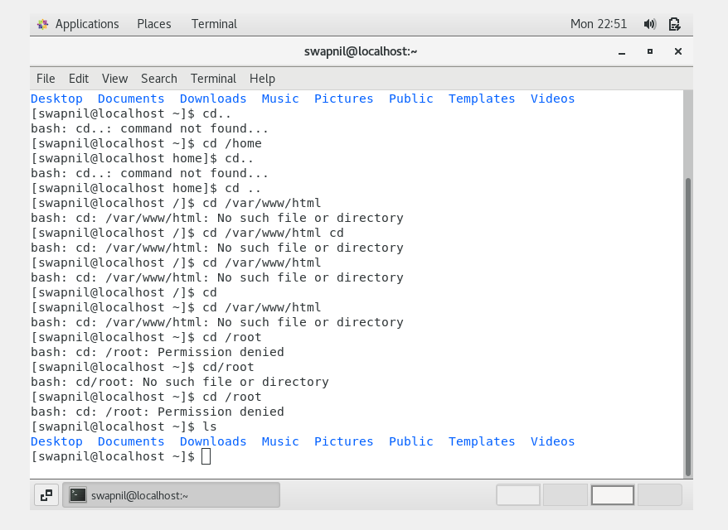

Assignment-4

Working with File Listing

* Go to **cd /etc** and type **ls**
  + Take screenshot and explain what files you have seeing?
  + 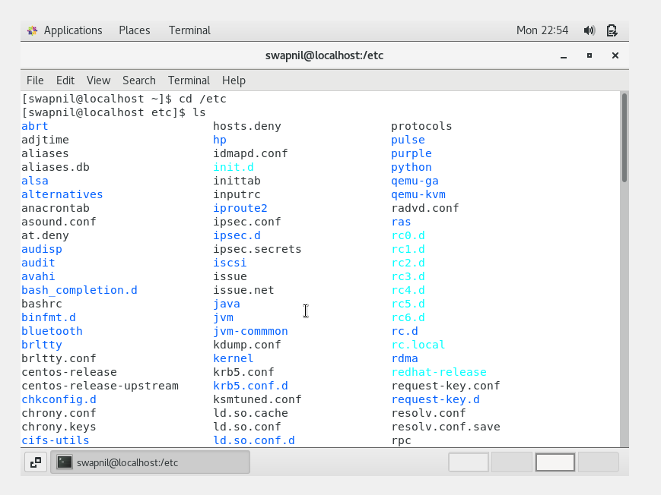

Ans: It will move the current directory to the /etc directory which contains different files ,system wide configuration and system databases.

* + Take screenshot and explain what different output you found compare to previous command you used?
  + Ans: Previous command used was cd /root which was trying to change the directory to the root user but the access was denied but here It moves the current directory to the /etc directory which contains different files ,system wide configuration and system databases.

----------------------------------------------------------------------------------------------------------------

* + Then type **ls -al** and hit **Enter** key

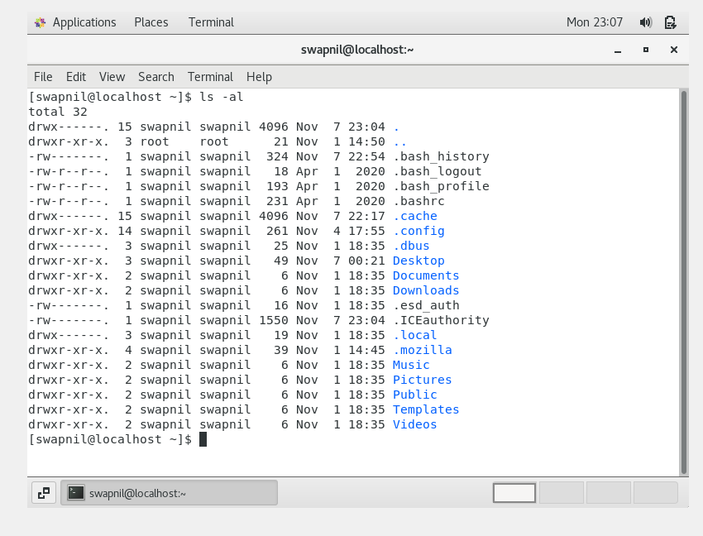

Ans: It will display all the files and also directories .

**ls** means listing of the directories along with files in the current directory.  
**a** denotes all the files in the directory, both hidden and not.  
**l** denotes the long listing of information about files+directory with their permissions and last updated time.

Take screenshot and explain what new file or directory you found?

* Then use **ls -i** and hit **Enter** key
  + Now see what different output its shows and take screenshot?

Ans: Sometimes you may want to know the inode number of a file for internal maintenance. Use -i option to display inode number. Using inode number you can remove files that has special characters in it’s name.

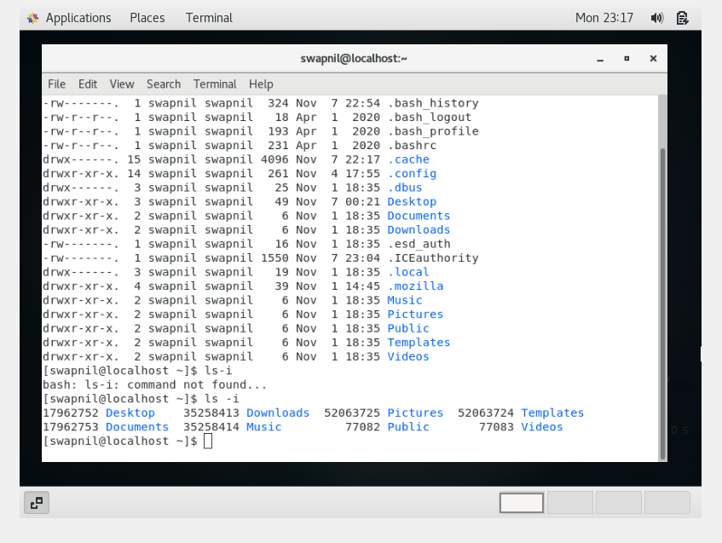

* Then use **ls –help** and see other options about **ls** command

Explore it and try with other attribute we can use with **ls** command

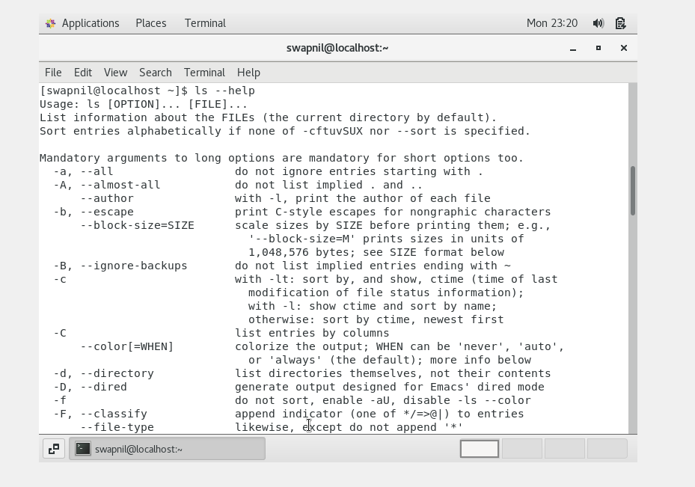

Assignment-5

Know where you are and where you working

*Here we use* ***pwd, cd and ls*** *as combine task to understand where you working on terminal and how you can switch from one directory to another one.*

* Open terminal after restart the linux
  + Check which location you working, type **pwd** and take screenshot
* Now use **cd /var** and hit **Enter** key
  + Do **ls,** and see what output comes, give screenshot?
* Do explore other help options of each command to learn more other things we can do with these commands

Ans : var is a standard subdirectory of the root directory in Linux that contains files to which the system writes data during the course of its operation.

**pwd** stands for **P**rint **W**orking **D**irectory. It prints the path of the working directory, starting from the root.

