**Supplemental Online Materials**

**Study 1**

**Item Characteristic Curves for the full 18 items**

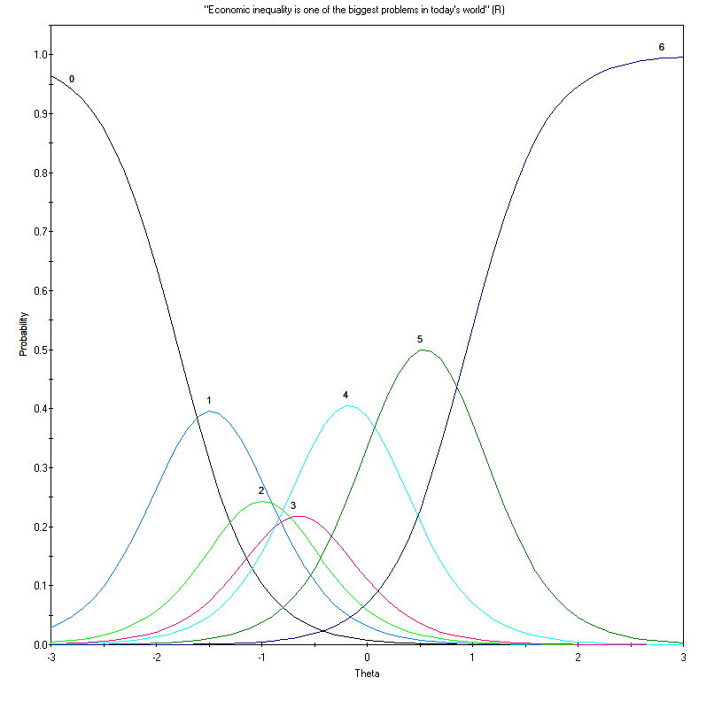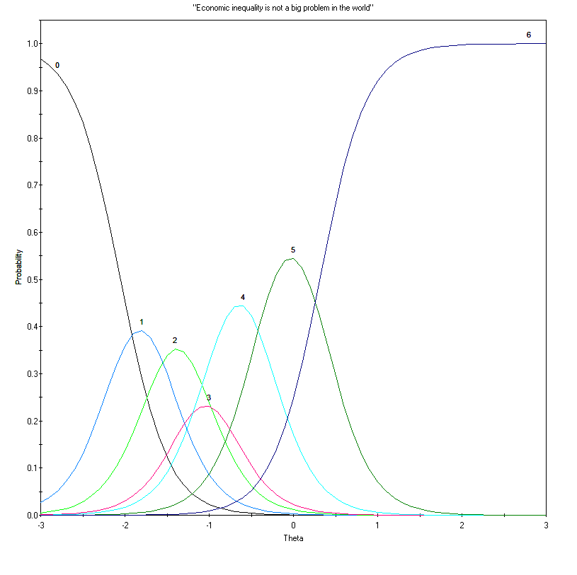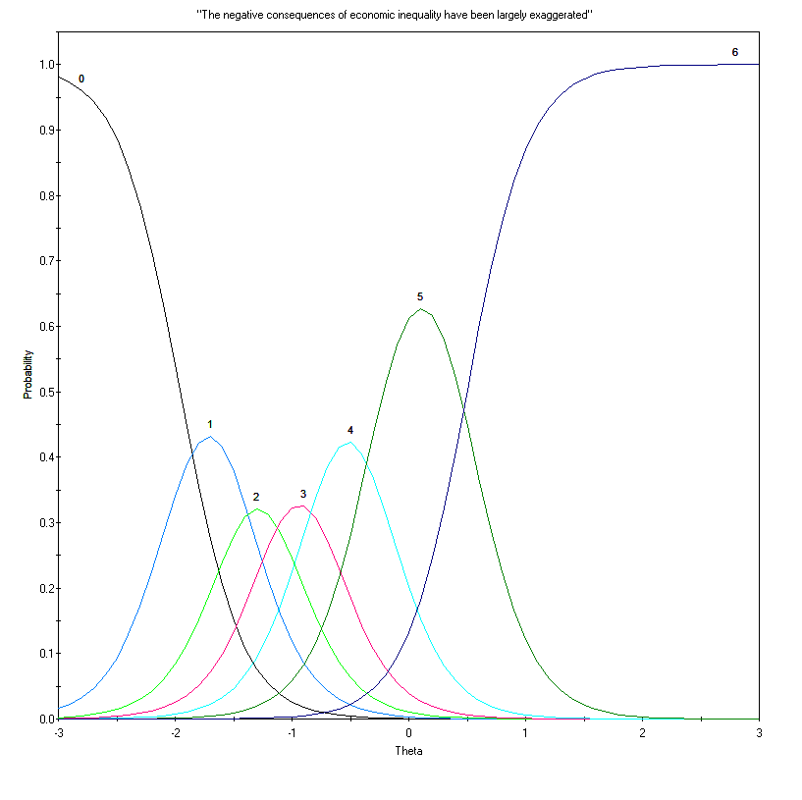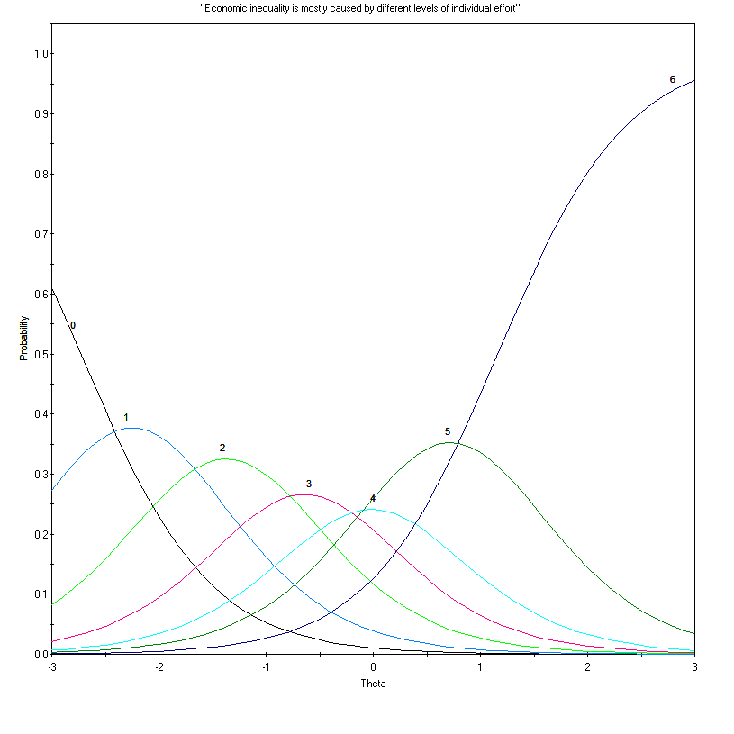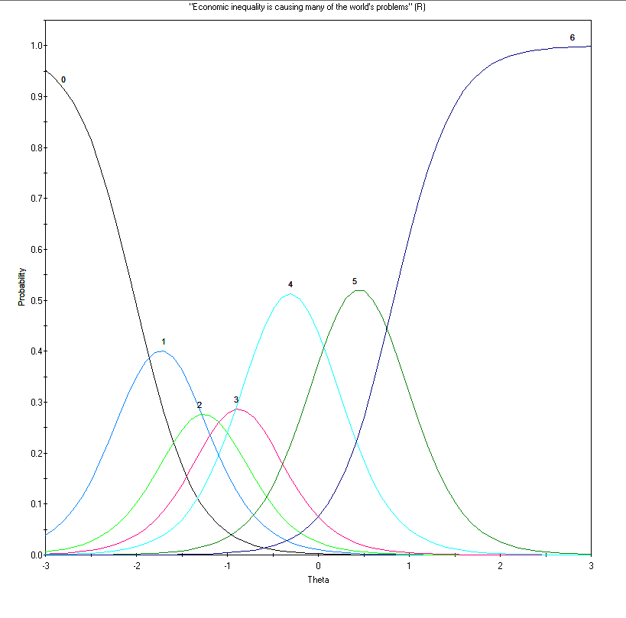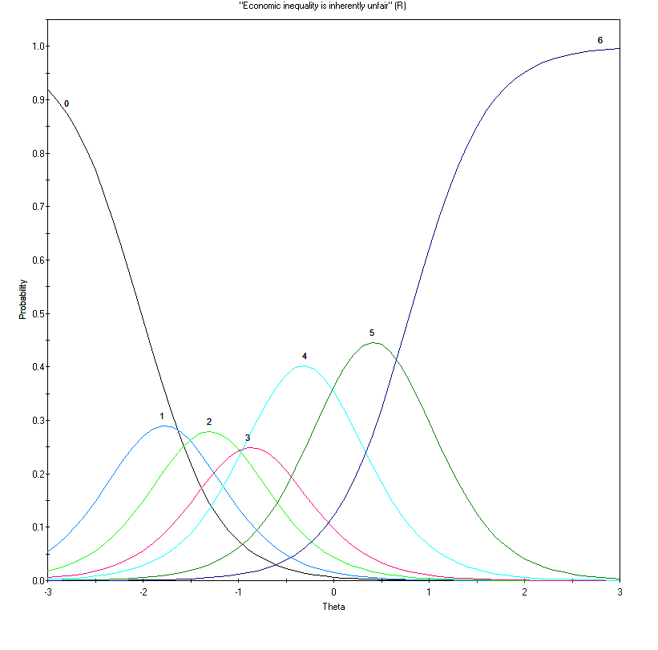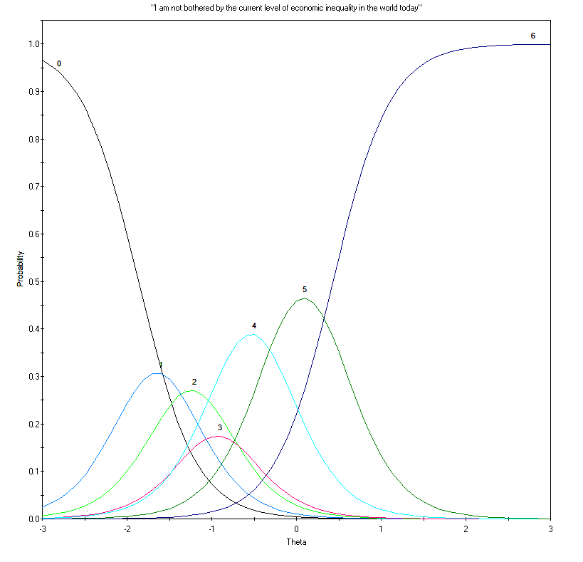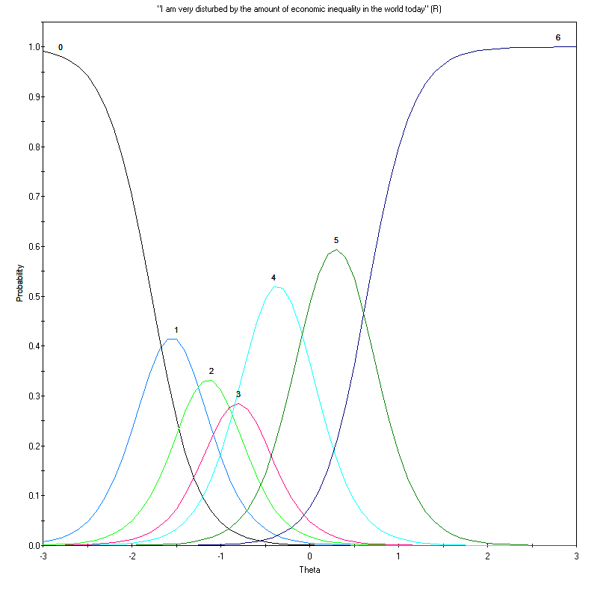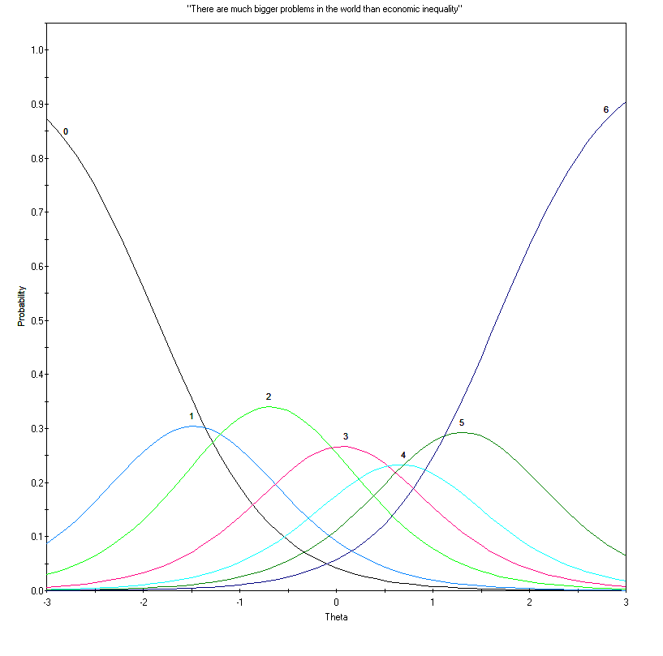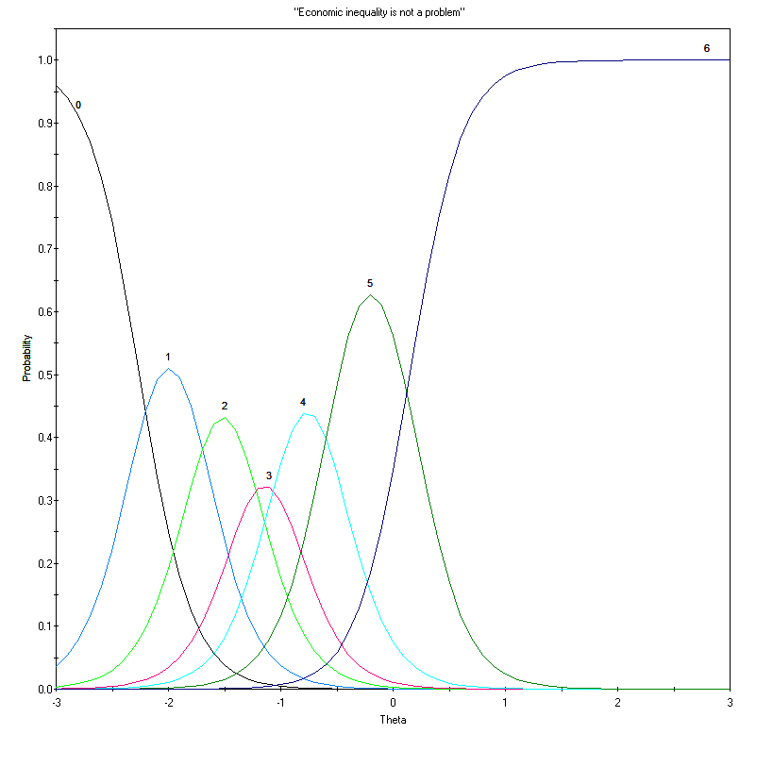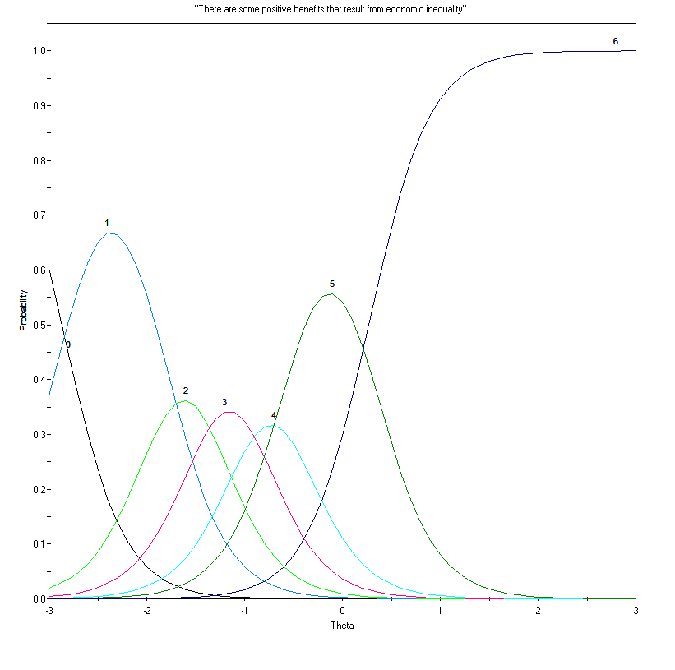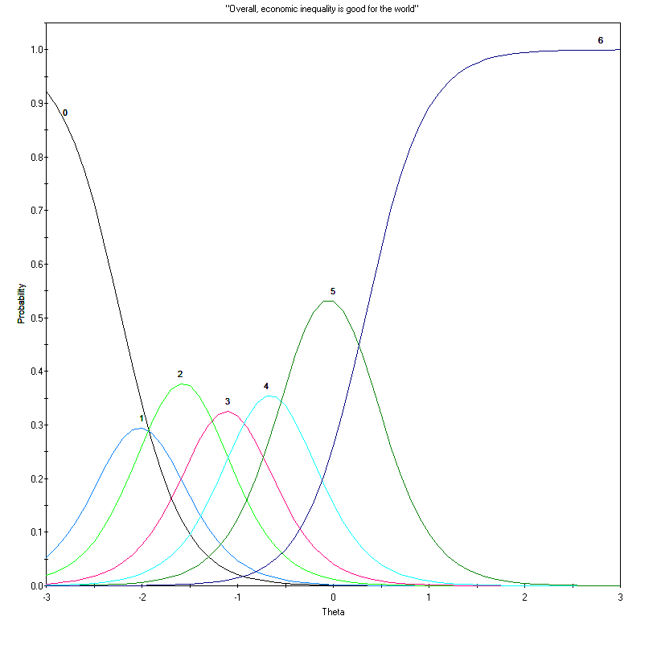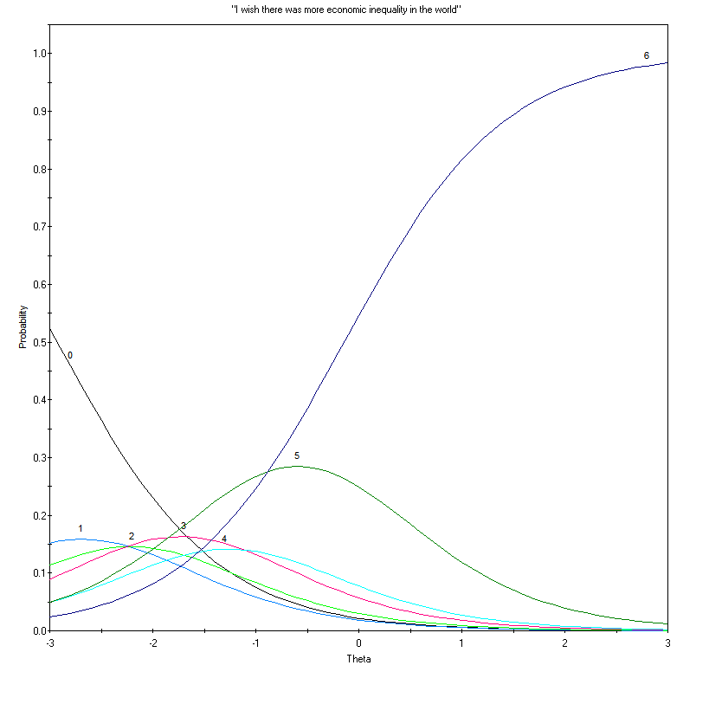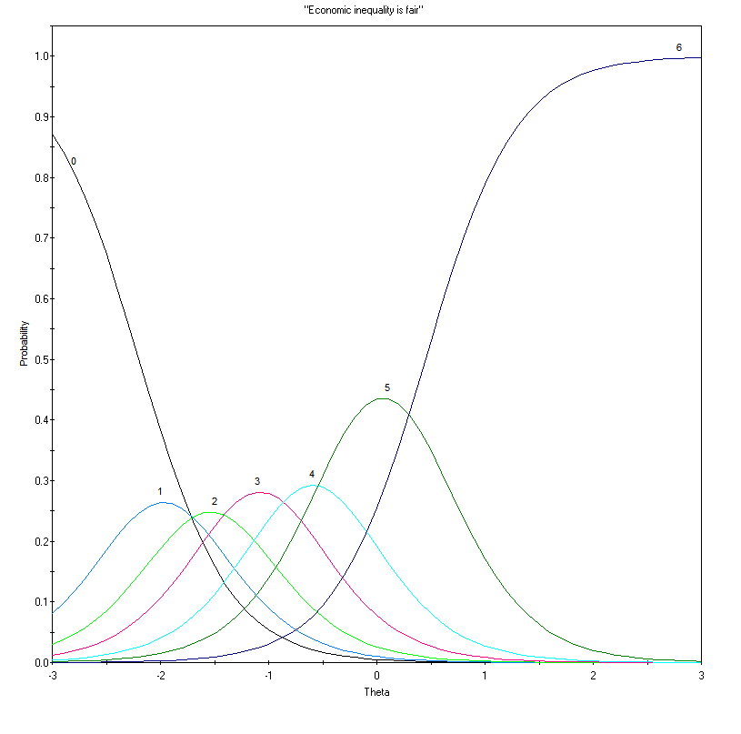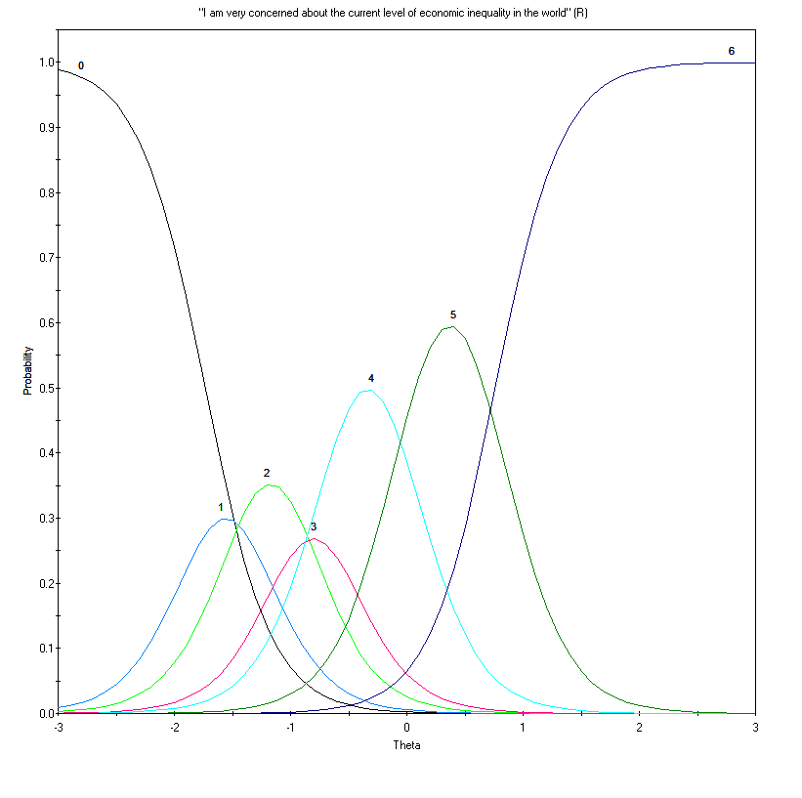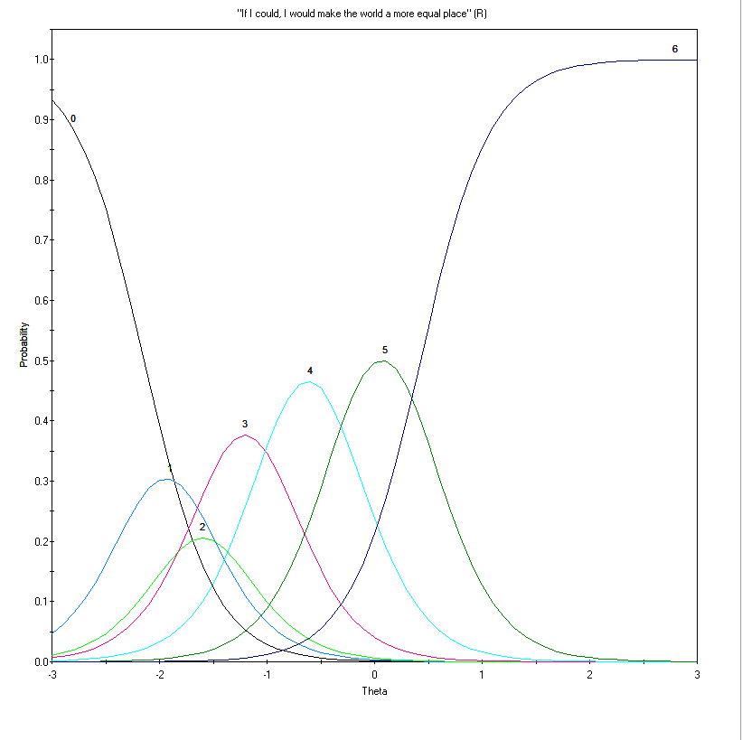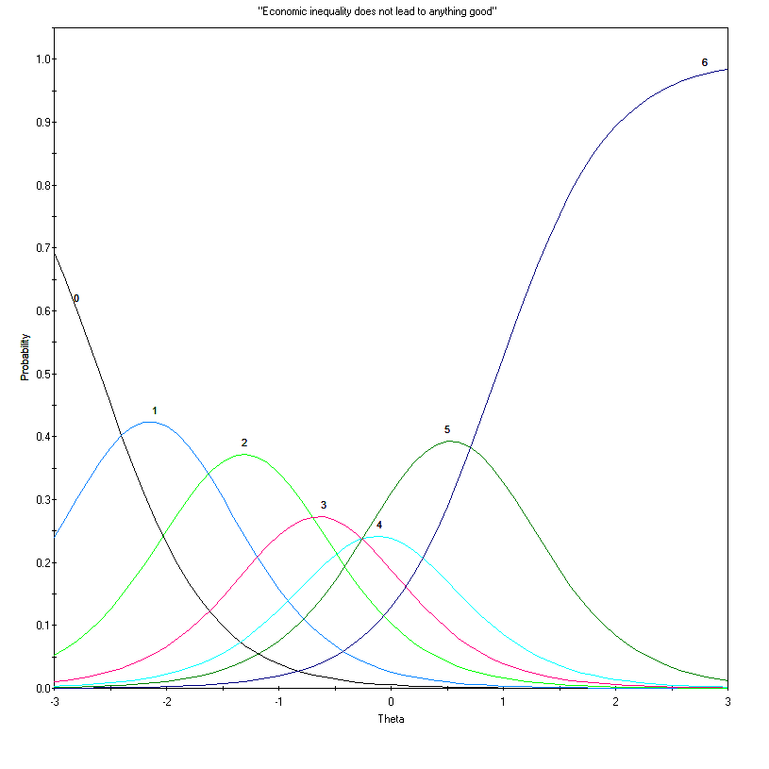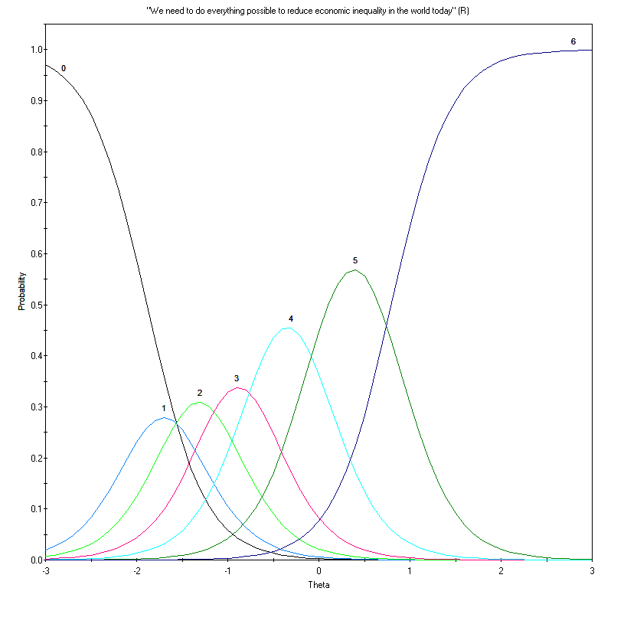

**Item Characteristic Curves for the final 5 items of Study 1**

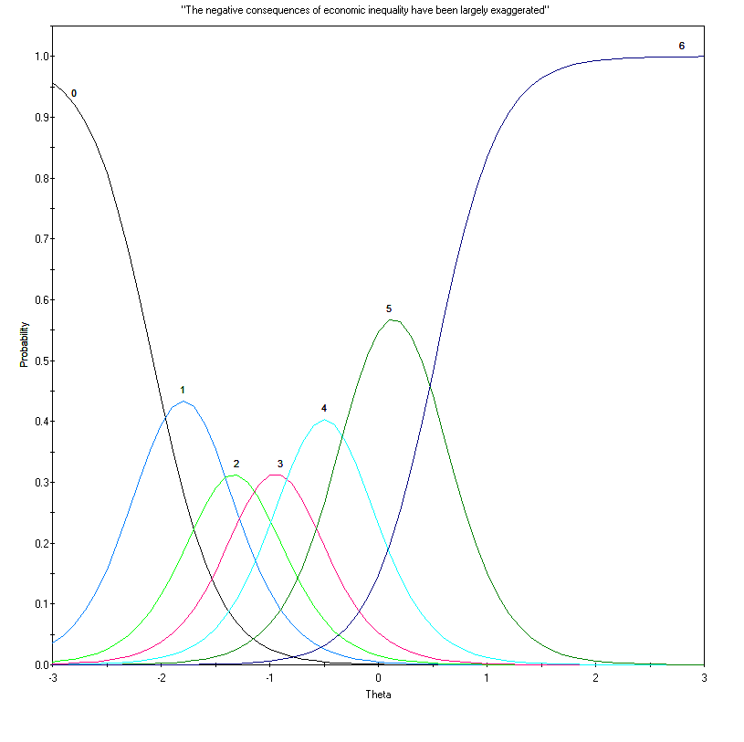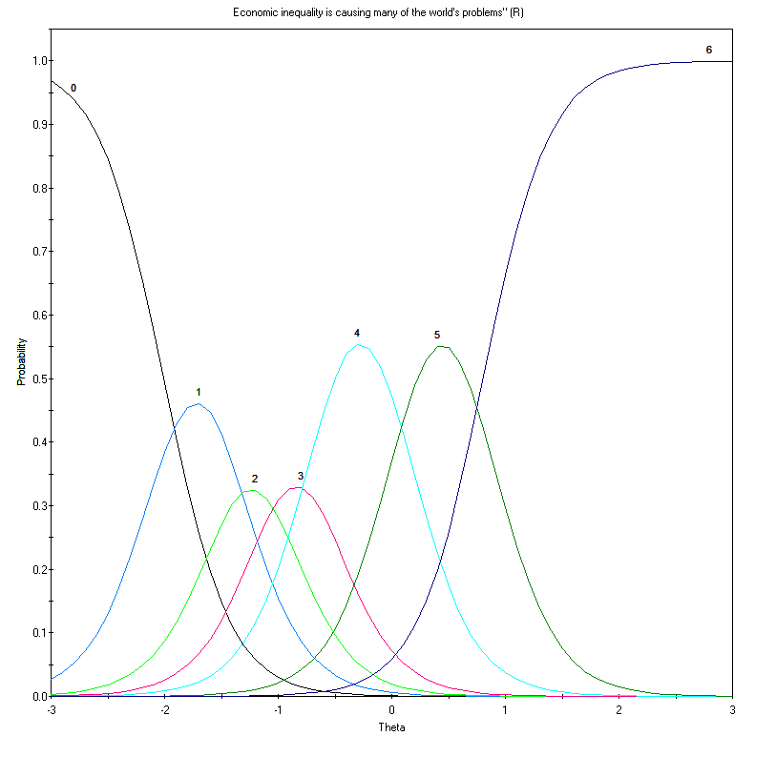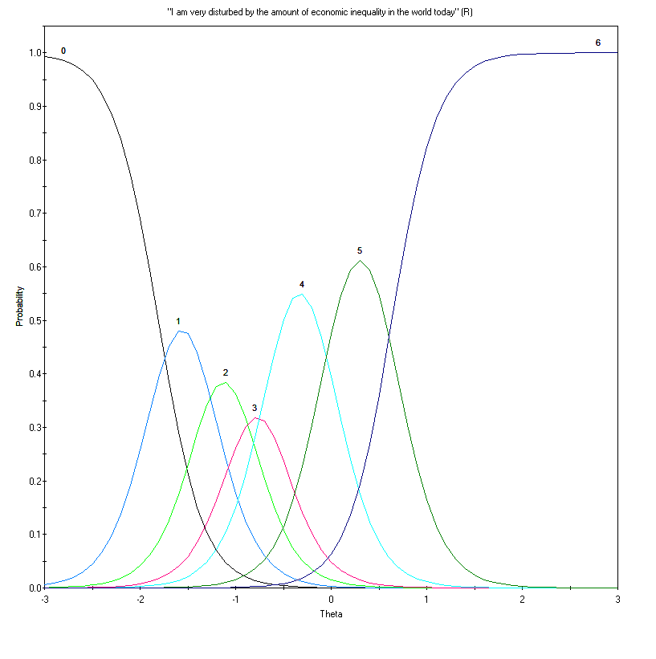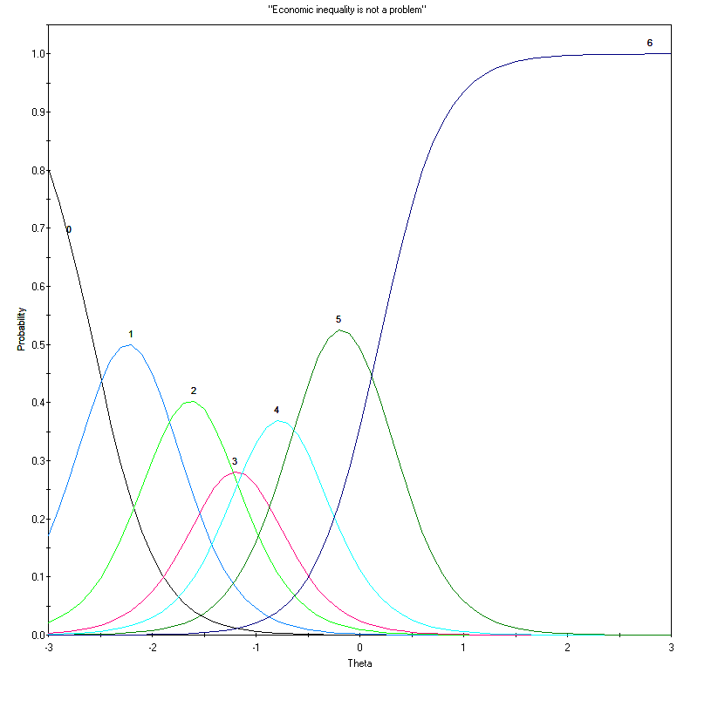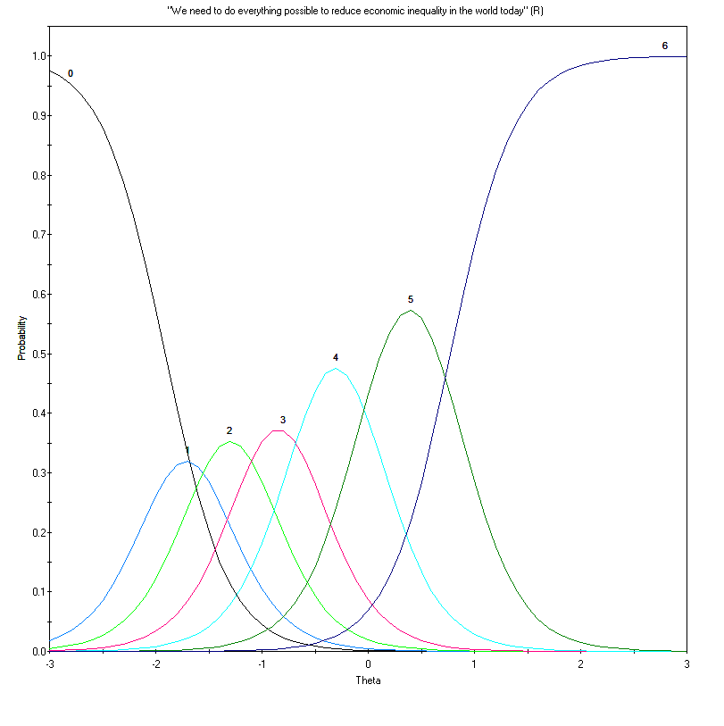

**Graded Model Item Parameter Estimates for the Final 5 Items in Study 1**

|  |  |  |  |  |  |  |  |
| --- | --- | --- | --- | --- | --- | --- | --- |
| Item | *a* | *b*1 | *b*2 | *b*3 | *b*4 | *b*5 | *b*6 |
| 3 | 3.37 | -2.07 (.12) | -1.52 (.08) | -1.14 (.07) | -0.75 (.06) | -0.24 (.05) | 0.52 (.06) |
| 5 | 3.45 | -2.01 (.12) | -1.43 (.08) | -1.03 (.07) | -0.64 (.06) | 0.08 (.05) | 0.80 (.07) |
| 8 | 4.23 | -1.81 (.10) | -1.31 (.07) | -0.93 (.06) | -0.61 (.05) | -0.04 (.05) | 0.64 (.06) |
| 10 | 3.25 | -2.57 (.18) | -1.89 (.10) | -1.37 (.08) | -1.01 (.07) | -0.54 (.06) | 0.18 (.06) |
| 18 | 3.36 | -1.91 (.11) | -1.52 (.09) | -1.07 (.07) | -0.61 (.06) | 0.00 (.05) | 0.05 (.07) |

*Note.* Standard Errors for each parameter are in brackets. a is the item’s discrimination parameter, b are the thresholds.

**Item and Total Scale Information for the Final Five Items in Study 1**

|  |  |  |
| --- | --- | --- |
| Item | Information | Proportion of  Total Information |
| 3 | 8.40 | 14.5% |
| 5 | 13.41 | 23.2% |
| 8 | 13.63 | 23.6% |
| 10 | 12.65 | 21.9% |
| 18 | 9.73 | 16.8% |
| **Total** | **57.82** | **100%** |

**Total Information Curve for the Final Five Items in Study 1**

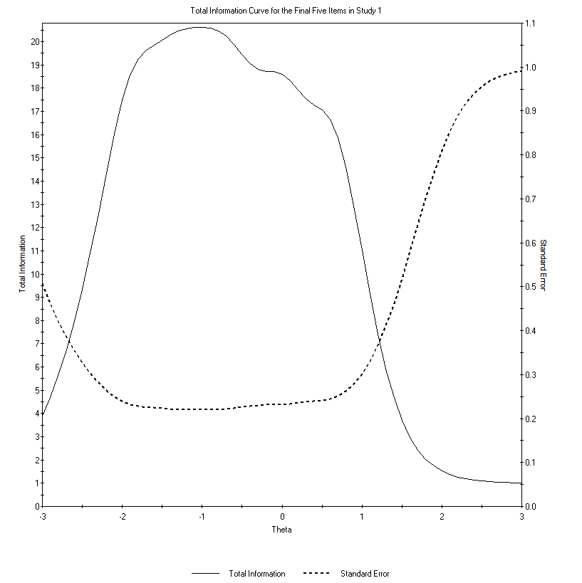

**Study 2**

**Item Characteristic Curves for Study 2**

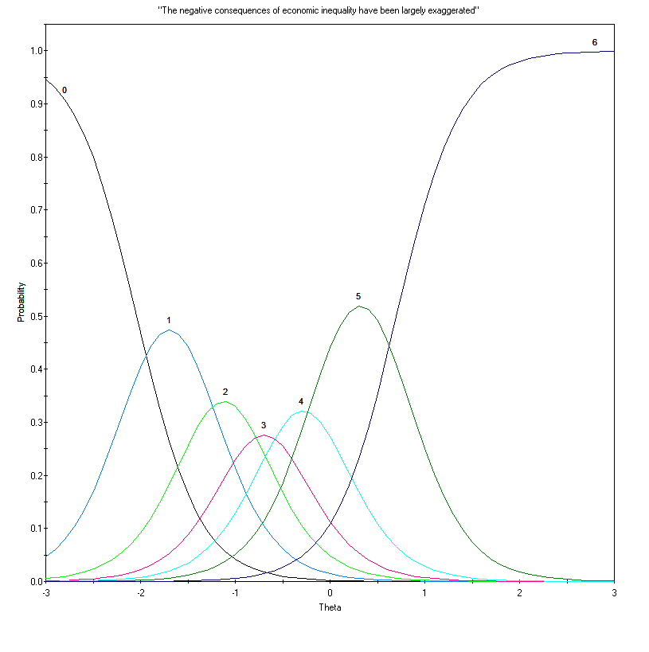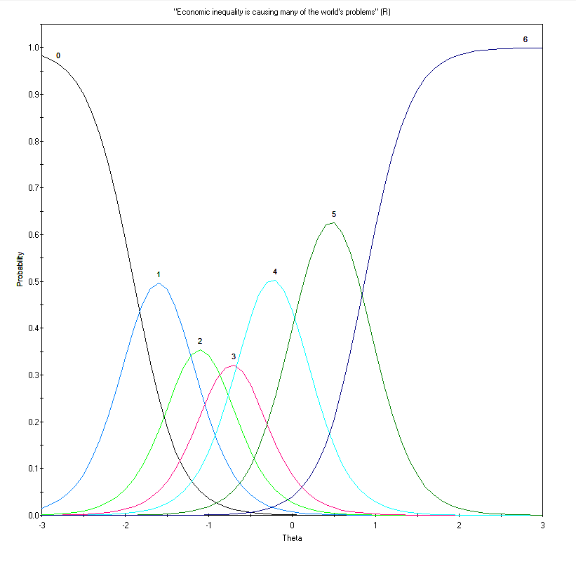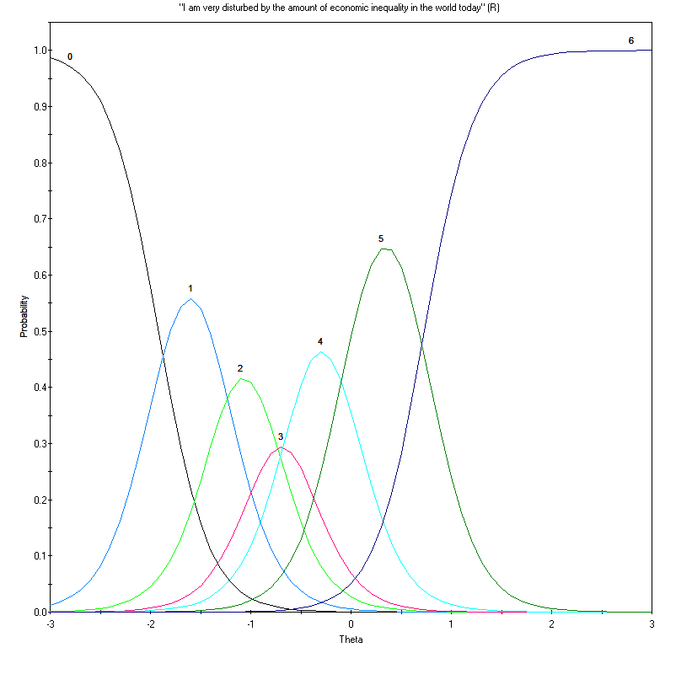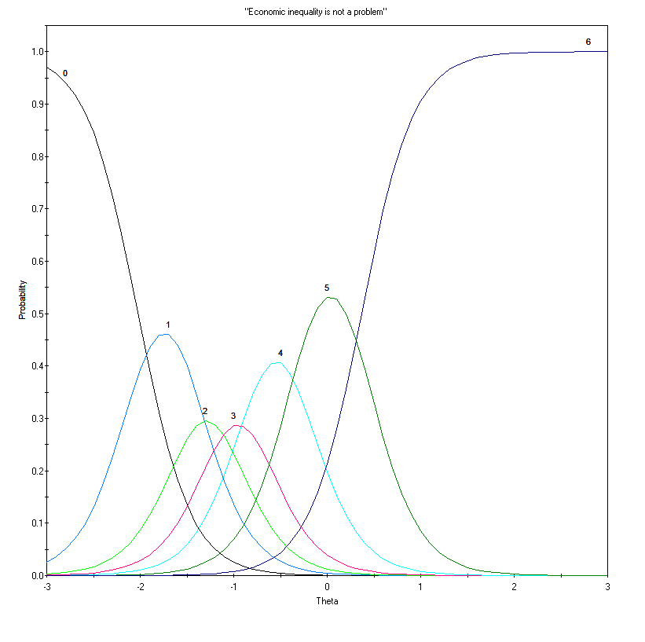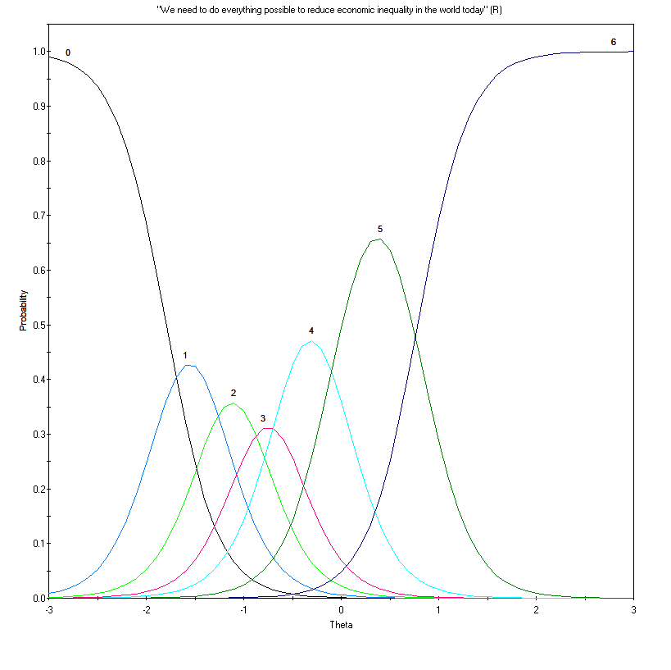

**Graded Model Item Parameter Estimates in Study 2**

|  |  |  |  |  |  |  |  |
| --- | --- | --- | --- | --- | --- | --- | --- |
| Item | *a* | *b*1 | *b*2 | *b*3 | *b*4 | *b*5 | *b*6 |
| 3 | 3.00 | -2.04 (.12) | -1.36 (.08) | -0.88 (.06) | -0.51 (.05) | -0.07 (.05) | 0.70 (.06) |
| 5 | 3.67 | -1.89 (.11) | -1.31 (.07) | -0.90 (.06) | -0.54 (.05) | 0.07 (.05) | 0.86 (.07) |
| 8 | 3.99 | -1.92 (.11) | -1.29 (.07) | -0.84 (.06) | -0.54 (.05) | -0.04 (.05) | 0.73 (.06) |
| 10 | 3.56 | -2.02 (.12) | -1.46 (.08) | -1.12 (.07) | -0.79 (.06) | -0.30 (.05) | 0.37 (.06) |
| 18 | 3.81 | -1.79 (.10) | -1.31 (.07) | -0.92 (.06) | -0.58 (.05) | -0.04 (.05) | 0.79 (.06) |

*Note.* Standard Errors for each parameter are in brackets. a is the item’s discrimination parameter, b are the thresholds.

**Item and Total Scale Information for Study 2**

|  |  |  |
| --- | --- | --- |
| Item | Information | Proportion of  Total Information |
| 3 | 9.60 | 15.3% |
| 5 | 13.27 | 21.2% |
| 8 | 14.15 | 22.6% |
| 10 | 11.38 | 18.2% |
| 18 | 14.17 | 22.6% |
| **Total** | **62.57** | **100%** |

**Total Information Function for the Five Items in Study 2**

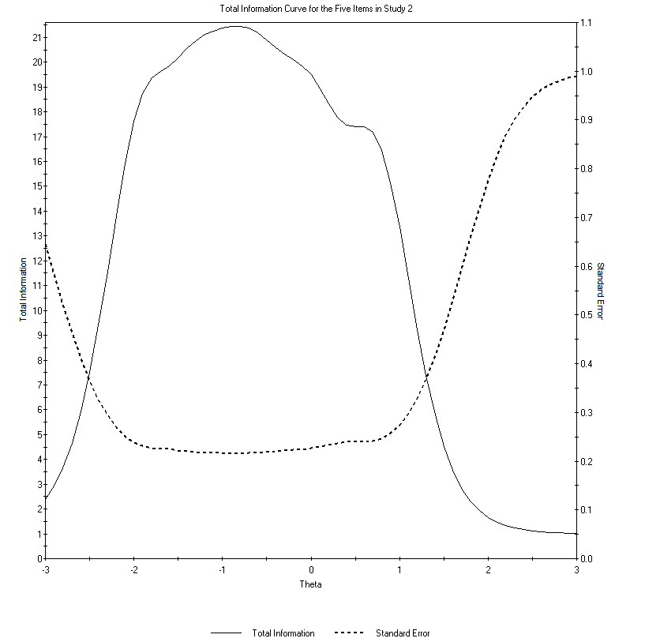

**Study 3**

**Item Characteristic Curves for Study 3**

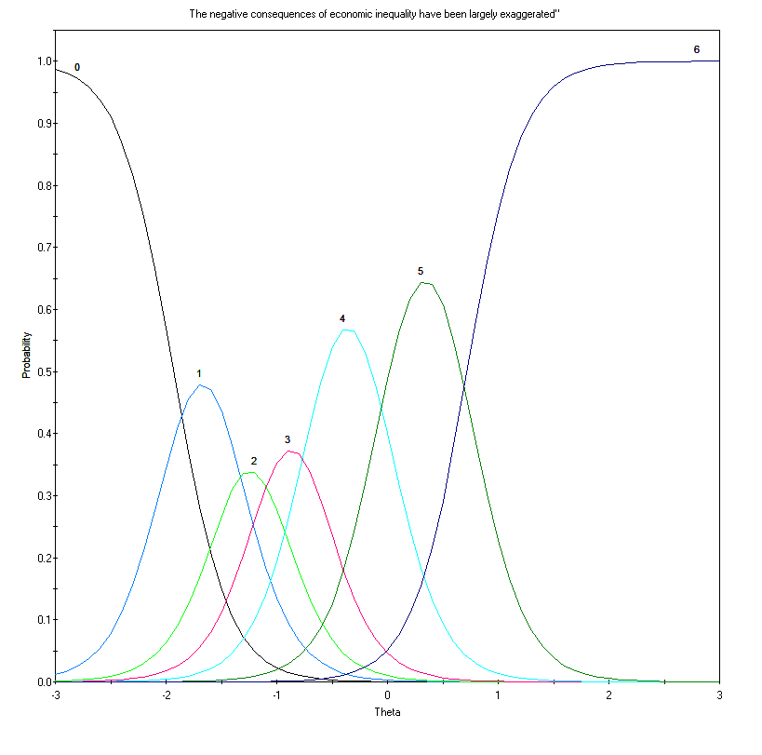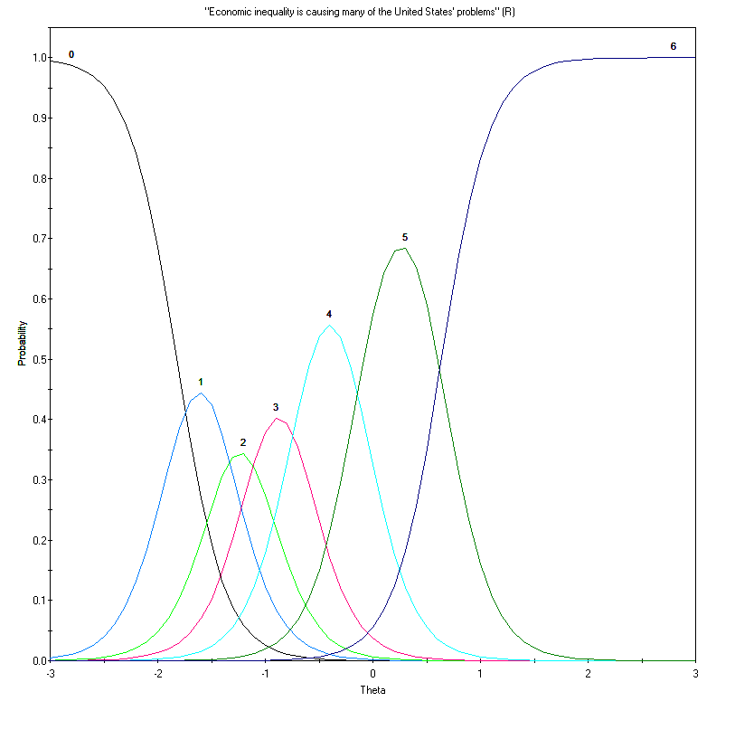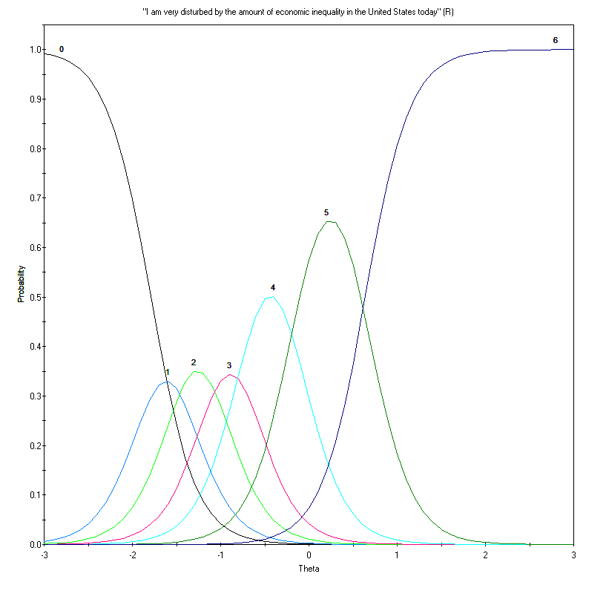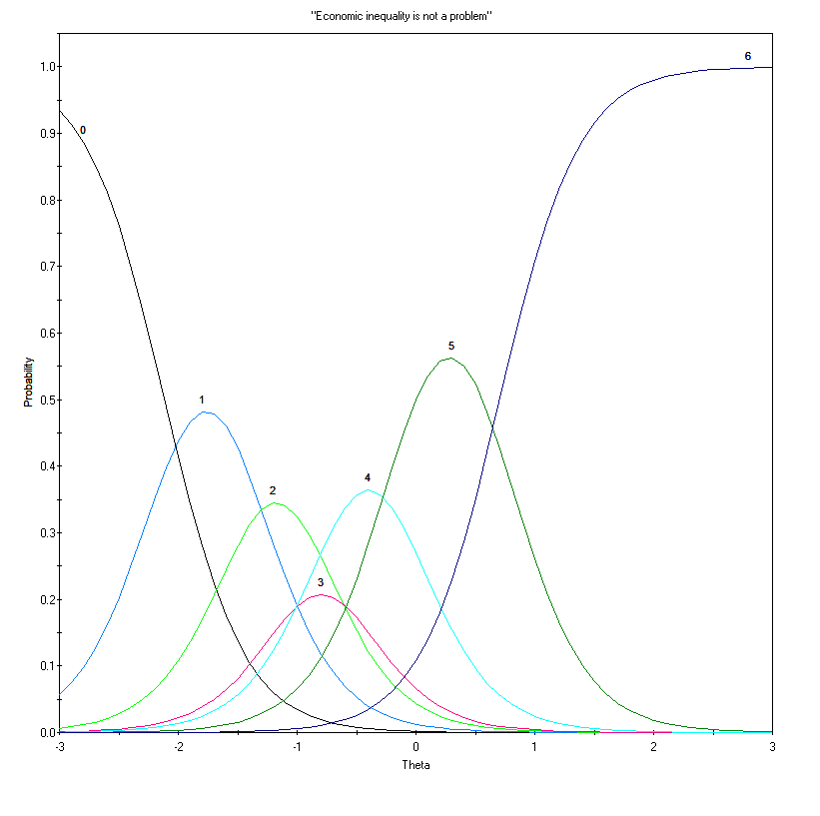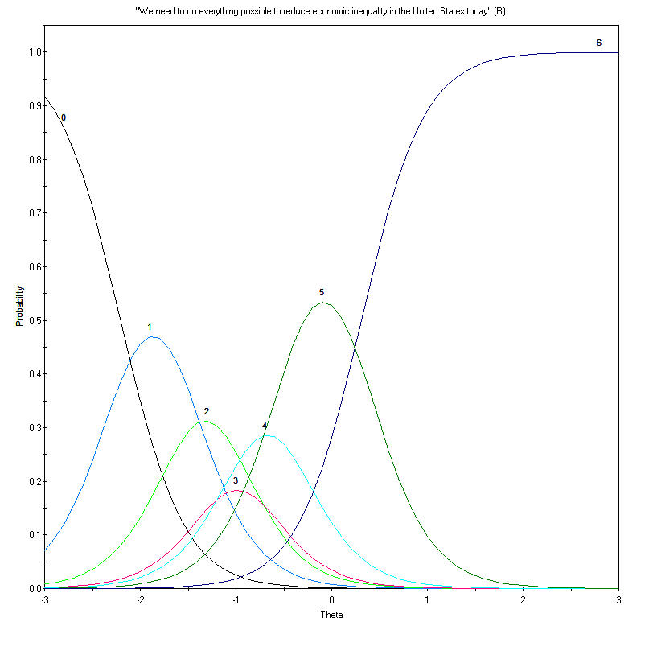

**Graded Model Item Parameter Estimates in Study 3**

|  |  |  |  |  |  |  |  |
| --- | --- | --- | --- | --- | --- | --- | --- |
| Item | *a* | *b*1 | *b*2 | *b*3 | *b*4 | *b*5 | *b*6 |
| 3 | 4.05 | -1.93 (.11) | -1.41 (.08) | -1.07 (.07) | -0.68 (.06) | -0.04 (.05) | 0.72 (.06) |
| 5 | 4.44 | -1.82 (.10) | -1.39 (.08) | -1.07 (.06) | -0.69 (.05) | -0.12 (.05) | 0.64 (.06) |
| 8 | 3.96 | -1.79 (.10) | -1.44 (.08) | -1.07 (.07) | -0.71 (.06) | -0.15 (.05) | 0.64 (.06) |
| 10 | 3.00 | -2.11 (.13) | -1.41 (.09) | -0.94 (.07) | -0.66 (.06) | -0.15 (.05) | 0.70 (.07) |
| 18 | 3.04 | -2.21 (.14) | -1.53 (.09) | -1.11 (.07) | -0.86 (.07) | -0.48 (.06) | 0.31 (.06) |

*Note.* Standard Errors for each parameter are in brackets. a is the item’s discrimination parameter, b are the thresholds.

**Item and Total Scale Information for Study 3**

|  |  |  |
| --- | --- | --- |
| Item | Information | Proportion of  Total Information |
| 3 | 14.64 | 23.3% |
| 5 | 15.67 | 25.0% |
| 8 | 13.32 | 21.2% |
| 10 | 9.79 | 15.6% |
| 18 | 9.35 | 14.9% |
| **Total** | **62.76** | **100%** |

**Total Information Curve for the Five Items in Study 3**

