# 安装

[Sourcetree | Free Git GUI for Mac and Windows (sourcetreeapp.com)](https://www.sourcetreeapp.com/)

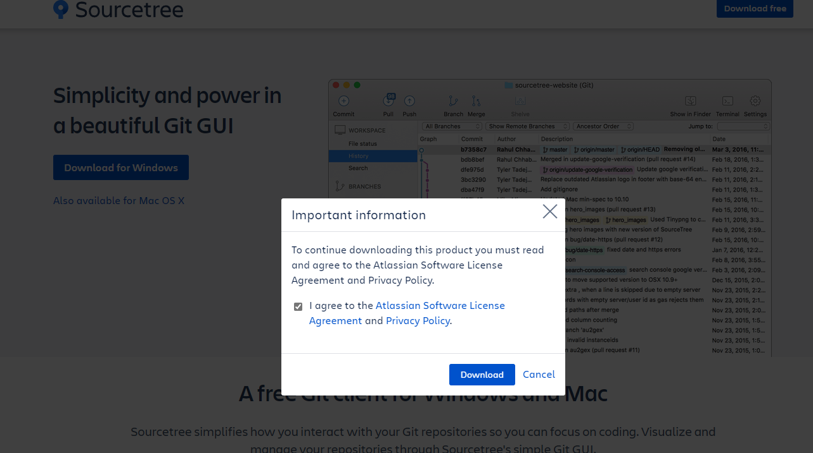



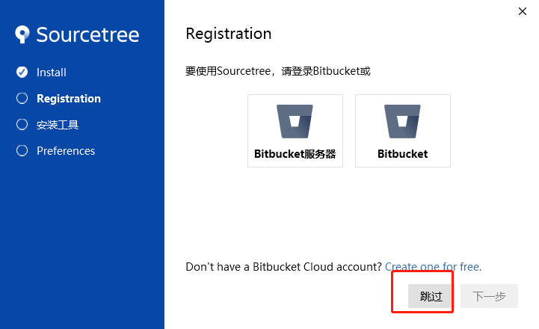

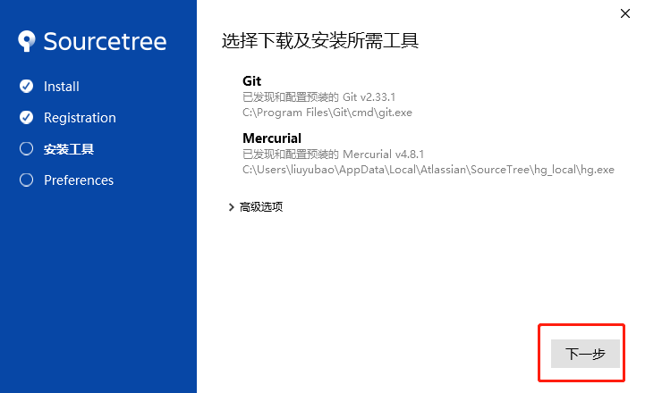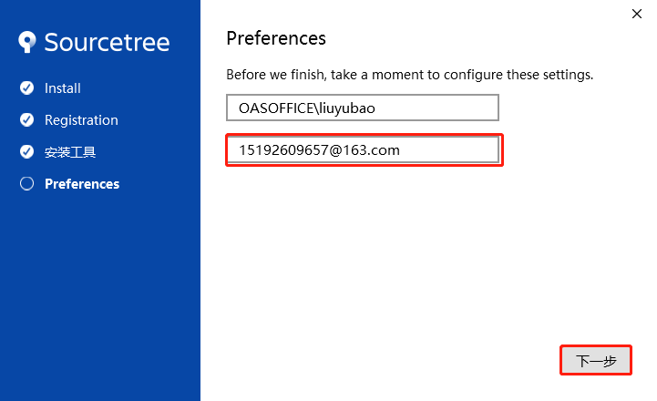

好了