COMP-SCI 5542 (SP17) - Big Data Analytics and Applications

**Tutorial 10 Assignment (Due 04/05/17 by 11:59 PM)**

***Dayu Wang* (45)**

1. **TensorFlow Programming**
2. Dataset

In my dataset, I have three folders: smile, cry, and angry. Each folder has more than 30 related emoticons (emoji impressions).

1. Accuracies

2017-04-05 16:49:47.252464: Step 0: Train accuracy = 60.0%

2017-04-05 16:49:47.253463: Step 0: Cross entropy = 0.806461

2017-04-05 16:49:47.539238: Step 0: Validation accuracy = 36.0% (N=100)

2017-04-05 16:49:48.415452: Step 10: Train accuracy = 100.0%

2017-04-05 16:49:48.415452: Step 10: Cross entropy = 0.751799

2017-04-05 16:49:48.678139: Step 10: Validation accuracy = 37.0% (N=100)

2017-04-05 16:49:49.043402: Step 20: Train accuracy = 90.0%

2017-04-05 16:49:49.043402: Step 20: Cross entropy = 0.603976

2017-04-05 16:49:49.207535: Step 20: Validation accuracy = 69.0% (N=100)

2017-04-05 16:49:49.458197: Step 30: Train accuracy = 80.0%

2017-04-05 16:49:49.458197: Step 30: Cross entropy = 0.594302

2017-04-05 16:49:49.624317: Step 30: Validation accuracy = 43.0% (N=100)

2017-04-05 16:49:49.846225: Step 40: Train accuracy = 90.0%

2017-04-05 16:49:49.846225: Step 40: Cross entropy = 0.554903

2017-04-05 16:49:49.986825: Step 40: Validation accuracy = 54.0% (N=100)

2017-04-05 16:49:50.191023: Step 50: Train accuracy = 90.0%

2017-04-05 16:49:50.191023: Step 50: Cross entropy = 0.628171

2017-04-05 16:49:50.330642: Step 50: Validation accuracy = 67.0% (N=100)

2017-04-05 16:49:50.531329: Step 60: Train accuracy = 100.0%

2017-04-05 16:49:50.531848: Step 60: Cross entropy = 0.438464

2017-04-05 16:49:50.672429: Step 60: Validation accuracy = 70.0% (N=100)

2017-04-05 16:49:50.869069: Step 70: Train accuracy = 100.0%

2017-04-05 16:49:50.869069: Step 70: Cross entropy = 0.386778

2017-04-05 16:49:51.031687: Step 70: Validation accuracy = 82.0% (N=100)

2017-04-05 16:49:51.248339: Step 80: Train accuracy = 100.0%

2017-04-05 16:49:51.248339: Step 80: Cross entropy = 0.270075

2017-04-05 16:49:51.439975: Step 80: Validation accuracy = 36.0% (N=100)

2017-04-05 16:49:51.657326: Step 90: Train accuracy = 100.0%

2017-04-05 16:49:51.657824: Step 90: Cross entropy = 0.309137

2017-04-05 16:49:51.817938: Step 90: Validation accuracy = 80.0% (N=100)

2017-04-05 16:49:52.029312: Step 100: Train accuracy = 100.0%

2017-04-05 16:49:52.029312: Step 100: Cross entropy = 0.333613

2017-04-05 16:49:52.174419: Step 100: Validation accuracy = 68.0% (N=100)

2017-04-05 16:49:52.389571: Step 110: Train accuracy = 100.0%

2017-04-05 16:49:52.390091: Step 110: Cross entropy = 0.282906

2017-04-05 16:49:52.544681: Step 110: Validation accuracy = 37.0% (N=100)

2017-04-05 16:49:52.748549: Step 120: Train accuracy = 100.0%

2017-04-05 16:49:52.748549: Step 120: Cross entropy = 0.315017

2017-04-05 16:49:52.896654: Step 120: Validation accuracy = 67.0% (N=100)

2017-04-05 16:49:53.093795: Step 130: Train accuracy = 100.0%

2017-04-05 16:49:53.093795: Step 130: Cross entropy = 0.365672

2017-04-05 16:49:53.237379: Step 130: Validation accuracy = 88.0% (N=100)

2017-04-05 16:49:53.500065: Step 140: Train accuracy = 100.0%

2017-04-05 16:49:53.500065: Step 140: Cross entropy = 0.264272

2017-04-05 16:49:53.697205: Step 140: Validation accuracy = 67.0% (N=100)

2017-04-05 16:49:53.910141: Step 150: Train accuracy = 100.0%

2017-04-05 16:49:53.910141: Step 150: Cross entropy = 0.218194

2017-04-05 16:49:54.058729: Step 150: Validation accuracy = 69.0% (N=100)

2017-04-05 16:49:54.319419: Step 160: Train accuracy = 100.0%

2017-04-05 16:49:54.319419: Step 160: Cross entropy = 0.177432

2017-04-05 16:49:54.466023: Step 160: Validation accuracy = 77.0% (N=100)

2017-04-05 16:49:54.661916: Step 170: Train accuracy = 100.0%

2017-04-05 16:49:54.661916: Step 170: Cross entropy = 0.172528

2017-04-05 16:49:54.816007: Step 170: Validation accuracy = 72.0% (N=100)

2017-04-05 16:49:55.014832: Step 180: Train accuracy = 100.0%

2017-04-05 16:49:55.014832: Step 180: Cross entropy = 0.216906

2017-04-05 16:49:55.151427: Step 180: Validation accuracy = 81.0% (N=100)

2017-04-05 16:49:55.358575: Step 190: Train accuracy = 100.0%

2017-04-05 16:49:55.358575: Step 190: Cross entropy = 0.148927

2017-04-05 16:49:55.514187: Step 190: Validation accuracy = 67.0% (N=100)

2017-04-05 16:49:55.700189: Step 199: Train accuracy = 100.0%

2017-04-05 16:49:55.700189: Step 199: Cross entropy = 0.182127

2017-04-05 16:49:55.845310: Step 199: Validation accuracy = 66.0% (N=100)

Final test accuracy = 66.7% (N=30)

1. TensorBoard Screenshots
2. Training

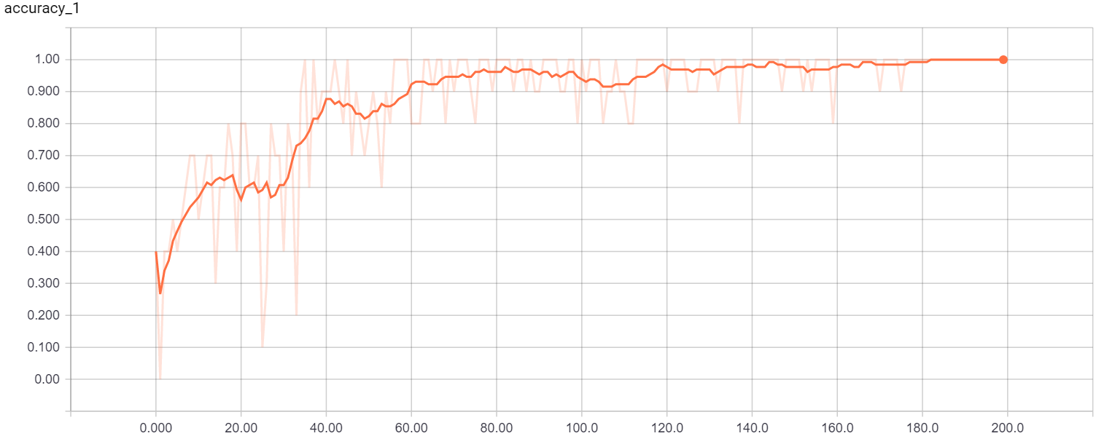

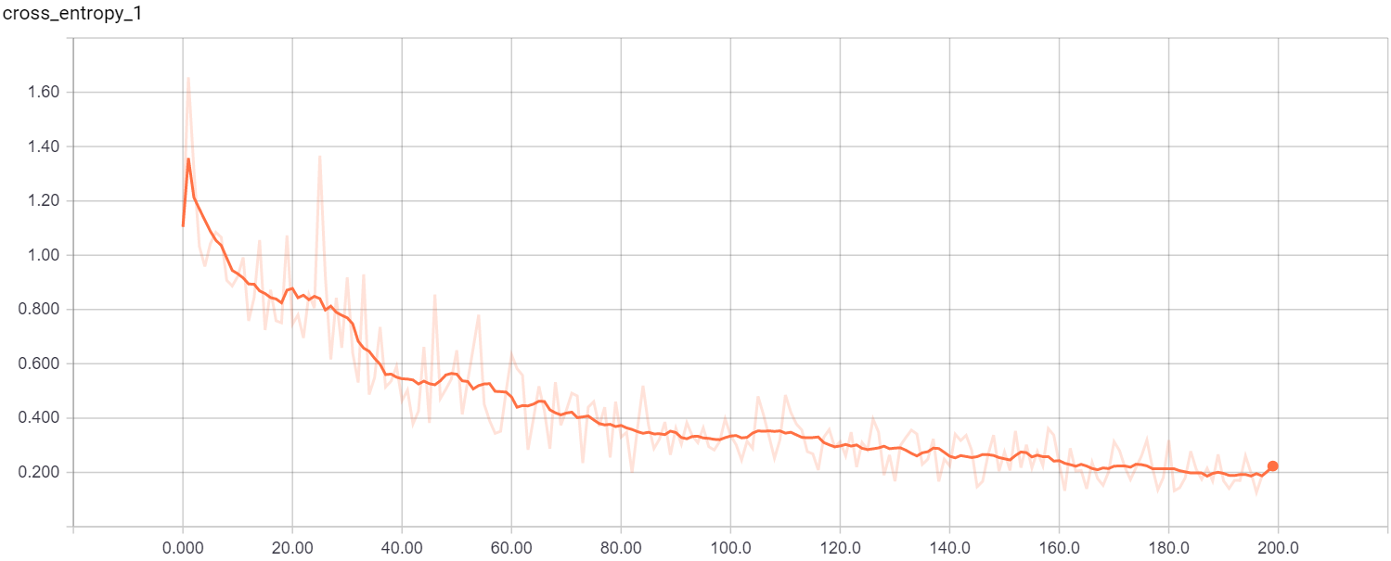

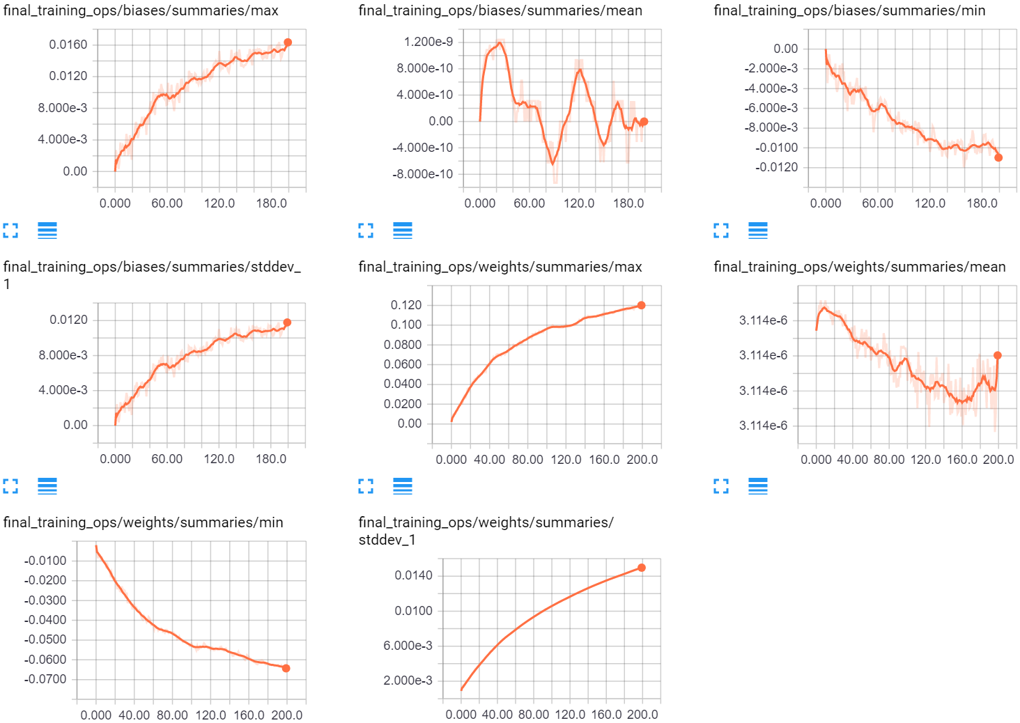

1. Validation

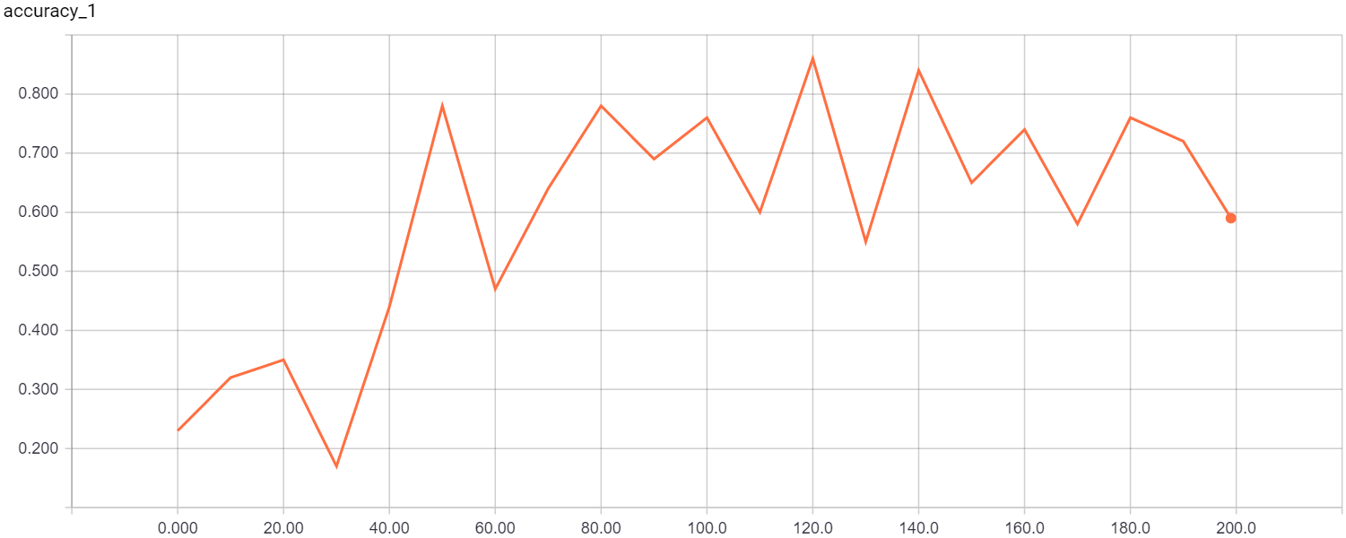

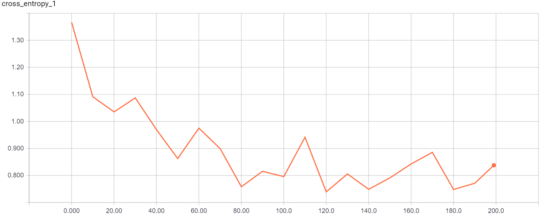

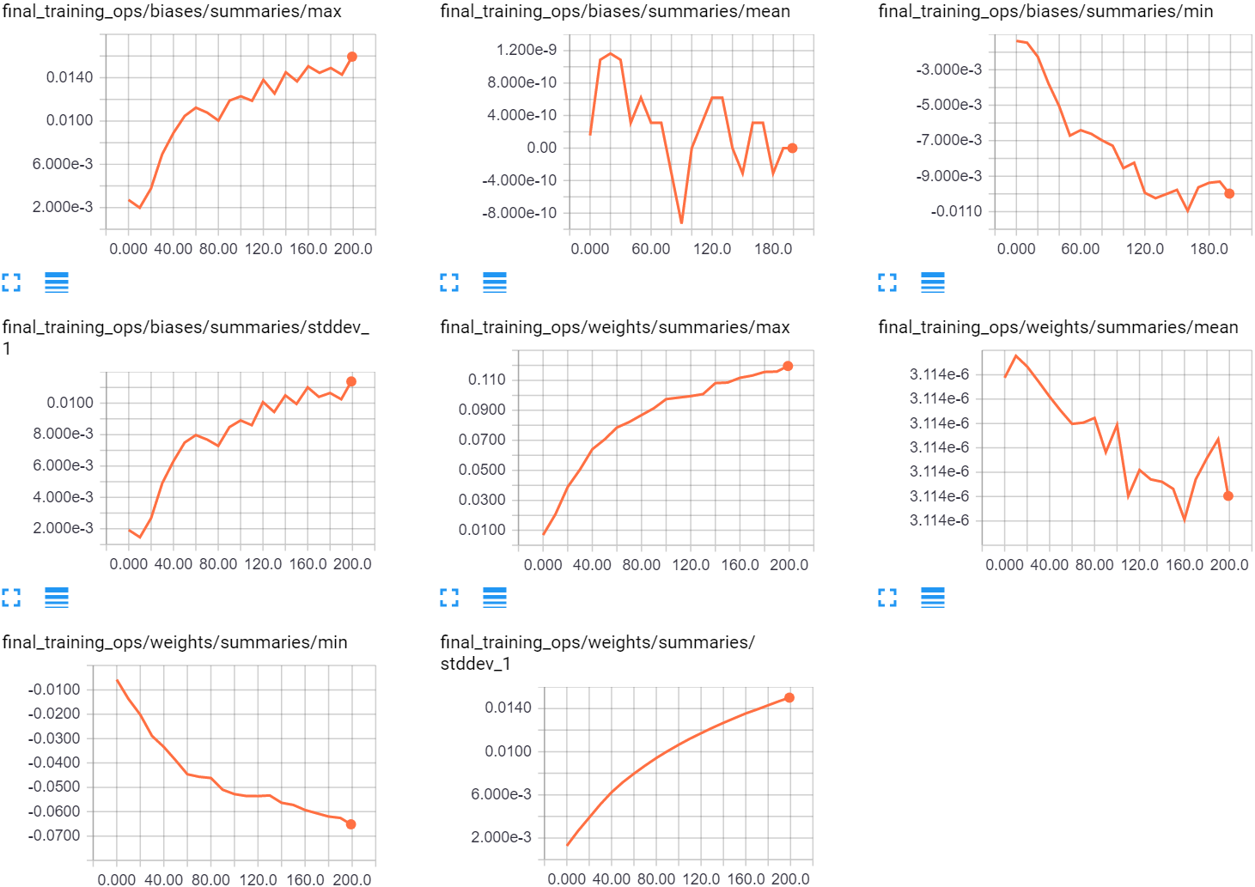

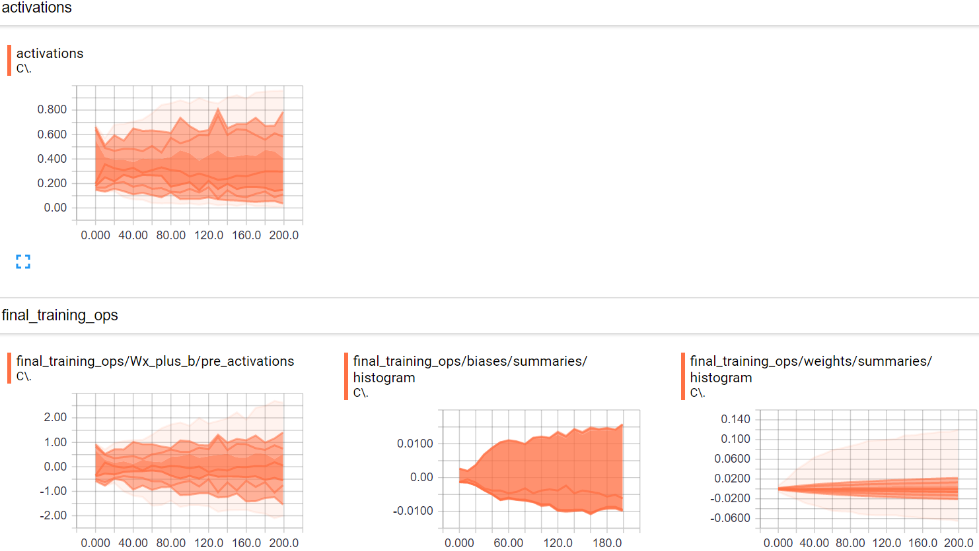

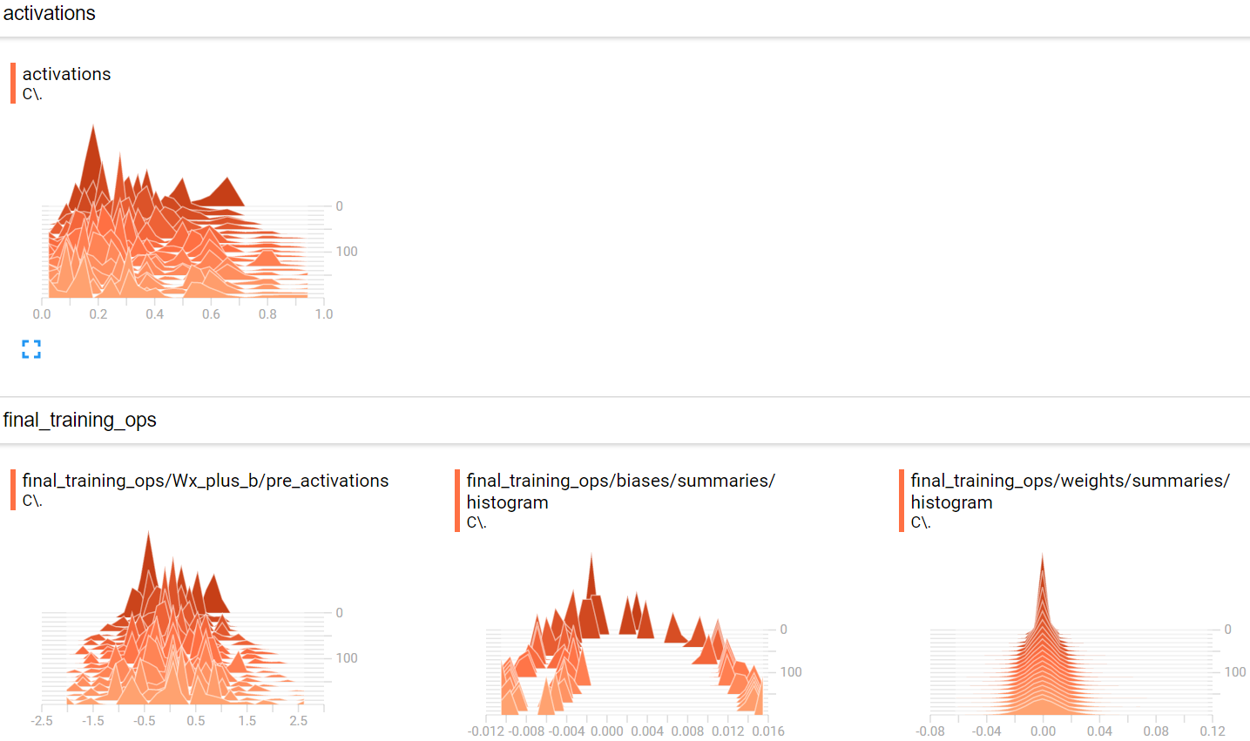

1. **Web Application (Screenshots)**

