COMP-SCI 5542 (SP17) - Big Data Analytics and Applications

**Tutorial 11 Assignment (Due 04/12/17 by 11:59 PM)**

***Dayu Wang* (45)**

1. **TensorFlow Programming**
2. Training Dataset

In this project, the **Flickr30k** dataset was chosen to serve as the training dataset, since the Flickr30k dataset has become a standard benchmark for sentence-based image description[1]. Since the dataset is too big (way over the file size limit of GitHub), the dataset itself was not uploaded to the Git repository.

1. Number of Captions for Each Image: **4**

**def** __init__(self,  
 model,  
 vocab,  
  
 beam_size = 4,  
  
 max_caption_length = 20,  
 length_normalization_factor = 0.0):  
  
self.vocab = vocab  
 self.model = model  
  
 self.beam_size = beam_size  
 self.max_caption_length = max_caption_length  
 self.length_normalization_factor = length_normalization_factor

1. Screenshots of Results

|  |  |  |
| --- | --- | --- |
|  |  |  |
| 20170331_182809177_iOS.jpg | professor.jpg | Messi.jpg |

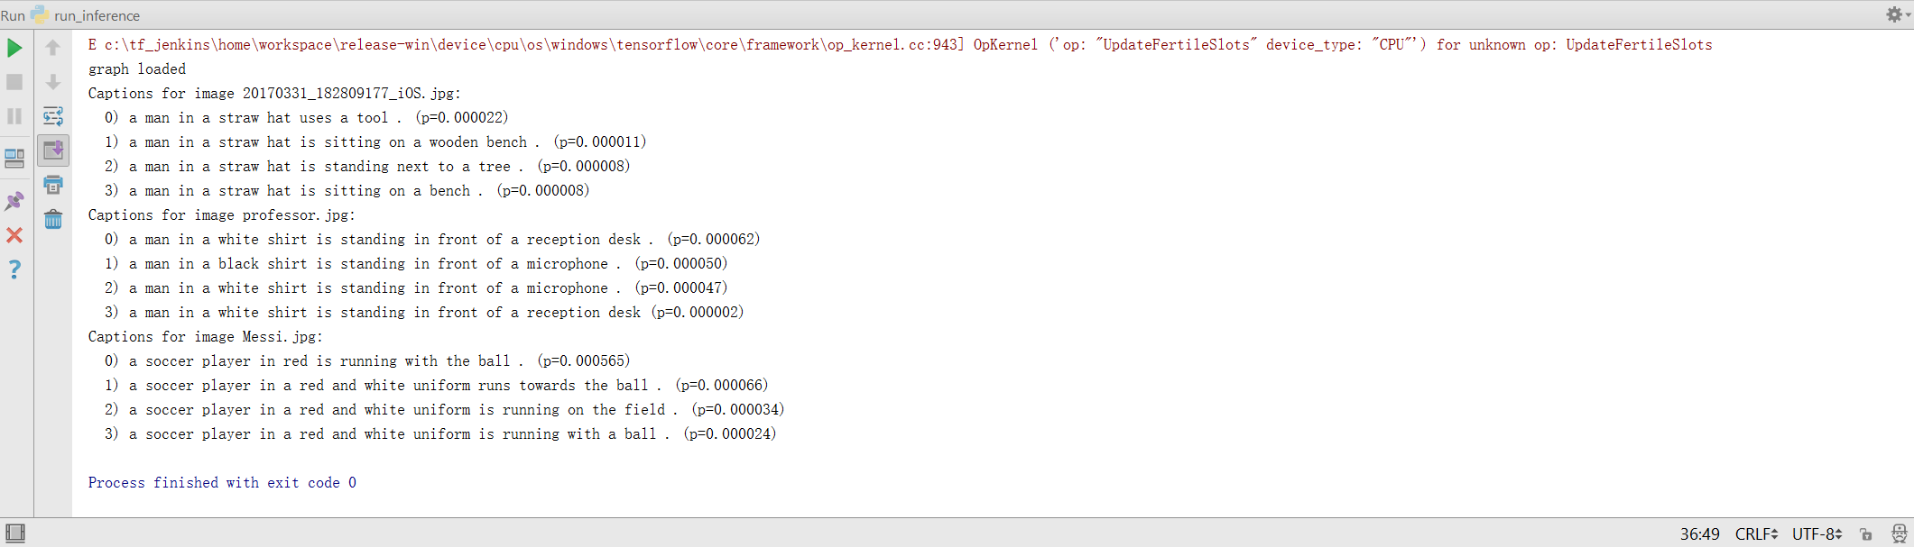

**?**

1. **Web-Based Question Answering (Screenshot)**

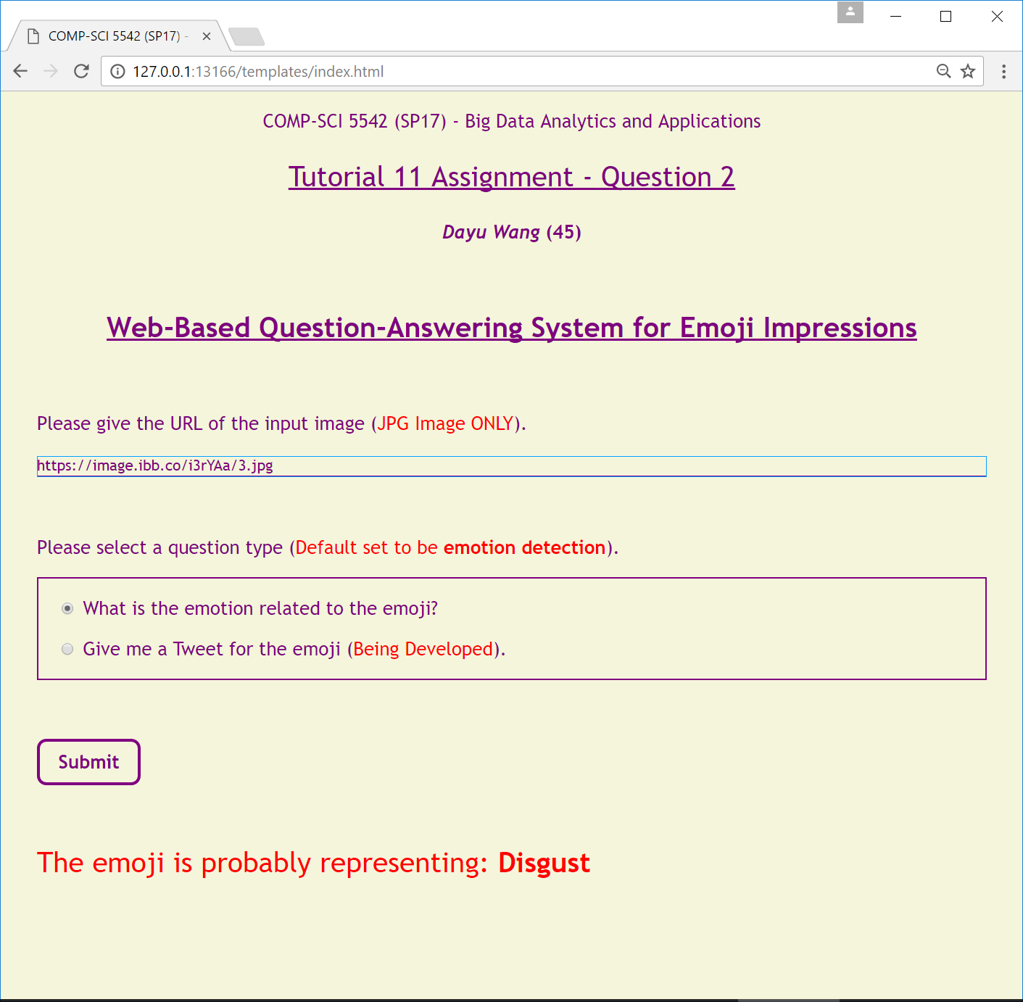

1. **Reference**
2. Plummer, B. A., Wang, L., Cervantes, C. M., Caicedo, J. C., Hockenmaier, J., & Lazebnik, S. (2015). Flickr30k Entities: Collecting Region-to-Phrase Correspondences for Richer Image-to-Sentence Models. In *Proceedings of the IEEE International Conference on Computer Vision* (pp. 2641-2649).

[View Original Paper](https://docs.google.com/viewer?url=https://github.com/dwk894/COMP-SCI_5542_SP17_Tutorials/raw/master/Tutorial_11_Assignment/Reference/Plummer_-_2015_-_IEEE_Computer_Vision_-_Flickr30k_-_PDF.pdf)