COMP-SCI 5542 (SP17) - Big Data Analytics and Applications

**Tutorial 1 Assignment (Due 01/25/17 by 11:59 PM)**

***Dayu Wang* (45)**

1. Problem Set 1
2. Draw a software architecture diagram and design workflow for the chimpanzee monitoring problem of Problem Set 1.

Software Architecture Diagram (Figure 1):



**Figure 1**. Software Architecture Diagram of the chimpanzee monitoring problem.

Design Workflow (Figure 2):



**Figure 2**. Workflow designation of the chimpanzee monitoring problem.

1. Write a pseudocode for the Odd Man Out problem of the Problem Set 1.

**Algorithm** **Find-Single-Number**(*A*[*n*]) // Assume the array contains at least 3 numbers.

1. *result* 🡐 0
2. **for** *i* 🡐 1 **to** *n*
3. *result* 🡐 *result* ***x*OR** *A*[*i*] // “*x*OR” is the bitwise exclusive-OR operation.
4. **endfor**
5. **return** *result*
6. **End**
7. Create GitHub Account. Create a repository in remote GitHub. Clone it to local machine. Create 2 (Source and Documentation) directories in local GitHub. Put the document with the pseudo code of question 1 under documentation directory in the local windows GitHub and sync it to remote Github.

GitHub repository: <https://github.com/dwk894/COMP-SCI_5542_SP17_Tutorials>

1. Create ZenHub Tool Account. Create a board, 3 iterations, at least 5 tasks and show the analytics graph.

Figure 3 shows the 3 iterations.

Figure 4 shows the 5 tasks.

Figure 5 shows the analytics graph.

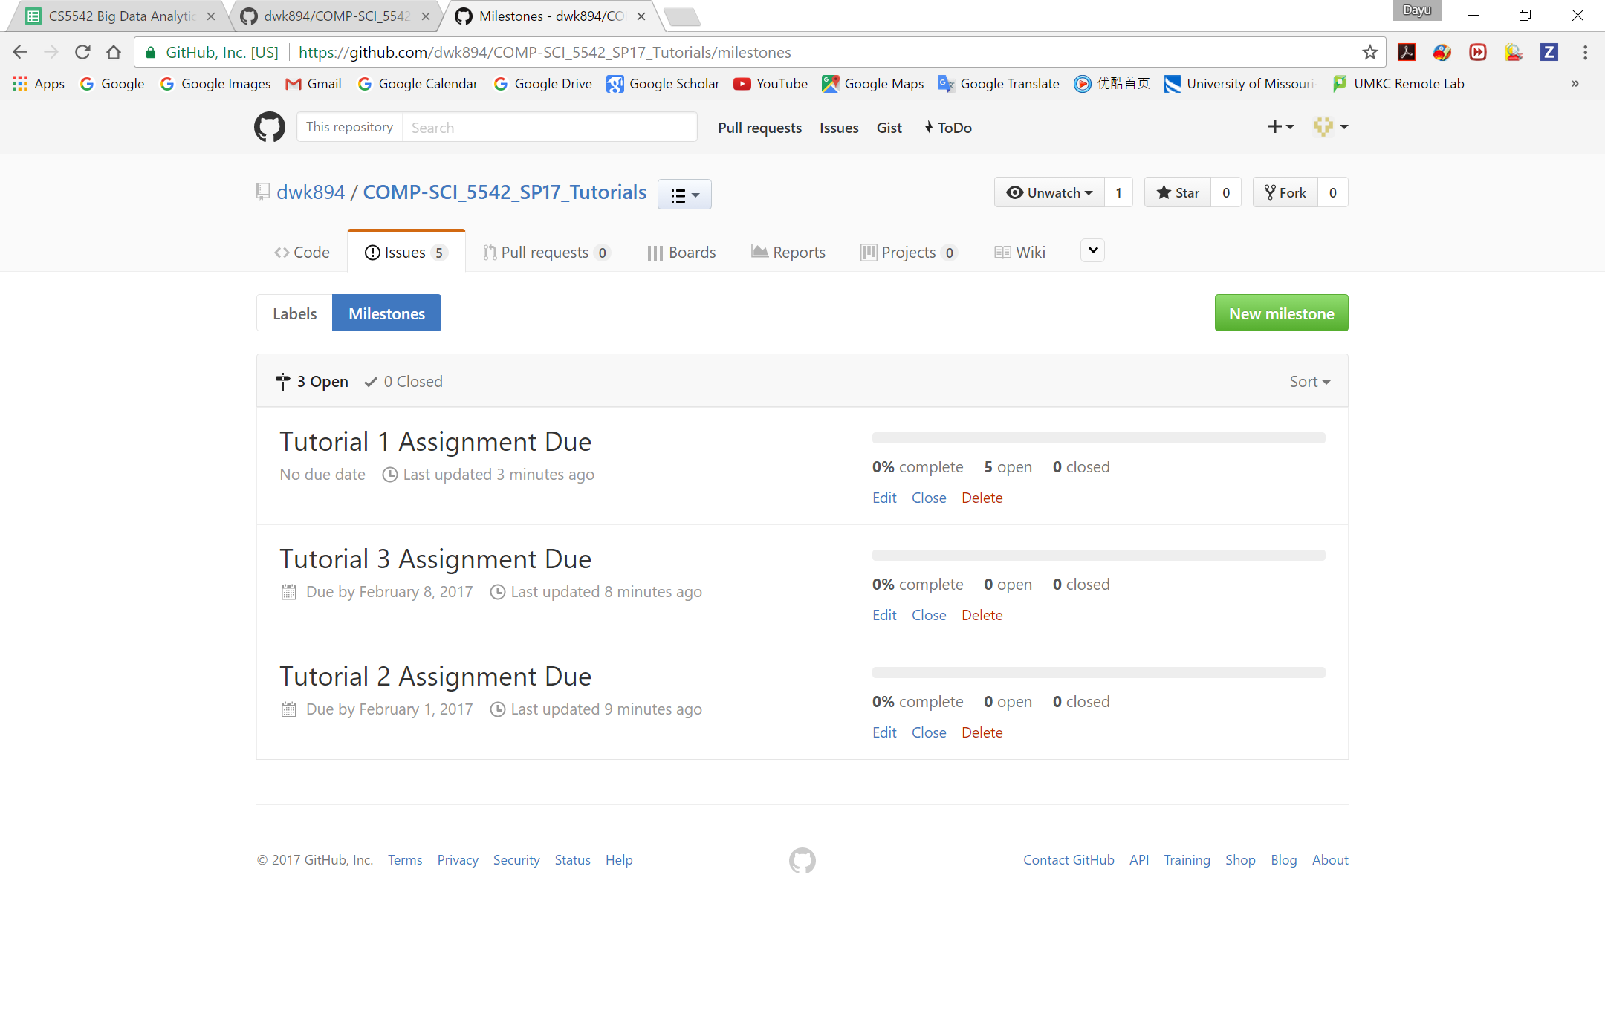

**Figure 3**. The 3 iterations in ZenHub.

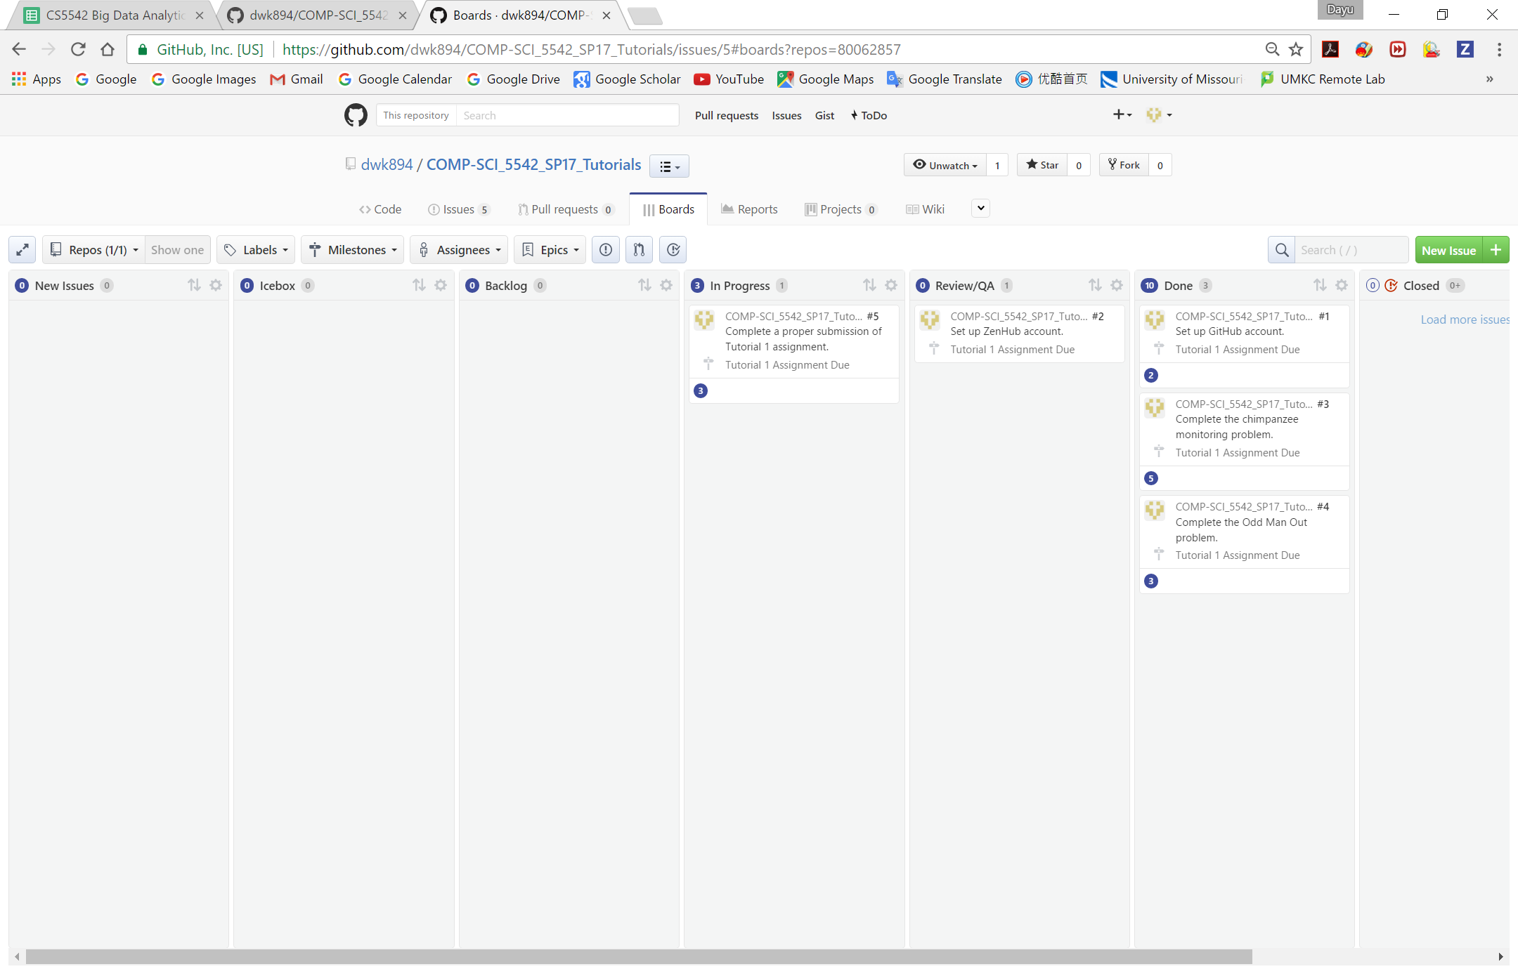

**Figure 4**. The 5 task created in ZenHub.

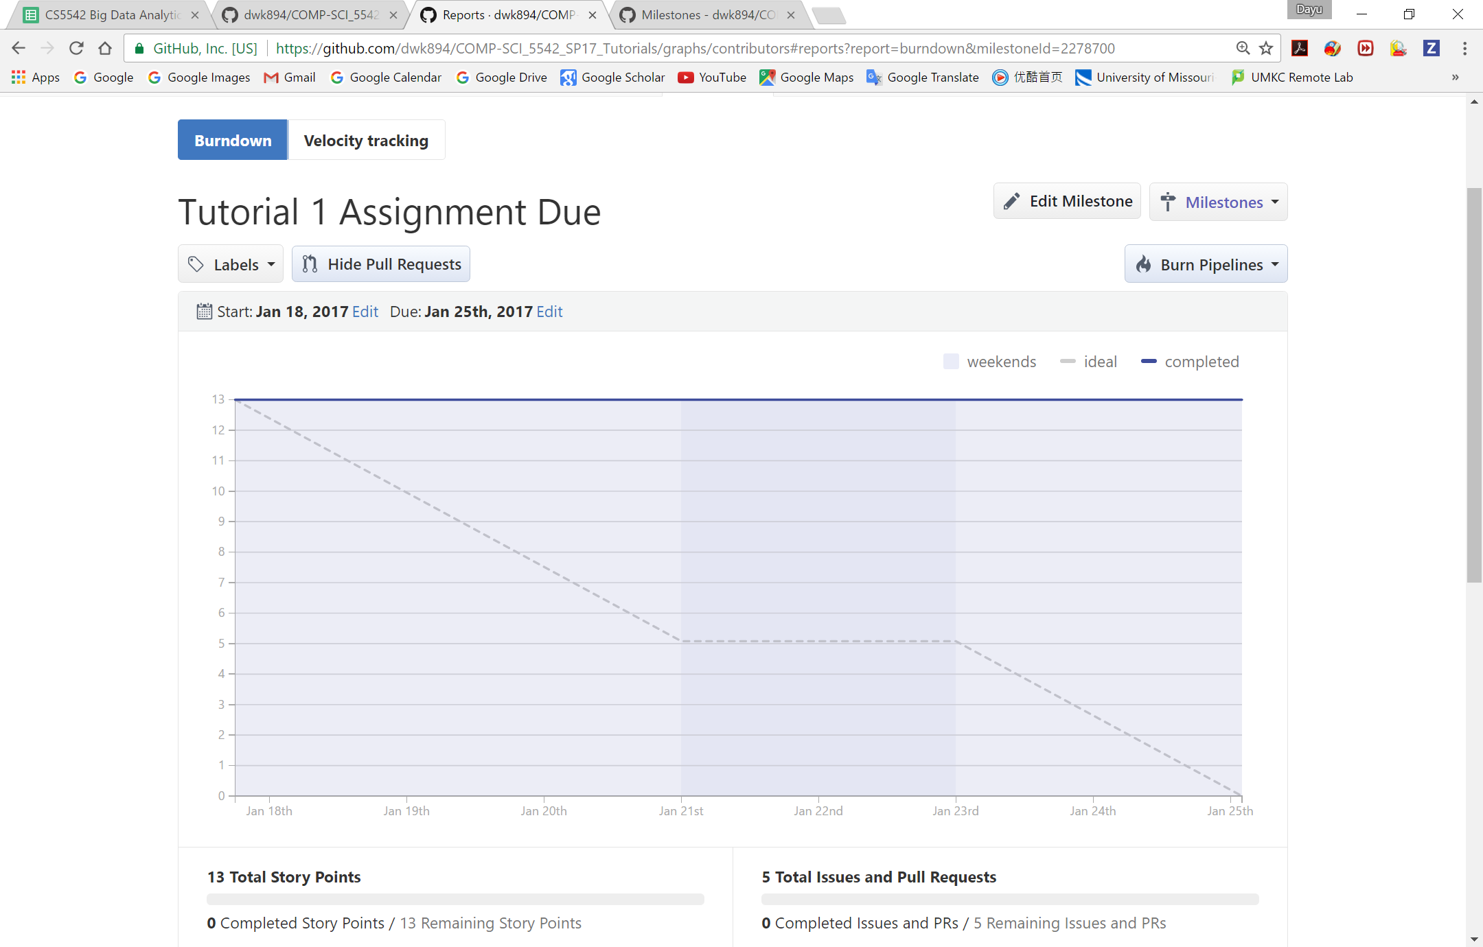

**Figure 5**. Analytics graph of in ZenHub.