COMP-SCI 5542 (SP17) - Big Data Analytics and Applications

**Tutorial 4 Assignment (Due 02/16/17 by 11:59 PM)**

***Dayu Wang* (45)**

1. **Spark Programming**
2. **Description of Dataset**

The dataset consists of **emoji** icons. The data is separated into two classes, the *smiling* icons and *crying* icons. I used the method mentioned in tutorial class and **decision tree algorithm** (instead of the random forest model in the TA’s source code). Figure 1 lists some images in my dataset.





**Figure 1**. Examples of my dataset of **emoji** of smiling and crying.

There are **40** training images (20 smiles and 20 cries) and **6** test images (3 smiles and 3 cries).

1. **Purpose behind Image Classification**

Image classification applied on **emoji** impressions can significantly help researches on cross-platform emoji interpretation area. It opens a novel way to recognize and translate new impressions, with the rapid development of new platform/devices nowadays.

1. **Accuracy and Confusion Matrix**

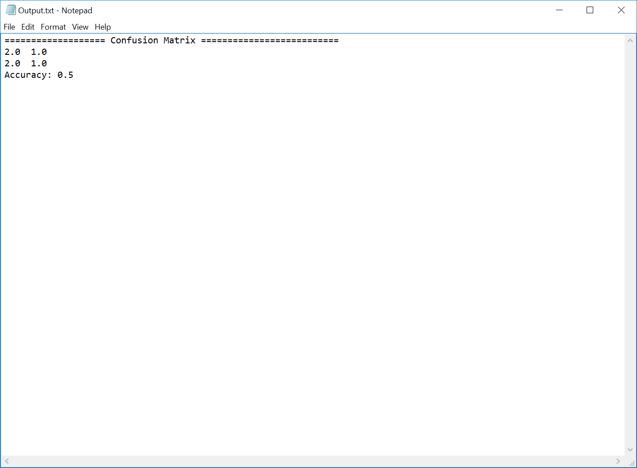

1. **Google Conversion API**

Web server: Apache Tomcat 8.5.11

Please see the code in my GitHub account.