COMP-SCI 5542 (SP17) - Big Data Analytics and Applications

**Tutorial 6 Assignment (Due 03/01/17 by 11:59 PM)**

***Dayu Wang* (45)**

1. **Spark Programming**
2. Dataset Justification

Based on the Plutchik’s Wheel model of eight basic emotions of creatures[1], I attempted to vector the extreme emotions which locate a the corners of the octagon. I used simple emoji impressions as the image files to train and test the data. Figure 1 demonstrates all the “standard” emotions.

|  |  |  |  |  |  |  |  |
| --- | --- | --- | --- | --- | --- | --- | --- |
|  |  |  |  |  |  |  |  |
| (a) | (b) | (c) | (d) | (e) | (f) | (g) | (h) |

**Figure 1**. Standard emoji impressions for the eight corners in Pluchik’s wheel. (a) Anger; (b) Anticipation; (c) Disgust; (d) Fear; (e) Joy; (f) Sadness; (g) Surprise; (h) Trust.

1. Screenshots of the Programming Result
2. Decision Tree Model (see Figure 2)

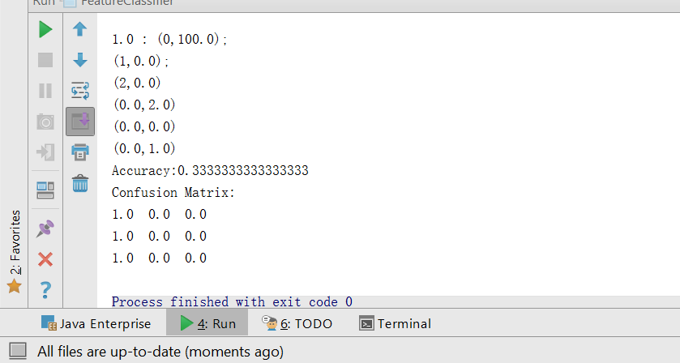

**Figure 2**. Screenshot of programming result for the *decision tree* model.

1. Random Forest Model (see Figure 3)

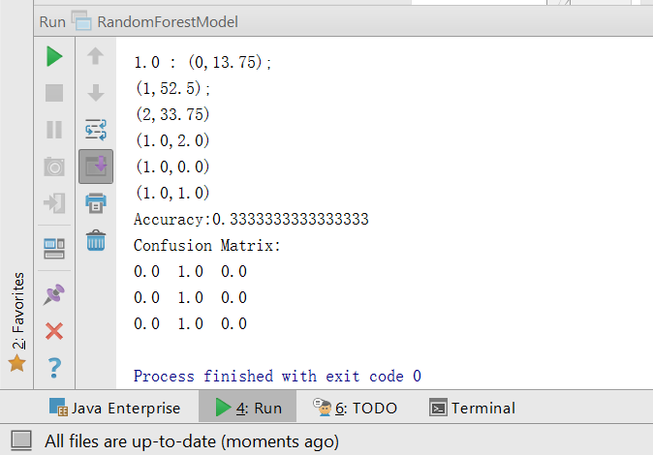

**Figure 3**. Screenshot of programming result for the *random forest* model.

1. **Android Application Programming**
2. Code Example

**final** Button image_classify_button = (Button) findViewById(R.id.***send***);  
image_classify_button.setOnClickListener(**new** View.OnClickListener() {  
 **public void** onClick(View v) {  
 BitmapFactory.Options options = **new** BitmapFactory.Options();  
 options.**inJustDecodeBounds** = **true**;  
 Bitmap bitmap = ((BitmapDrawable) **imageView**.getDrawable()).getBitmap();  
 ByteArrayOutputStream baos = **new** ByteArrayOutputStream();  
 bitmap.compress(Bitmap.CompressFormat.***JPEG***, 100, baos); *//bm is the bitmap object* **img** = baos.toByteArray();  
 }  
});

1. Screenshot

