COMP-SCI 5542 (SP17) - Big Data Analytics and Applications

**Tutorial 7 Assignment (Due 03/08/17 by 11:59 PM)**

***Dayu Wang* (45)**

1. **TensorFlow Programming**
2. Dataset Description

We are doing an acid-base titration experiment. Different acids have different pH value, which can be describe as

where is the concentration (mol·L−1) of in the solution. For example, if an acid solution’s pH value is 3, then the concentration of is 10−3 mol·L−1, or 0.001 mol·L−1.

Suppose we have 25 mL of each acid solution for titration, and we have NaOH solution ready to neutralize the acids. The concentration of in the NaOH solution is 0.04 mol·L−1. Our data records the amount (in mL) used of NaOH to completely titrate the acids. For example,

X = [6, 3, 11, 9, ...],

Y = [0.00061250, 0.61250000, 0.00000001, 0.00000063, ...].

Our work is to verify the linear relation in acid-base titration.

1. Critical Code for Input/Output

*# Read raw data from file.*trX = []  
trY = []  
xy = 0  
file = open(**'data/rawData.txt'**,**'r'**)  
**for** line **in** file.readlines():  
 **for** i **in** line.split():  
 **if** xy == 0:  
 trX.append(float(pow(10, -int(i))))  
 xy = 1  
 **else**:  
 trY.append(float(i))  
 xy = 0

1. Screenshots of Results

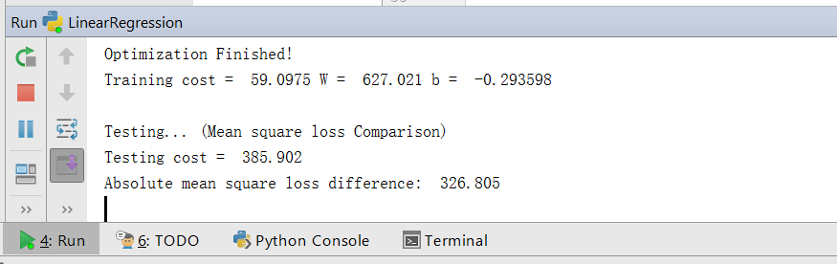

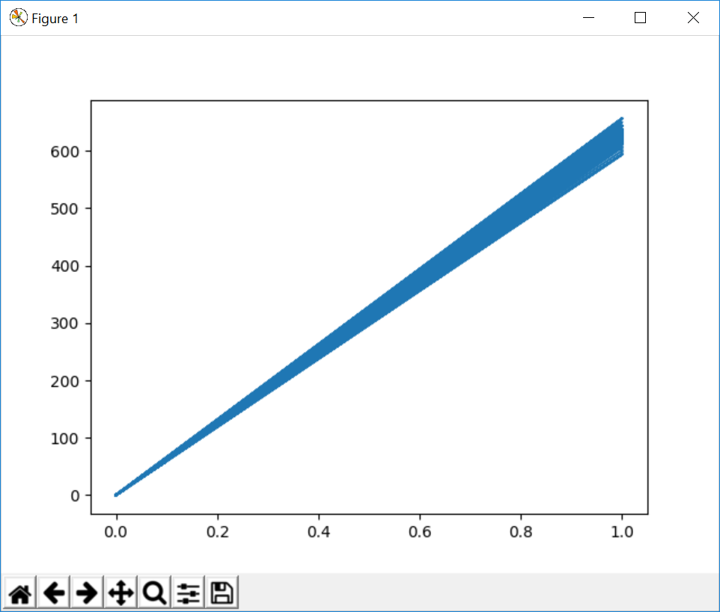

The results proves a very nice proportionality of acid-base titration.