COMP-SCI 5542 (SP17) - Big Data Analytics and Applications

**Tutorial 8 Assignment (Due 03/15/17 by 11:59 PM)**

***Dayu Wang* (45)**

1. **Tensorflow Programming**
2. Description of Dataset

|  |  |  |
| --- | --- | --- |
| **File Range** | **Class Index** | **Class Name** |
| 0.jpg to 19.jpg | 0 | Joy |
| 20.jpg to 39.jpg | 1 | Sadness |
| 40.jpg to 59.jpg | 2 | Surprise |

1. Loading the Data

*# Input my own data.*filenames = [(**'/data/%d.jpg'** % i) **for** i **in** range(60)]  
filename_queue = tf.train.string_input_producer(filenames)  
reader = tf.WholeFileReader()  
filename, content = reader.read(filename_queue)  
image = tf.image.decode_jpeg(content, channels = 3)  
image = tf.cast(image, tf.float32)  
resized_image = tf.image.resize_images(image, [32, 32])  
input = tf.train.batch(resized_image, batch_size = 8)  
fp = open(**'data/label.txt'**, **'r'**)  
labels = fp.readlines()  
**for** i **in** labels:  
 i = int(i)  
fp.close()

1. Screenshots of the Results

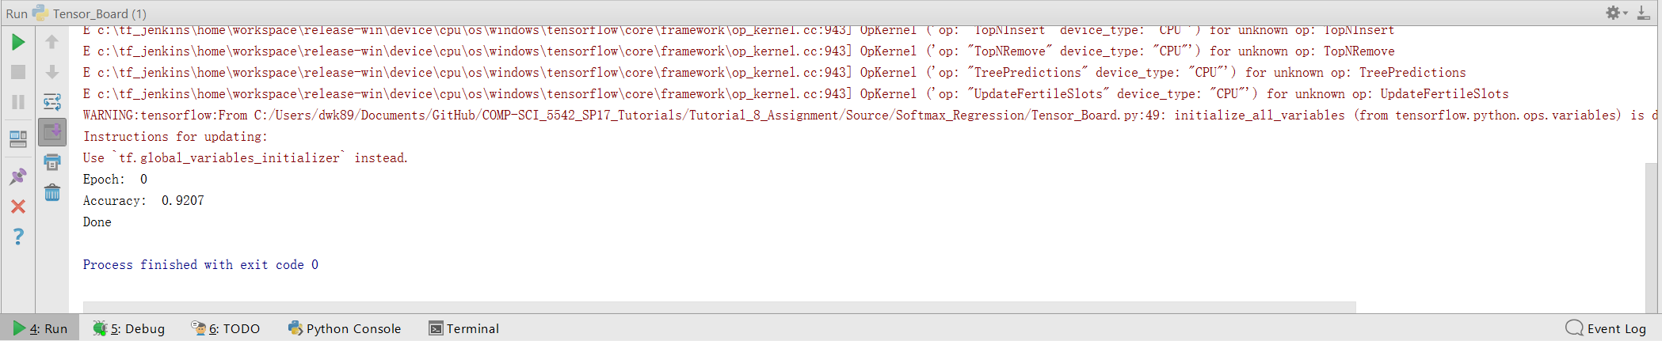

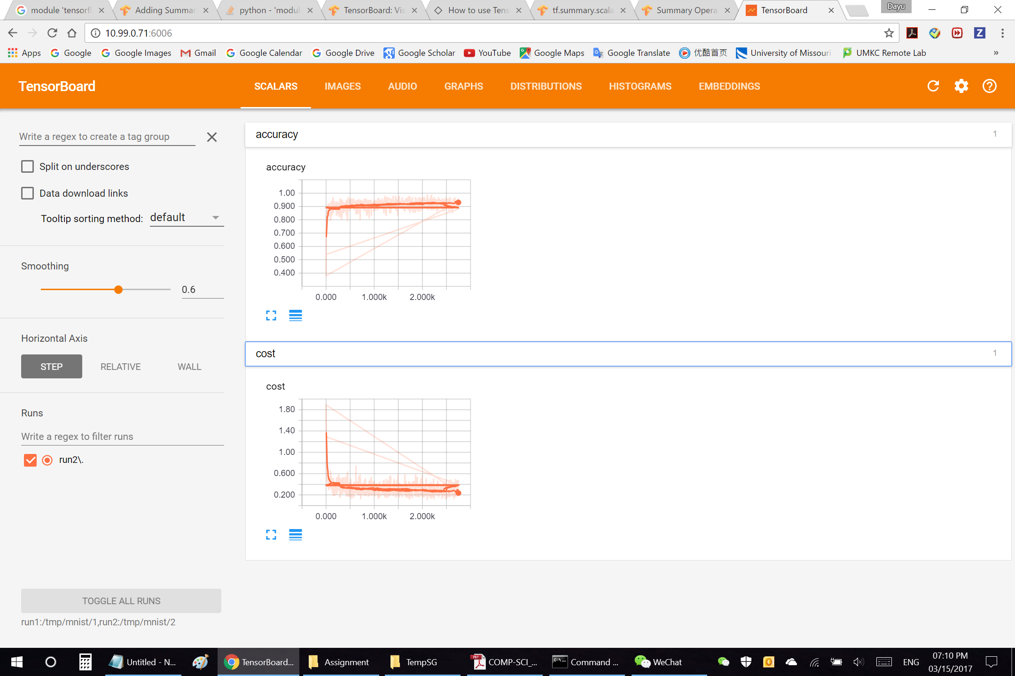

1. **Google CardBoard App**

Function implemented: **Click to stop the video**.

*// Shut down the applciation by a single click.***public void** stopthevideo() {  
 **mVrVideoView** = (VrVideoView) findViewById(R.id.***video_view***);  
 **mSeekBar** = (SeekBar) findViewById(R.id.***seek_bar***);  
 **mVolumeButton** = (Button) findViewById(R.id.***btn_stop***);  
 **mVolumeButton**.setOnClickListener(**new** View.OnClickListener() {  
 @Override  
 **public void** onClick(View view) {  
 onclickstop();  
 }  
 });  
 **mVrVideoView**.setEventListener(**new** ActivityEventListener());  
 **mSeekBar**.setOnSeekBarChangeListener(**this**);  
}

public void onclickstop() {

mVrVideoView.shutdown();

}

Screenshots

