COMP-SCI 5542 (SP17) - Big Data Analytics and Applications

**Tutorial 9 Assignment (Due 03/24/17 by 11:59 PM)**

***Dayu Wang* (45)**

1. **TensorFlow Programming**
2. Description of Dataset (see Figure 1)

The dataset (other than the MNIST) I used in this program is the SVHN (Street View House Number) data. It is a real-world image dataset for developing machine learning and object recognition algorithms with minimal requirement on data preprocessing and formatting. It can be seen as similar in flavor to MNIST, but incorporates an order of magnitude more labeled data (over 600,000 digit images) and comes from a significantly harder, unsolved, real world problem. SVHN is obtained from house numbers in Google Street View images.

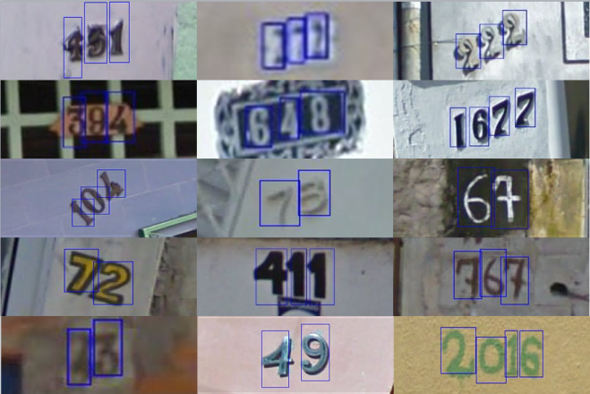 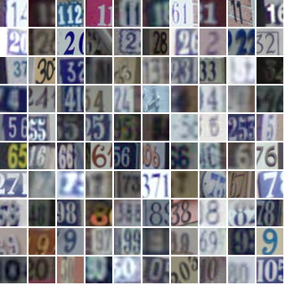

**Figure 1**. The uncropped (left) and cropped (right) example of the SVHN dataset.

1. Screenshots of the Results (see Figure 2, Figure 3, and Figure 4)

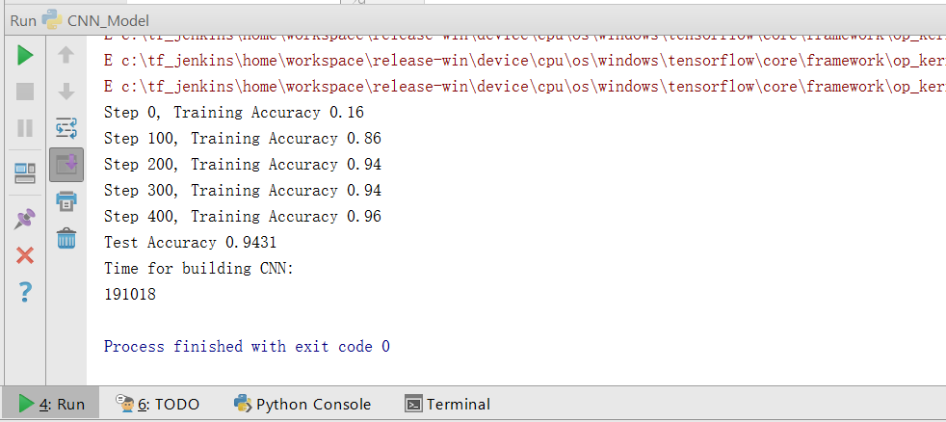

**Figure 2**. CNN mode, accuracy and building time.

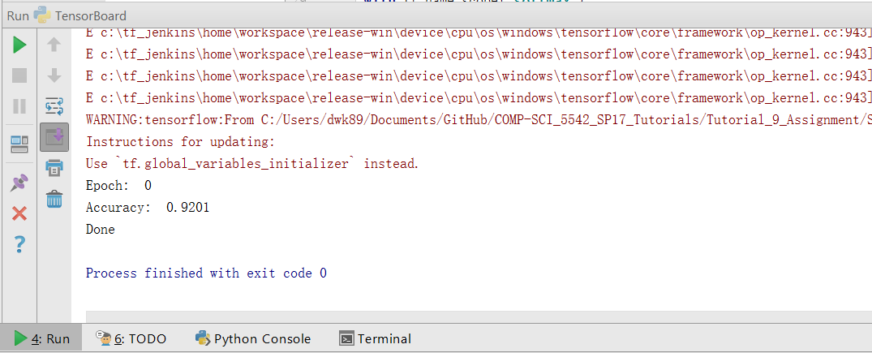

**Figure 3**. TensorBoard, accuracy.

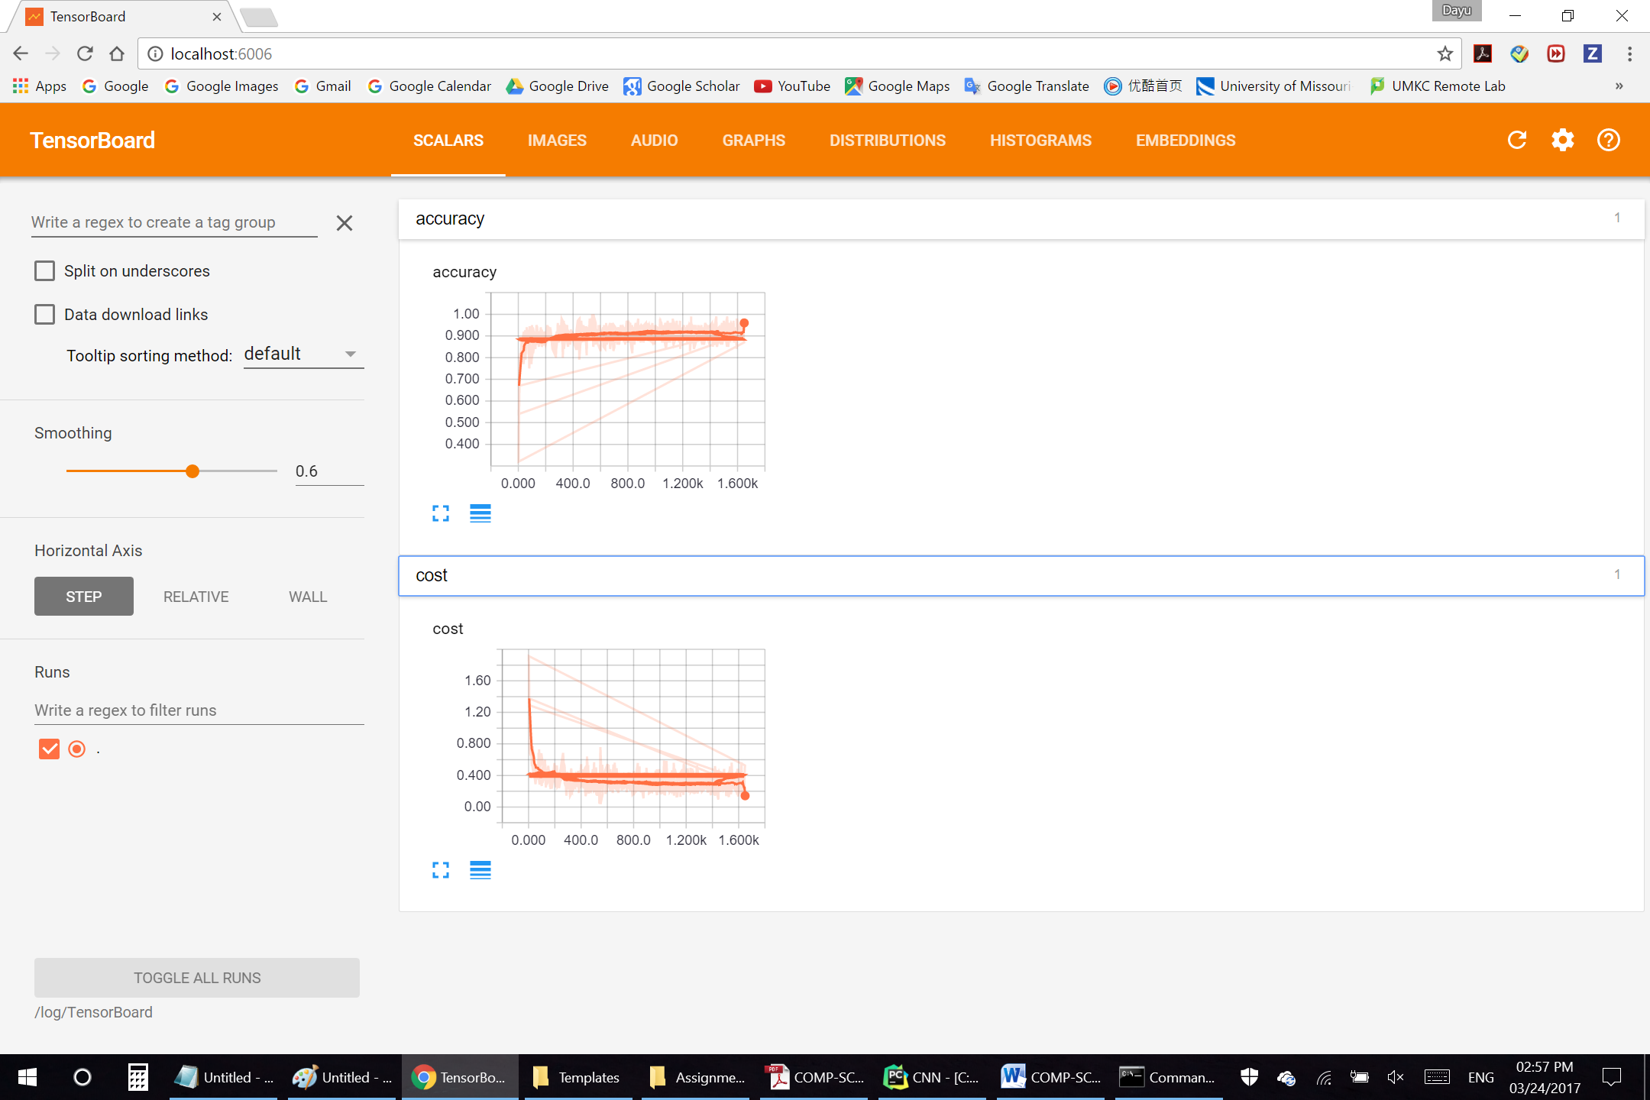

**Figure 4**. TensorBoard, screenshot of localhost:6006.

1. **Web Application of Image Recognition**

Please see the screenshots in Figure 5, Figure 6, and Figure 7. The input URL of emoji impression is <http://imgh.us/StdEmoji06.jpg>.

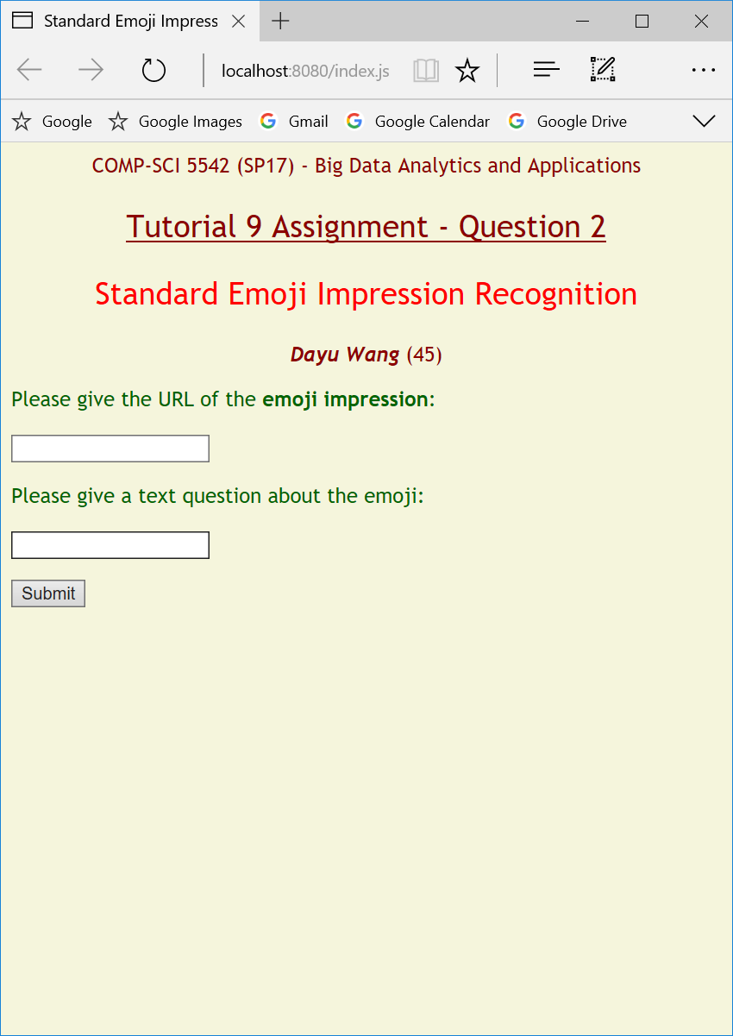

**Figure 5**. Main page of the simple application.

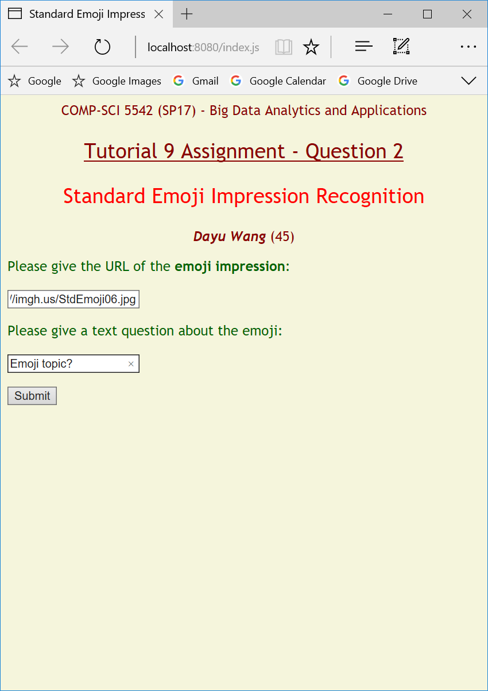

**Figure 6**. Input.

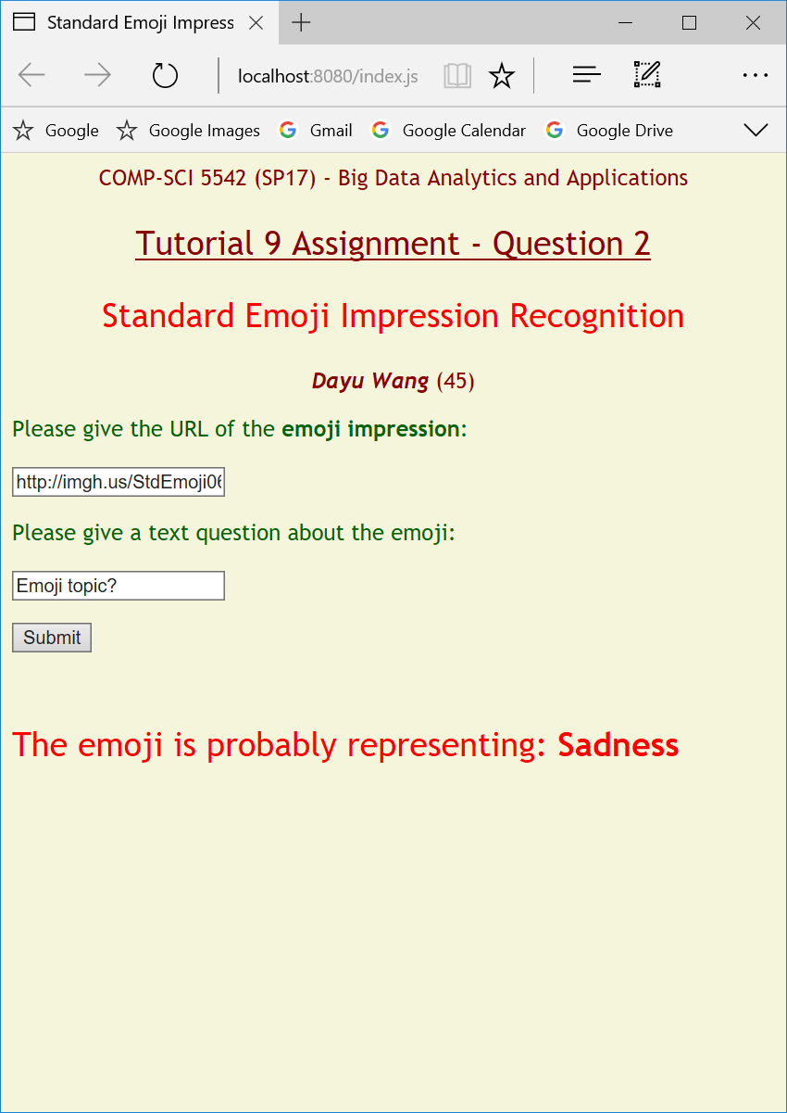

**Figure 7**. Output.