**“Pocket Manager”**

**Management**

* **Project management report**

We met and communicated with each other every day, progress will be report each time and the new assignment will be allocated after the meeting. We separate the project as four parts then all of us can do it as an individual work. But when some parts need to do together or some difficult problem appeared, we always help each other and solve the problem as a team. Our leader allocated and coordinated the assignment based on the whole project progress, and all of us communicated and helped others frequently. GitHub has been used as a platform that to assign the task and communication.

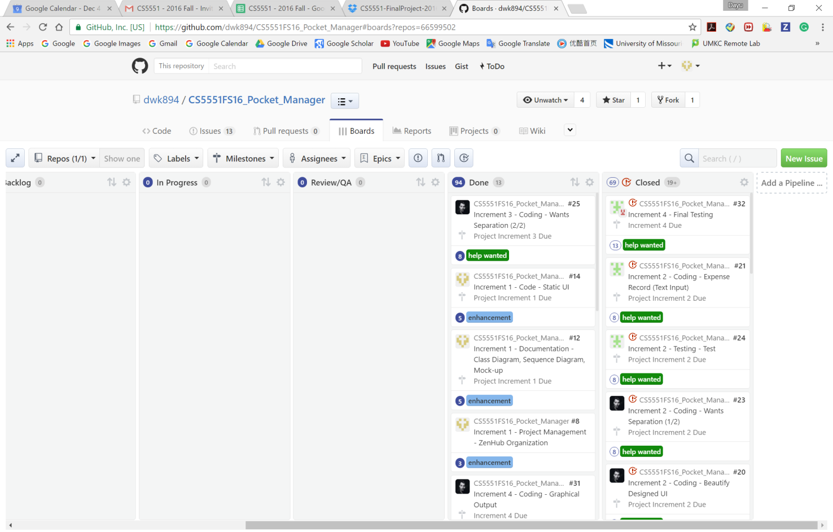

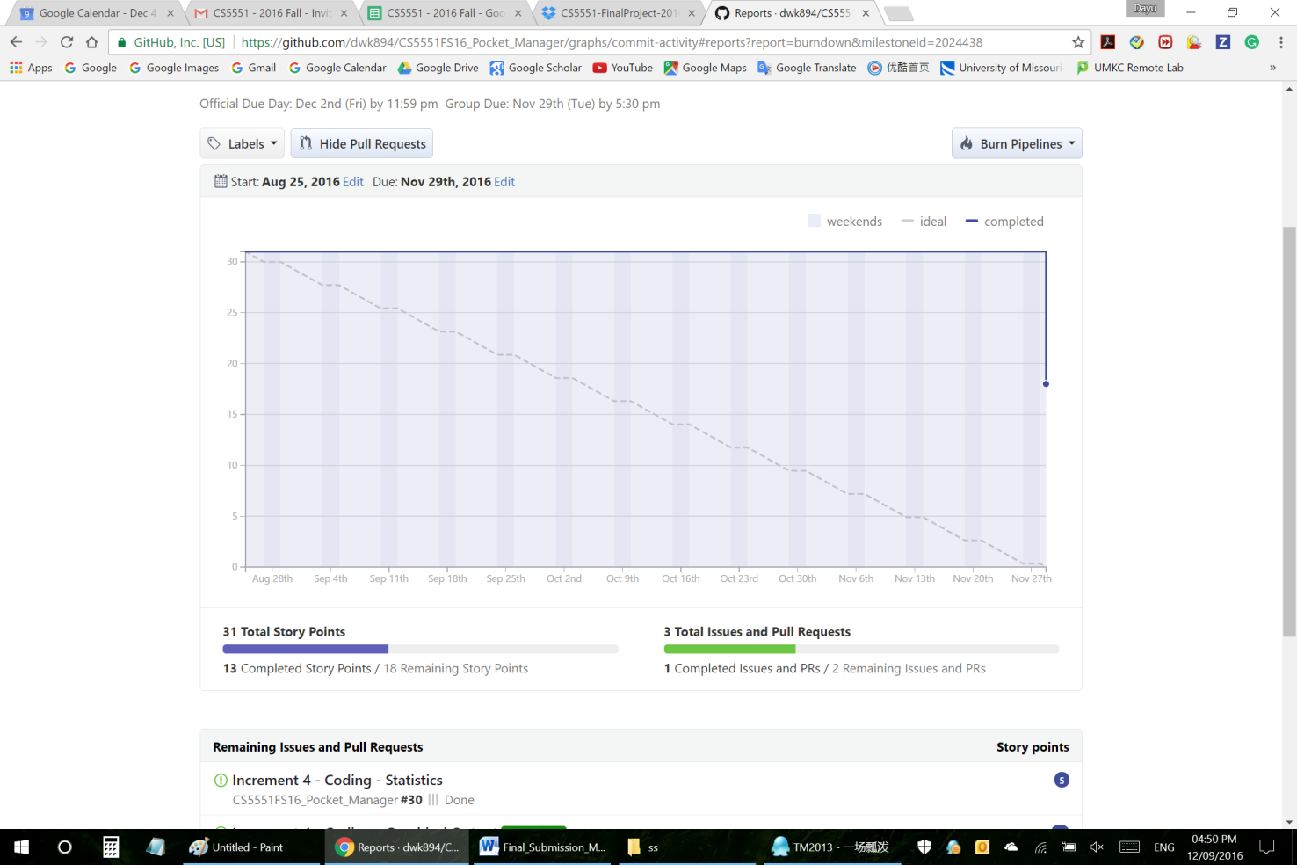

* **Final project evaluation**

**Discuss how well your project satisfies your original requirement specifications, were you satisfied with your design process?**

Our application is analyzing and managing the expense that targeted to college students, focusing on expense control and management. We were trying to develop an android application so that student can manage their money in their pocket, and also manage their expense in the phone which response to nowadays college students’ living habits, that’s why our application is called “Pocket Manager”.

And the Create budgets, Separate wants from needs, Expense input and record, graphical representation features can complete satisfy the requirements what we designed at the first stage of the application development.

**How helpful was the agile process?**

The agile process help out teams respond to unpredictability through incremental, iterative work cadences and empirical feedback.

**How would you do the agile process next time?**

what we going to do in the future project, we will still follow agile process which means we will focus on frequent delivery of products.

**Did you stick to your project plan schedule?**

Actually during the whole developing process we did sticked a little bit to the plan schedule within the first two increment, I think that’s because we need a few weeks to get team members familiar with each other, that’s really important.

**What was the real management structure within your group?**

The management structure within our team was that after the team meeting, we decided the possible tasks of the application, then our team leader assign the task for all the team members, and every member have right to make small changes and design portion UI. We follow this management till our project done.

**Discuss what you might have done differently if this were a real world project?**

We might do some pre-survey before decide the requirements and before releasing the application we will choose some users use the application and ask for the feedbacks.